GRIT: A plume-surface interaction experiment in vacuum microgravity
Wesley A. Chambers,^{1,2} Philip T. Metzger,^{1,2,3} Adrienne R. Dove^{1,2}, Daniel T. Britt^{1,2}

¹ Physics Department, University of Central Florida, Orlando, FL 32816
² Center for Lunar and Asteroid Surface Science, University of Central Florida, Orlando, FL 32816
³ Florida Space Institute, Orlando, FL 32826
chambers@knights.ucf.edu

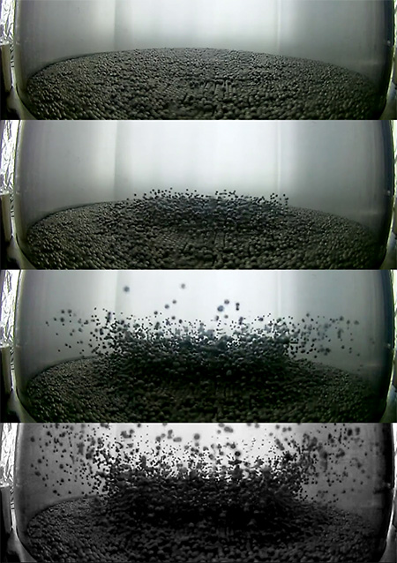
Abstract. The recent uptick in space missions to small bodies highlights the need for scientists and engineers to understand the interactions between gas jets and granular media in a microgravity environment. Current and future missions such as NASA’s OSIRIS-REx, and JAXA’s Hayabusa2 and MMX will each visit the surface of an asteroid or other small body. The exhaust plume from a spacecraft conducting near surface operations may loft material which poses a hazard to the spacecraft or nearby assets.
Prior work studying plume-soil interactions has tended to be mission specific, focused on mitigating hazards to a particular spacecraft. Because Martian and lunar landings have been more common, and due to the challenges of replicating these conditions, plume-soil interactions in a vacuum microgravity environment have been largely unexplored. We take more general approach to study these phenomena, building an experiment to observe and characterize gas-jet interactions in a vacuum microgravity experiment.
We have constructed a cylindrical vacuum chamber to house a plume-surface interaction experiment that is dropped in our laboratory drop tower to explore microgravity behaviors. Regolith simulant is filled to controlled depths in the base of the chamber. Just after the experiment drops, a trigger opens a valve, sending air in through a hole drilled into the center of the chamber’s lid for a specified pulse duration to simulate jetting. The chamber’s pre-pulse vacuum quality ranges between 200 – 600 milliTorr, or roughly 1/10 Mars atmospheric pressure. Final vacuum pressure ranges up into the tens of Torr, increasing linearly with pulse time.
Figure 1 – Example GRIT images.
Top and side mounted cameras record the interaction of the jet plume with regolith simulant in the base of the chamber. We conduct experiments with several media, including spherical beads and high-fidelity asteroid simulant, both with defined particle sizes and size distributions. The former are more easily compared to computer models, while the latter closely replicate the target environment.
The jet produces a crater and ejecta spray that qualitatively look similar to low-velocity impact experiments. Gas-flow interactions, however, produce distinct features such as off-center disturbance of the regolith. Observations of these features, initial quantitative analysis, and comments on relevant gas flow mechanics are presented.

