ISRU Challenges From Heating Carbonaceous Chondrite Material For Water
A. Springmann^{1*}, D.S. Lauretta¹, B. Klaue², Y.S. Goreva³, J.D. Blum⁴, A. Andronikov⁵, J.K. Steckloff^{6,7}
¹University of Arizona, Tucson, AZ; ²TSI GMBH, Aachen, Germany; ³NASA JPL, Pasadena, CA; ⁴University of Michigan, Ann Arbor, MI; ⁵Czech Geological Survey, Prague, Czech Republic; ⁶University of Texas at Austin, Austin, TX; ⁷Planetary Science Institute, Tucson, AZ
sondy@lpl.arizona.edu

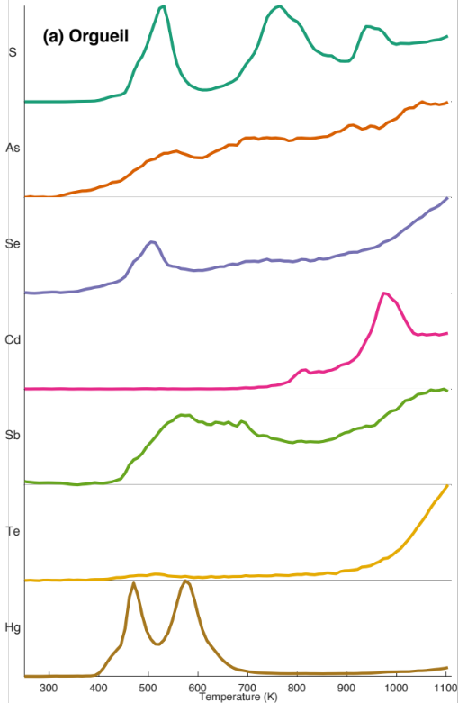
Carbonaceous chondrite meteorites are some of the oldest Solar System planetary materials available for study. Of particular interest in carbonaceous chondrites are labile elements, which vaporize and mobilize efficiently during post-accretionary parent-body heating events. We characterized the thermally induced movements of the labile elements S, As, Se, Te, Cd, Sb, and Hg in carbonaceous chondrites by conducting experimental simulations of volatile-element mobilization during thermal metamorphism. This process results in appreciable loss of some elements at temperatures as low as 500 K. Elements such as S and Hg have the most active response to temperature across different meteorite groups. This work is also critical for constraining the concentrations of contaminants in vaporized water extracted from asteroid regolith as part of future in situ resource utilization for sustained robotic and human space exploration.
For future in situ resource utilization, it is critical to know the abundance of volatile elements in a primitive meteorite, along with the percentage of water, for creating both drinking water and rocket propellant. Heating primitive meteorites to release water vapor will also release high concentrations of labile elements, many of which exceed EPA limits for contaminants in drinking water. Water mined from extraterrestrial sources has long been predicted to be polluted with labile elements such as Hg; however, this could be mitigated by adsorption via ion exchange resins. Producing water with high concentrations of Hg to make hydrogen gas for fuel could cause metal failure from brittle fracture in the hydrolyzer system, considering that Hg can cause brittleness in aluminum in natural gas processing plants.
Fig. 1: Element release with temperature for Orgueil, normalized to maximum release counts for each element.

Kelsey, L., Lauretta, D.S., 2013. Metsco Proceedings 2013, p. 21.
Reed, Jr., G.W., 1999. Meteoritics and Planetary Science 34, 809–812.
Chiarle, S., Ratto, M., Rovatti, M., 2000. Water Research 34, 2971–2978.
Nichols, H., Rostoker, W., 1961. Acta Metallurgica 9, 504–509.

