**Extracting information about the first stars and black holes from sky-averaged radio data from lunar orbit**

Keith Tauscher,1,2 David Rapetti,2,3 Jack Burns2

*1 Department of Physics, University of Colorado, Boulder CO 80309*

*2 Center for Astrophysics and Space Astronomy, University of Colorado, Boulder, CO 80309*

*3 NASA Ames Research Center, Mountain View, CA 94035*

Keith.Tauscher@colorado.edu

**Abstract**. The signal generated by the 21 cm line of neutral hydrogen is one of the only known ways to directly probe the very high redshift universe. By observing the sky-averaged component of this signal, we can infer properties of the first stars and black holes, which we cannot directly detect, such as when they formed. However, to mine this information from real observations, the $\sim 100$ mK signal must be extracted from $\gtrsim 1000$ K foregrounds. The observations must also be made in a way that avoids human-generated Radio Frequency Interference (RFI). I am part of a team investigating a mission concept called the Dark Ages Polarimeter PathfindER (DAPPER) where this RFI avoidance is implemented by making the observations from a lunar orbiting SmallSat telescope. In this presentation, I will describe a pipeline I have written for DAPPER that uses the different properties of the foreground and signal, including spatial dependence, spectral dependence, and polarization, to separate them. It performs an initial fit to separate the signal from the foreground in frequency space and follows them up by transforming them into a distribution of physical parameters using a Markov Chain Monte Carlo (MCMC) exploration. The image below shows confidence intervals output by the pipeline for 100 hours of integration in the 40-120 MHz regime. DAPPER will observe at the low frequencies of 17-38 MHz.

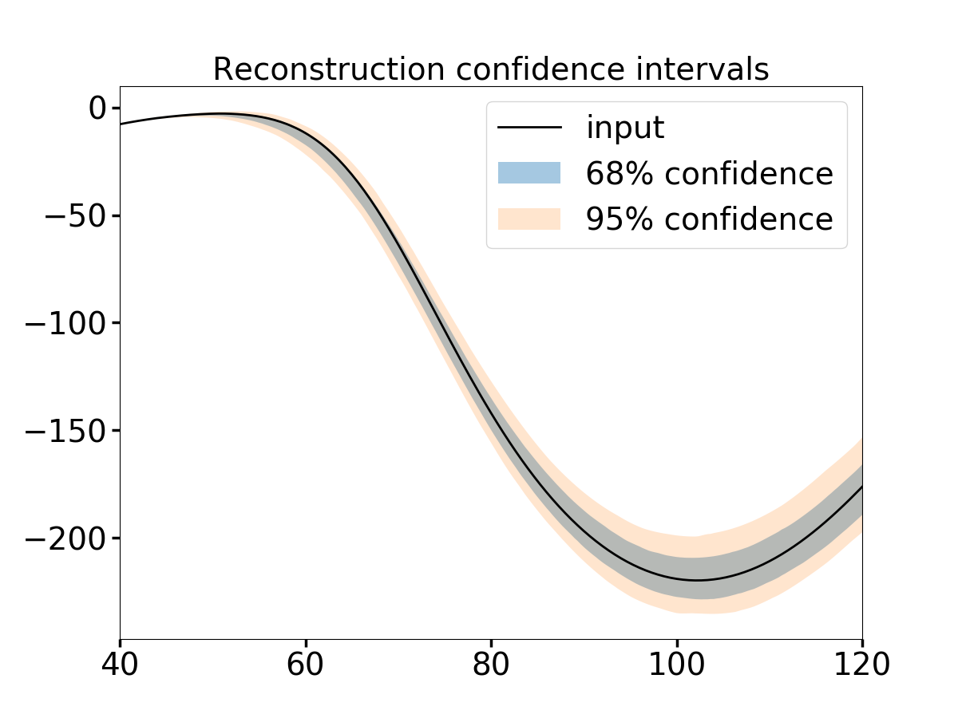

Brightness [mK]

ν [MHz]