**MEASURING THE EARTH'S SYNCHROTRON EMISSION FROM RADIATION BELTS WITH A LUNAR NEAR SIDE RADIO ARRAY.** A. M. Hegedus1, Q. Nenon2, A. Brunet3, J. Kasper1, A. Sicard3, B. Cecconi4, and R. J. MacDowall5, 1University of Michigan, Department of Climate and Space Sciences and Engineering, Ann Arbor, MI, USA, 2Space Sciences Laboratory, University of California, Berkeley, CA, USA, 3ONERA / DPHY, Universite de Toulouse, F-31055 Toulouse – France, 4LESIA, Observatoire de Paris, Universite PSL, CNRS, Sorbonne Universite, Univ. de Paris, Meudon, France, 5NASA Goddard Space Flight Center, Greenbelt, MD, USA. (alexhege@umich.edu)

**Introduction:** The brightness of the Earth's synchrotron emission from its radiation belts reveals the electron distribution across different energy levels. A lunar near side array would be uniquely positioned to image this emission and provide a near real time measure of how the Earth's radiation belts are responding to the current solar input. The high kinetic energy electrons that populate the Earth radiation belts spontaneously emit synchrotron emissions (the relativistic counterpart of cyclotron emissions) because of their interaction with the planetary magnetic field. The Salammbô code is a physical model of the dynamics of the three-dimensional phase-space electron densities in the radiation belts, allowing the realistic prediction of 1 keV to 100 MeV electron distributions trapped in the belts. This information is put into a synchrotron emission simulation which provides the brightness distribution of the emission up to 1 MHz from a given observation point. We run simulations on a “quiet time” which represents what can be seen on 11th of October 2016 (midnight) and a “storm time” (1st of November 2016). These yield brightness maps from 0.1 to 1 MHz for a Lunar observer with an overall spectral flux density in the 1 - 3.75 Jy range.

**Locations and Noise Sources:** Using Digital Elevation Models from Lunar Reconnaissance Orbiter (LRO) Lunar Orbiter Laser Altimeter (LOLA) data, we select a set of locations near the Lunar sub-Earth point with minimum elevation variation over various sized patches where we simulate radio receivers to create a synthetic aperture. We decide on a science bandwidth of 500-1000 kHz to avoid most of the transient auroral interference. By using various post processing techniques and order of magnitude arguments, we reduce the noise problem to amplifier noise and electron quasithermal noise. The latter of these is contested in its intensity, and we have thus created an optimal, moderate, and conservative noise budget by varying the level of electron quasithermal noise.

**Data Processing and Results:** We use SPICE to align the Moon ME frame to the celestial sky in order to track its relative position with the Sun and Earth. We then use a custom CASA code to image and process the data from our defined array. We find that for a moderate lunar surface electron density of 250/cm3, the radiation belts may be detected in 1-2 times a day with a 16384 element array over a 10 km diameter circle. Lunar surface electron densities in the 1000s mean there will be too much quasithermal noise to observe the radiation belts in a reasonable time frame. Such high densities are only theoretically possible at low Solar Zenith Angles, and would fall off towards the night side. If functional at Lunar night, such an array could make a snapshot of Earth's radiation belts 10-20 times a day.

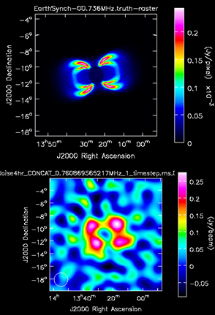

Figure 1 Top: Simulated Synchrotron Emission as seen from the Lunar Near Side. Bottom: 4 hour integration dirty image with 10 km diameter array under amplifier limited noise scenario, 5.85 SNR detection for each lobe.

This work was directly supported by the NASA Solar System Exploration Virtual Institute Cooperative Agreement 80ARCC017M0006.