An Example Using American FactFinder

Objective

For this example, we want to download a file in Comma Separated Value (CSV) format that contains information on poverty rates by county.

Navigate to ACS Tables on AFF

1. Navigate to **factfinder.census.gov.**
2. Click on Advanced **Search** > **Show Me All.**

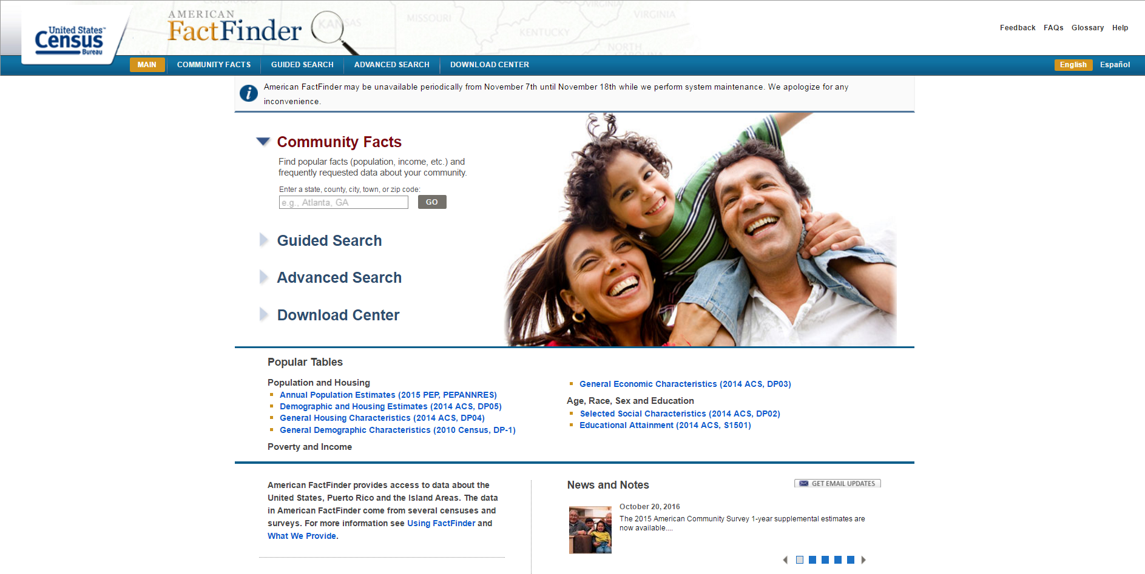

Select a Topic

1. On the left-hand side, navigate to **Topics** > **Dataset** > **2015 ACS 1-year estimates**.
2. **Close** the “Select Topics” frame.

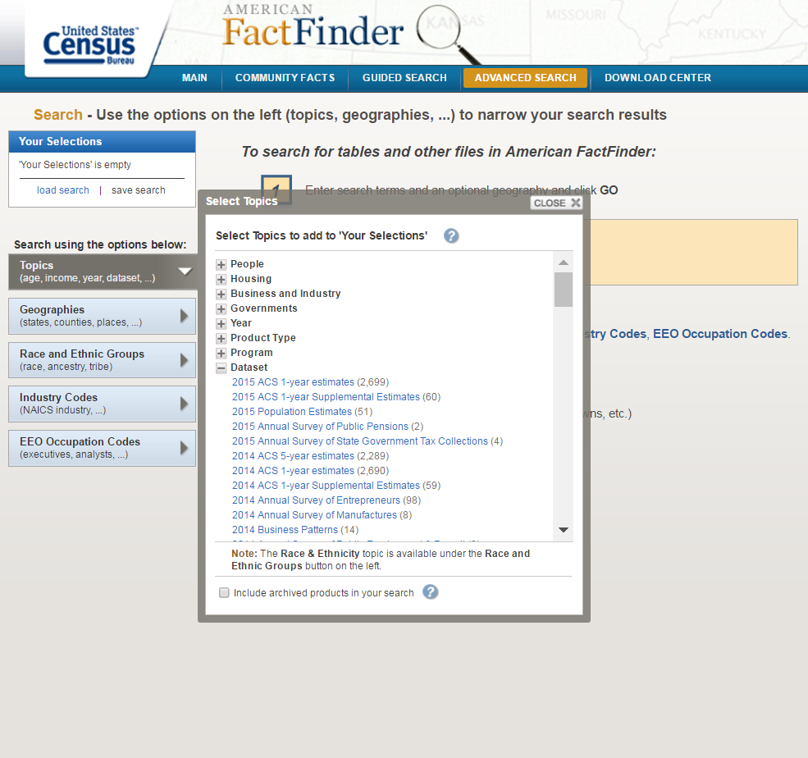

Choose a Subject Table

1. Search for “Poverty” in the search bar.
2. We want information on poverty status for the last year. Select **S1701**.
3. Note that you can get this table for previous years by using the navigation bar on the left-hand side of the page.

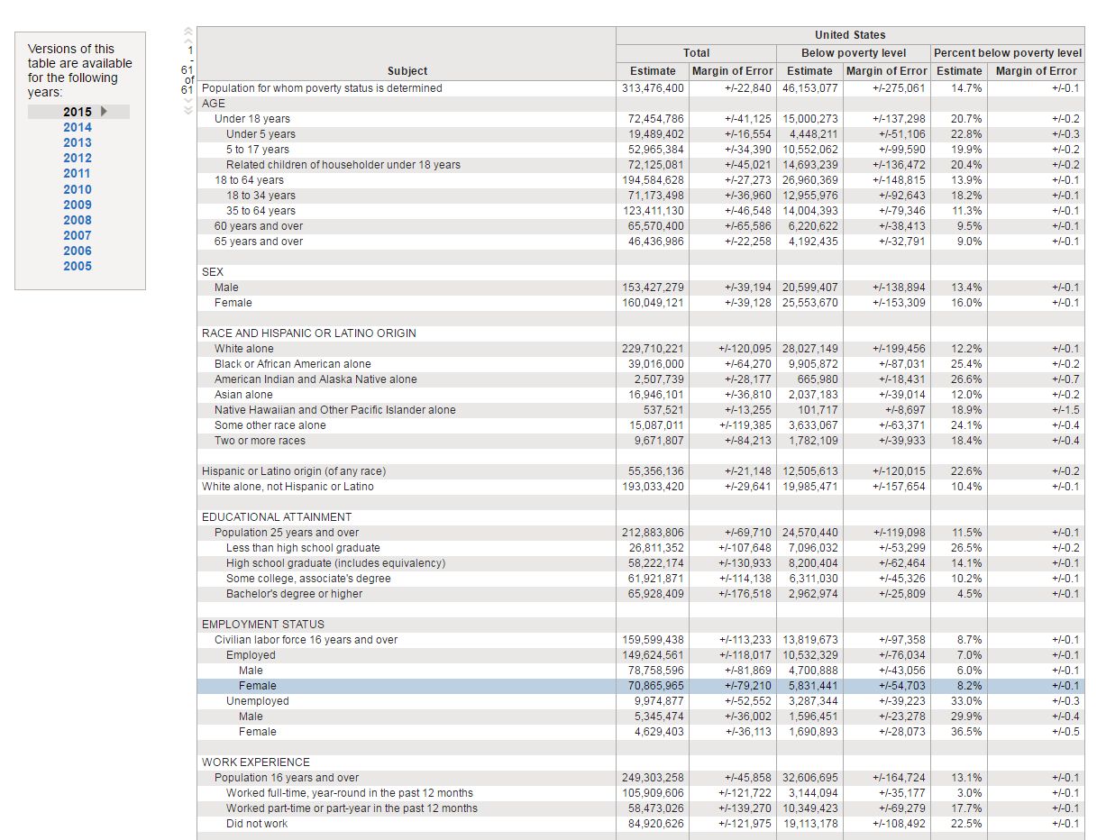

Change Geographies

1. Note that this table is for the entire United States. You can add or remove geographies from this page, but we’re going to go back one page.
2. Hit the **Back** button on your browser or select **Back to Advanced Search** in the upper right- hand corner.
3. On the left-hand navigation bar, select **Geographies** > **Name** > **Counties** > **All Counties Within United States**.

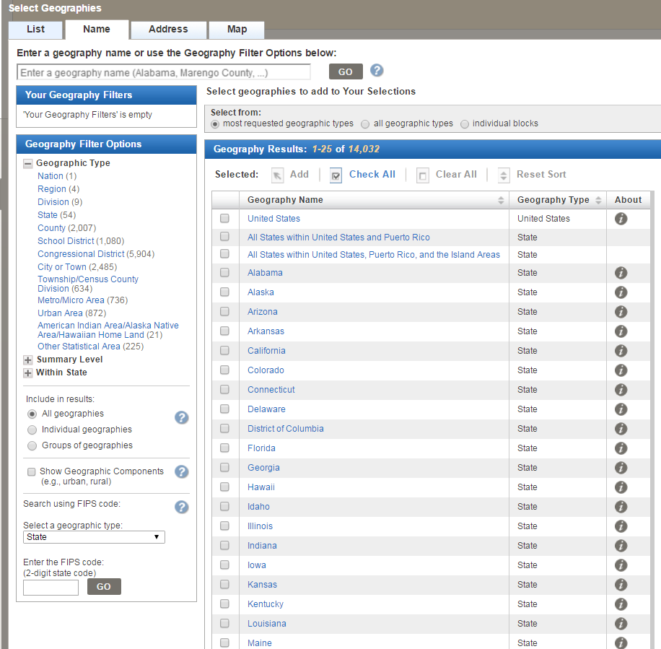

1. **Close** this frame.
2. Select table **S1701** again. You should now see the same table, but for each county in the U.S.

Modify Table and Download CSV

1. The data is currently in the wide format. Usually, we want data in long form (i.e., with the geographies listed as rows).
2. At the top of the page, select **Modify Table**. Select **Transpose Rows/Columns**. And voila! Your rows now represent counties.

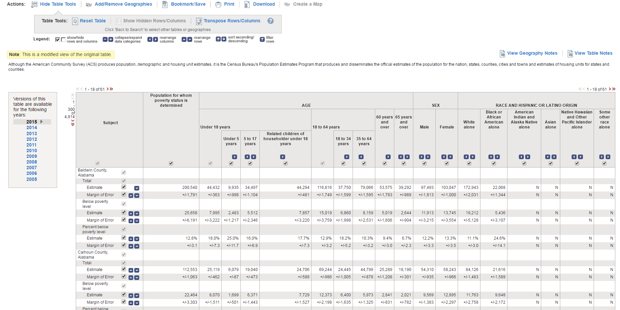

1. At the top of the page, select **Download**. Note that if you choose to save the file in .xls format, there is a row and column limit. It’s usually just better to download the data in .csv format.
2. Check the “Data and annotations in separate files” and “Include descriptive data element options” boxes. It will not meaningfully change your dataset if you choose different boxes.

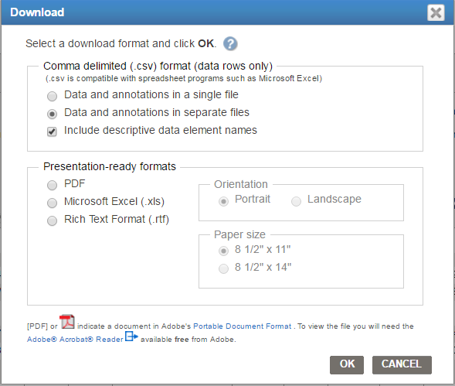

1. Click **OK** and you’re all done!

Raheem Chaudhry

Center on Budget and Policy Priorities

rchaudhry@cbpp.org

202.408.1080 x8352

www.cbpp.org