Syc8c9a_three Length Based Indicators

Supplied values. **Change in Linf**

Lmat = 54.2

**Linf = 93.75**

M/k=1.5

Table 1 Selected indicators for LBI screening plots. Indicator ratios in bold used for stock status assessment with traffic light system.

| Indicator | Calculation | Reference point | Indicator ratio | Expected value | Property |
| --- | --- | --- | --- | --- | --- |
| Lmax5% | Mean length of largest 5% | Linf | Lmax5% / Linf | > 0.8 | Conservation (large individuals) |
| L95% | 95th percentile | L95% / Linf |
| Pmega | Proportion of individuals above Lopt + 10% | 0.3–0.4 | Pmega | > 0.3 |
| L25% | 25th percentile of length distribution | Lmat | L25% / Lmat | > 1 | Conservation (immatures) |
| Lc | Length at first catch (length at 50% of mode) | Lmat | Lc/Lmat | > 1 |
| Lmean | Mean length of individuals > Lc | Lopt | Lmean/Lopt | ≈ 1 | Optimal yield |
| Lmaxy | Length class with maximum biomass in catch | Lopt | Lmaxy / Lopt | ≈1 |
| Lmean | Mean length of individuals > Lc | LF=M = (0.75Lc+0.25Linf) | Lmean / LF=M | ≥ 1 | MSY |

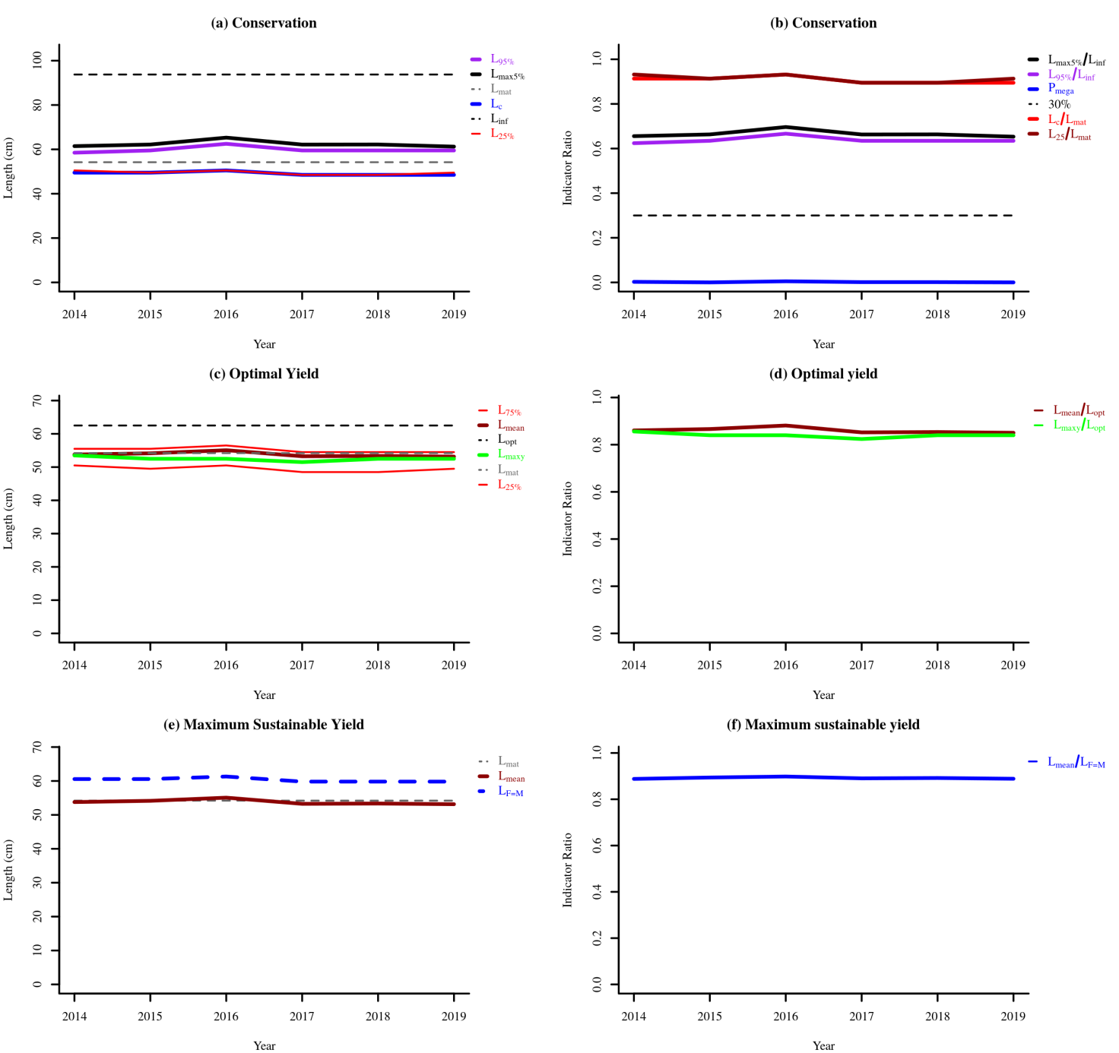

Figure 1 Indicator trends

Table 2 Indicator status for the most recent three years

|  | Conservation | | | | Optimizing Yield | MSY |
| --- | --- | --- | --- | --- | --- | --- |
| Year | Lc / Lmat | L25% / Lmat | Lmax 5 / Linf | Pmega | Lmean / Lopt | Lmean / LF = M |
| 2017 | 0.89 | 0.89 | 0.66 | 0 | 0.85 | 0.89 |
| 2018 | 0.89 | 0.89 | 0.66 | 0 | 0.85 | 0.89 |
| 2019 | 0.89 | 0.91 | 0.65 | 0 | 0.85 | 0.89 |

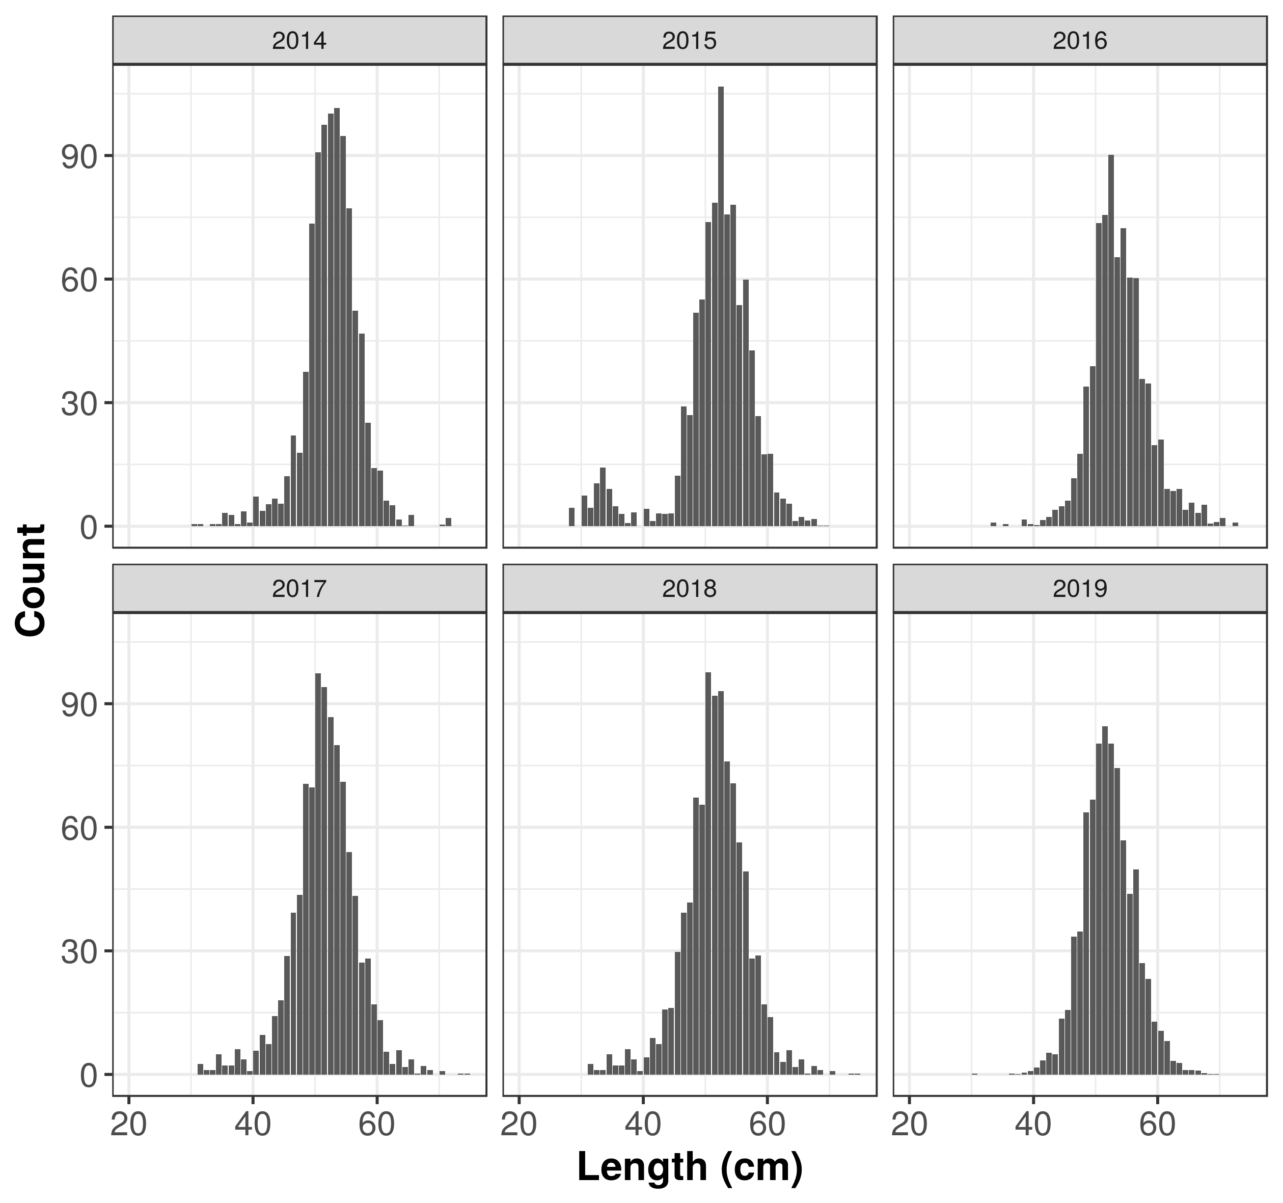

LFD_PLOT

Figure 2 Binned length frequency distributions

Table 3 Table of binned length frequency distributions

| Length class  (cm) | Length midpoint  (cm) | 2014 | 2015 | 2016 | 2017 | 2018 | 2019 |
| --- | --- | --- | --- | --- | --- | --- | --- |
| [20,21] | 20.5 | 0.0 | 0.0 | 0.00 | 0.0 | 0.0 | 0.0 |
| (21,22] | 21.5 | 0.0 | 0.0 | 0.00 | 0.0 | 0.0 | 0.0 |
| (22,23] | 22.5 | 0.0 | 0.0 | 0.00 | 0.0 | 0.0 | 0.0 |
| (23,24] | 23.5 | 0.0 | 0.0 | 0.00 | 0.0 | 0.0 | 0.0 |
| (24,25] | 24.5 | 0.0 | 0.0 | 0.00 | 0.0 | 0.0 | 0.0 |
| (25,26] | 25.5 | 0.0 | 0.0 | 0.00 | 0.0 | 0.0 | 0.0 |
| (26,27] | 26.5 | 0.0 | 0.0 | 0.00 | 0.0 | 0.0 | 0.0 |
| (27,28] | 27.5 | 0.0 | 0.0 | 0.00 | 0.0 | 0.0 | 0.0 |
| (28,29] | 28.5 | 0.0 | 4.5 | 0.00 | 0.0 | 0.0 | 0.0 |
| (29,30] | 29.5 | 0.0 | 0.0 | 0.00 | 0.0 | 0.0 | 0.0 |
| (30,31] | 30.5 | 0.5 | 7.5 | 0.00 | 0.0 | 0.0 | 0.2 |
| (31,32] | 31.5 | 0.5 | 4.5 | 0.00 | 2.5 | 2.5 | 0.0 |
| (32,33] | 32.5 | 0.0 | 10.4 | 0.00 | 1.1 | 1.1 | 0.0 |
| (33,34] | 33.5 | 0.5 | 14.2 | 0.83 | 1.1 | 1.1 | 0.0 |
| (34,35] | 34.5 | 0.5 | 9.0 | 0.00 | 4.9 | 4.9 | 0.0 |
| (35,36] | 35.5 | 3.2 | 4.9 | 0.49 | 2.2 | 2.2 | 0.0 |
| (36,37] | 36.5 | 2.7 | 3.0 | 0.00 | 2.2 | 2.2 | 0.2 |
| (37,38] | 37.5 | 0.5 | 0.8 | 0.00 | 6.1 | 6.1 | 0.1 |
| (38,39] | 38.5 | 3.6 | 3.4 | 1.69 | 3.7 | 3.7 | 0.4 |
| (39,40] | 39.5 | 0.9 | 0.0 | 0.51 | 0.8 | 0.8 | 0.8 |
| (40,41] | 40.5 | 7.2 | 4.2 | 0.33 | 5.7 | 4.1 | 1.7 |
| (41,42] | 41.5 | 3.7 | 1.3 | 1.45 | 9.6 | 8.8 | 3.4 |
| (42,43] | 42.5 | 5.3 | 3.1 | 2.25 | 7.4 | 7.4 | 5.2 |
| (43,44] | 43.5 | 6.7 | 3.0 | 3.95 | 14.2 | 15.8 | 4.9 |
| (44,45] | 44.5 | 5.5 | 3.1 | 4.90 | 18.0 | 16.1 | 13.5 |
| (45,46] | 45.5 | 12.2 | 12.3 | 6.25 | 28.7 | 29.7 | 15.7 |
| (46,47] | 46.5 | 22.0 | 29.1 | 11.70 | 39.3 | 39.3 | 33.4 |
| (47,48] | 47.5 | 17.8 | 27.0 | 17.56 | 43.6 | 41.7 | 34.7 |
| (48,49] | 48.5 | 37.5 | 51.8 | 33.94 | 70.6 | 67.2 | 63.6 |
| (49,50] | 49.5 | 73.5 | 55.0 | 38.82 | 69.7 | 65.5 | 66.7 |
| (50,51] | 50.5 | 90.8 | 73.9 | 73.56 | 97.4 | 97.6 | 80.3 |
| (51,52] | 51.5 | 97.5 | 78.5 | 75.60 | 94.1 | 92.0 | 84.5 |
| (52,53] | 52.5 | 100.2 | 106.8 | 90.18 | 86.7 | 93.0 | 80.3 |
| (53,54] | 53.5 | 101.5 | 75.7 | 65.27 | 80.0 | 76.0 | 74.4 |
| (54,55] | 54.5 | 94.8 | 78.0 | 72.32 | 71.0 | 70.7 | 56.8 |
| (55,56] | 55.5 | 77.2 | 53.7 | 60.38 | 54.0 | 56.3 | 43.9 |
| (56,57] | 56.5 | 52.3 | 59.9 | 60.28 | 43.4 | 49.3 | 49.8 |
| (57,58] | 57.5 | 46.8 | 42.7 | 35.74 | 27.1 | 28.1 | 27.0 |
| (58,59] | 58.5 | 25.1 | 26.7 | 34.70 | 28.1 | 28.9 | 23.2 |
| (59,60] | 59.5 | 14.1 | 17.4 | 19.63 | 17.0 | 17.0 | 12.8 |
| (60,61] | 60.5 | 13.5 | 17.6 | 21.08 | 13.2 | 13.9 | 10.6 |
| (61,62] | 61.5 | 6.2 | 8.2 | 9.01 | 5.5 | 5.4 | 8.1 |
| (62,63] | 62.5 | 5.1 | 6.7 | 8.50 | 2.5 | 3.0 | 3.3 |
| (63,64] | 63.5 | 1.6 | 5.5 | 9.04 | 5.9 | 5.9 | 2.8 |
| (64,65] | 64.5 | 0.1 | 1.3 | 3.94 | 1.8 | 1.8 | 1.1 |
| (65,66] | 65.5 | 2.7 | 2.2 | 5.75 | 3.7 | 3.7 | 1.0 |
| (66,67] | 66.5 | 0.0 | 1.4 | 3.21 | 0.2 | 0.2 | 0.9 |
| (67,68] | 67.5 | 0.0 | 1.7 | 5.18 | 2.0 | 2.0 | 0.3 |
| (68,69] | 68.5 | 0.0 | 0.2 | 0.67 | 1.1 | 1.1 | 0.1 |
| (69,70] | 69.5 | 0.0 | 0.1 | 1.03 | 0.0 | 0.0 | 0.1 |
| (70,71] | 70.5 | 0.4 | 0.0 | 2.05 | 0.8 | 0.8 | 0.0 |
| (71,72] | 71.5 | 2.0 | 0.0 | 0.00 | 0.0 | 0.0 | 0.0 |
| (72,73] | 72.5 | 0.0 | 0.0 | 0.87 | 0.0 | 0.0 | 0.0 |
| (73,74] | 73.5 | 0.0 | 0.0 | 0.00 | 0.2 | 0.2 | 0.0 |
| (74,75] | 74.5 | 0.0 | 0.0 | 0.00 | 0.2 | 0.2 | 0.0 |

Table 4 Table of binned mean weight at length frequency distributions

| Length class  (cm) | Length midpoint  (cm) | 2014 | 2015 | 2016 | 2017 | 2018 | 2019 |
| --- | --- | --- | --- | --- | --- | --- | --- |
| [20,21] | 20.5 | 23.2 | 23.2 | 23.2 | 23.2 | 23.2 | 23.2 |
| (21,22] | 21.5 | 26.9 | 26.9 | 26.9 | 26.9 | 26.9 | 26.9 |
| (22,23] | 22.5 | 31.0 | 31.0 | 31.0 | 31.0 | 31.0 | 31.0 |
| (23,24] | 23.5 | 35.5 | 35.5 | 35.5 | 35.5 | 35.5 | 35.5 |
| (24,25] | 24.5 | 40.4 | 40.4 | 40.4 | 40.4 | 40.4 | 40.4 |
| (25,26] | 25.5 | 45.7 | 45.7 | 45.7 | 45.7 | 45.7 | 45.7 |
| (26,27] | 26.5 | 51.5 | 51.5 | 51.5 | 51.5 | 51.5 | 51.5 |
| (27,28] | 27.5 | 57.7 | 57.7 | 57.7 | 57.7 | 57.7 | 57.7 |
| (28,29] | 28.5 | 64.5 | 64.5 | 64.5 | 64.5 | 64.5 | 64.5 |
| (29,30] | 29.5 | 71.8 | 71.8 | 71.8 | 71.8 | 71.8 | 71.8 |
| (30,31] | 30.5 | 79.6 | 79.6 | 79.6 | 79.6 | 79.6 | 79.6 |
| (31,32] | 31.5 | 88.0 | 88.0 | 88.0 | 88.0 | 88.0 | 88.0 |
| (32,33] | 32.5 | 96.9 | 96.9 | 96.9 | 96.9 | 96.9 | 96.9 |
| (33,34] | 33.5 | 106.4 | 106.4 | 106.4 | 106.4 | 106.4 | 106.4 |
| (34,35] | 34.5 | 116.6 | 116.6 | 116.6 | 116.6 | 116.6 | 116.6 |
| (35,36] | 35.5 | 127.4 | 127.4 | 127.4 | 127.4 | 127.4 | 127.4 |
| (36,37] | 36.5 | 138.9 | 138.9 | 138.9 | 138.9 | 138.9 | 138.9 |
| (37,38] | 37.5 | 151.0 | 151.0 | 151.0 | 151.0 | 151.0 | 151.0 |
| (38,39] | 38.5 | 163.8 | 163.8 | 163.8 | 163.8 | 163.8 | 163.8 |
| (39,40] | 39.5 | 177.4 | 177.4 | 177.4 | 177.4 | 177.4 | 177.4 |
| (40,41] | 40.5 | 191.7 | 191.7 | 191.7 | 191.7 | 191.7 | 191.7 |
| (41,42] | 41.5 | 206.7 | 206.7 | 206.7 | 206.7 | 206.7 | 206.7 |
| (42,43] | 42.5 | 222.5 | 222.5 | 222.5 | 222.5 | 222.5 | 222.5 |
| (43,44] | 43.5 | 239.2 | 239.2 | 239.2 | 239.2 | 239.2 | 239.2 |
| (44,45] | 44.5 | 256.6 | 256.6 | 256.6 | 256.6 | 256.6 | 256.6 |
| (45,46] | 45.5 | 274.9 | 274.9 | 274.9 | 274.9 | 274.9 | 274.9 |
| (46,47] | 46.5 | 294.1 | 294.1 | 294.1 | 294.1 | 294.1 | 294.1 |
| (47,48] | 47.5 | 314.1 | 314.1 | 314.1 | 314.1 | 314.1 | 314.1 |
| (48,49] | 48.5 | 335.1 | 335.1 | 335.1 | 335.1 | 335.1 | 335.1 |
| (49,50] | 49.5 | 357.0 | 357.0 | 357.0 | 357.0 | 357.0 | 357.0 |
| (50,51] | 50.5 | 379.8 | 379.8 | 379.8 | 379.8 | 379.8 | 379.8 |
| (51,52] | 51.5 | 403.6 | 403.6 | 403.6 | 403.6 | 403.6 | 403.6 |
| (52,53] | 52.5 | 428.4 | 428.4 | 428.4 | 428.4 | 428.4 | 428.4 |
| (53,54] | 53.5 | 454.1 | 454.1 | 454.1 | 454.1 | 454.1 | 454.1 |
| (54,55] | 54.5 | 481.0 | 481.0 | 481.0 | 481.0 | 481.0 | 481.0 |
| (55,56] | 55.5 | 508.9 | 508.9 | 508.9 | 508.9 | 508.9 | 508.9 |
| (56,57] | 56.5 | 537.8 | 537.8 | 537.8 | 537.8 | 537.8 | 537.8 |
| (57,58] | 57.5 | 567.9 | 567.9 | 567.9 | 567.9 | 567.9 | 567.9 |
| (58,59] | 58.5 | 599.0 | 599.0 | 599.0 | 599.0 | 599.0 | 599.0 |
| (59,60] | 59.5 | 631.3 | 631.3 | 631.3 | 631.3 | 631.3 | 631.3 |
| (60,61] | 60.5 | 664.8 | 664.8 | 664.8 | 664.8 | 664.8 | 664.8 |
| (61,62] | 61.5 | 699.4 | 699.4 | 699.4 | 699.4 | 699.4 | 699.4 |
| (62,63] | 62.5 | 735.3 | 735.3 | 735.3 | 735.3 | 735.3 | 735.3 |
| (63,64] | 63.5 | 772.4 | 772.4 | 772.4 | 772.4 | 772.4 | 772.4 |
| (64,65] | 64.5 | 810.7 | 810.7 | 810.7 | 810.7 | 810.7 | 810.7 |
| (65,66] | 65.5 | 850.3 | 850.3 | 850.3 | 850.3 | 850.3 | 850.3 |
| (66,67] | 66.5 | 891.2 | 891.2 | 891.2 | 891.2 | 891.2 | 891.2 |
| (67,68] | 67.5 | 933.3 | 933.3 | 933.3 | 933.3 | 933.3 | 933.3 |
| (68,69] | 68.5 | 976.9 | 976.9 | 976.9 | 976.9 | 976.9 | 976.9 |
| (69,70] | 69.5 | 1021.7 | 1021.7 | 1021.7 | 1021.7 | 1021.7 | 1021.7 |
| (70,71] | 70.5 | 1068.0 | 1068.0 | 1068.0 | 1068.0 | 1068.0 | 1068.0 |
| (71,72] | 71.5 | 1115.6 | 1115.6 | 1115.6 | 1115.6 | 1115.6 | 1115.6 |
| (72,73] | 72.5 | 1164.7 | 1164.7 | 1164.7 | 1164.7 | 1164.7 | 1164.7 |
| (73,74] | 73.5 | 1215.2 | 1215.2 | 1215.2 | 1215.2 | 1215.2 | 1215.2 |
| (74,75] | 74.5 | 1267.2 | 1267.2 | 1267.2 | 1267.2 | 1267.2 | 1267.2 |