rjn.27.9a_two Length Based Indicators

Supplied values

Lmat = 56.5

Linf = 56.3

Table 1 Selected indicators for LBI screening plots. Indicator ratios in bold used for stock status assessment with traffic light system.

| Indicator | Calculation | Reference point | Indicator ratio | Expected value | Property |
| --- | --- | --- | --- | --- | --- |
| Lmax5% | Mean length of largest 5% | Linf | Lmax5% / Linf | > 0.8 | Conservation (large individuals) |
| L95% | 95th percentile | L95% / Linf |
| Pmega | Proportion of individuals above Lopt + 10% | 0.3–0.4 | Pmega | > 0.3 |
| L25% | 25th percentile of length distribution | Lmat | L25% / Lmat | > 1 | Conservation (immatures) |
| Lc | Length at first catch (length at 50% of mode) | Lmat | Lc/Lmat | > 1 |
| Lmean | Mean length of individuals > Lc | Lopt | Lmean/Lopt | ≈ 1 | Optimal yield |
| Lmaxy | Length class with maximum biomass in catch | Lopt | Lmaxy / Lopt | ≈1 |
| Lmean | Mean length of individuals > Lc | LF=M = (0.75Lc+0.25Linf) | Lmean / LF=M | ≥ 1 | MSY |

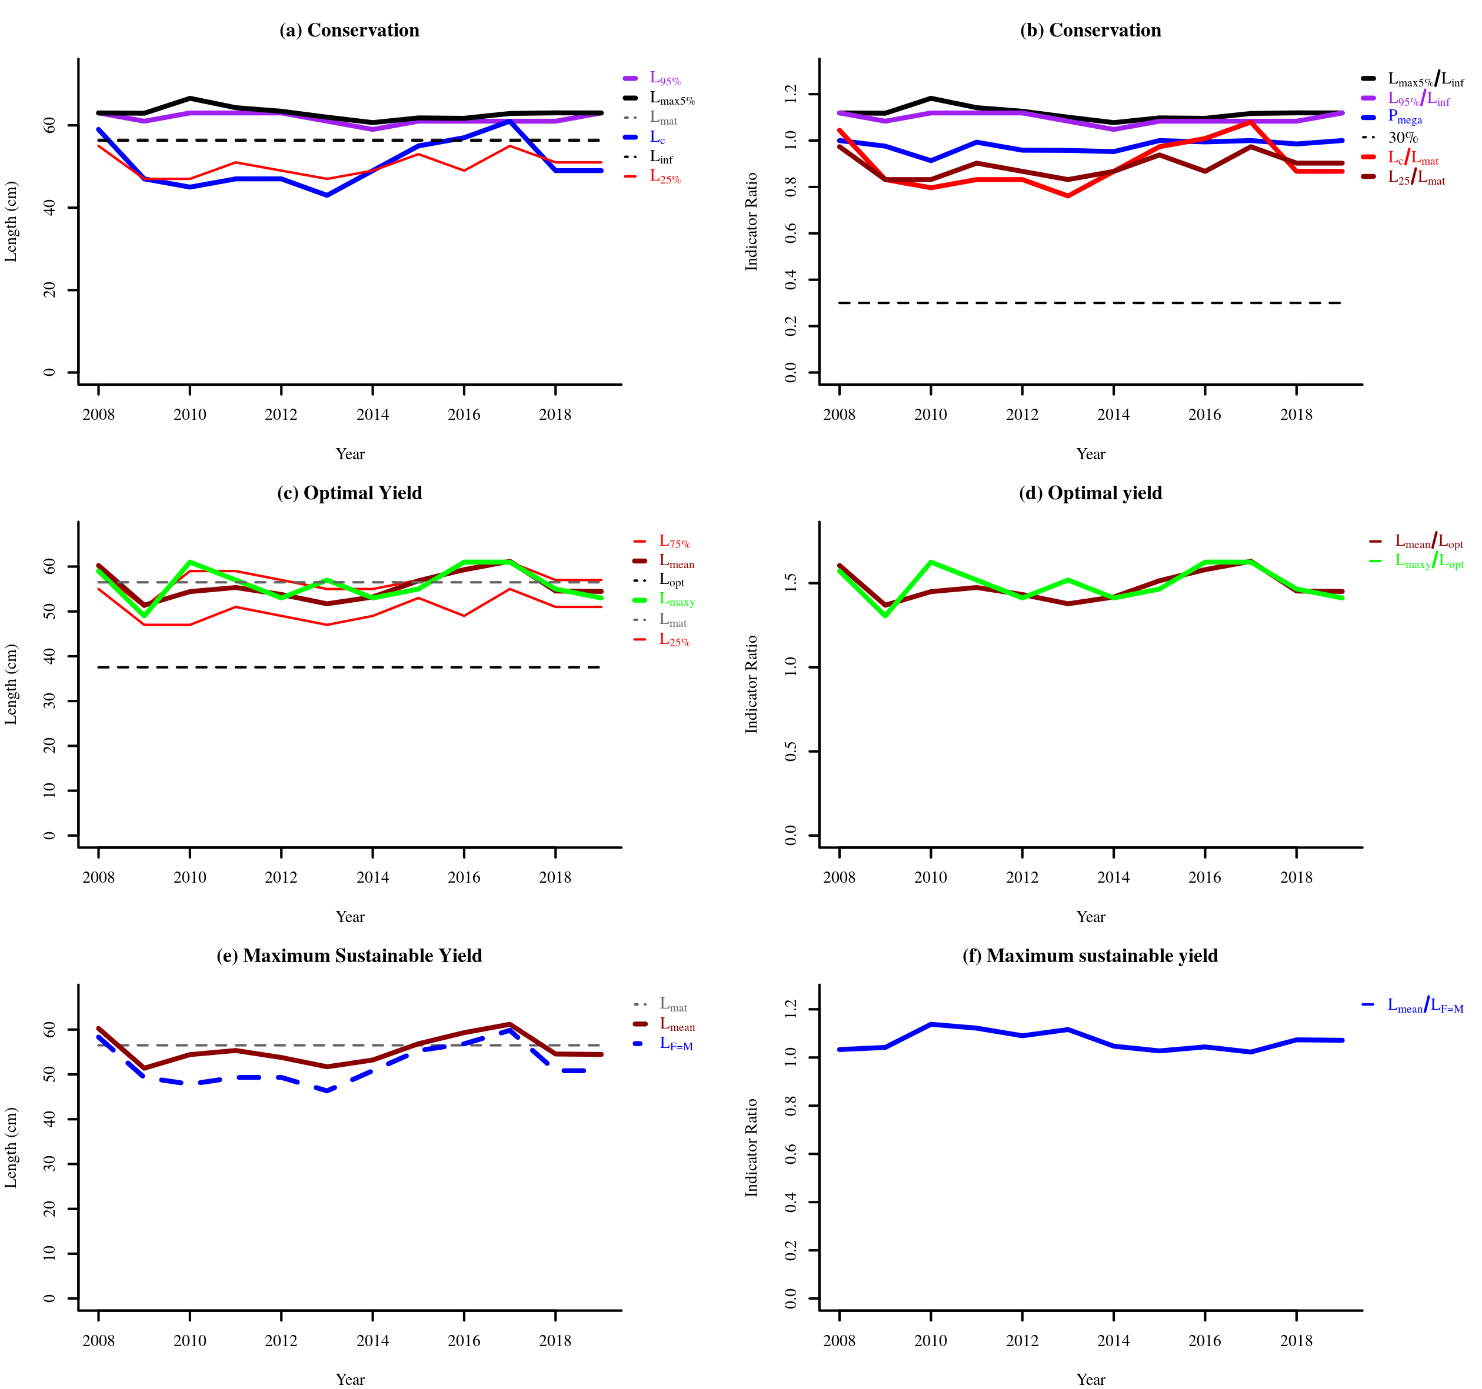

Figure 1 Indicator trends

Table 2 Indicator status for the most recent three years

|  | Conservation | | | | Optimizing Yield | MSY |
| --- | --- | --- | --- | --- | --- | --- |
| Year | Lc / Lmat | L25% / Lmat | Lmax 5 / Linf | Pmega | Lmean / Lopt | Lmean / LF = M |
| 2017 | 1.08 | 0.97 | 1.12 | 1.00 | 1.63 | 1.02 |
| 2018 | 0.87 | 0.90 | 1.12 | 0.99 | 1.45 | 1.07 |
| 2019 | 0.87 | 0.90 | 1.12 | 1.00 | 1.45 | 1.07 |

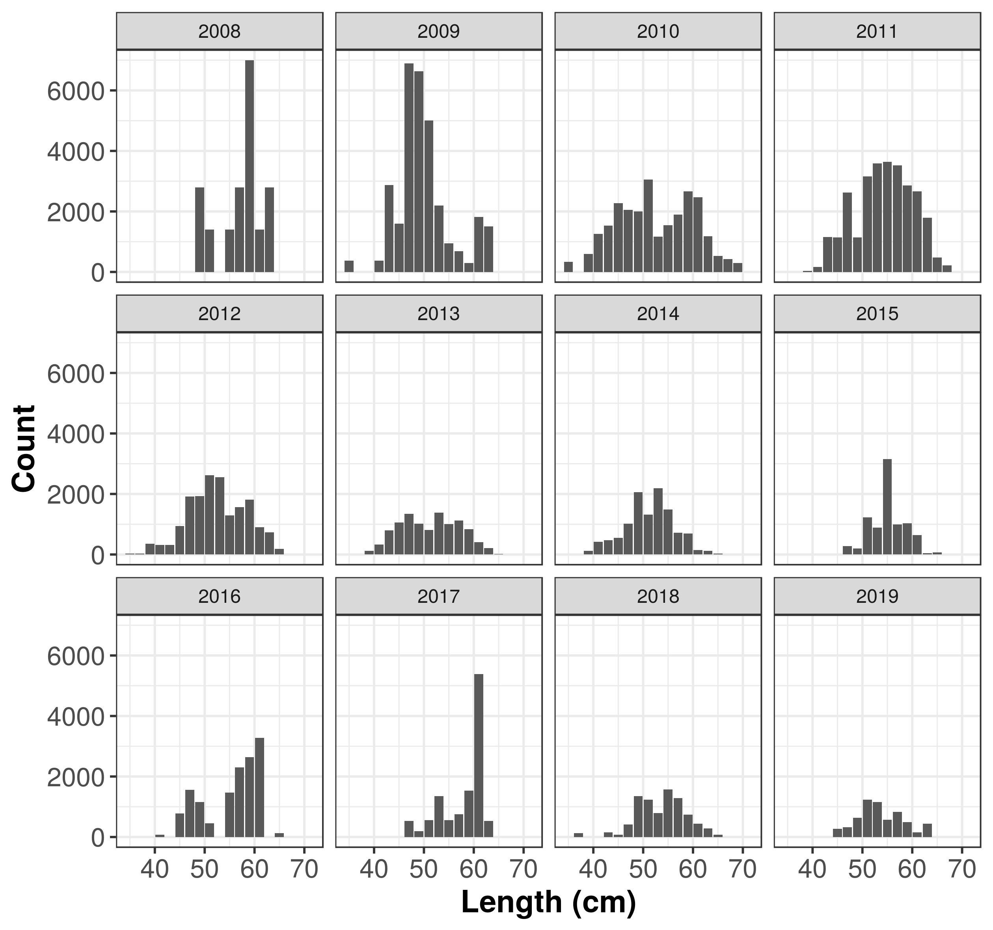

LFD_PLOT

Figure 2 Binned length frequency distributions

Table 3 Table of binned length frequency distributions

| Length class  (cm) | Length midpoint  (cm) | 2008 | 2009 | 2010 | 2011 | 2012 | 2013 | 2014 | 2015 | 2016 | 2017 | 2018 | 2019 |
| --- | --- | --- | --- | --- | --- | --- | --- | --- | --- | --- | --- | --- | --- |
| [34,36] | 35 | 0.00 | 376.05 | 340.38 | 0.00 | 25.52 | 0.00 | 0.00 | 0.00 | 0.00 | 0.00 | 0.00 | 0.00 |
| (36,38] | 37 | 0.00 | 0.00 | 0.00 | 0.00 | 25.52 | 0.00 | 0.00 | 0.00 | 0.00 | 0.00 | 124.54 | 0.00 |
| (38,40] | 39 | 0.00 | 0.00 | 597.39 | 34.64 | 360.21 | 117.31 | 122.30 | 0.00 | 0.00 | 0.00 | 0.00 | 0.00 |
| (40,42] | 41 | 0.00 | 376.05 | 1253.63 | 159.91 | 316.27 | 326.74 | 417.96 | 0.00 | 79.71 | 0.00 | 0.00 | 0.00 |
| (42,44] | 43 | 0.00 | 2874.24 | 1527.27 | 1154.95 | 318.01 | 793.53 | 475.76 | 0.00 | 0.00 | 0.00 | 157.50 | 0.00 |
| (44,46] | 45 | 0.00 | 1597.10 | 2268.43 | 1134.80 | 934.33 | 1059.96 | 550.15 | 0.00 | 778.52 | 0.00 | 76.67 | 265.23 |
| (46,48] | 47 | 0.00 | 6890.44 | 2052.90 | 2618.49 | 1916.45 | 1350.26 | 1016.48 | 273.30 | 1557.04 | 534.44 | 411.87 | 320.44 |
| (48,50] | 49 | 2797.98 | 6630.39 | 2003.72 | 1142.63 | 1935.60 | 1016.75 | 2062.82 | 200.03 | 1156.22 | 187.13 | 1348.31 | 634.75 |
| (50,52] | 51 | 1398.99 | 5012.59 | 3059.69 | 3157.85 | 2622.28 | 809.39 | 1317.60 | 1233.28 | 447.70 | 561.70 | 1239.74 | 1233.15 |
| (52,54] | 53 | 0.00 | 2190.31 | 1161.93 | 3593.08 | 2550.75 | 1377.93 | 2191.02 | 892.74 | 0.00 | 1349.80 | 790.27 | 1151.97 |
| (54,56] | 55 | 1398.99 | 949.66 | 1543.04 | 3636.50 | 1295.91 | 1004.88 | 1491.05 | 3154.61 | 1464.67 | 561.84 | 1574.14 | 576.85 |
| (56,58] | 57 | 2797.98 | 681.18 | 1892.35 | 3527.96 | 1562.64 | 1128.45 | 721.25 | 989.25 | 2303.48 | 748.98 | 1289.76 | 831.66 |
| (58,60] | 59 | 6994.94 | 297.59 | 2658.56 | 2861.11 | 1810.53 | 841.19 | 698.15 | 1031.98 | 2645.01 | 1536.94 | 740.43 | 488.11 |
| (60,62] | 61 | 1398.99 | 1813.84 | 2464.64 | 2664.99 | 907.15 | 402.19 | 146.49 | 638.73 | 3282.36 | 5380.91 | 434.56 | 154.38 |
| (62,64] | 63 | 2797.98 | 1504.21 | 1183.17 | 1794.93 | 732.68 | 213.80 | 114.91 | 40.94 | 0.00 | 534.44 | 279.29 | 436.28 |
| (64,66] | 65 | 0.00 | 0.00 | 525.94 | 478.40 | 180.77 | 20.72 | 31.58 | 65.03 | 121.87 | 0.00 | 76.67 | 0.00 |
| (66,68] | 67 | 0.00 | 0.00 | 419.07 | 212.99 | 0.00 | 0.00 | 0.00 | 0.00 | 0.00 | 0.00 | 0.00 | 0.00 |
| (68,70] | 69 | 0.00 | 0.00 | 293.98 | 0.00 | 0.00 | 0.00 | 0.00 | 0.00 | 0.00 | 0.00 | 0.00 | 0.00 |
| (70,72] | 71 | 0.00 | 0.00 | 0.00 | 0.00 | 0.00 | 0.00 | 0.00 | 0.00 | 0.00 | 0.00 | 0.00 | 0.00 |

Table 4 Table of binned mean weight at length frequency distributions

| Length class  (cm) | Length midpoint  (cm) | 2008 | 2009 | 2010 | 2011 | 2012 | 2013 | 2014 | 2015 | 2016 | 2017 | 2018 | 2019 |
| --- | --- | --- | --- | --- | --- | --- | --- | --- | --- | --- | --- | --- | --- |
| [34,36] | 35 | 501.7 | 501.7 | 501.7 | 501.7 | 501.7 | 501.7 | 501.7 | 501.7 | 501.7 | 501.7 | 501.7 | 501.7 |
| (36,38] | 37 | 597.1 | 597.1 | 597.1 | 597.1 | 597.1 | 597.1 | 597.1 | 597.1 | 597.1 | 597.1 | 597.1 | 597.1 |
| (38,40] | 39 | 705.2 | 705.2 | 705.2 | 705.2 | 705.2 | 705.2 | 705.2 | 705.2 | 705.2 | 705.2 | 705.2 | 705.2 |
| (40,42] | 41 | 826.1 | 826.1 | 826.1 | 826.1 | 826.1 | 826.1 | 826.1 | 826.1 | 826.1 | 826.1 | 826.1 | 826.1 |
| (42,44] | 43 | 960.5 | 960.5 | 960.5 | 960.5 | 960.5 | 960.5 | 960.5 | 960.5 | 960.5 | 960.5 | 960.5 | 960.5 |
| (44,46] | 45 | 1109.2 | 1109.2 | 1109.2 | 1109.2 | 1109.2 | 1109.2 | 1109.2 | 1109.2 | 1109.2 | 1109.2 | 1109.2 | 1109.2 |
| (46,48] | 47 | 1273.1 | 1273.1 | 1273.1 | 1273.1 | 1273.1 | 1273.1 | 1273.1 | 1273.1 | 1273.1 | 1273.1 | 1273.1 | 1273.1 |
| (48,50] | 49 | 1452.9 | 1452.9 | 1452.9 | 1452.9 | 1452.9 | 1452.9 | 1452.9 | 1452.9 | 1452.9 | 1452.9 | 1452.9 | 1452.9 |
| (50,52] | 51 | 1649.5 | 1649.5 | 1649.5 | 1649.5 | 1649.5 | 1649.5 | 1649.5 | 1649.5 | 1649.5 | 1649.5 | 1649.5 | 1649.5 |
| (52,54] | 53 | 1863.6 | 1863.6 | 1863.6 | 1863.6 | 1863.6 | 1863.6 | 1863.6 | 1863.6 | 1863.6 | 1863.6 | 1863.6 | 1863.6 |
| (54,56] | 55 | 2096.1 | 2096.1 | 2096.1 | 2096.1 | 2096.1 | 2096.1 | 2096.1 | 2096.1 | 2096.1 | 2096.1 | 2096.1 | 2096.1 |
| (56,58] | 57 | 2347.8 | 2347.8 | 2347.8 | 2347.8 | 2347.8 | 2347.8 | 2347.8 | 2347.8 | 2347.8 | 2347.8 | 2347.8 | 2347.8 |
| (58,60] | 59 | 2619.5 | 2619.5 | 2619.5 | 2619.5 | 2619.5 | 2619.5 | 2619.5 | 2619.5 | 2619.5 | 2619.5 | 2619.5 | 2619.5 |
| (60,62] | 61 | 2912.3 | 2912.3 | 2912.3 | 2912.3 | 2912.3 | 2912.3 | 2912.3 | 2912.3 | 2912.3 | 2912.3 | 2912.3 | 2912.3 |
| (62,64] | 63 | 3226.6 | 3226.6 | 3226.6 | 3226.6 | 3226.6 | 3226.6 | 3226.6 | 3226.6 | 3226.6 | 3226.6 | 3226.6 | 3226.6 |
| (64,66] | 65 | 3563.7 | 3563.7 | 3563.7 | 3563.7 | 3563.7 | 3563.7 | 3563.7 | 3563.7 | 3563.7 | 3563.7 | 3563.7 | 3563.7 |
| (66,68] | 67 | 3924.2 | 3924.2 | 3924.2 | 3924.2 | 3924.2 | 3924.2 | 3924.2 | 3924.2 | 3924.2 | 3924.2 | 3924.2 | 3924.2 |
| (68,70] | 69 | 4309.0 | 4309.0 | 4309.0 | 4309.0 | 4309.0 | 4309.0 | 4309.0 | 4309.0 | 4309.0 | 4309.0 | 4309.0 | 4309.0 |
| (70,72] | 71 | 0.0 | 0.0 | 0.0 | 0.0 | 0.0 | 0.0 | 0.0 | 0.0 | 0.0 | 0.0 | 0.0 | 0.0 |