**NEPHROPS FU 2627 (West Galicia and North Portugal)**

|  |  |  |
| --- | --- | --- |
| **Category** | 3 | **Basis** |
| **MSY Btrigger** | Not defined |  |
| **FMSY** | 0.16 | F0.1 average across sexes, proxy based on length-based yield per recruit analysis linked to mean length method |
| **Flower** | Not defined |  |
| **Fupper** | Not defined |  |
| **Advice in 2019** | ICES precautionary approach: zero TAC advice | |
| **Assessment type** | Trends from commercial CPUE | |
| **References** | Reference points:  Assessment: WGBIE ICES (2019) | |

**Stock Summary**

The *Nephrop*s stock from FU 26 extends along the Atlantic area off the northwestern Spanish coast, south of Cape Finisterre, whereas FU 27 covers the Atlantic area off northern Portugal. The distribution of *Nephrops* in this area is limited to depths ranging from 90-500 m. These FUs are assessed together because landings could not be differenced before 1996.

*Nephrops* is caught in a mixed bottom-trawl fishery, which takes place throughout the year, with the highest *Nephrops* landings in spring and summer. The bottom-trawl fleet comprises three main components: baca trawl, high vertical opening trawl (HVO) and pair trawl, each targeting different species. Only the baca trawl catches *Nephrops*. Other targeted species include hake, anglerfish, megrim, horse mackerel, mackerel and a variety of other fish and cephalopods. *Nephrops* is considered as by-catch.

Landings and LPUE show a continuous decreasing trend since 70’s. This stock is currently classified by ICES as category 3 and the advice has been a recovery plan and zero catch since 2003 because the biomass is extremely low.

**Data and life history parameters**

The available information for this stock comprises the following (ICES, 2019):

* Length composition of the catches for the period 1988-2019. There are no discards on this fishery and then landings correspond to catches.
* Bottom-trawl survey (DEMERSALES) index, 1983-2019 with a gap in 1987.
* Fishing effort and LPUE estimates are available for Marin trawl fleet (SP-MATR) for the period 1990-2019.
* Life-history parameters:
  + Weight – Length relationship for both sexes combined (Fariña, 1984)
  + L50 for females (maturity ogive) (Fariña, 1996)
  + Growth parameters (Figueiredo, 1989)
  + Natural mortality (assumed the same value of other NE Atlantic *Nephrops* stocks).

**Stock assessment and advice**

These stocks have been regularly assessed since 1990 (ICES, 1990). The last analytical assessment for these FUs were carried out by the WGHMM in 2006 (ICES, 2006). XSA (eXtended Survival Analysis) using the length composition of the catches transformed in ages by slicing employing the L2AGE program. The 2006 assessment was calibrated using data from a single commercial LPUE series, where the definition of fishing effort was based on nominal effort. The results were accepted only as indicative of stock trends and not used for projections. This method has proved not to be appropriate for *Nephrops* stocks and abandoned. After 2006, no improvements in relation to a methodological assessment were achieved and the WG did not attempt any further analytical assessment for this stock. The time-series of fisheries data were updated every year and LPUE series used to depict the stock trends.

Since 2012, the advice for this stock was based on fishery LPUE and effort trend, according to the ICES data-limited approach (ICES, 2012). This stock is classified according to Data Limited Stocks (DSL) category 3.1.4.: stocks with extremely low biomass.

Proxies of MSY reference points were defined using the methods developed in WKLIFE and WKProxy (ICES, 2015, 2016). F0.1, taken as proxy of FMSY, from length–based analysis for the period 1988–2014 was 0.137 for both sexes combined but the value of MSY Btrigger proxy is not available.

**Further explorations**

Further explorations of length-based methods will be performed and are summarized below.

*Length-based Indicators (LBI)*

This model assumes: equilibrium, logistic selectivity, length composition representative of catches.

Main indicators (ICES, 2015):

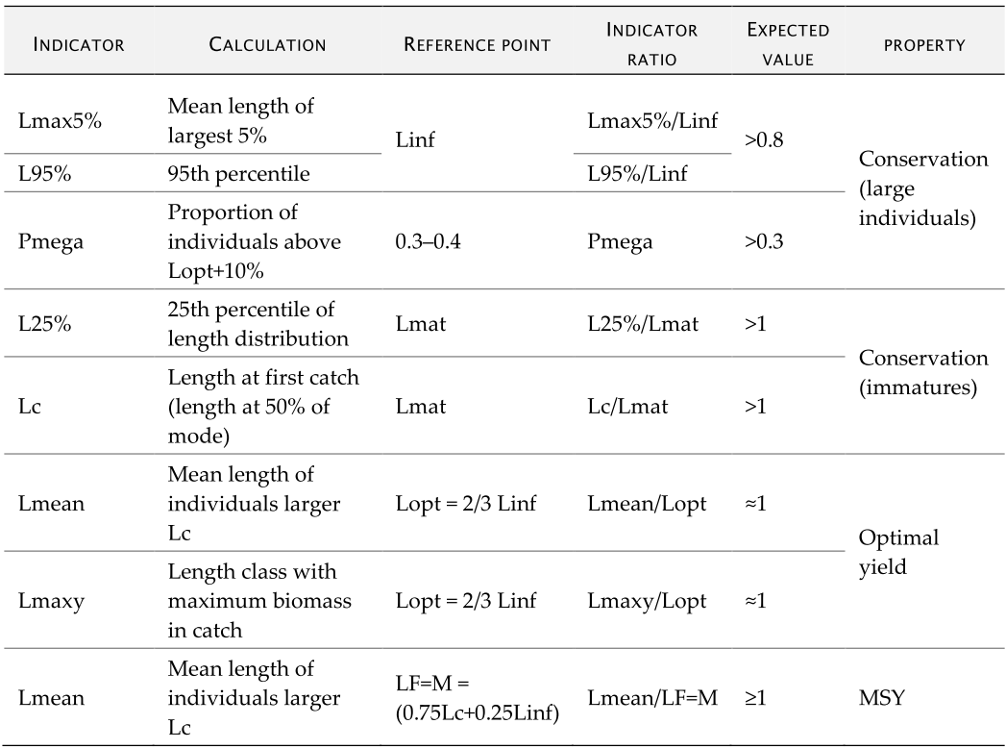

Input data:

|  |  |  |
| --- | --- | --- |
| INPUT (in mm) | Males | Females |
| Length composition by sex | 1988 – 2019 | |
| Mean weight by length class and sex | 1988 – 2019 | |
| Linf | 80 mm | 65 mm |
| Lmat | 28 mm | 26 mm |
| k | 0.150 | 0.080 |
| M | 0.3 | 0.2 |
| M/k | 2.0 | 2.5 |

**NepFU2627\_Males**

**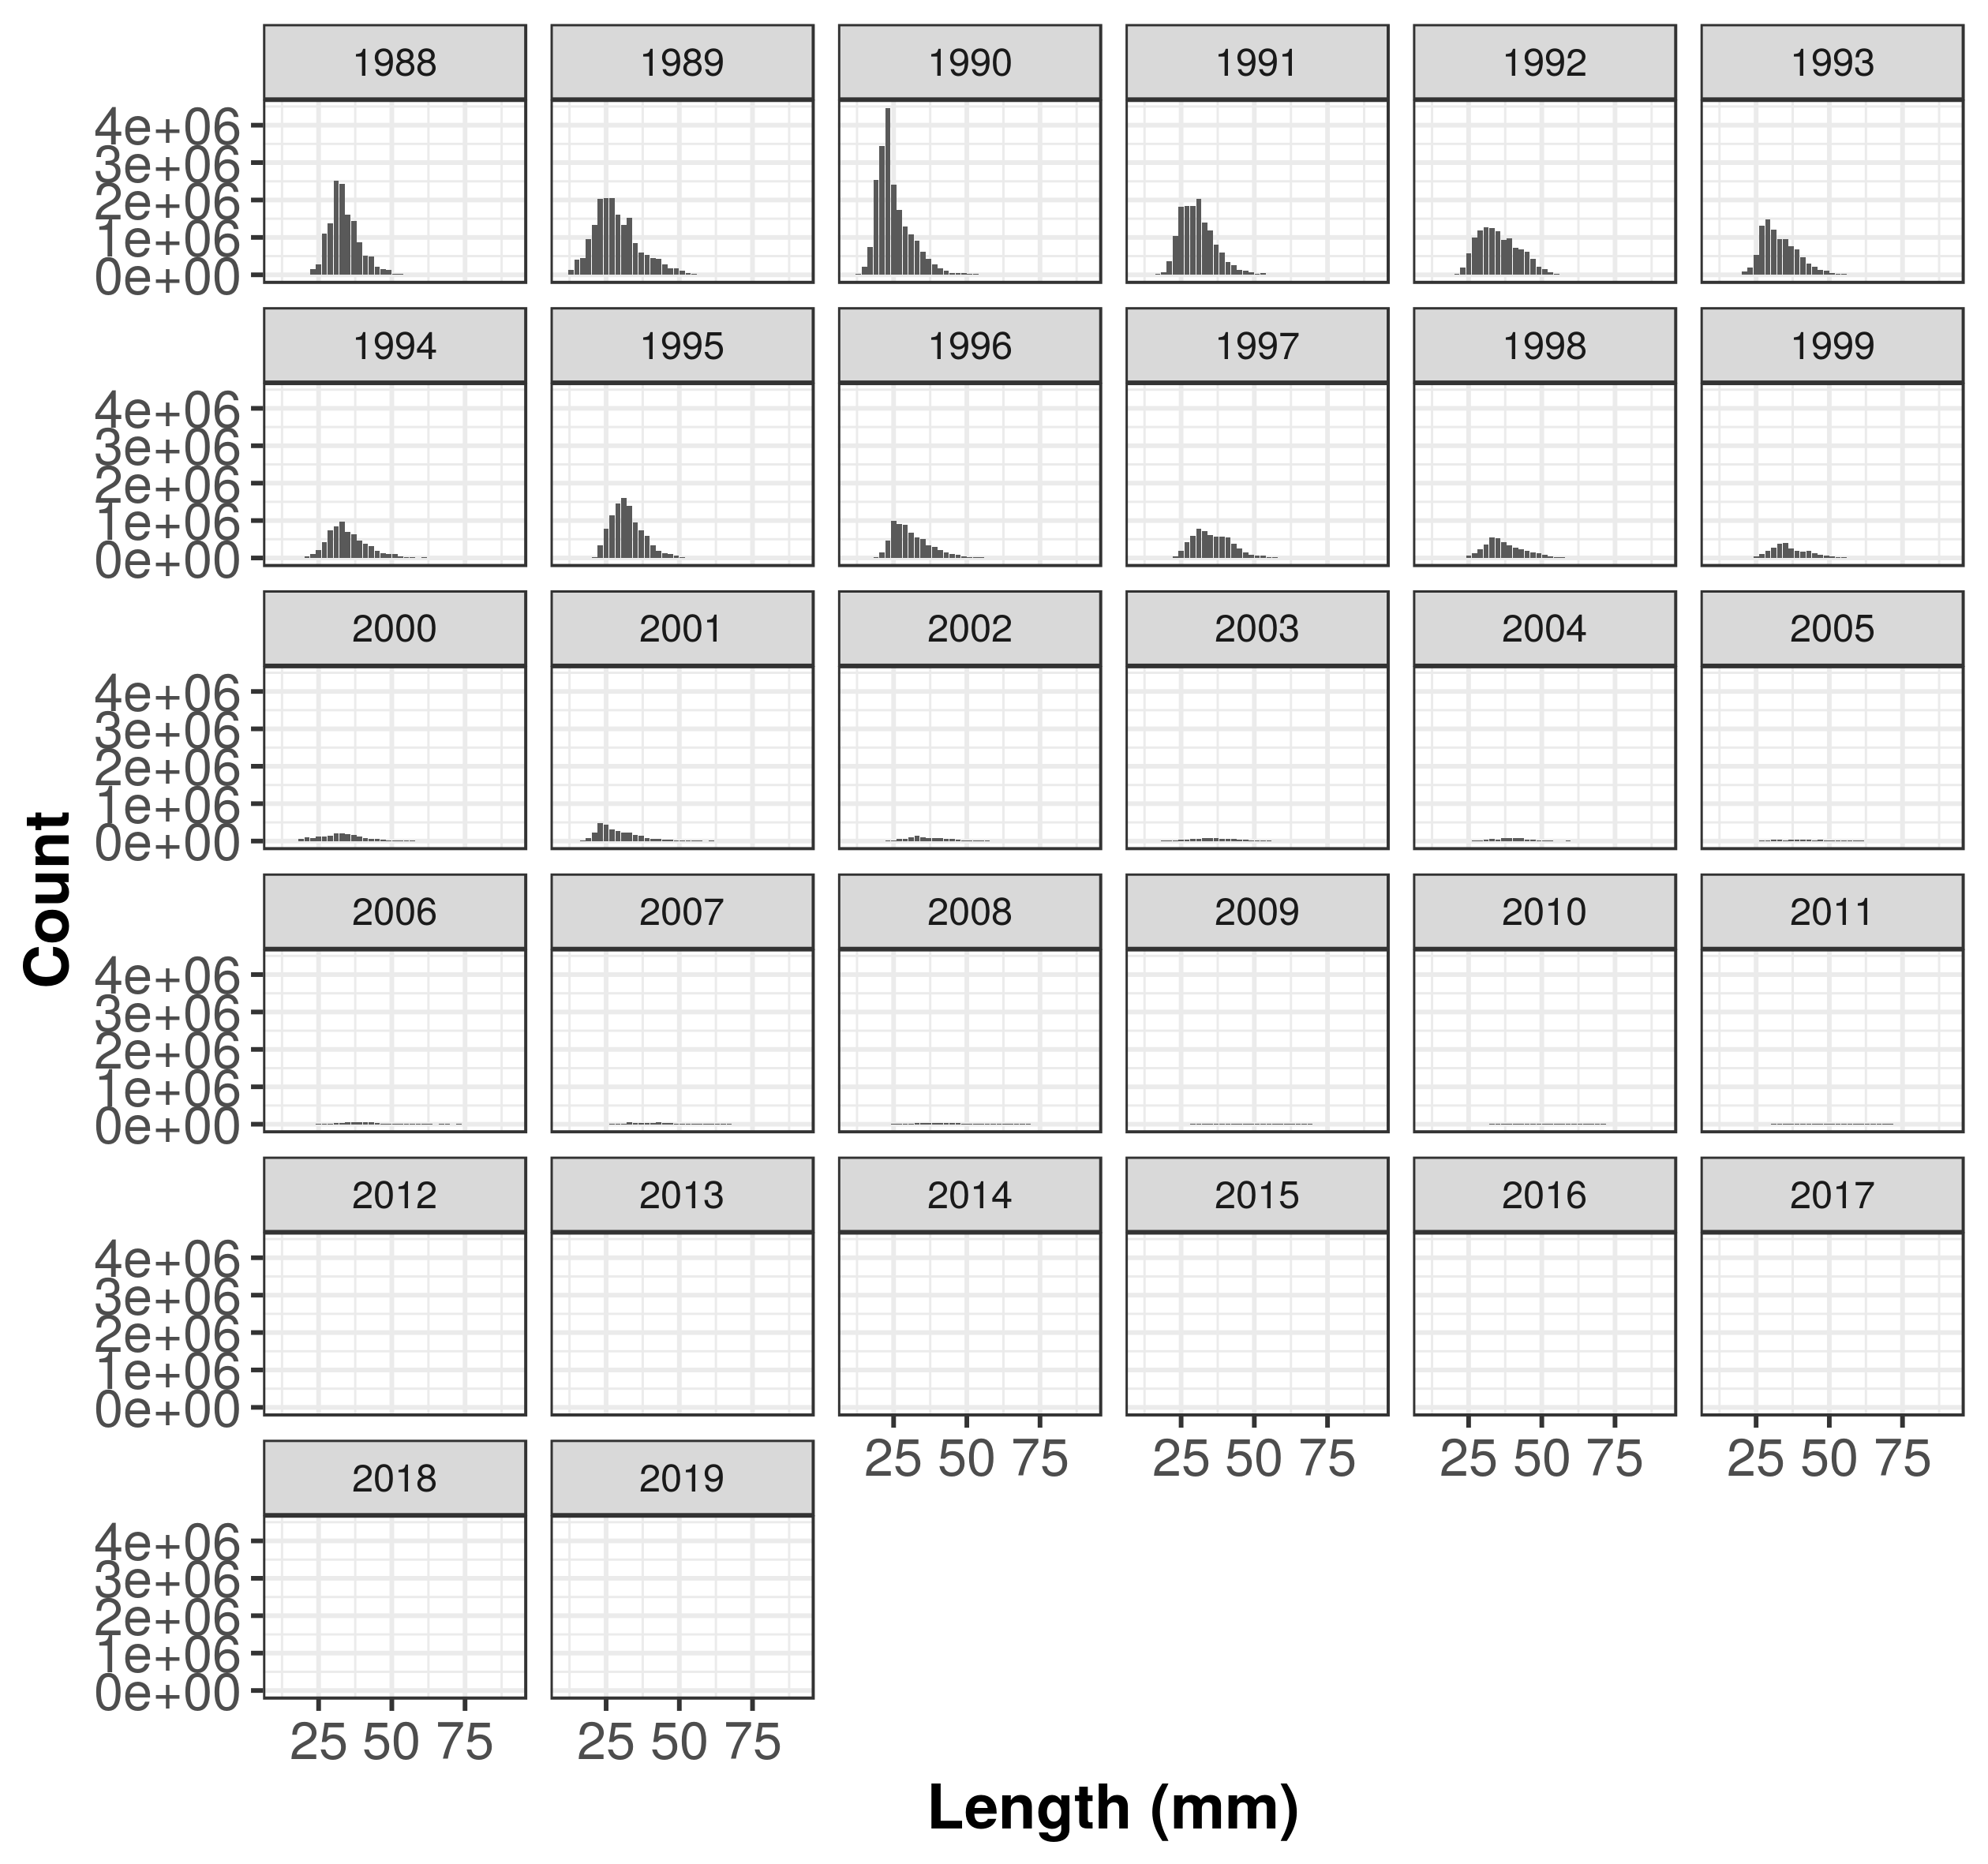**

**NepFU2627\_Females**

**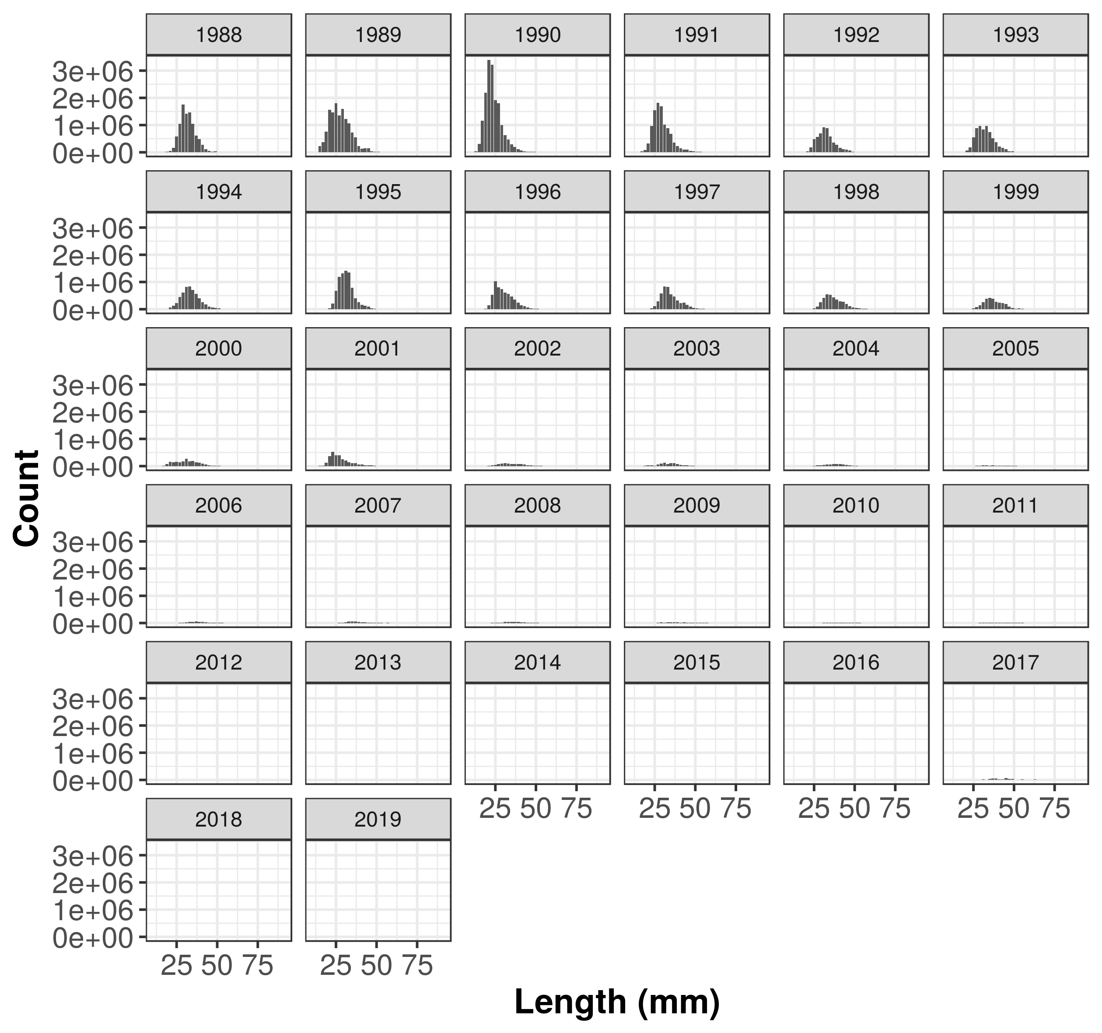**

Figure 1. Length composition of *Nephrops* catches in FUs 2627 by sex, for the period 1988-2019 (in 2mm carapace length classes)

*Results*

Table 1 below shows the results of the indicator ratios for the last three years. Results are presented in a traffic light system, according to conservation/sustainability, yield optimization and MSY considerations. Figure 2 shows the time series for the indicators and ratios.

**Table 1.** Length-based screening, traffic light indicators.

**Males**



**Females**



Regarding to Lc/Lmat and L25%/Lmat ratios series for *Nephrops* in FUs 26 27 are upper than 1 in both sexes since 2003 (Figures 1 and 2). So there are no concerns regarding fishing on immature individuals.

Lack of mega-spawners (Pmega) in the catches is observed at the beginning of the time series and mainly for males (Figure 1 and 2). In the last three years, Pmega is very above the limit value of 0.3 for females but it is very close to 0.3 for males in 2017 and 2018, and below 0.3 in 2019. Looking at Lmax5%/Linf ratio, it is close to the lower limit of 0.8 in last ten years for both sexes.

The mean length was increasing during the time series, mainly in males. The catch is close to the theoretical length of optimal yield for both sexes. The mean length is close to the MSY proxy of LF=M for males and females.

The overall perception from the length-based indicators analysis is that, in 2019 the stock was fished sustainably at levels close to optimum yield and with exploitation at MSY level.

**NepFU26 27\_Males**



**Figure 1**. Length indicators and ratios for males *Nephrops* in FU 26 27.

**NepFU26 27\_Females**



**Figure 2**. Length indicators and ratios for females *Nephrops* in FU 26 27.

*Sensibility analysis*

*Length-based Stock Potential Ratio (LBSPR)*

In general, the Stock Potential Ratio is defined as the ratio of the total reproductive production at equilibrium for a given level of fishing mortality divided by the reproductive production in the unfished state, and represents the expected equilibrium SPR if a stock was held indefinitely at the given fishing mortality and recruitment was constant. It is a direct function of instantaneous fishing mortality (F), the selectivity of the fishery, and the maturity schedule for the species. The Length-based Spawning Potential Ratio method uses maximum likelihood methods to find the values of relative fishing mortality (F/M) and selectivity-at-length that minimize the difference between the observed and the expected length composition of the catch, and calculates the resulting SPR (Hordyk et al, 2015).

Like any assessment method, the LBSPR model relies on a number of simplifying assumptions. In particular, the LBSPR models are equilibrium based, and assume that the length composition data is representative of the exploited population at steady state.

The LBSPR method has been developed for data-limited fisheries, data requested are:

* A representative sample of the size structure of the catch.
* An understanding of the life history of the species.

The LBSPR method does not require knowledge of the natural mortality rate, but instead uses the ratio of natural mortality and the von Bertalanffy growth coefficient, M/K, which is believed to vary less across stocks and species than M (Prince et al. 2015).

Input data:

|  |  |  |
| --- | --- | --- |
| INPUT (in mm) | Males | Females |
| Length composition by sex | 1988 – 2019 | |
| Linf | 80 mm | 65 mm |
| k | 0.150 | 0.080 |
| M | 0.3 | 0.2 |
| M/k | 2.0 | 2.5 |
| L50mat | 28 mm | 26 mm |
| L95mat | 32.2 mm | 29.9 mm |

*Results:*

A SPR in the range of 35% - 40% are usually considered a population at MSY level although this is a quite variable parameter. A population with SPR below 0.1-0.15 are considered collapsed.

F/M shows a decreasing trend while SPR shows an increasing trend during the time series for both sexes, maintaining relatively stable since 2011 for males and 2013 for females. Spawning Potential Ratio value higher than 35% was observed since 2005 and 1996 for males and females, respectively (Figure 4).

The LB-SPR method indicates that the Spawning Potential Ratio of this stock is at 69% for males and at 82% for females (Figure 4).

|  |  |
| --- | --- |
| **NepFU2627\_MALES** | **NepFU2627\_FEMALES** |
| Nepfu2627_males_MatSel.png | Nepfu2627_females_MatSel.png |

**Figure 3**. Selectivity and maturity ogives for males and females.

**NepFU2627\_MALES**

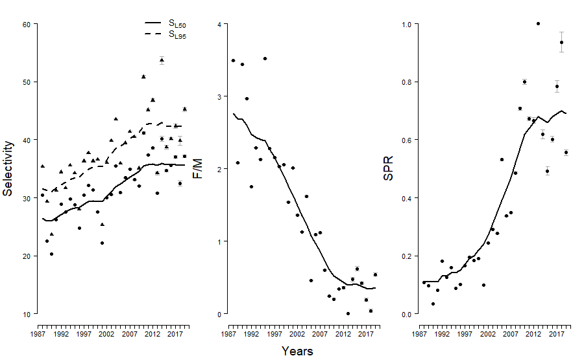

**NepFU2627\_FEMALES**

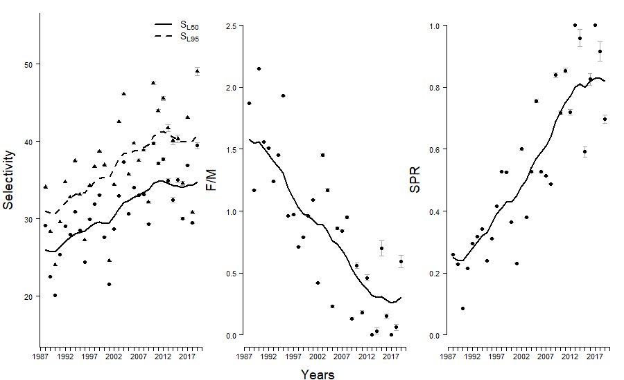

**Figure 4**. LB-SPR outputs: Selectivity, F/M and Spawning Potential Ratio for males and females with 95% confidence intervals and a smoother.

|  |  |
| --- | --- |
| **NepFU2627\_MALES** | **NepFU2627\_FEMALES** |
| Nepfu2627_males_SPREst_S_plot last year.png | Nepfu2627_females_SPREst_S_plot last year.png |

**Figure 4**. Spawning Potential Ratio smoother for males and females in the last year.

*Sensibility analysis*

|  |  |
| --- | --- |
| **NepFU2627\_MALES** | **NepFU2627\_FEMALES** |
| Nepfu2627_Males_FM_sensibilidad.jpg | Nepfu2627_Females_FM_Sensibilidad.jpg |
| Nepfu2627_Males_SPR_sensibilidad.jpg | Nepfu2627_Females_SPR_Sensibilidad.jpg |

