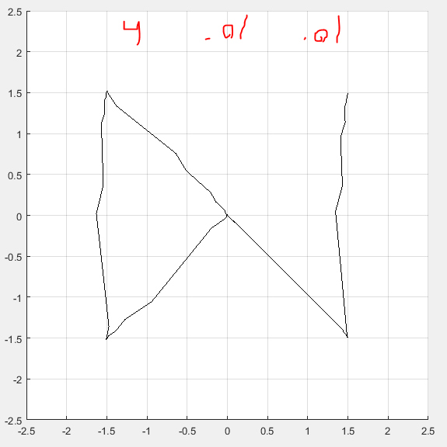

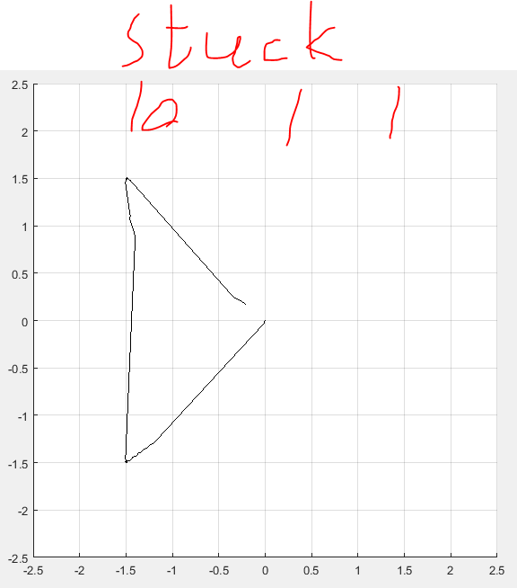

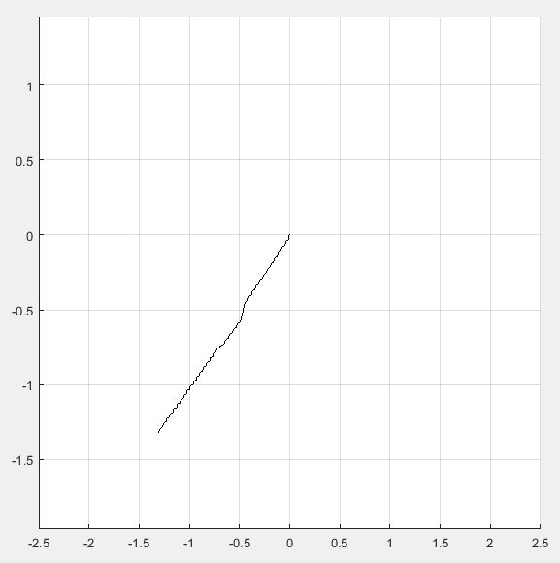

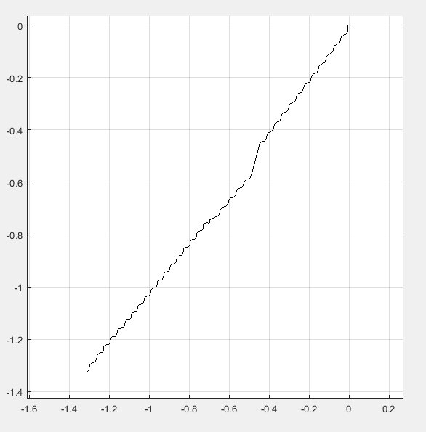 10, 0.1, 0.1 TOO MUCH VIBRATION

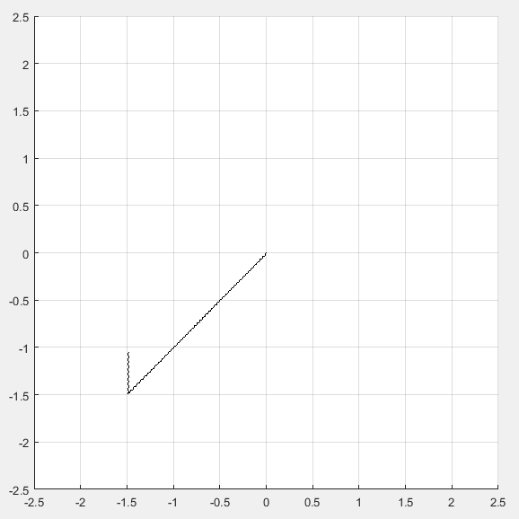

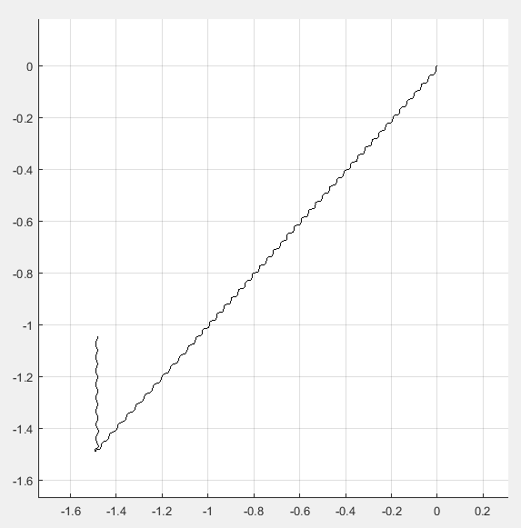 KP = 10, 0.05, 0

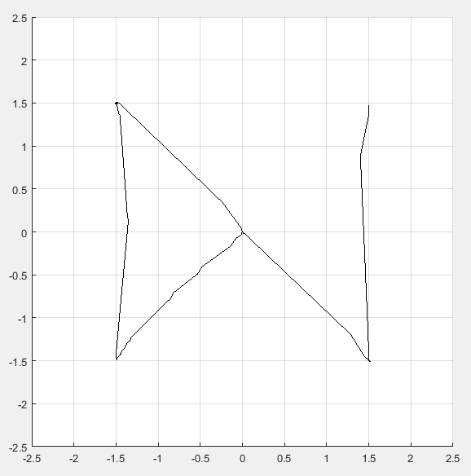

STUCK on top left corner for some time – stopped, velocity was too low – 5, 0.1, 0

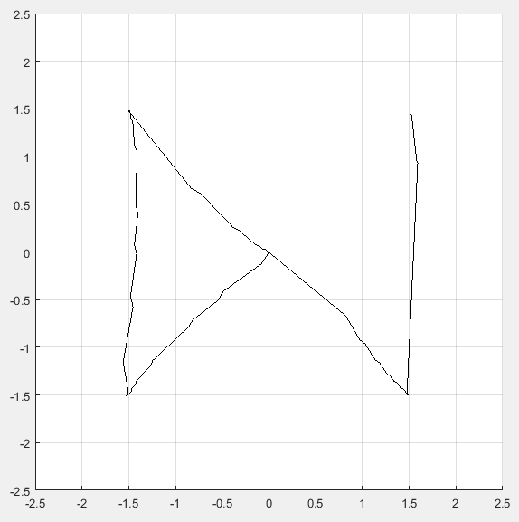

Kp = 5, Ki = 0.1, Kd = 0.1

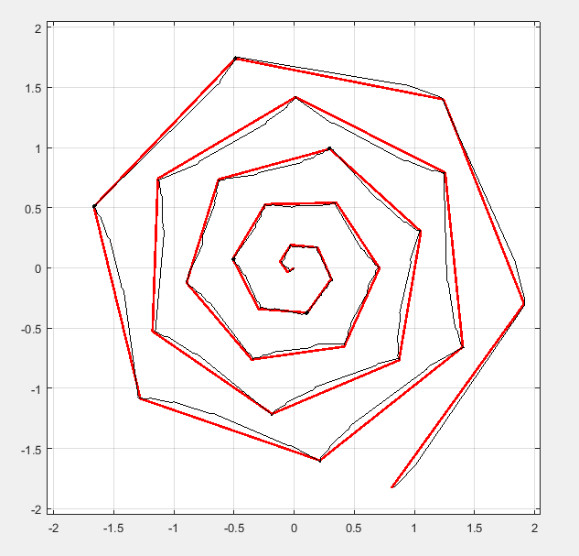

Kp = 5;

Ki = 0.01;

Kd = 0.01

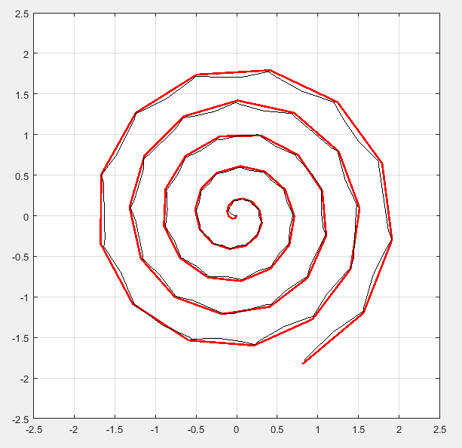

Kp = 5;

Ki = 0.01;

Kd = 0.01;

distThresh = 0.05;

angleThresh = 0.2;

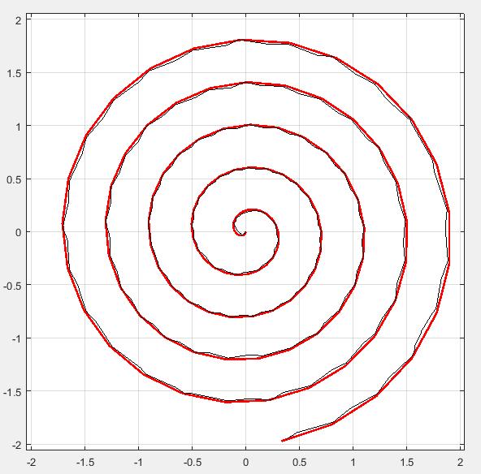

Same, different spiral