Original Article

Dysregulated lipid metabolism persists after weaning in mouse model of gestational diabetes

Samuel Furse1,2,3,§,*, Denise S. Fernandez-Twinn2,§, Jessica H. Beeson2, Davide Chiarugi4, Susan E. Ozanne2, Albert Koulman1,2,**

*1 Core Metabolomics and Lipidomics Laboratory, Wellcome Trust-MRL Institute of Metabolic Science, University of Cambridge, Addenbrooke’s Treatment Centre, Keith Day Road Cambridge, CB2 0QQ, United Kingdom.*

*2 Metabolic Disease Unit, Wellcome Trust-MRL Institute of Metabolic Science, University of Cambridge, Addenbrooke’s Treatment Centre, Keith Day Road Cambridge, CB2 0QQ, United Kingdom.*

*3 Biological chemistry group, Jodrell laboratory, Royal Botanic Gardens Kew, United Kingdom.*

*4 Bioinformatics and Biostatistics Core, Wellcome Trust-MRL Institute of Metabolic Science, University of Cambridge, Addenbrooke’s Treatment Centre, Keith Day Road Cambridge, CB2 0QQ, United Kingdom.*

*\*Correspondence to* [*sf615@cam.ac.uk*](mailto:sf615@cam.ac.uk) *or* [*samuel@samuelfurse.com*](mailto:samuel@samuelfurse.com)*. Tel. +44 (0) 1223 76 9067.*

*\*\*Correspondence to* [*ak675@medschl.cam.ac.uk*](mailto:ak675@medschl.cam.ac.uk)*. Tel. +44 (0) 1223 76 3202.*

ORCiD

0000-0003-4267-2051 (SF); ; 0000-0003-2752-3189 (DC); 0000-0001-9998-051X (AK).

**Abstract**

Gestational diabetes is associated with an increased risk of cardio-vascular disease and type II diabetes mellitus for the mother in the decade after delivery. This risk is still higher in obese individuals. However, the molecular mechanism that drives this effect is unknown. Recent studies in humans have shown that lipid metabolism is dysregulated before and during the onset of gestational diabetes. These observations led us to the hypothesis that dysregulation of lipid metabolism persists after GDM pregnancy. We used an updated purpose-built computational tool for plotting the distribution of lipid variables throughout the maternal system (Lipid Traffic Analysis v2.3). This network analysis showed that unlike glycaemia, lipid distribution and traffic do not return to normal after weaning. We found evidence that triglyceride distribution differed between lean and post-GDM groups, as did the control over phospholipid biosynthesis and FA distribution, including in the heart. These results highlight how dams who developed GDM maintain dysregulated lipid metabolism after pregnancy and provides a possible explanation for increased risk of cardiovascular disease in the years after pregnancy.

**Introduction**

Gestational diabetes (GDM) is the most common complication of pregnancy and is also now associated with an increased risk of metabolic disease *post partum*. Obesity is known as a risk factor for GDM, with around a third of women with a BMI >30 developing GDM [1-3] during pregnancy compared to around 8% across the general UK population [4]. There is also mounting evidence for increased risk of both type II diabetes mellitus (T2DM) and cardio-vascular disease (CVD) in individuals who experienced GDM in the decade after delivery [5-9]. Furthermore, a systematic review of over 5 million women in 9 studies found that women who previously had GDM had a two-fold increased risk of cardiovascular events independent of a progression to T2DM [10].

However, it is not clear what the molecular mechanism(s) are that drive the increased occurrence of T2DM and CVD in post-GDM mothers. The evidence that CVD risk is not dependent on T2DM suggests distinct aetiology. However, this has not been reported. Furthermore, typically, the hyperglycaemia that defines gestational diabetes disappears soon after delivery, suggesting that the CVD that emerges later is not attributable to long-term hyperglycaemia. The lack of correlation between this well-known characteristic of GDM, *i.e.* hyperglycaemia and future cardio-metabolic disease has motivated us to search for other possible explanations.

Studies of lipid metabolism during pregnancy and even before the diagnosis of GDM showed that several lipid pathways are dysregulated before the hyperglycaemia associated with GDM becomes established [11-13]. Specifically, serum-serum comparisons of lean and hyperglycaemic groups have identified candidate biomarkers in triglyceride (TG), phosphatidylcholine (PC) and sphingomyelin (SM) lipid classes [11-13]. These classes cover both energy storage and distribution (TGs) and structural lipids (PC, SM). Furthermore, most of the variables identified have several olefin bonds, indicating that the supply and distribution of poly-unsaturated fatty acids may also be important. As these changes show dysregulation of lipid metabolism in humans 10 weeks before diagnosis of gestational diabetes and cover both structural and energy-based lipid metabolism, there is evidence of systemic dysregulation.

This evidence led us to the hypothesis that diet-induced GDM establishes long-term changes to lipid metabolism after pregnancy. To test this, we used an established mouse model of GDM [14-16] (*Fig. 1A*), collecting glycaemia and insulinaemia data as well as a battery of tissues to determine organismal lipid metabolism after weaning (*Fig. 1B*). An updated version of Lipid Traffic Analysis [17, 18] (LTA, v2.3) was used to analyse lipidomics data from the tissues to characterise the number, type and abundance of lipid variables in and between compartments in the two phenotype groups. LTA is useful for testing the hypothesis because it uses the spatial distribution of lipids to indicate how the infrastructure or machinery that controls lipid metabolism differs between two phenotypes.

It was important to test this hypothesis because poor metabolic health during pregnancy has profound and long-term consequences for both the mother and offspring. Studies of humans show that there is a much higher risk of metabolic disease in women following a diagnosis of GDM [5-8, 10], and that the maternal obesity that increases the risk of GDM also drives nutritional programming associated with metabolic disease in offspring [19, 20]. A focus on lipid metabolism for this investigation is important because altered lipid metabolism in parents is increasingly being linked to metabolic disease in the parents themselves [11, 13] and potentially dangerous nutritional programming in offspring [18, 21, 22]. Furthermore, changes to lipid metabolism are associated with an increased risk of cardio-metabolic disease (CMD) [23-27].

**Results**

The model used was characterised by similar glycaemic control during a glucose challenge in both lean and obese-GDM groups *post partum* (*Fig. 2A, B*), with higher insulin levels in the obese group (*Fig. 2C*). The gross body composition shows that the obese group retains a similar fat mass to that pre-pregnancy (*Fig. 2D, E*). The clinical lipid profile of the two groups also remained distinct, showing an increase in total cholesterol (mainly in HDLs) and increased circulating fatty acids in the obese group (*Fig. 3*). This suggested that lipid metabolism differed between the two groups. We first tested the hypothesis that these effects were driven by a difference in the dietary intake of the two groups.

Profiling of the fatty acid (FA) composition of the feeds given to the two groups showed that their FA intake was very different, with the associated *p* values for the comparisons of chow and the components of the high fat diet being < 0.001 for 26 out of the 33 FAs measured (Bonferroni correction for multiple variables *p* = 0.00152; *Supplementary information 1*). It was therefore important to test whether any effects observed between the two phenotypes could be attributed to dietary intake. This was tested first in triglyceride storage tissues. The TGs stored in adipose do not typically represent a functional property as, unlike membranes, their physical behaviour is less important. Thus, one would expect the adipose to reflect the diet closely. However, despite the huge differences in fatty acid intake, most FAs in the adipose form the two groups were of a similar abundance (*Supplementary information 2*).

Three C18 FAs differed (*p* < 0.05) between the two groups in adipose tissue, with FA(18:0) more abundant in adipose tissue from the obese group whereas FA(18:1) and FA(18:2) were less abundant (*Fig. 4A*). However, in each case there is a remarkable disparity between the intake and the accumulation. The abundance of FA(18:0) in adipose tissue from the lean group was about 3× that of the dietary intake. Unexpectedly, although the composition of FA(18:0) in the obesogenic diet was at least twice as high as that of lean dams, the accumulation of FA(18:0) in adipose was only about 10% higher. FA(18:1) was more abundant in the obesogenic diet but the abundance in their adipose was lower than that of lean dams (*Fig. 4A*). This trend also obtained for FA(18:2), however the accumulation of FA(18:2) was only about 10% of the intake in the adipose of lean dams, whereas it was around 30% in the adipose of obese dams.

These results showed that the fatty acid profile of the stored fat was not reflective of dietary intake (*p* < 0.05). However, as a storage tissue, the adipose compartment is necessarily flexible and therefore not as tightly controlled as a compartment with a more physical/functional role for lipids. In order to understand whether the change in FA abundance differed both against dietary intake and between groups for functional purposes, the hypothesis was also tested on a tissue that relies on fatty acid supply both for structure (phospholipids) and energy supply (TGs), *i.e.* heart tissue. Three FAs showed a highly significant difference in mean abundance (*p* < 0.001) and one further with a *p* = 0.003, *Fig. 4B*. The differences here were even more pronounced than those of the adipose tissue (*Fig. 4A*). For all three FAs, the hearts of lean mice accumulated FA(12:0, 14:0, 15:0) with respect to dietary intake whereas in obese hearts, the abundance of all three FAs was lower despite being more abundant in the obesogenic diet (*Fig. 4B*). Furthermore, the ratio of FA(15:0)/FA(17:0) is higher in the obese group; 3.7 in obese and 2.4 in lean (*p* = 0.006), showing that the obesogenic increases the relative abundance of FA(15:0) relative to FA(17:0), consistent with a higher intake of diary fat [28, 29]. There was also a disparity in FA(16:0) (*p* = 0.003), the most abundant FA in the system. FA(16:0) was around 10% more abundant in hearts from the obese group, however it was around 35% more abundant in their dietary intake (*Supplementary information 2*).

This evidence shows convincingly that the controls of FA accumulation and distribution of the four most abundant fatty acids, and at least three more minor ones, differed between the two groups. This strongly suggests that the effects observed are not due only to the FA profile of dietary intake but are shaped by differences in the control mechanisms that govern metabolism in the two phenotypes. Furthermore, the different effects observed in the heart and adipose compartments suggested that a set of tissue-tissue comparisons would provide only a fragmentary pattern of lipid metabolism in the phenotypes. In order to test the primary hypothesis that lipid metabolism differed systemically between the two phenotypes, we used a network analysis to characterise the lipid metabolism throughout the systems of the two phenotypes.

The Switch Analysis part of a Lipid Traffic Analysis [22, 30, 31] (updated v2.3, see *Methods*) was used to plot the distribution of lipid variables throughout the biological network (*Fig. 1B*). The accumulation/absence of variables across the network used indicates how the metabolic infrastructure differs between the two phenotypes. The Switch Analysis of TGs showed that there were generally more variables associated with the lean group, indicating a wider variety of TGs through the network in that phenotype (*Fig. 5A*). The ***B***-type TG variables were associated with Jaccard-Tanimoto co-efficicents (*J*)of around 0.65 with accompanying false positive probabilities (*p*) of <0.4. Where *J* = 0.65, about two thirds of variables are the same for both phenotypes. Where *p* < 0.5 for this type of comparison (distinct from a Student’s *t-*test), both groups being compared have variables that the other does not. These statistics show that the similarity between the two groups is not particularly strong, consistent with the evidence of different distribution suggested above (*Fig. 4*). The same trend is observed in PCs, with *J* ~0.72 and *p* < 0.4 throughout ***B***-type PCs (*Fig. 5B*). This shows that the metabolic machinery is organised differently in the two phenotypes.

The difference in variety and number of isoforms in both TGs and PCs throughout the network led us to ask how this differed between phenotypes. Isoforms of commonplace TGs associated with dietary intake such as TG(52:3) appeared throughout the networks of both organisms, as expected (*Fig. 6*). This was also true for species associated with *de novo* lipogenesis (DNL), such as TG(50:1, 50:2). However several isoforms of TG were only found throughout the lean network and not the obese one, *e.g.* TG(48:1, 50:3, 52:4). This indicated that a variety of TGs were involved in the effects seen, strongly suggesting that distribution as well as biosynthesis differed between the two phenotypes.

This result was echoed in the variables for structural lipid classes such as PCs, phosphatidylethanolamines (PEs) and sphingomyelins (SMs). Several ordinary, abundant isoforms of PC appear throughout the networks of both phenotypes (*Fig. S1*), however the adducts detected suggest that some are less abundant in the obese group, *e.g.* chloride adducts ofPC(36:3, 38:5). Despite this, some poly-unsaturated PCs are found widely across the network, such as the DHA-containing PC(36:6, 40:6), suggesting subtle but important changes in the control of FA composition of PCs. The contrasts are sharper in PEs, where although several isoforms are found throughout, PE(36:1, 36:2, 36:4), but PE(34:2) appears important in obese systems where PE(34:0) is similarly important in lean mice (*Fig. S2*). This suggests that the gross PE composition of the systems differs between phenotypes.

A similar pattern is observed in SMs in which several isoforms (33:1, 34:1, 36:1, 37:1), appear throughout most or all of the network for both phenotypes, but not others. For example, SM(39:1) appeared throughout the obese network but not in the lean, and SM(35:1) appeared throughout the lean phenotype but not in the obese (*Fig. S3*). SM(39:1) is a known marker of dairy intake, consistent with the composition of the obesogenic diet, however what directs the appearance of SM(35:1) only in the lean phenotype is unclear. Despite structural similarities to SM(39:1) and SM(35:1), SM(37:1) appears almost throughout both networks, suggesting no connection with diet or phenotype,.

The ***U***-type variables also provided evidence that supported the hypothesis. We found that there were several TGs that only appeared in the adipose tissues, with about three times as many in adipose from the lean group (21:7, *J* 0.22, *p* 0.05; *Fig. 5A*). This was similar for hearts (14:5, *J* 0.06, *p* 0.01; *Fig. 5A*). However, the trend was reversed for liver, where there were more ***U***-type variables for the obese than the lean group (14:33, *J* 0.07, *p* 0.00; *Fig. 5A*). This led us to compare the TG isoforms present in those tissues and groups in order to determine whether there was a connection. Six of the variables involved were found in the livers of the obese group *and* the hearts of the lean group, TG(40:00, 40:01, 42:00, 46:02, 50:05, 52:05). This group of variables comprises isoforms associated with *de novo* lipogenesis, TG(40:00, 40:01, 42:00, 46:02), and poly-unsaturated species more closely associated with dietary intake, TG(50:05, 52:05). Thus, the distribution of TGs differs between the two phenotypes, with a possible restriction on TGs being transported out of the liver in the obese phenotype.

This accounts for 6 variables whereas there are around 20 more ***U-***type TGs in obese than lean livers. A further comparison of the isoform lists suggests that these are mainly odd-chain containing TGs with little overlap between the three tissues (*Table S2*). This suggests that several odd-chain TGs are produced locally. There are also a variety of odd-chain-containing PCs on the serum-brain axis that appear in both phenotypes (*Fig.* 5B), suggesting that odd-chain fatty acid metabolism is not a hallmark difference of these two phenotypes.

**Discussion**

This study was motivated by the hypothesis that diet-induced GDM precedes established changes in lipid metabolism that continue after weaning. While glycaemic control during a glucose challenge was maintained in the obese group, this was only achieved by increasing circulating insulin concentrations, a phenotype that precedes progression to T2DM. Analysis of FA intake and the FA composition of individual tissues showed that both intake and control of FA composition in tissues differed considerably between phenotypes in a way not driven by dietary intake. Lipid Traffic Analysis showed that the lean phenotype had a wider variety of both TGs and PCs than the obese phenotype, but also that the two phenotypes had different profiles of TGs and PC to one another. There was also evidence of different traffic between the two, with some variables being retained in the liver in the obese phenotype but being found in the heart in the lean phenotype.

The hypothesis was based on evidence of increased risk of CVD and T2DM after GDM [5-8, 10], and altered lipid metabolism in advance of GDM in humans [11-13]. This is the first study to show altered system and local lipid metabolism after development of GDM and thus with the existing research, strongly suggests that lipid metabolism is altered both before and after obese GDM. The same lipid classes are involved in both mouse and human systems, supporting the assertion that the effects observed are linked to the condition. As the effects on lipid metabolism happen both before and after hyperglycaemia becomes established, this leads one to the hypothesis that GDM is as much a dysregulation of lipid metabolism as one of dysregulated glycaemia. The evidence collected in the present study suggests that there are several effects on lipid metabolism, some of which may be general.

The evidence that both TGs and PCs show different isoform profiles and different breadths (more variables present in the lean system) between the two groups is an important characteristic of these systems. There are several possible explanations for the existence of such lipid profiles. The supply of FAs is an obvious possible driver of FA abundance *in vivo*. However, although the abundance of FAs in the dietary intake of the two groups was distinct, the accumulation and distribution of FAs in either was different (*Figs 4, 5*). The intake of carbohydrate was higher in the lean group, suggesting that endogenous production of FAs (*de novo* lipogenesis) may contribute to the range of lipid isoforms observed. However, the abundance of two known markers of DNL were higher in obese humans who later developed GDM [11, 13]. As obesity in humans can be driven both by excess carbohydrate and/or excess fat, this might suggest that the endogenous biosynthesis of TGs is more a marker of carbohydrate intake than of GDM. The apparent connection of GDM with DNL as data from obese human pregnancies suggested in previous reports [11, 13], may therefore only exist through excess intake.

Another mechanism to explain this is the modification of fatty acids *in vivo*. This could be desaturation and chain lengthening (elongation) but could also be shortening of the chain, for example to produce fatty acids with an odd number of carbons in its chain. However tracking these without labelled compounds is confounded as the intake of odd-chain fatty acids (ocFAs, *e.g.* FAs with 15 or 17 carbons) is perfectly normal and typically non-toxic, with dairy fat being a source of such FAs. Endogenous biosynthesis of margaric acid FA(17:0) is also a normal process, arising from the product of *Hacl1*. A considerable number of odd-chain-containing PCs were found in the brains of both phenotypes, suggesting this is a healthy part of lipid metabolism that is not modulated either by obesity or GDM. ocFAs are also commonplace in TGs. Evidence from the present study (*Table S2*) suggested that they appear across tissues in both phenotypes but with little overlap between them, indicating that circulation of ocFA-containing species is poor or that they are generally made locally.

There are also several possible effects of a differing lipid profile. The wiring/Underground map diagrams [22] showed that several variables were only found throughout the network of one of the two phenotypes (*Figs 6, S1-3*). Importantly, this includes PE(34:0, 34:2). The saturated PE(34:0) was only found throughout most of the lean system whereas the unsaturated PE(34:2) only found throughout the obese system. PE is a non-bilayer lipid and has been found to be a key regulator of membrane fluidity[32]. This result, along with the phenotype-linked effects in PCs and SMs (*Figs S1 and S3*) therefore suggests that the composition of membranes is differs between the two groups. This has profound importance in biological systems as it shapes membrane traffic and the activity of membrane proteins. Such changes may also invite long-term effects *in vivo*.

As humans known to have developed GDM are at significantly higher risk of developing T2DM and CVD in the decade after delivery [5-8], it is appealing to speculate that the mouse model used in the present study models this risk phenotype. However, this model of GDM was designed for testing hypotheses about metabolic dysregulation during pregnancy and subsequent nutritional programming in F1 offspring. Thus, possible CVD events and T2DM developing after weaning have not been investigated. Further work in this area in humans could include long term follow-up of women who developed GDM, with samples collected and the lipid metabolism characterised both soon after delivery and when evidence of T2DM and CVD is found.

Evidence for considerable dysregulation in systemic lipid metabolism in the maternal system after delivery raises questions about nutrient supply *in utero* and during lactation. This includes the role of these changes as possible drivers of nutritional programming effects. Growth restriction *in utero* in obese expectant mothers is well documented (refs) however the precise nutrient supply to the foetus in those models and in humans has not been determined. It is clear that the nutrient supply is generally weaker, however the present study suggests that it may also be unbalanced. A study in which labelled species are followed is required to answer this question formally, however the ratio of endogenous fats such as FA(16:0) and essential poly-unsaturated fatty acids supplied to the foetus may also indicate a general effect.

In conclusion, the present study shows that there are considerable differences in the control of lipid metabolism in the lean and obese phenotypes that are not attributable to the molecular composition of dietary intake. There are differences in the control of lipid metabolism that arise through other mechanisms. This provides a possible explanation for the observation that GDM is around four times as common in obese individuals, but does not affect all obese women during pregnancy. GDM may therefore represent a change to controls of fatty acid accumulation throughout the system, some of which may be harmful. Where this affects the heart, as shown in the present study, this leads one to the hypothesis that GDM is associated with long term dysregulation in lipid metabolism that increases the likelihood of CVD.

**Materials and Methods**

**Animal model.** All procedures were conducted in accordance with the UK Home Office Animal (Scientific Procedures) Act 1986 and local ethics committees at the University of Cambridge. Animals were maintained at the University’s biomedical research facility as described previously [14-16]. Briefly, female C57BL/6 mice were fed either a control/lean (RM1) or an obesogenic high-fat diet from weaning and throughout 2 pregnancies and lactation (both diets manufactured by Special Dietary Services Ltd; Witham, UK). Diet compositions have been described previously [33]. *n* = 8 dams per group were used in this study.

**Glucose tolerance test.** On the day of weaning, dams were fasted over night, beginning at 16:30. Dams were placed individually into a clean cage with access to water. They were fasted for 16 hours and blood drawn from the tail for basal (0 minute) glucose measurements (AlphaTRAK2, Zoetis, USA). Dams were then injected intraperitoneally (i.p.) with 1 g/kg glucose and further tail blood glucose measurements were made at timed intervals after injection (15 minutes, 30 minutes, 45 minutes, 60 minutes, 90 minutes and 120 minutes). Blood was also collected at 0 minutes, 15 minutes and 30 minutes time points in to haematocrit Na- heparin capillary tubes (Hirschmann-Laborgeräte, Germany). Plasma was isolated after centrifugation (Haematospin, Hawksley, UK) for four minutes and plasma insulin was measured using a Mouse Insulin ELISA (CrystalChem, USA) following manufacturer’s instructions. Area under the curve (AUC) was calculated by summation of trapezoids (Prism 8, GraphPad, USA). Using the matched plasma insulin and glucose values, HOMA-IR was calculated using the HOMA calculator (Diabetes Trial Unit, University of Oxford available here: https://www.dtu.ox.ac.uk/homacalculator/).

**Lipidomics.** Lipidomics data for this study were drawn from a previous study, that used a combination of mass spectrometry and phosphorus NMR [34]. All procedures used are therefore precisely as already described[18]. Briefly, whole tissue/organ samples were homogenised in a chaeotropic buffer to prepare a stable, pipettable solution that was then extracted with a mixture of dichloromethane, methanol and triethylammonium chloride, with adjustments for the abundance of triglyceride in adipose[34]. Mass spectrometry samples were prepared and data collected in a high throughput fashion using Direct Infusion Mass Spectrometry [34, 35], via glass-coated 384 well plates. NMR samples were prepared and data collected in a low throughput fashion using a modified form of the CUBO solvent system and assigned using reference 2D spectra acquired for the purpose[34, 36]. This identified up to 776 lipid variables in positive ionisation mode and up to 467 lipid variables in negative ionisation mode in liver, brain, heart, vastus and adipose homogenates and in serum.

**Lipid Traffic Analysis.**  Lipid Traffic Analysis code v1.0[18] was further developed in the present study to produce Lipid Traffic Analysis code v2.3. The code for the Binary Traffic analysis (Switch Analysis) was updated to include alignment of lists and automated calculation of JTCs and *p-*values from binary lists and improved categorisation of lipid variables (including assessment of all TG-derived glycerides). The configuration of the ***U***-lipid, ***A***-lipid and ***B***-lipid sections of the code was altered to make running any of the three individual parts of the code feasible. Novel code was written in R(v3.6.x) and processed in RStudio(v1.2.5x). The full code for Lipid Traffic Analysis v2.3 can be found in the *Supplementary Information file 3*.

The analysis of the present study was similar to previous studies [18, 31]. The tissues used were mapped to the known biological/metabolic network (*Fig. 1B*). Categories for the Switch Analysis were ***A***, ***B*** and ***U*** lipids. Variables were regarded as present if they had a signal strength >0 in ≥66% of samples per group.

**Statistical methods.** Univariate and bivariate statistical analyses, and error normalised fold change (ENFC)[18], were calculated in Microsoft Excel 2016. Graphs were prepared in Excel 2016 or OriginLab 2018. Calculations of Jaccard-Tanimoto Coefficients (JTCs, *J*) and associated *p-*values [18] were used as a non-parametric measure of the distinctions between lipid variables associated with phenotype(s). The *p*-value associated with each *J* represents the probability that the difference between the lists of variables for the two phenotypes occurred by random chance, representing both the number of variables only found in either of the two groups and the order of the binary list.

**Acknowledgments**

The authors gratefully acknowledge funding from the BBSRC (BB/M027252/1 for SF and AK and BB/T014210/1 for SF) and MRC/BHF (MC_UU_12012/4 for DFT and SEO). JHB was supported by a British Heart Foundation Studentship [FS/14/59/31282].

**Author contributions**

SF and DFT conceived the research question with AK and SEO. SF carried out all lipid analyses and wrote the manuscript. DC conceived improvements to previous code with SF and wrote all novel code. DFT and SEO developed the mouse model, and with JB did all animal work and produced all tissue samples. AK and SEO wrote the original grant proposals. SF, DFT and AK interpreted data and revised the manuscript with comments from all authors. All authors commented on the manuscript and approved the final version.

**Conflicts of Interest**

The authors have no conflicts of interest.

**Data availability statement**

The novel R code developed in the present study for Lipid Traffic Analysis v2.3 is in *Supplementary Information S3*. LTA v1.0 is available publicly available [17, 18, 37]. The MS dataset generated in the present study is available publicly with as are the original NMR data[34].

References

1. Poston L, Bell R, Croker H, Flynn AC, Godfrey KM, Goff L, et al. Effect of a behavioural intervention in obese pregnant women (the UPBEAT study): a multicentre, randomised controlled trial. The Lancet Diabetes & Endocrinology. 2015;3(10):767-77. doi: 10.1016/S2213-8587(15)00227-2.

2. Briley AL, Barr S, Badger S, Bell R, Croker H, Godfrey KM, et al. A complex intervention to improve pregnancy outcome in obese women; the UPBEAT randomised controlled trial. BMC Pregnancy and Childbirth. 2014;14(1):74. doi: 10.1186/1471-2393-14-74.

3. Kim SY, England L, Wilson HG, Bish C, Satten GA, Dietz P. Percentage of gestational diabetes mellitus attributable to overweight and obesity. American journal of public health. 2010;100(6):1047-52. doi: 10.2105/AJPH.2009.172890. PubMed PMID: 20395581.

4. McIntyre HD, Catalano P, Zhang C, Desoye G, Mathiesen ER, Damm P. Gestational diabetes mellitus. Nature Reviews Disease Primers. 2019;5(1):47. doi: 10.1038/s41572-019-0098-8.

5. Damm P. Future risk of diabetes in mother and child after gestational diabetes mellitus. International Journal of Gynecology & Obstetrics. 2009;104(Supplement):S25-S6. doi: 10.1016/j.ijgo.2008.11.025.

6. Herath H, Herath R, Wickremasinghe R. Gestational diabetes mellitus and risk of type 2 diabetes 10 years after the index pregnancy in Sri Lankan women-A community based retrospective cohort study. PloS one. 2017;12(6):e0179647-e. doi: 10.1371/journal.pone.0179647. PubMed PMID: 28644881.

7. Damm P, Houshmand-Oeregaard A, Kelstrup L, Lauenborg J, Mathiesen ER, Clausen TD. Gestational diabetes mellitus and long-term consequences for mother and offspring: a view from Denmark. Diabetologia. 2016;59(7):1396-9. doi: 10.1007/s00125-016-3985-5.

8. Coustan DR. Recurrent GDM and the development of type 2 diabetes have similar risk factors. Endocrine. 2016;53(3):624-5. doi: 10.1007/s12020-016-1016-4.

9. Chen L-W, Soh SE, Tint M-T, Loy SL, Yap F, Tan KH, et al. Combined analysis of gestational diabetes and maternal weight status from pre-pregnancy through post-delivery in future development of type 2 diabetes. Scientific Reports. 2021;11(1):5021. doi: 10.1038/s41598-021-82789-x.

10. Kramer CK, Campbell S, Retnakaran R. Gestational diabetes and the risk of cardiovascular disease in women: a systematic review and meta-analysis. Diabetologia. 2019;62(6):905-14. doi: 10.1007/s00125-019-4840-2.

11. Furse S, White SL, Meek CL, Jenkins B, Petry CJ, Vieira MC, et al. Altered triglyceride and phospholipid metabolism predates the diagnosis of gestational diabetes in obese pregnancy. Molecular Omics. 2019;15(6):420-30. doi: 10.1039/C9MO00117D.

12. White SL, Pasupathy D, Sattar N, Nelson SM, Lawlor DA, Briley AL, et al. Metabolic profiling of gestational diabetes in obese women during pregnancy. Diabetologia. 2017;60(10):1903-12. doi: 10.1007/s00125-017-4380-6.

13. Acharjee A, Prentice P, Acerini C, Smith J, Hughes IA, Ong K, et al. The translation of lipid profiles to nutritional biomarkers in the study of infant metabolism. Metabolomics. 2017;13(3):25. doi: 10.1007/s11306-017-1166-2.

14. Fernandez-Twinn DS, Gascoin G, Musial B, Carr S, Duque-Guimaraes D, Blackmore HL, et al. Exercise rescues obese mothers’ insulin sensitivity, placental hypoxia and male offspring insulin sensitivity. Scientific Reports. 2017;7:44650. doi: 10.1038/srep44650.

15. Loche E, Blackmore HL, Carpenter AA, Beeson JH, Pinnock A, Ashmore TJ, et al. Maternal diet-induced obesity programmes cardiac dysfunction in male mice independently of post-weaning diet. Cardiovascular Research. 2018;114(10):1372-84. doi: 10.1093/cvr/cvy082.

16. Musial B, Vaughan OR, Fernandez-Twinn DS, Voshol P, Ozanne SE, Fowden AL, et al. A Western-style obesogenic diet alters maternal metabolic physiology with consequences for fetal nutrient acquisition in mice. The Journal of Physiology. 2017;595(14):4875-92. doi: 10.1113/JP273684.

17. Furse S, Watkins AJ, Chiarugi D, Smith J, Hojat N, Williams HEL, et al. Revealing grand-paternal programming of lipid metabolism using a novel computational tool. BioRxiv. 2020. doi: 10.1101/2020.06.23.166819

18. Furse S, Watkins AJ, Hojat N, Smith J, Williams HEL, Chiarugi D, et al. Lipid Traffic Analysis reveals the impact of high paternal carbohydrate intake on offsprings’ lipid metabolism. Communications Biology. 2021. doi: 10.1038/s42003-021-01686-1.

19. Jazwiec PA, Sloboda DM. Nutritional adversity, sex and reproduction: 30 years of DOHaD and what have we learned? 2019;242(1):T51. doi: 10.1530/joe-19-0048.

20. Tarry-Adkins JL, Ozanne SE. Nutrition in early life and age-associated diseases. Ageing Research Reviews. 2017;39:96-105. doi: <https://doi.org/10.1016/j.arr.2016.08.003>.

21. Furse S, Snowden SG, Laurentya O, Prentice P, Ong K, Hughes IA, et al. Evidence that feeding post partum and exposures in utero shape lipid metabolism in infancy. Scientific Reports. 2019;9:14321. doi: 10.1038/s41598-019-50693-0.

22. Furse S, Watkins AJ, Hojat N, Smith J, Williams HEL, Chiarugi D, et al. Lipid Traffic Analysis reveals the impact of high paternal carbohydrate intake on offsprings’ lipid metabolism. Communications Biology. 2021;4(1):163. doi: 10.1038/s42003-021-01686-1.

23. Fernandez-Twinn DS, Hjort L, Novakovic B, Ozanne SE, Saffery R. Intrauterine programming of obesity and type 2 diabetes. Diabetologia. 2019;62(10):1789-801. doi: 10.1007/s00125-019-4951-9.

24. Perng W, Oken E, Dabelea D. Developmental overnutrition and obesity and type 2 diabetes in offspring. Diabetologia. 2019;62(10):1779-88. doi: 10.1007/s00125-019-4914-1.

25. Ng S-F, Lin RCY, Laybutt DR, Barres R, Owens JA, Morris MJ. Chronic high-fat diet in fathers programs β-cell dysfunction in female rat offspring. Nature. 2010;467(7318):963-6. doi: 10.1038/nature09491.

26. Wei Y, Yang C-R, Wei Y-P, Zhao Z-A, Hou Y, Schatten H, et al. Paternally induced transgenerational inheritance of susceptibility to diabetes in mammals. Proceedings of the National Academy of Sciences. 2014;111(5):1873-8. doi: 10.1073/pnas.1321195111.

27. Cropley JE, Eaton SA, Aiken A, Young PE, Giannoulatou E, Ho JWK, et al. Male-lineage transmission of an acquired metabolic phenotype induced by grand-paternal obesity. Molecular Metabolism. 2016;5(8):699-708. doi: 10.1016/j.molmet.2016.06.008. PubMed PMID: 27656407.

28. Jenkins B, Aoun M, Feillet-Coudray C, Coudray C, Ronis M, Koulman A. The Dietary Total-Fat Content Affects the In Vivo Circulating C15:0 and C17:0 Fatty Acid Levels Independently. Nutrients. 2018;10(11):1646. PubMed PMID: doi:10.3390/nu10111646.

29. Jenkins BJ, Seyssel K, Chiu S, Pan P-H, Lin S-Y, Stanley E, et al. Odd Chain Fatty Acids; New Insights of the Relationship Between the Gut Microbiota, Dietary Intake, Biosynthesis and Glucose Intolerance. Scientific Reports. 2017;7:44845. doi: 10.1038/srep44845.

30. Fernandez-Twinn D, Furse S, Sandovici I, XXX, YYY, Constância M, et al. Dietary restriction in utero alters the storage of triglycerides and the distribution of phospholipids throughout adulthood. In prep for Cell Rep. 2021.

31. Furse S, Watkins AJ, Williams HEL, Snowden SG, Chiarugi D, Koulman A. Paternal nutritional programming of lipid metabolism is propagated by sperm and seminal plasma. Submitted to EMBOJ. 2021.

32. Dawaliby R, Trubbia C, Delporte C, Noyon C, Ruysschaert J-M, Van Antwerpen P, et al. Phosphatidylethanolamine Is a Key Regulator of Membrane Fluidity in Eukaryotic Cells. Journal of Biological Chemistry. 2016;291(7):3658-67. doi: 10.1074/jbc.M115.706523.

33. Samuelsson A-M, Matthews PA, Argenton M, Christie M, R., McConnell JM, Jansen EHJM, et al. Diet-Induced Obesity in Female Mice Leads to Offspring Hyperphagia, Adiposity, Hypertension, and Insulin Resistance. Hypertension. 2008;51(2):383-92. doi: 10.1161/HYPERTENSIONAHA.107.101477.

34. Furse S, Fernandez-Twinn D, Jenkins B, Meek CL, Williams HE, Smith GCS, et al. A high throughput platform for detailed lipidomic analysis of a range of mouse and human tissues. Anal Bioanal Chem. 2020;412:2851-62. doi: 10.1007/s00216-020-02511-0.

35. Harshfield EL, Koulman A, Ziemek D, Marney L, Fauman EB, Paul DS, et al. An Unbiased Lipid Phenotyping Approach To Study the Genetic Determinants of Lipids and Their Association with Coronary Heart Disease Risk Factors. Journal of Proteome Research. 2019;18(6):2397-410. doi: 10.1021/acs.jproteome.8b00786.

36. Furse S, Williams HEL, Watkins AJ, Virtue S, Vidal-Puig A, Amarsi R, et al. A pipeline for making 31P NMR accessible for small- and large-scale lipidomics studies. ChemRxiv, In prep for Anal and Bioanal Chem. 2021. doi: 10.26434/chemrxiv.14053976.v1.

37. Furse S, Watkins AJ, Hojat N, Smith J, Williams HEL, Chiarugi D, et al. Code for: Lipid traffic analysis reveals the impact of high paternal carbohydrate intake on offsprings' lipid metabolism. 2021. doi: 10.5281/zenodo.4309347.

**Figure captions**

**Fig. 1. The mouse model and tissue network used in the present study.** Panel **A**, Schematic representation of the mouse model showing the groups, pregnancies and weaning. Panel **B**, the network that describes the lipid traffic associated with this model, including tissues whose activity is typically associated with diet-driven diabetes. The termini represent traffic flow from synthesis (liver), for structural purposes (CNS), fatty acid oxidation (heart, vastus, liver) and storage (adipose). This metabolic relationship between tissues was used as the structure of the network for all analyses in the present study. Lean refers to mice fed exclusively a diet of normal chow *ad libitum* whereas Obese refers to mice fed a high fat diet drawn from mainly dairy fat sources.

**Fig. 2. Glucose tolerance test and gross body composition of the mouse model at the time of tissue collection.** Panel **A**, Blood glucose concentrations in post-weaning dams during a glucose tolerance test (GTT). Panel **B**, Glucose area under the curve during the GTT. Panel **C**, Insulin concentrations in dams’ plasma at basal (0), 15 and 30 minutes post glucose challenge and calculated fasting HOMA-IR (0 min). Panel **D**, Dam bodyweight at weaning. Panel **E**, Dam fat mass as a percentage of bodyweight at weaning. The *p* values are based on unpaired Student *t*-tests between the lean and obese groups for comparisons given above braces between distributions. I.P., Intra-peritoneal; HOMA-IR, HOmeostatic Model Assessment for Insulin Resistance.

**Fig. 3. Clinical lipid measures.** Values given in *Table S1*. The *p* values for comparisons given above braces between distributions.

**Fig. 4. Relative abundance of FAs in chow and high fat feeds and tissues from lean and obese groups.** Panel **A**, Adipose tissue. Panel **B**, Heart tissue. \**p* < 0.05; \*\**p* < 0.005; \*\*\**p* < 0.001. CM, condensed milk; FA, fatty acid; HFP, high fat pellet.

**Fig. 5. Switch Analysis of the tissue network used in the present study.** Panel **A**, Triglycerides (TGs); Panel **B**, Phosphatidylcholines (PCs). Small pie charts represent the numbers of variables only found in the given tissue, larger pie charts represent the numbers of variables found in both adjacent tissues. *J* represents the Jaccard-Tanimoto distance and *p* the accompanying probability that the binary list of variables for the two groups differed by random chance[22].

**Figure 6. Wiring diagrams of triglyceride (TG) variables found in which tissues.** Blue lines represent the lean group whereas orange lines represent the obese-GDM group. A variable was considered present if *B* = >0.66.

**Table S1. Clinical lipid measures.** Values plotted in *Fig. 3*. All measures in mmol/L.

**Table S2. Odd-chain containing triglyceride and triglyceride fragments.**

**Figure S1. Wiring diagrams of phosphatidylcholine (PC) variables found in which tissues.** Blue lines represent the lean group whereas orange lines represent the obese-GDM group. A variable was considered present if *B* = >0.66.

**Figure S2. Wiring diagrams of phosphatidylethanolamine (PE) variables found in which tissues.** Blue lines represent the lean group whereas orange lines represent the obese-GDM group. A variable was considered present if *B* = >0.66.

**Figure S3. Wiring diagrams of sphingomyelin (SM) variables found in which tissues.** Blue lines represent the lean group whereas orange lines represent the obese-GDM group. A variable was considered present if *B* = >0.66.

**Figures**

A B

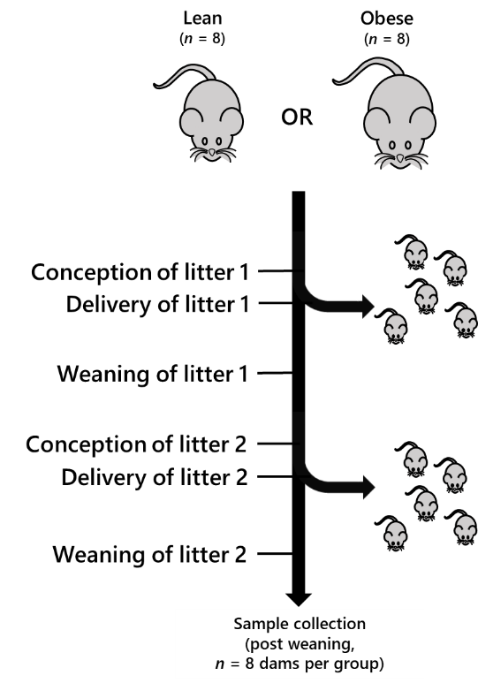 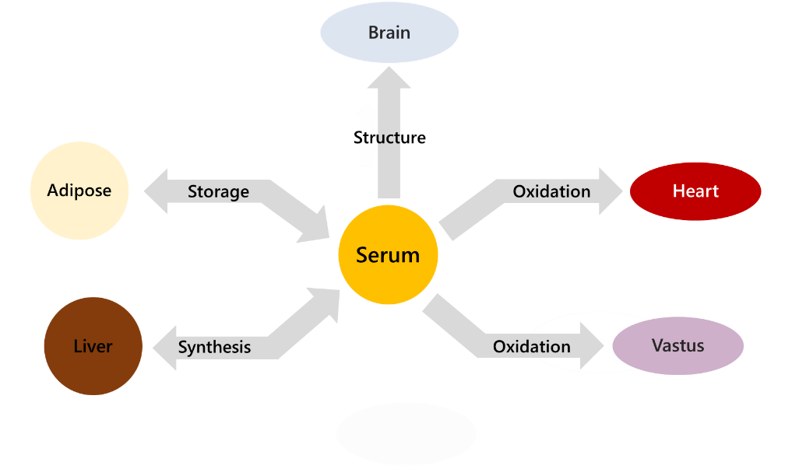

**Fig. 1. The mouse model and tissue network used in the present study.** Panel **A**, Schematic representation of the mouse model showing the groups, pregnancies and weaning. Panel **B**, the network that describes the lipid traffic associated with this model, including tissues whose activity is typically associated with diet-driven diabetes. The termini represent traffic flow from synthesis (liver), for structural purposes (CNS), fatty acid oxidation (heart, vastus, liver) and storage (adipose). This metabolic relationship between tissues was used as the structure of the network for all analyses in the present study. Lean refers to mice fed exclusively a diet of normal chow *ad libitum* whereas Obese refers to mice fed a high fat diet drawn from mainly dairy fat sources.



D E

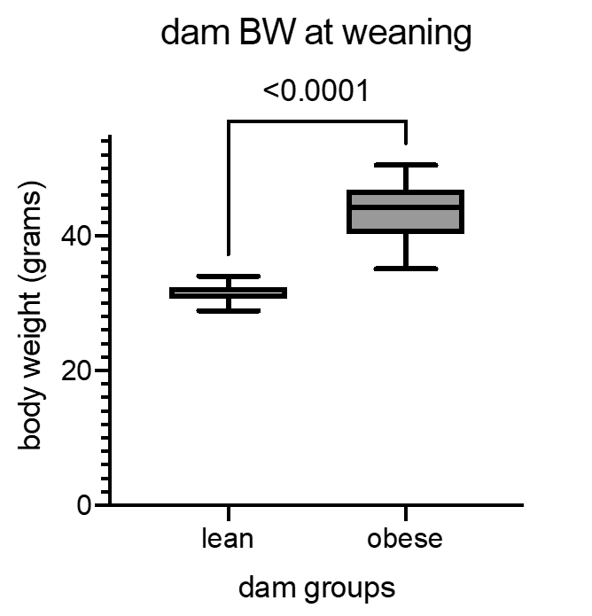 

**Fig. 2. Glucose tolerance test and gross body composition of the mouse model at the time of tissue collection.** Panel **A**, Blood glucose concentrations in post-weaning dams during a glucose tolerance test (GTT). Panel **B**, Glucose area under the curve during the GTT. Panel **C**, Insulin concentrations in dams’ plasma at basal (0), 15 and 30 minutes post glucose challenge and calculated fasting HOMA-IR (0 min). Panel **D**, Dam bodyweight at weaning. Panel **E**, Dam fat mass as a percentage of bodyweight at weaning. The *p* values are based on unpaired Student *t*-tests between the lean and obese groups for comparisons given above braces between distributions. I.P., Intra-peritoneal; HOMA-IR, HOmeostatic Model Assessment for Insulin Resistance.



**Fig. 3. Clinical lipid measures.** Values given in *Table S1*. The *p* values for comparisons given above braces between distributions. Chol, cholesterol.

A

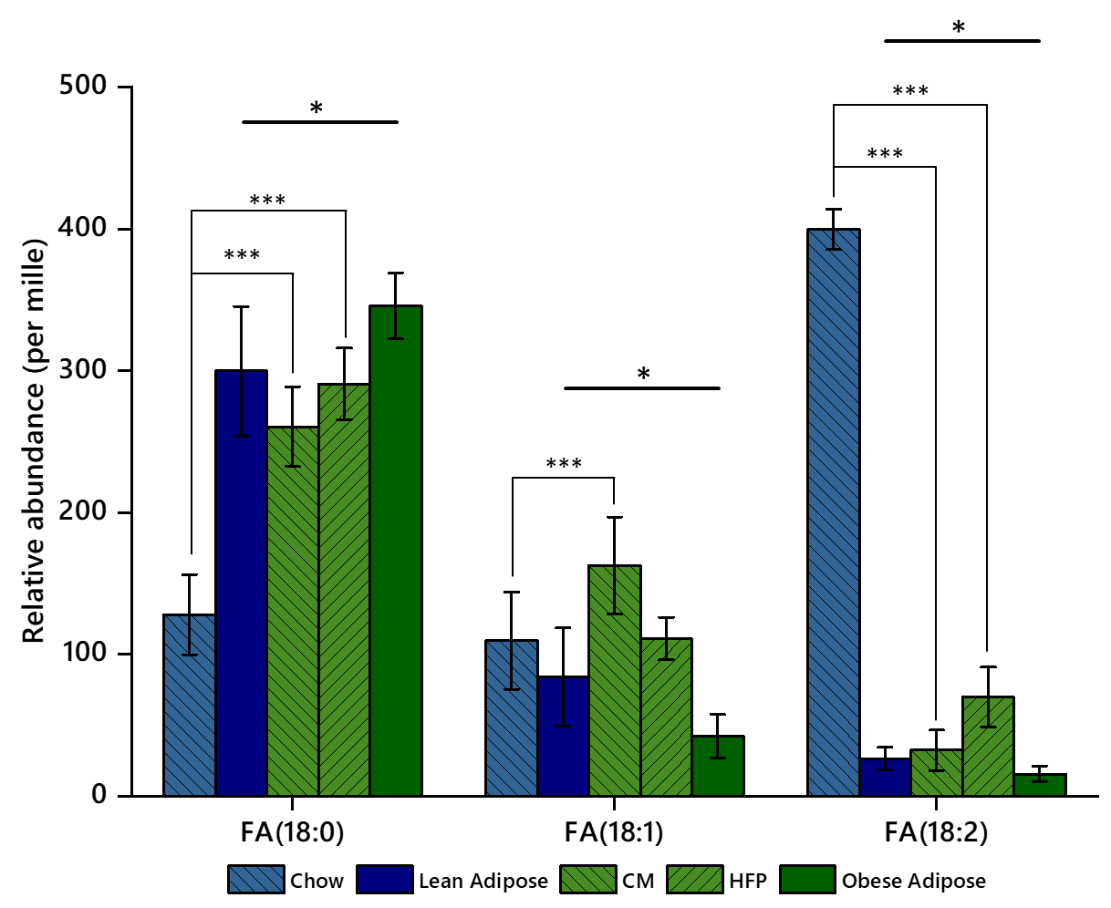

B

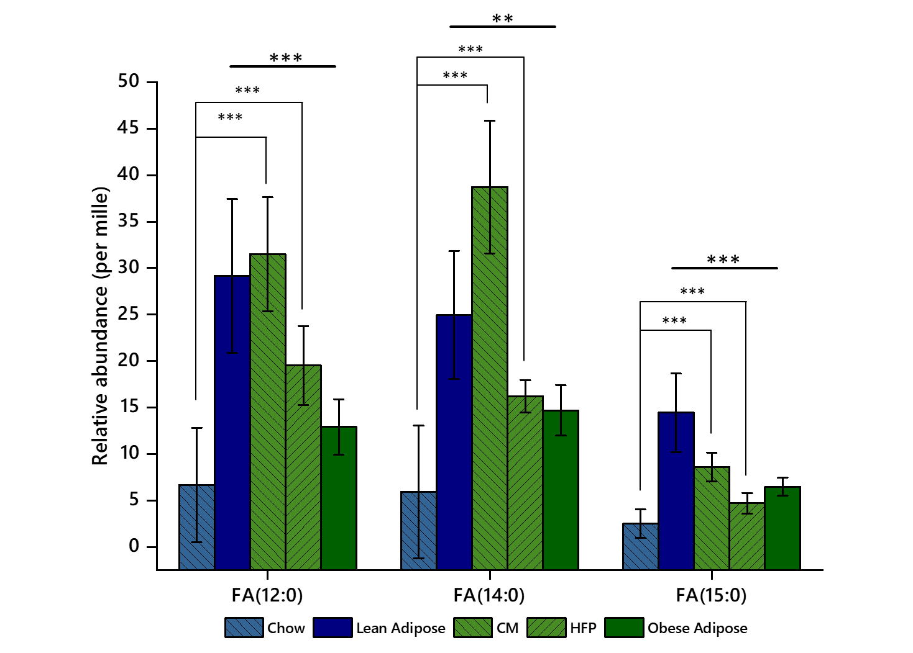

**Fig. 4. Relative abundance of FAs in chow and high fat feeds and tissues from lean and obese groups.** Panel **A**, Adipose tissue. Panel **B**, Heart tissue. \**p* < 0.05; \*\**p* < 0.005; \*\*\**p* < 0.001. CM, condensed milk; FA, fatty acid; HFP, high fat pellet.

A

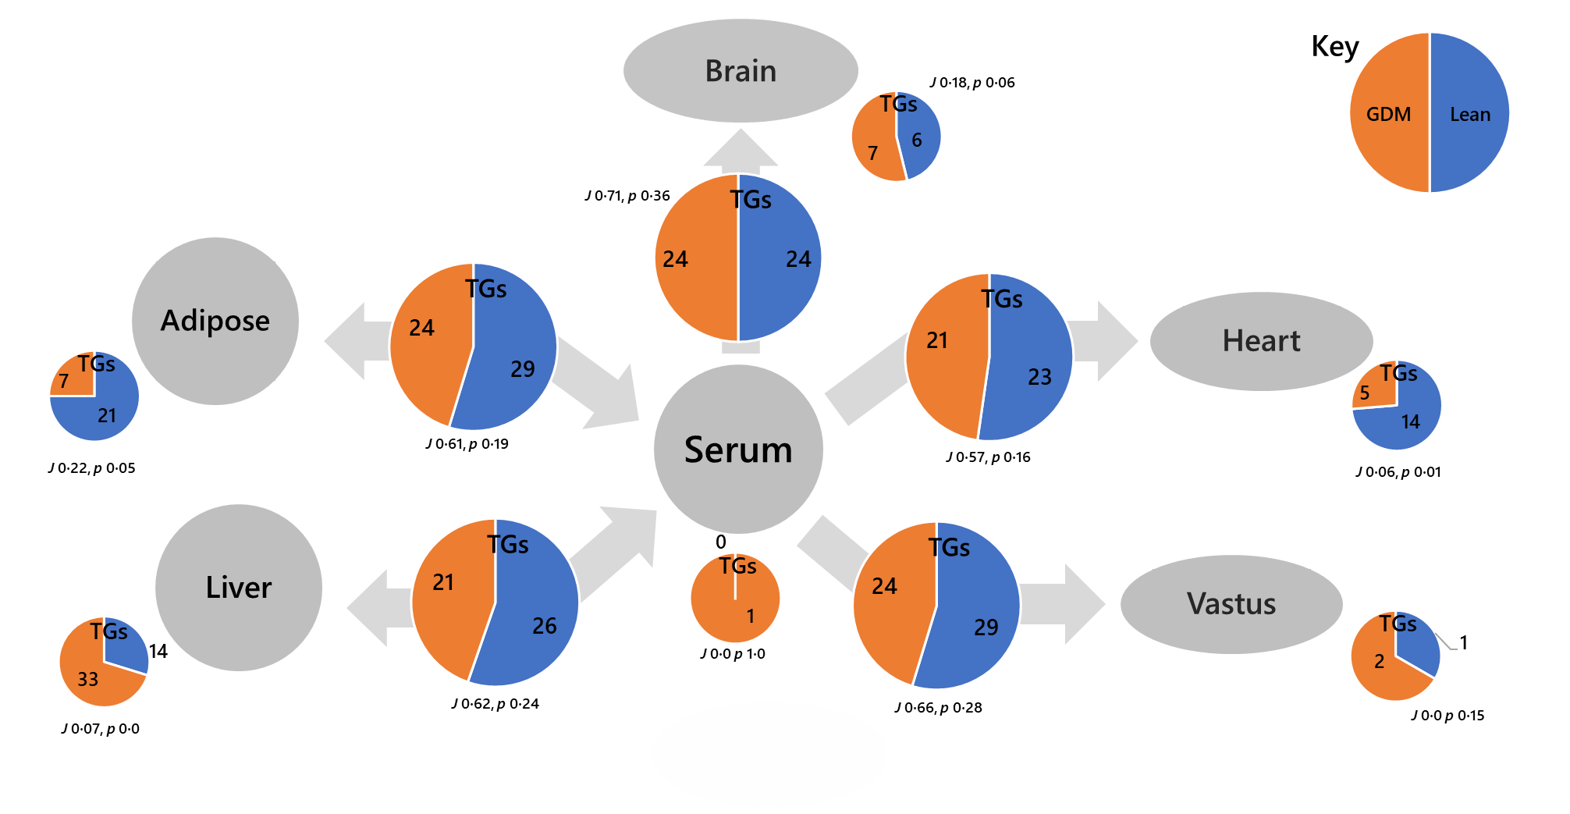

B

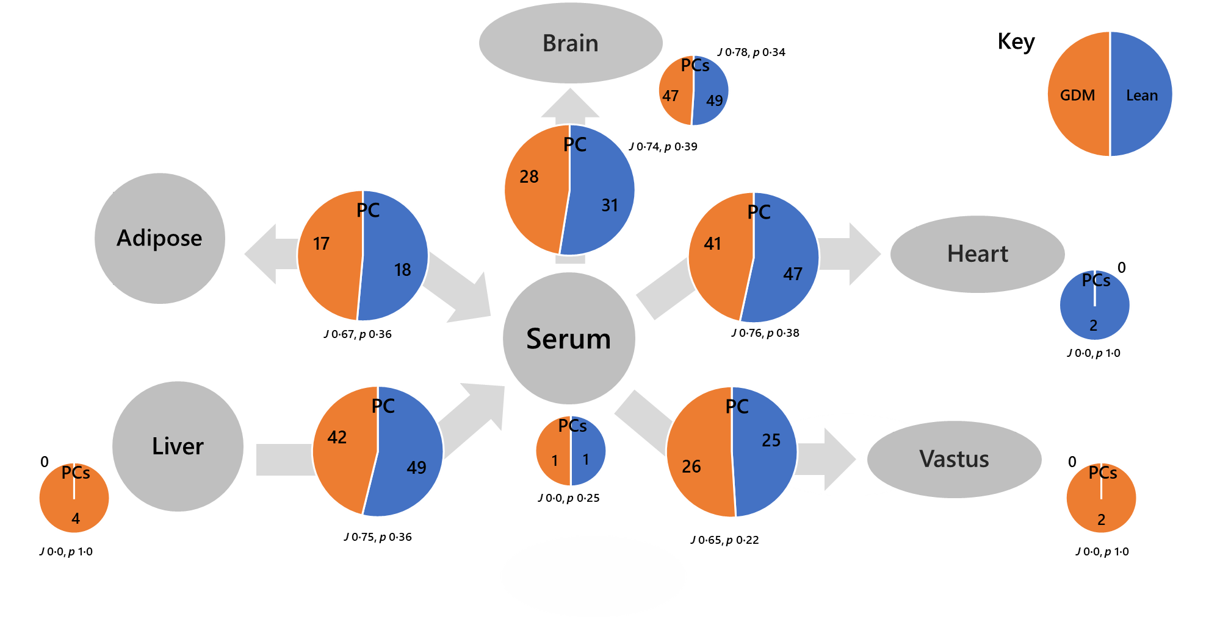

**Fig. 5. Switch Analysis of the tissue network used in the present study.** Panel **A**, Triglycerides (TGs); Panel **B**, Phosphatidylcholines (PCs). Small pie charts represent the numbers of variables only found in the given tissue, larger pie charts represent the numbers of variables found in both adjacent tissues. *J* represents the Jaccard-Tanimoto distance and *p* the accompanying probability that the binary list of variables for the two groups differed by random chance[22].

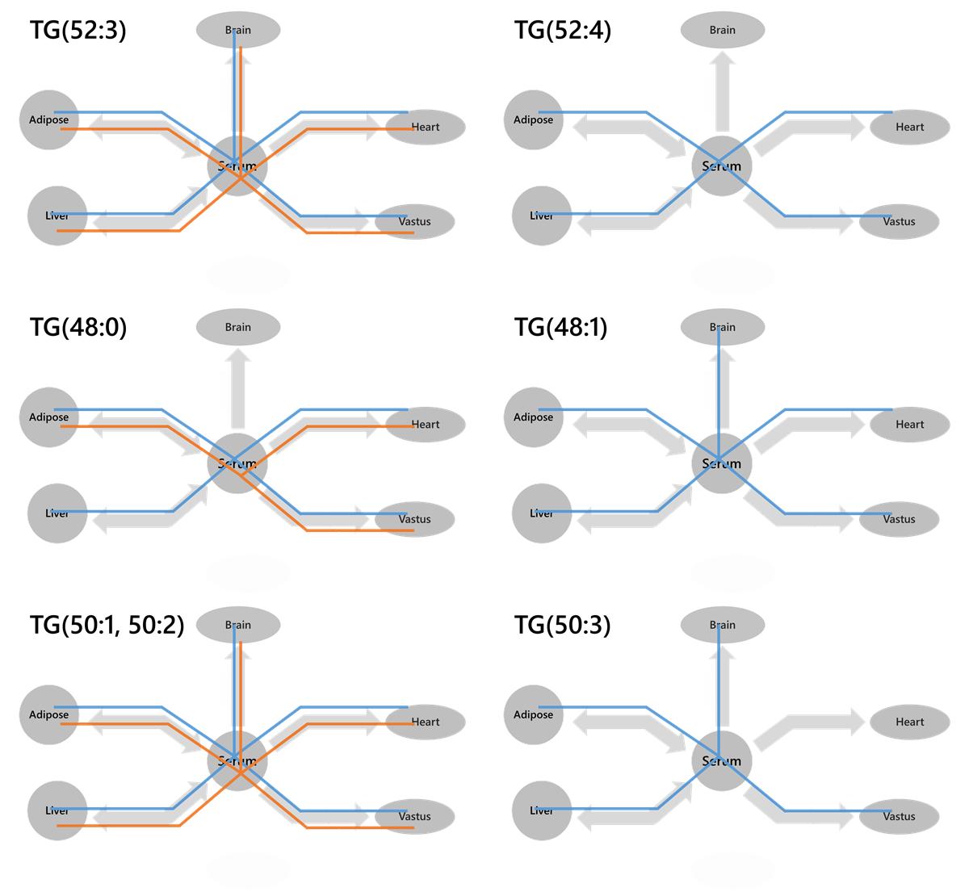

**Fig. 6. Wiring diagrams of triglyceride (TG) variables found in which tissues.** Blue lines represent the lean group whereas orange lines represent the obese-GDM group. A variable was considered present if *B* = >0.66.

**Supplementary Figures and Tables**

|  |  |  |  |  |  |
| --- | --- | --- | --- | --- | --- |
|  | Lean | | Obese | | *p* value |
| mean | s.d. | mean | s.d. |
| Total chol | 2.1 | 0.4 | 3.8 | 0.5 | 0.005 |
| LDL chol | 0.9 | 0.3 | 1.1 | 0.6 | 0.604 |
| HDL chol | 1.0 | 0.2 | 1.7 | 0.3 | 0.003 |
| TGs | 0.8 | 0.3 | 0.8 | 0.4 | 0.916 |
| FAs | 0.4 | 0.1 | 0.8 | 0.3 | 0.024 |

**Table S1. Clinical lipid measures.** Values plotted in *Fig. 3*. All measures in mmol/L.

|  |  |  |
| --- | --- | --- |
| LIV  (obese) | ADI  (lean) | HEA  (lean) |
| DG(23:00) |  |  |
| DG(27:00) |  |  |
| DG(27:01) |  |  |
| DG(31:02) |  |  |
| DG(33:02) |  |  |
|  | DG(35:01) |  |
|  | DG(35:02) |  |
|  | DG(35:05) |  |
| TG(33:00) |  |  |
| TG(35:00) |  |  |
| TG(37:00) |  |  |
| TG(37:01) | TG(37:01) |  |
| TG(39:00) |  |  |
|  | TG(39:01) |  |
|  |  | TG(45:01) |
| TG(47:01) |  |  |
|  |  | TG(49:00) |
| TG(49:01) |  |  |
|  | TG(49:02) |  |
| TG(51:02) |  |  |
| TG(51:03) |  |  |
|  | TG(51:04) |  |
|  |  | TG(51:05) |
| TG(53:03) |  |  |
|  |  | TG(55:01) |

**Table S2. Odd-chain containing triglyceride and triglyceride fragments.**

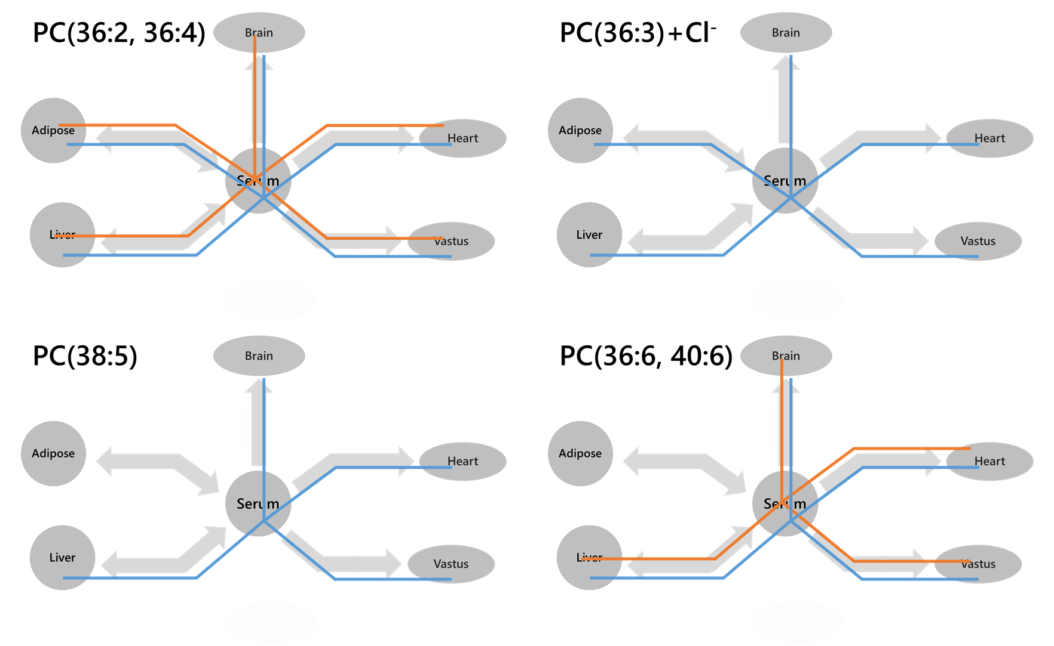

**Figure S1. Wiring diagrams of phosphatidylcholine (PC) variables found in which tissues.** Blue lines represent the lean group whereas orange lines represent the obese-GDM group. A variable was considered present if *B* = >0.66.

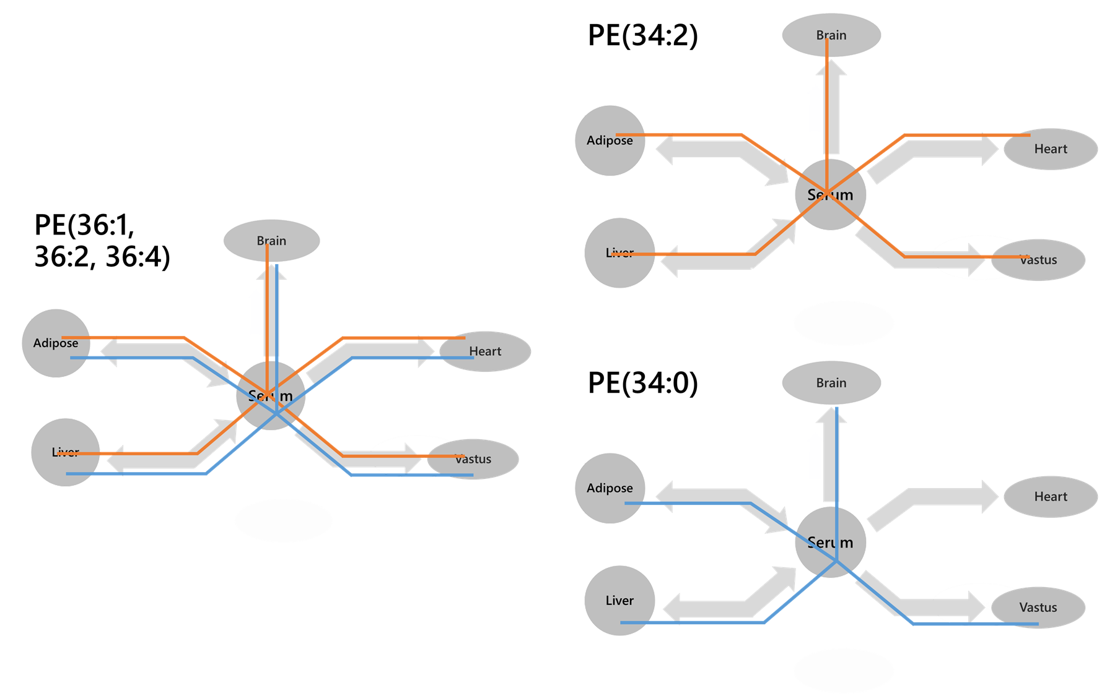

**Figure S2. Wiring diagrams of phosphatidylethanolamine (PE) variables found in which tissues.** Blue lines represent the lean group whereas orange lines represent the obese-GDM group. A variable was considered present if *B* = >0.66.

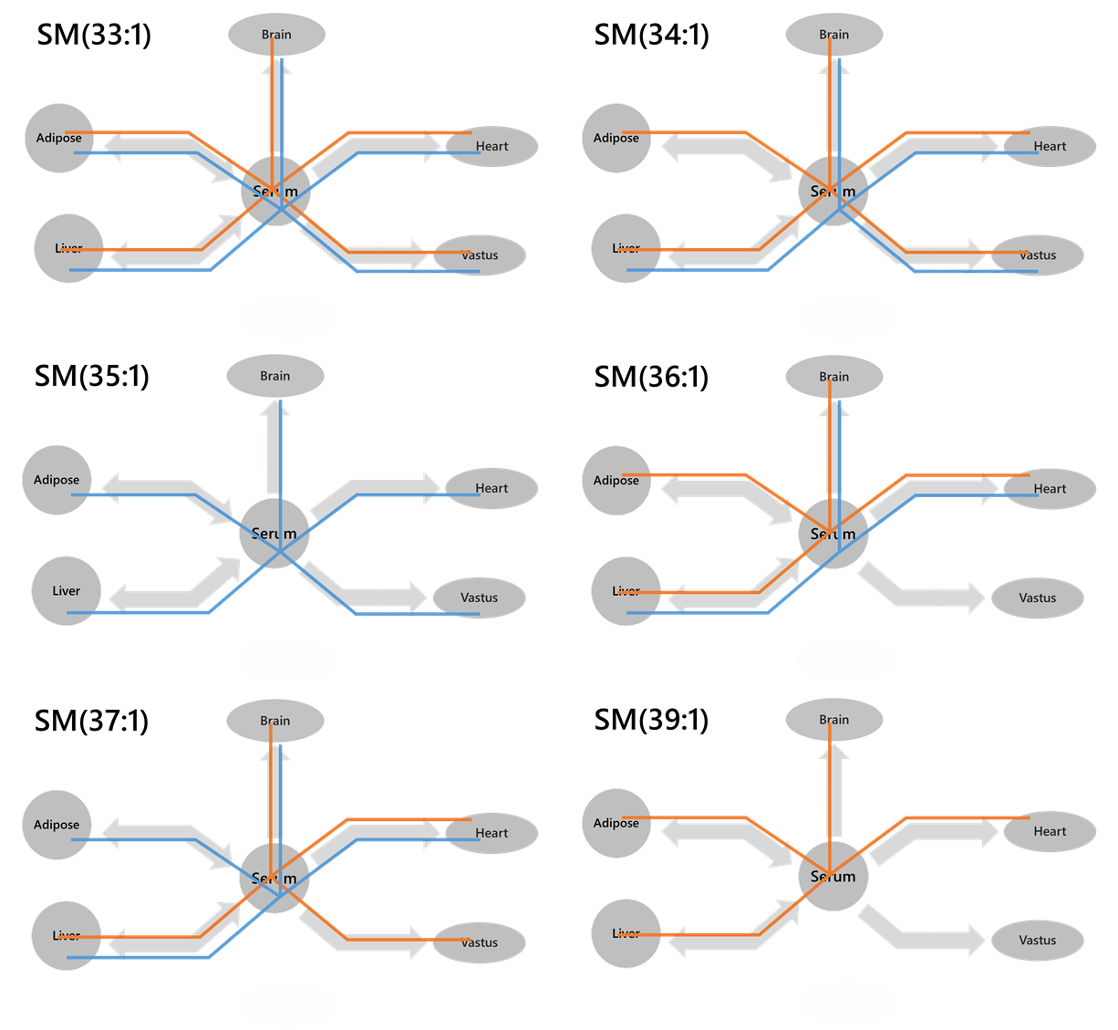

**Figure S3. Wiring diagrams of sphingomyelin (SM) variables found in which tissues.** Blue lines represent the lean group whereas orange lines represent the obese-GDM group. A variable was considered present if *B* = >0.66.

**Supplementary Materials**

1. Supplementary information file S1. FA composition of feeds and statistics
2. Supplementary information file S2. FA composition of heart and adipose tissues and statistics
3. Supplementary information file S3. Lipid traffic Analysis v2.3 (R code for conducting Lipid Traffic analysis.)