Example

Input:

* SEER*Stat DIC File: [shinyapp_recurrence_example_SEERStat.dic](https://github.com/recurrencerisk/recurrence/blob/example/shinyapp_recurrence_example_SEERStat.dic)
* SEER*Stat Data File: [shinyapp_recurrence_example_SEERStat.txt](https://github.com/recurrencerisk/recurrence/blob/example/shinyapp_recurrence_example_SEERStat.txt)
* CanSurv CSV File: [shinyapp_recurrence_example_CanSurv.csv](https://github.com/recurrencerisk/recurrence/blob/example/shinyapp_recurrence_example_CanSurv.csv)
* Stage Variable: SEER_historic_stage_LRD
* Distant Stage Value: 2
* Adjustment Factor r: 1.5
* Years of Follow-up: 25

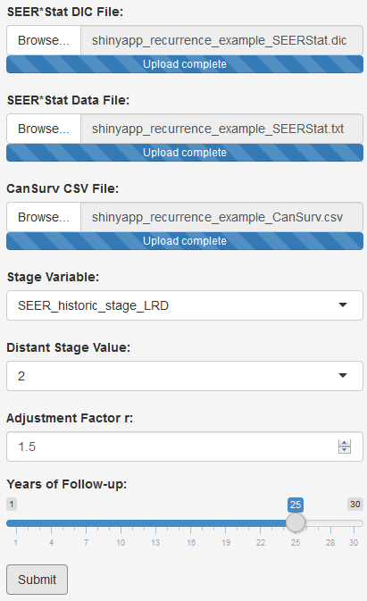

|  |  |
| --- | --- |
| Output: | [shinyapp_recurrence_example_out.csv](https://github.com/recurrencerisk/recurrence/blob/example/shinyapp_recurrence_example_out.csv) |