Jiajian Chen

CPE301 – SPRING 2018

Design Assignment 3

**DO NOT REMOVE THIS PAGE DURING SUBMISSION:**

The student understands that all required components should be submitted in complete for grading of this assignment.

|  |  |  |  |
| --- | --- | --- | --- |
| **NO** | **SUBMISSION ITEM** | **COMPLETED (Y/N)** | **MARKS**  **(/MAX)** |
| 1 | COMPONENTS LIST AND CONNECTION BLOCK DIAGRAM w/ PINS |  |  |
| 2. | INITIAL CODE OF TASK 1/A |  |  |
| 3. | INCREMENTAL / DIFFERENTIAL CODE OF TASK 2/B |  |  |
| 3. | INCREMENTAL / DIFFERENTIAL CODE OF TASK 3/C |  |  |
| 3. | INCREMENTAL / DIFFERENTIAL CODE OF TASK 4/D |  |  |
| 3. | INCREMENTAL / DIFFERENTIAL CODE OF TASK 5/E |  |  |
| 4. | SCHEMATICS |  |  |
| 5. | SCREENSHOTS OF EACH TASK OUTPUT |  |  |
| 5. | SCREENSHOT OF EACH DEMO |  |  |
| 6. | VIDEO LINKS OF EACH DEMO |  |  |
| 7. | GOOGLECODE LINK OF THE DA |  |  |
|  |  |  |  |
|  |  |  |  |

1. **COMPONENTS LIST AND CONNECTION BLOCK DIAGRAM w/ PINS**

List of Components used

Block diagram with pins used in the Atmega328P

1. **INITIAL/DEVELOPED CODE OF TASK 1/A**

Insert initial code here

1. **MODIFIED CODE OF TASK 2/A from TASK 1/A**

Insert only the modified sections here. Use more sections if needed

1. **SCHEMATICS**

Use fritzing.org

1. **SCREENSHOTS OF EACH TASK OUTPUT (ATMEL STUDIO OUTPUT)**

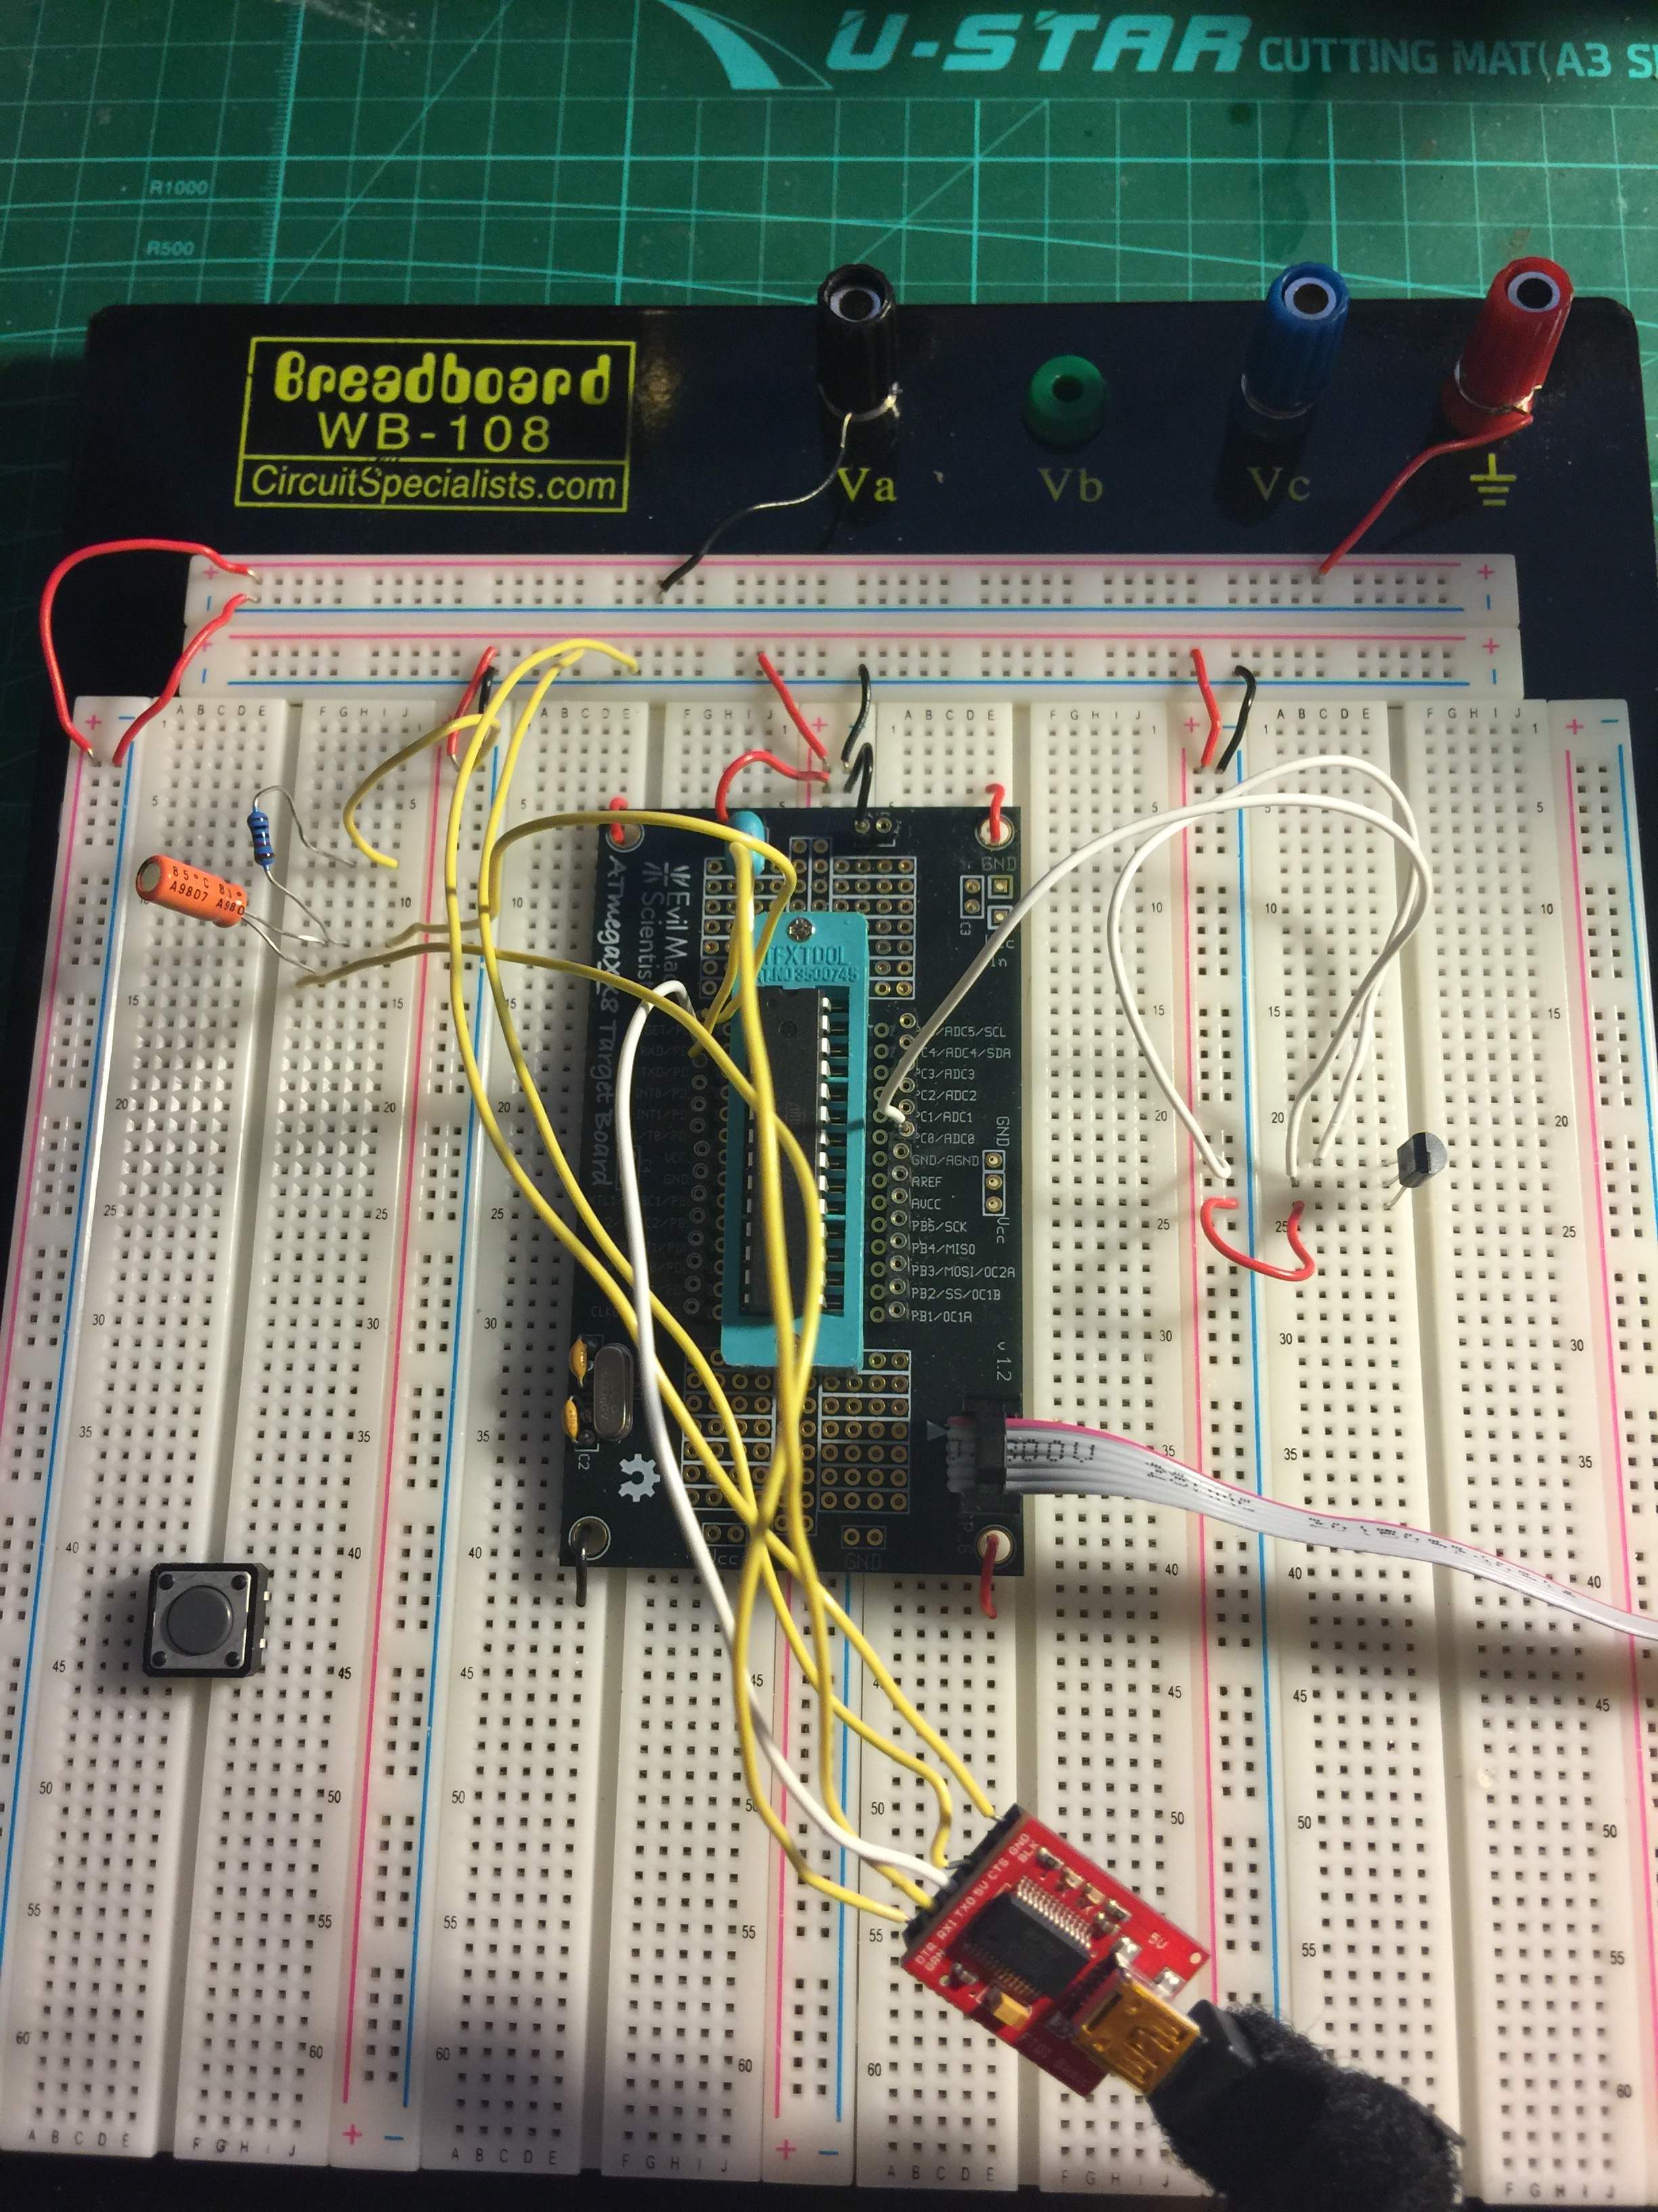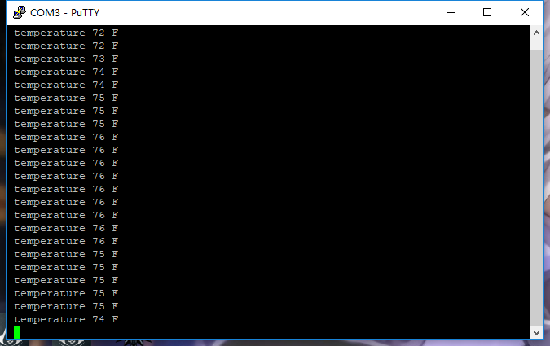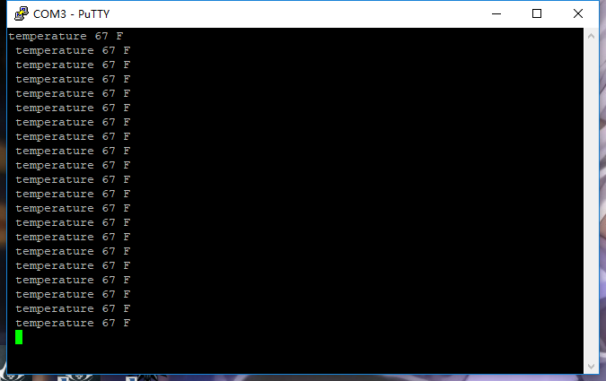

1. **SCREENSHOT OF EACH DEMO (BOARD SETUP)**
2. **VIDEO LINKS OF EACH DEMO**
3. **GITHUB LINK OF THIS DA**

**Student Academic Misconduct Policy**

<http://studentconduct.unlv.edu/misconduct/policy.html>

“This assignment submission is my own, original work”.

NAME OF THE STUDENT