

**SUBJECT----OBJECT ORIENTED PROGRAMMING 2**

**SECTION----E**

**GROUP [5] MEMBERS:**

|  |  |
| --- | --- |
| **NAME** | **ID** |
| **PAUL, PROMIT** | **20-42904-1** |
| **KHAN, MD MOBIN** | **20-42925-1** |
| **AHMED, IMTIAZ** | **20-42933-1** |

**TITLE:** HOSPITAL MANAGEMENT SYSTEM

**INTRODUCTION:**

HospitalManagement System is introduced to solve the complications coming from managing all paper works of every patient, doctor, nurse, associated with the various departments of hospitalization. The hospital Management system provides the ability to manage all the paperwork in one place, reducing the work of staff in arranging and analyzing the paperwork of the patients.

**PROJECT DESCRIPTION:**

There are several activities going on in a hospital and everyone has some particular duties. To conduct these duties everyone for example authorities, doctors, nurses and account officers must have an account in that hospital. In fact, creating an account is also mandatory for the patients if they want to set a serial for a particular doctor. Whenever that patient comes to the account officer to make payment for consulting doctor, first serial is verified by the account officer. Not only for consulting, patient also do payment for medicines and tests. Another two verifications are also done by the account officers which are room status whenever doctor suggests admission to the patient and availability of medicines. Besides that, they also know all the costs of medicines and tests. In case of doctor role, clinical note and next follow up date are made by them. Nurse is another role whose duties are checking blood pressure, temperature, weight, sugar daily and maintaining medicines time for the admitted patients. Finally, the authorities set the salaries, handle who is going to join or leave the hospital and fixed the duties for everyone.

**USERS:**

1. Authority
2. Doctor
3. Nurse
4. Account officer
5. Patient

**Functionality:**

1. **Authority**

* See his own name, id, and salary
* Fixed the duties for everyone
* Set salaries
* Handle the joining and resignation

1. **Doctor**

* See his own name, id, department and salary
* Make clinical note
* Set next follow up date

1. **Nurse**

* See his own name, id and salary
* Check blood pressure, temperature, weight and sugar
* Maintain medicines time

1. **Account officer**

* See his own name, id and salary
* Verify serial, room status and medicines availability
* Observe the tests and medicines costs

1. **Patient**

* Set serial for particular doctor
* See clinical note and test report

**USE CASE:**

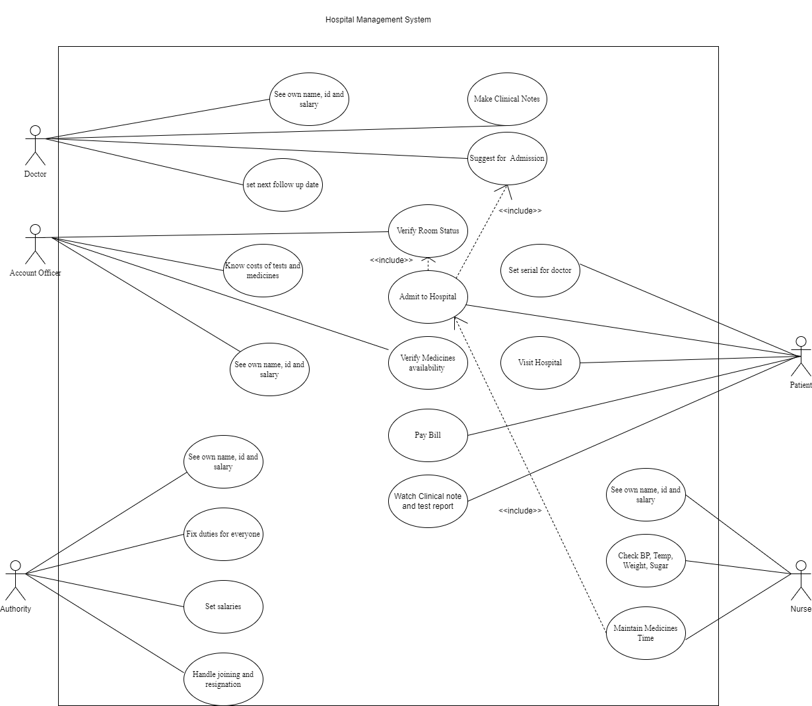

**ER DIAGRAM:**

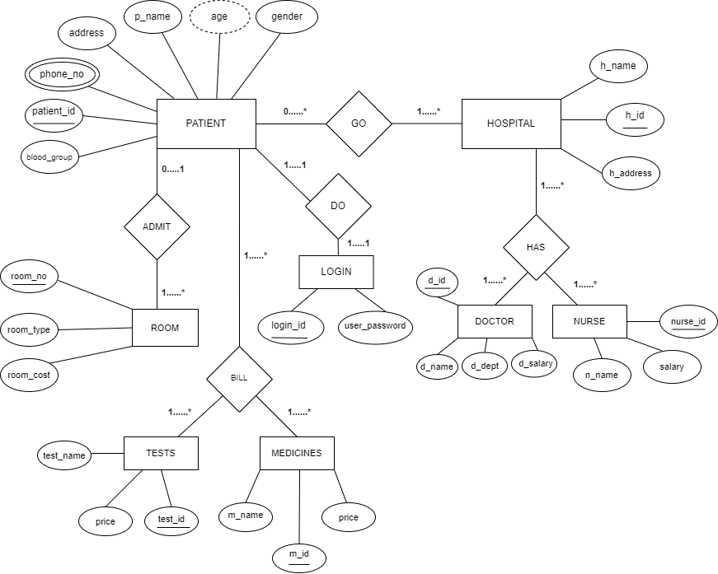

**Significance of the project:**

* **ECONOMIC**

Patients who live far from the hospital can save much money as they don’t need to come to the hospital only for giving serial or taking their reports

* **SOCIAL**

It will be like a curse for the patients if they come to the hospital several times which can be easily done by from a hospital management system. So, hassle of the patients can be reduced much by this system.

**Conclusion:**

Implementation of hospital management system project helps to store all the kinds of records, provide coordination and user communication, implement policies, improve day-to-day operations, arrange the manage financial and human resources, and market hospital services