17-655 Architectures for Software Systems

Software Architecture Document

Assignment 1

Pipe-and Filter

David Qiu, Roy Hsiao, Sashank Pandem , Yahui Chu

February 15, 2016

Revision History

|  |  |  |  |
| --- | --- | --- | --- |
| Date | Version | Description | Author |
| 02/06/2016 | 1.0 | Initial version of SAD for comments by team | Roy Hsiao |
| 02/09/2016 | 1.1 | Changed based on Team Discussion |  |

Contents

1. Introduction 4

1.1. Purpose 4

1.2. Scope 4

1.3. Definitions, Acronyms, and Abbreviations 4

1.4. References 4

1.5. Overview 4

2. Architectural Representation 4

3. Architectural Goals and Constraints 5

3.1. Security 5

3.2. Persistence 5

3.3. Reliability/Availability 6

3.4. Performance 6

4. Use-Case View 6

4.1. Actors 6

4.2. Use-Case Realizations 6

5. Logical View 6

5.1. Overview 6

6. Process View 6

7. Module Decomposition View 6

8. Data View 6

9. Deployment View 6

10. Size and Performance 7

11. Issues and concerns 7

12. References 8

# Introduction

This document provides a high level architecture overview and explains the process of Assignment one Pipe-and-Filter

## Purpose

This Software Architecture Document (SAD) provides a comprehensive architectural overview of Assignment one Pipe-and-Filter (A1_P&F). By analyzing the A1_P&F’s static, dynamic and physical perspective, we have create and believe the following architecture views to depict different aspect of the A1_P&F: dynamic views, static views and physical views. The structure of this document is based on

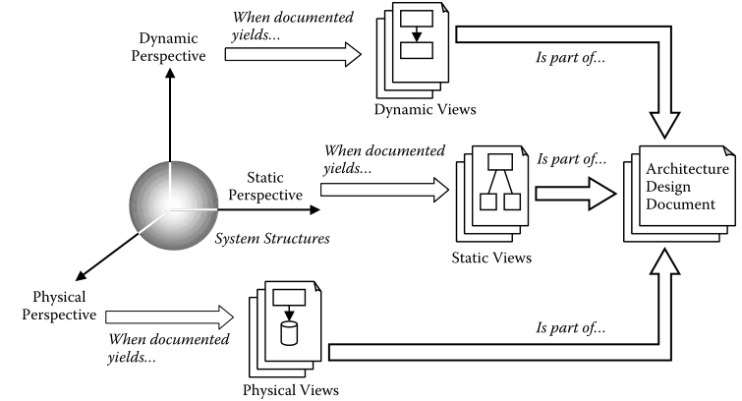

Figure 1 views from various perspectives (Lattanze, 2008, p. 54)

## Scope

The scope of this SAD is to depict the architecture of a Pipe-and-Filter sample system in the assignment one. Also, the report will provide instruction on running this working implementation that use a Pipe-and-Filter paradigm.

## Definitions, Acronyms, and Abbreviations



## Overview

# Architectural Representation

**Use Case view**

**Audience**: all the stakeholders of the system, including the end-users.

**Area**:

**Related Artifacts** : Use-Case Model, Use-Case documents

**Static view**

**Audience**: Designers.

**Area**:.

**Related Artifacts**: Design model

**Dynamic view**

**Audience**: Integrators.

**Area**:

**Related Artifacts**: (no specific artifact).

**Physical view**

**Audience**: Integrators.

**Area**:

**Related Artifacts**: (no specific artifact).

**Module Decomposition view**

**Audience**: Programmers.

**Area**: Software components: describes the modules and subsystems of the application.

**Related Artifacts**: Implementation model, components

**Data view**

**Audience**: Data specialists, Database administrators

**Area**: Persistence: describes the architecturally significant persistent elements in the data model

**Related Artifacts**: Data model.

**Deployment view**

**Audience**: Deployment managers.

**Area**:

**Related Artifacts**: Deployment model.

# Architectural Goals and Constraints

This assignment will use P&F architectural pattern. The goal

## Security

## Persistence

## Reliability/Availability

## Performance

# Use-Case View

## Actors

## Use-Case Realizations

# Logical View

## Overview

# Process View

# Module Decomposition View

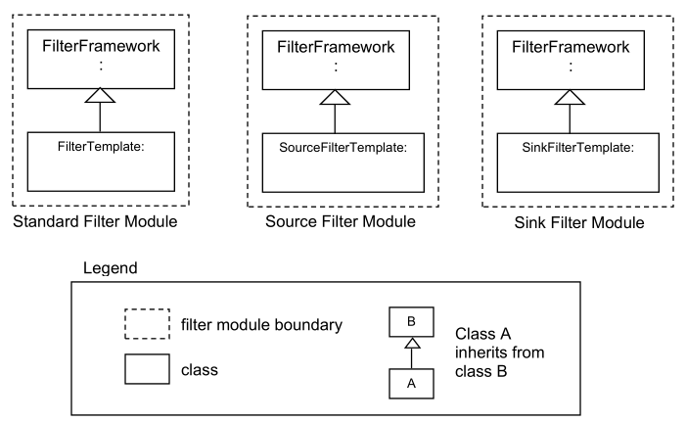

# Data View

# Deployment View

# Size and Performance

# Issues and concerns

# References

Bass, L., Clements, P., & Kazman, R. (2013). *Software architecture in practice.* Upper Saddle River, NJ: Addison-Wesley.

Clements, P., Bachmann, F., & Bass, L. (2003). *Documenting software architectures: views and beyond.* Boston: Addison-Wesley.

Eeles, P. (2006, May 15). *The benefits of software architecting*. Retrieved from IBM The Rational Edge: http://www.ibm.com/developerworks/rational/library/may06/eeles/

Garlan, D., & Shaw, M. (1994). *An Introduction to Software Architecture.* New Jersey: World Scientific Publishing Company.

Intel. (2001). *N-tier Architecture Improves Scalability, Availability and Ease of Integration.* Santa Clara: Intel.

Lattanze, A. (2008). *Architecting Software Intensive Systems.* New York, NY: Auerbach.