|  |
| --- |
|  |
|  |  |



**Tashkent University of Information Technologies**

**named after Muhammad al-Khorazmi**

Faculty of Cyber Security Student of group ACL401-1

Madatov Islam

Prepared from the subject of

“Access control”

**Practicum works**

**Student:                  Madatov I.**

**Teacher:            Akhmedova N.**

**TASHKENT - 2024**

**Topic: Implementation of biometric identification with the authentication system based on facial recognition**

**Practical Part**



Download the finished facial recognition file

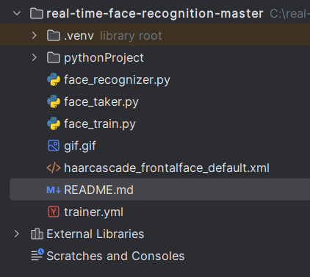

Files that the face recognition zip file contains

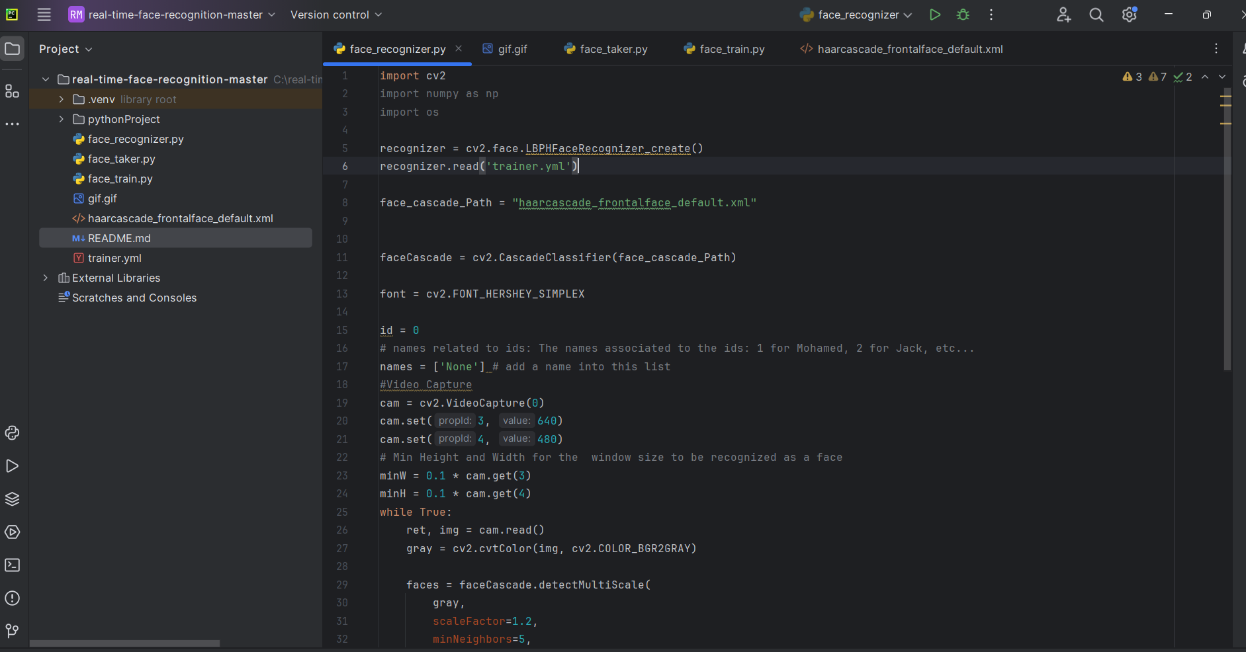

I will run this project on the Pycharm code editor

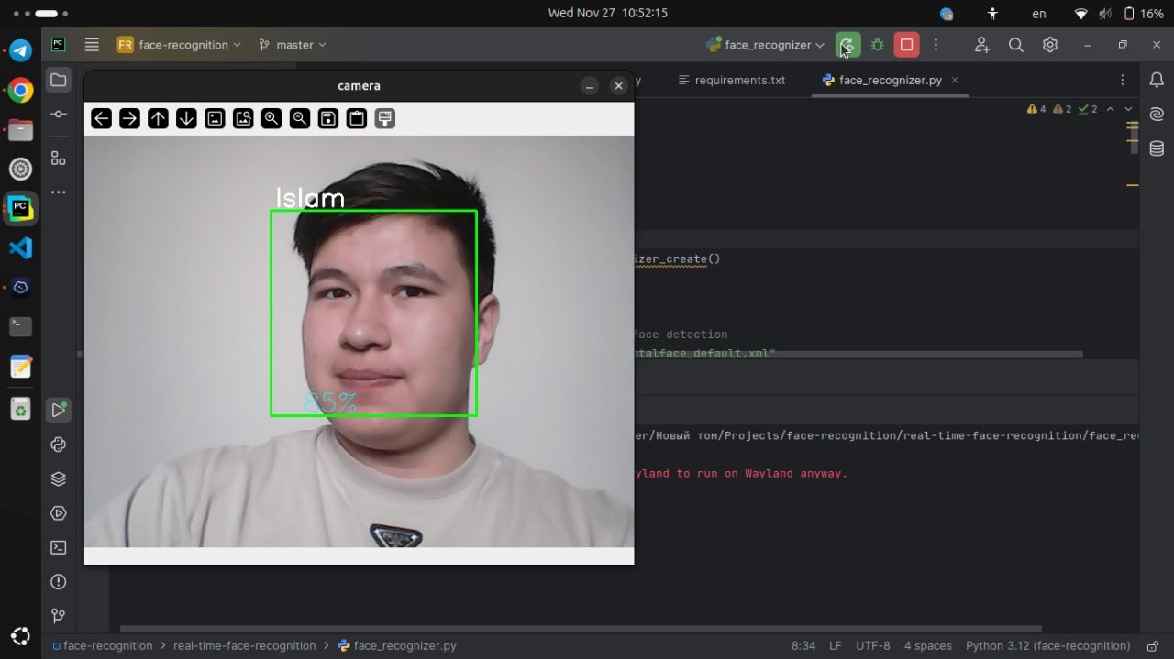

Result of launching and running the script

**Practical Work No.5**

**Topic: Implementation of biometric identification with the authentication system based on voice recognition**



Download the finished voice recognition file



Go to the project folder



Create a virtual environment

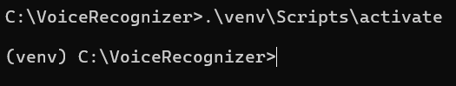

Activate the virtual environment

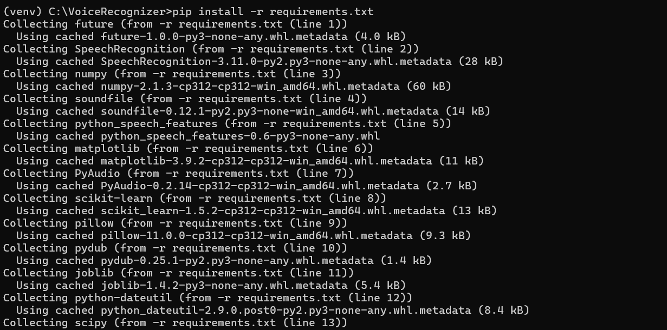

Install dependencies



Start the project

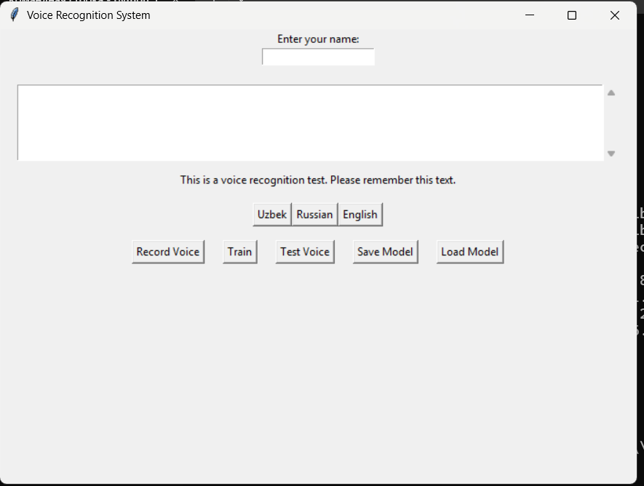

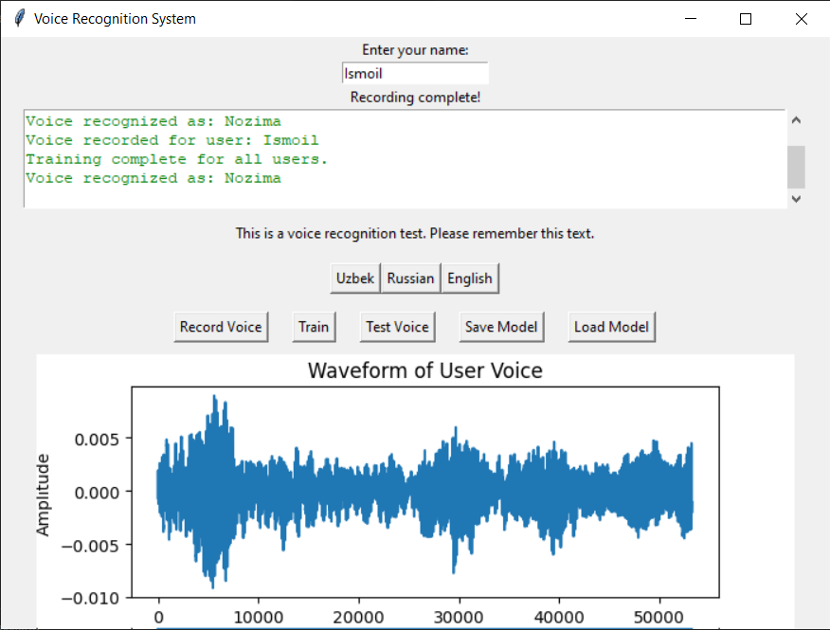

This code working perfect