POFACETS
Version 4.1 (3/15/12)

Installation
Copy the zipped file to the desired hard drive and unzip. The programs and directories shown in the figure below should be present. After the MATLAB application is started, the user must change MATLAB’s Current Directory to the directory of POFACETS. Then, POFACETS can be executed by typing pofacets at the MATLAB prompt.
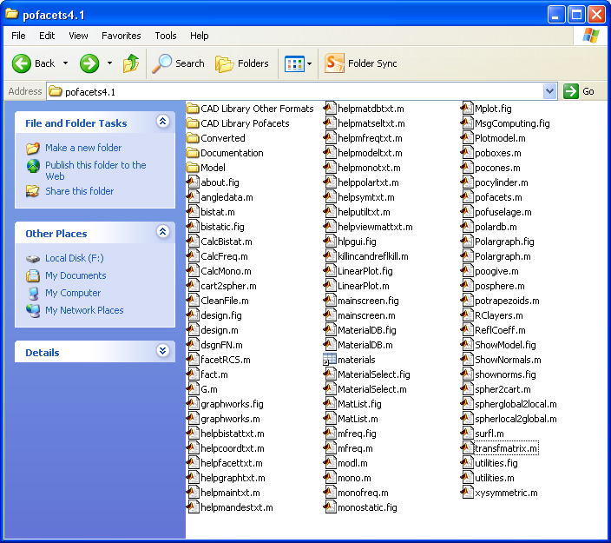

Introduction
POFACETS is an implementation of the physical optics approximation for predicting the radar cross section (RCS) of complex objects. It utilizes the scientific computational features of MATLAB and its Graphical User Interface (GUI) functions to provide an error-free encoding of input parameters and efficient calculation of RCS. POFACETS provides a convenient tool for a “first cut” at the RCS of complex shapes by representing its constituent parts by triangular facets.
The software calculates the monostatic or bistatic RCS of the object for the parameters specified by the user, and displays plots for the model geometry and its RCS. Note that POFACETS calculations do not include multiple reflections, shadowing, edge diffraction or surface waves. These contributions would have to be taken into account to accurately model a low RCS object.
Summary of Program Capabilities
A summary listing of the software capabilities follows:
- Matlab Graphical Users Interface (GUI)
- Library of common geometrical shapes readily available
- Manual Model Design capability (the model triangle nodes are entered manually)
- Graphical Model Design capability (the model is generated from basis geometrical components from the library)
- Scaling, rotation, and translation of a model or its subparts
- Merging of several existing models
- Model import capability from standard CAD packages (STL format), ACADS (facet) and triangle format.
- Bistatic or monostatic RCS calculation versus angle or frequency
- One dimensional RCS cuts or surface contours in direction cosine space
- Polar plots and RCS plots superimposed on model geometry
- (TM_{z}) or (TE_{z}) incident polarizations
- Co- and cross-polarized RCS components are computed
- Circular polarization
- Approximate diffuse RCS component can be computed for rough surfaces
- Approximate effects of an infinite ground can be included
- A user-updateable library of materials is included
- Materials layers can be applied
- Symmetry planes in a model can be defined and exploited to reduce run-time
- Open code architecture allows the user to tailor the code to specific needs
- Help functions and error checking are included for all windows
- Several sample model files are included
Major Changes for Version 3.0
Version 3.0 introduced the GUI interface and featured new options and tools for complex target design. It provided new computational capabilities, including the approximate effects of the ground, the exploitation of symmetry planes in targets, and the effects of materials and coatings.
Major Changes for Version 3.1
The major change was the implementation of the wave matrix method for computing the reflection from multilayered materials. The previous version used a transmission line equivalent model, which had some approximations with regard to multiple reflections between layers (this change originally appeared in version 3.0.1). Minor modifications to the import utilities for facet files were made to allow more variation in the files that can be read.
Changes for Version 3.2
1. CAD import and export was enhanced. STL (stereolithographic, *.stl) capability was added by incorporating freeware from the Matlab Central web page. Raw triangle files can also be read (*.raw).
2. More models have been added to the samples and examples.
3. Some bugs in subroutine facetRCS.m were removed. At some point in the software development the factors “ct2” in the monostatic section and “cti2” in the bistatic section were removed from the current density terms. In the previous versions of POFACETS there are comments on the lines noting this fact. These cosine squared factors should be put back into the second terms in parentheses. The correct expressions follow along with modified comments:
Lines 80-81: (in monostatic section of facetRCS.m)
Jx2 = (-Et2*cp2*para + Ep2*sp2*perp*ct2); % ct2 added
Jy2 = (-Et2*sp2*para - Ep2*cp2*perp*ct2); % ct2 added

Lines 228-229: (in bistatic section of facetRCS.m)
Jx2 = (-Et2*cpi2*para + Ep2*spi2*perp*cti2); % cti2 added
Jy2 = (-Et2*spi2*para - Ep2*cpi2*perp*cti2); % cti2 added

The omission of the factor does not have a significant effect in most cases. It affects the falloff in facet RCS at wide angles from the normal.
Changes for Version 4.0 and 4.1
1. A capability to calculate and plot the circularly polarized (CP) RCS was added to the Utilities.
2. The ability to display the surface normals was added to the Utilities. Version 4.1 has the normals scaled by the same factor as the model display (this was not the case for version 4.0).

Software Compatibility
The POFACETS 4.0 version is designed to run under MATLAB version 7.0 (Release 14) or later. The program will not run under MATLAB version 6.1. It appears to run in MATLAB version 6.5, but some warnings will be displayed. Most of the GUIs were generated using MATLAB guide command in version 6.5. Some GUIs were updated and saved using MATLAB version 7, so they may not work in MATLAB 6.5. In some cases the “help” text does not display. To fix this check the property inspector in the Matlab GUI editor (type “guide” in the command window) to make sure the point size is large enough to be seen.
The case sensitivity for function names is not adhered to in all instances because POFACETS originated with much earlier versions of Matlab.

RCS Calculation Methodology and Limitations
The Physical Optics (PO) approximation is one of the most convenient RCS prediction methods for an arbitrary three-dimensional target. The geometrical optics current is used over the illuminated portions of the target surface, while zero current is assumed over the shadowed portions. The current is then used in the radiation integrals to compute the scattered far field from the target. PO is a high-frequency approximation method that gives best results for electrically large bodies 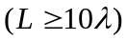 and is most accurate in the specular directions.
One approach to high frequency prediction calculations is to estimate a complex model with an array of simple shapes, such as triangular flat plates. The RCS is obtained by computing the scattered field of the collection of these simple shapes to obtain the total RCS of the target. POFACETS computes the scattering from each triangle as if it is isolated in free space. Multiple reflections, diffraction and surface waves are not included. There is a limited capability to include shadowing, which involves defining which side of a particular triangle is internal to a closed body and, hence, not allowed to be illuminated. Shadows on one part of the object cast by other parts of the object are not included.
Program Execution, Main Menu and File Directories
The POFACETS Main Menu displays the three main functions of the program:
- Model Design (Manual or Graphical)
- RCS Calculation (Monostatic or Bistatic) versus frequency or versus angle
- Utilities (conversion from/to previous POFACETS versions, import/export of models from/to commercial CAD programs, material database management)
Each of these selections invokes GUIs that contain all the necessary help files that provide to the user the necessary instructions and information to design a model and compute its RCS.
The POFACETS directory contains all the MATLAB functions, script files, figure files and data files necessary for program execution.
The Models subdirectory contains the model files that accompany the program. However, the user can save new model files to any other directory.
The Results subdirectory is an empty directory which provides a space for saving RCS computation results. However, the user can save new model files to any other directory.
The Pics subdirectory contains the JPG files of the pictures displayed in the Main Menu GUI.
Import/Export of CAD Files
The utilities include the capability to import and export the following formats:
1. Facet files (Demaco, *.dem, and ACAD, *.facet)
2. Stereolithographic files(*.stl)
3. Raw triangle files (*.raw)
The most reliable method is *.stl. All CAD software packages can handle this file format. MeshLab (http://meshlab.sourceforge.net/) is a free program that can import all file types and convert them to *.stl.
There is no way to re-mesh a model once it is imported into POFACETS. (Note it is always possible to do this manually by going into “Design Model Manually” and changing nodes and facets, but this approach is not practical for a large target.)
Tips for RCS Calculations
Curved Surfaces
The discretization of curved surfaces into triangular facets can create significant errors in the RCS calculations (referred to as facet noise, which is a type of quantization error). One approach would be to use a large number of facets to approximate a curved surface. This method yields satisfactory results in the case of singly curved surfaces, such as cylinders, with acceptable side-effects on model size and run-time. However, in the case of doubly curved surfaces, this method leads to large model sizes and long run-times.
When computing the RCS of doubly curved surfaces the user must examine the way that these surfaces were faceted and the effects the facetization could have on the RCS results. For example, it is obvious that the two sphere models shown below would have different RCS behavior, especially when taking cuts (i.e. finding RCS versus ).
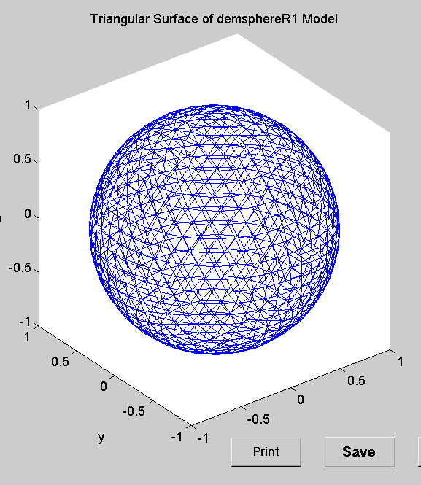 | 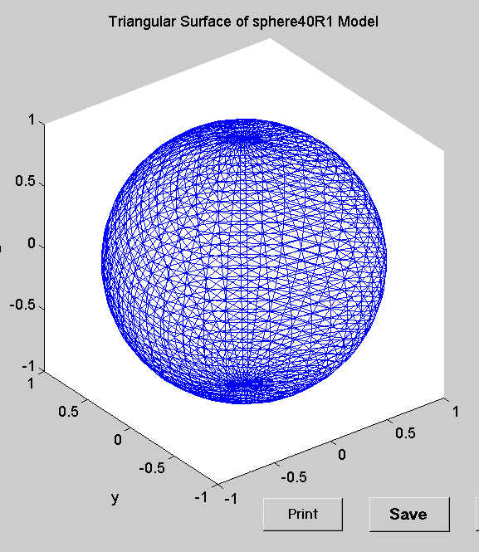
Good rules-of-thumb when designing and computing the RCS of doubly curved surfaces involve the following:
- Ensure that the object is electrically large.
- The size of the facet’s edge should be about 2.5 to 4.5 times greater than the wavelength.
- Take or cuts that will produce symmetrical results (for example, avoid cuts for the sphere shown in the right above).
- Keep the “Length of the Taylor Region” at its default value (1e-5). This value yields good results for both small and large facets.
Diffuse Calculations
One measure of the roughness of a surface is the standard deviation of its variation about the mean value. In addition, the correlation interval indicates how rapidly the surface changes as one moves along the surface. All triangles are assumed to have the same correlation interval and standard deviation. The roughness should be small in terms of wavelength (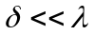). The random deviation of the surface results in diffuse scattering which yields a relatively angle independent term to the RCS. The random surface calculation has not been thoroughly validated.
Generating Zero Thickness Sheets
When surfaces are thin compared to a wavelength it may be acceptable to model them as infinitely thin sheets. There is no function to generate a polygonal sheet in the graphic mode. One can use a “box” or “trapezoid” with a height of zero. The result is 6 faces (usually 12 triangles), where the triangles on the sides have zero area. Due to the outward normal convention, the top plate scatters only when illuminated from the top and the bottom plate scatters only when illuminated from the bottom, which is correct. However, the presence of zero-area triangles slows the computation and increases data file size. A “file clean” utility that removes zero-angle triangles and duplicate nodes and triangles is planned for a future release.
Pattern Spikes
If unexplained pattern spikes occur it is generally due to numerical errors. Try reducing the Taylor Series “Length of Region” parameter. The default is 1e-5 (pattern shown below left for the “helio” model); to eliminate spikes try 1e-7 (below right) as a first step.
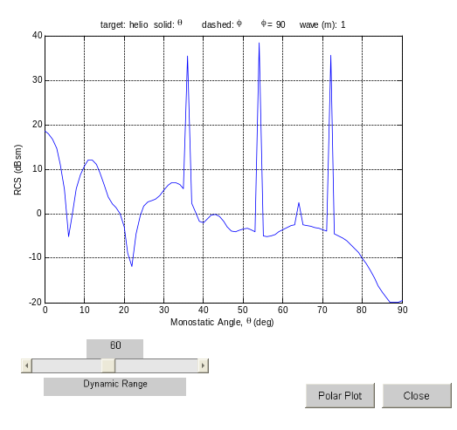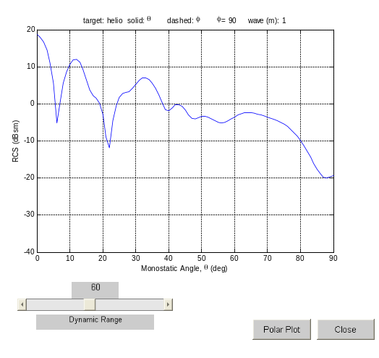
POFACETS Data File Structure
POFACETS uses two types of data files: the model files and the material database file described below.

1. Model File Structure
Each model file is comprised of the following data structures.

a. Coord
This is a data array that contains the coordinates of the vertices of the model. Each row corresponds to a vertex. The first field in each row represents the x coordinate of the vertex, the second field represents y and the third represents z.

b. Facet
This is a data array that contains the definition data for the facets of the model. Each row corresponds to a facet. The first three fields in each row represent the facet’s vertices. The sequence of the vertices defines the normal to the facet according to the right hand rule. The fourth field in each row indicates whether a facet can only be illuminated from its front side (when it contains a 1) or from both its back and front side (when it contains a 0). The fifth field in each row is the surface resistivity of the facet normalized to the impedance of free space (377 ohms).

c. Scale
This field stores the scale of the model

d. Symplanes
This is a data array that contains the points that form the symmetry planes of the model. If no symmetry planes exist, the array simply holds one row with three fields equal to zero. If symmetry planes exist, each symmetry plane is defined by three points represented by three consecutive rows. Each row contains the coordinates 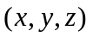 of each point. The sequence of the points defines the normal to the symmetry plane according to the right hand rule. Up to three symmetry planes (i.e., nine rows) can be stored.

e. Comments
This is a cell array that contains the description of the parts of the model to which the facets belong. Each row contains the parts description for one facet.

f. Matrl
This is a cell array that contains the material of the facets of the model. Each row of the cell array corresponds to one facet. The first cell of the array contains the description of the type of the material used on the facet. The available options here are: “PEC”, “Composite”, “Composite Layer on PEC”, “Multiple Layers”, and “Multiple Layers on PEC”. The second cell is a one–row vector. For each layer of material used, 5 columns are included in the vector. Thus, if three layers are used, the vector will have 15 columns. In each layer, the first column is the relative electric permittivity, the second column is the loss tangent, the third column is the real part of the relative magnetic permeability, the fourth column is the imaginary part of the relative magnetic permeability, and the fifth column is the thickness of the layer in millimeters.

2. Material Database File Structure
The material database file contains a struct array called materials.mat, which is comprised of the following fields.

a. Name
This field holds the name of the material.

b. er
This field holds the relative electric permittivity of the material.

c. tande
This field holds the loss tangent of the material.

d. mpr
This field holds the real part of the relative magnetic permeability of the material.

e. m2pr
This field holds the imaginary part of the relative magnetic permeability of the material.

Disclaimer
These codes were created for instructional purposes. Basic test geometries have been validated, but there is no guarantee of accuracy in all cases.

Reporting of Bugs and Suggestions for Improvement
Program “bugs” and anomalous results can be reported to the authors at the following email addresses:
jenn@nps.navy.mil
jenn@nps.edu
dcjenn@dcjenn.com

Software Support
There is no support provided for the use or installation of this software.

