1.0) AIM:
Write a program in Java3D to create a canvas in a frame with label at top & bottom.
2.0) SCOPE:
The scope of the program is to provide a basic example of how to use the Java 3D API to create a 3D scene and display it in a canvas.

3.0) FACILITIES/ APPARATUS:
i) Software: Java & Java 3d

4.0) THEORY:
Program detail
This is a Java program that demonstrates how to create a 3D scene using the Java 3D API. The program creates a canvas (a 2D window where the 3D scene is rendered), adds labels to the top and bottom of the applet, and then adds a ColorCube object to the 3D scene.
The program starts by importing the necessary classes from the Java 3D API, including SimpleUniverse, ColorCube, BranchGroup, and Canvas3D. It also imports classes from the AWT and Applet libraries.
The main class of the program is called CanvasDemo, which extends the Applet class. The constructor of the class creates a BorderLayout layout manager and creates a new instance of Canvas3D using the getPreferredConfiguration() method of SimpleUniverse. The canvas is added to the center of the layout, and labels are added to the top and bottom.
A new BranchGroup called contents is created and a ColorCube object is added to it. The SimpleUniverse class is then used to create a new 3D universe, and the contents of the BranchGroup are added to it. Finally, the viewing transform of the universe is set, and the 3D scene is rendered in the canvas.
The main method of the program sets a system property to prevent the AWT from erasing the background, creates a new instance of CanvasDemo, and displays it in a new MainFrame with a size of 400x400 pixels.

Program
import com.sun.j3d.utils.universe.SimpleUniverse;

import com.sun.j3d.utils.geometry.ColorCube;

import javax.media.j3d.BranchGroup;

import javax.media.j3d.Canvas3D;

import java.awt.GraphicsConfiguration;

import java.awt.BorderLayout;

import java.awt.Label;

import java.applet.Applet;

import com.sun.j3d.utils.applet.MainFrame;

public class CanvasDemo extends Applet {

public CanvasDemo() {

setLayout(new BorderLayout());

GraphicsConfiguration config =

SimpleUniverse.getPreferredConfiguration();

Canvas3D canvas = new Canvas3D(config);

add("North",new Label("This is the top"));

add("Center", canvas);

add("South",new Label("This is the bottom"));

BranchGroup contents = new BranchGroup();

contents.addChild(new ColorCube(0.3));

SimpleUniverse universe = new SimpleUniverse(canvas);

universe.getViewingPlatform().setNominalViewingTransform();

universe.addBranchGraph(contents);

}

public static void main( String[] args ) {

System.setProperty("sun.awt.noerasebackground", "true");

CanvasDemo demo = new CanvasDemo();

new MainFrame(demo,400,400);

}

}
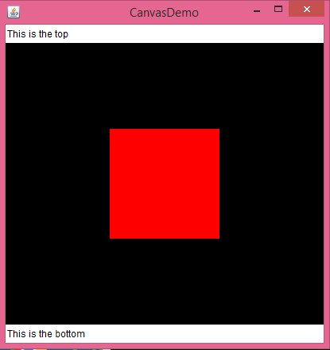
5.0) Conclusion:
It demonstrates how to add objects to a BranchGroup, create a SimpleUniverse, and set the viewing transform. The program can be used as a starting point for more complex 3D applications.

