**Preparation**

You typically need to install matlab MCR to run starrynite in its compiled form <http://www.mathworks.com/products/compiler/mcr/>

You want version 8.0 for the current compiled version, if this isn’t right the error message when trying to run it will tell you the version you need to download.

Note that on a PC a reboot is usually necessary for MCR to be loaded.

To run acetree you will usually need the oracle Java rather than standard windows java

<http://www.oracle.com/technetwork/java/javaseproducts/downloads/index.html>

You’ll also need to install Java3D,

For 64 bit pc java, you need the AMD64 version of Java3D. Download the zip binary version. Copy the bin and lib directories in the zip onto the matching directories in your java runtime and/or jdk.

e.g.

C:\Program Files\Java\jdk1.7.0_25

C:\Program Files\Java\jdk1.7.0_25\jre

C:\Program Files\Java\jre1.7.0_25

**Running Starrynite**

Double click StarryniteIII_july_2014.exe

The Order of steps doesn’t matter but tiff radio button needs to be set before choosing the image.

Set start/end time (I would strongly recommend testing on only 3-5 frames the first time you try this to avoid waiting a long time to find something breaks or your parameters are wrong)

Select Simple Tiff radio button

Make sure ‘make 8 bit tiff slices’ radio button is marked if this is first time analyzing this data set

Click on browse by ‘base parameter file name:’ and select provide param file ‘detection_parameters-tiffdata.txt’

Click browse by ‘output directory:’ and select directory for acetree file output

Click browse near ‘image name’ select any image from the series to analyze

Draw a loose circle around the embryo, closing it by clicking on first point

Click run

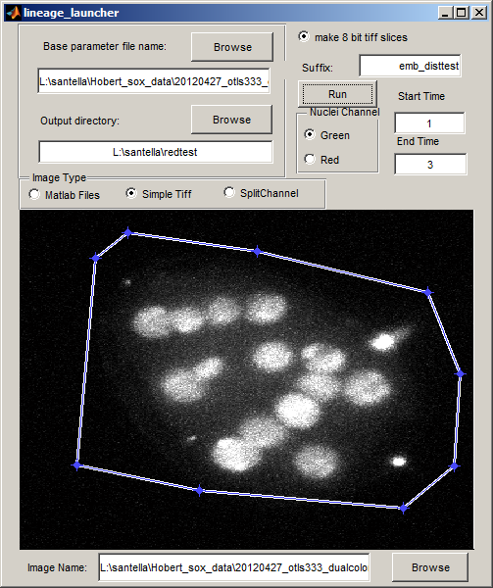

Should output 8 bit slices in format expected by acetree, and acetree zip and xml files

These will include two copies of identical content one suffixed –edited the _edited one will have an auxinfo file accompanying. See Lineage_Editing_Notes.doc for instructions on how to edit this file and the lineage to ensure accurate Sulston naming.

**Running AceTree**

The AceTree.jar can be clicked on to run it, but to test a new installation or debug problems run it from a terminal window. On Mac, linux, cygwin type: ‘cd [full path to directory where acetree.jar is]’ e.g. ‘cd c:/acetree/. On windows terminal type ‘[driveletter]:’ e.g. ‘C:’ then type cd [full path minus drive letter to acetree.jar] e.g. ‘cd acetree\’

On all platforms type ‘java –jar AceTree.jar’

Launch the 3D window to test java3D, even if you don’t need the 3D window you need java3D as computation of cannonical *C. elegans* names depends on Java3D vector math libraries.

**Editing Lineages with Acetree**

*note this is a brief general overview of editing tools see Lineage_Editing_Notes.doc for details of establishing correct systematic cell names.

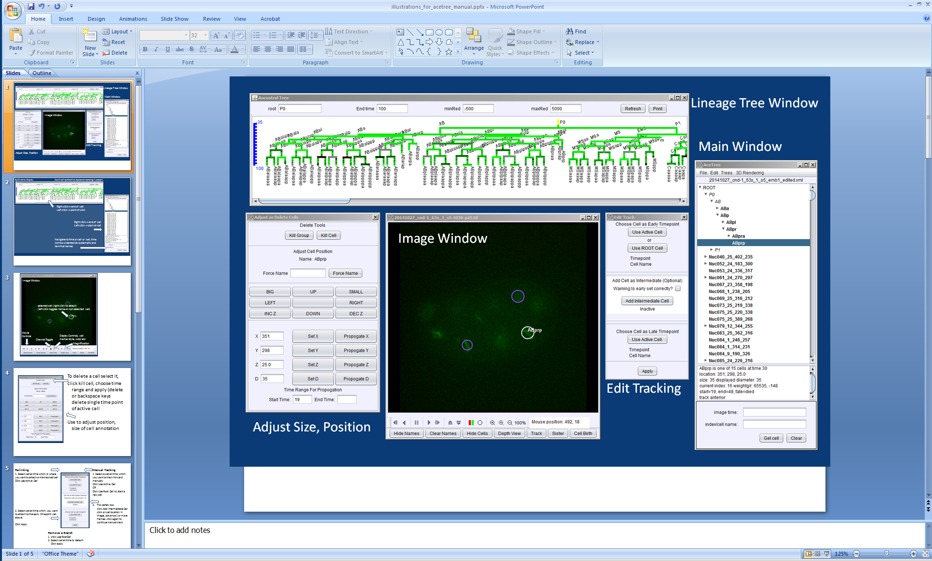

Overview of Acetree UI

Navigation

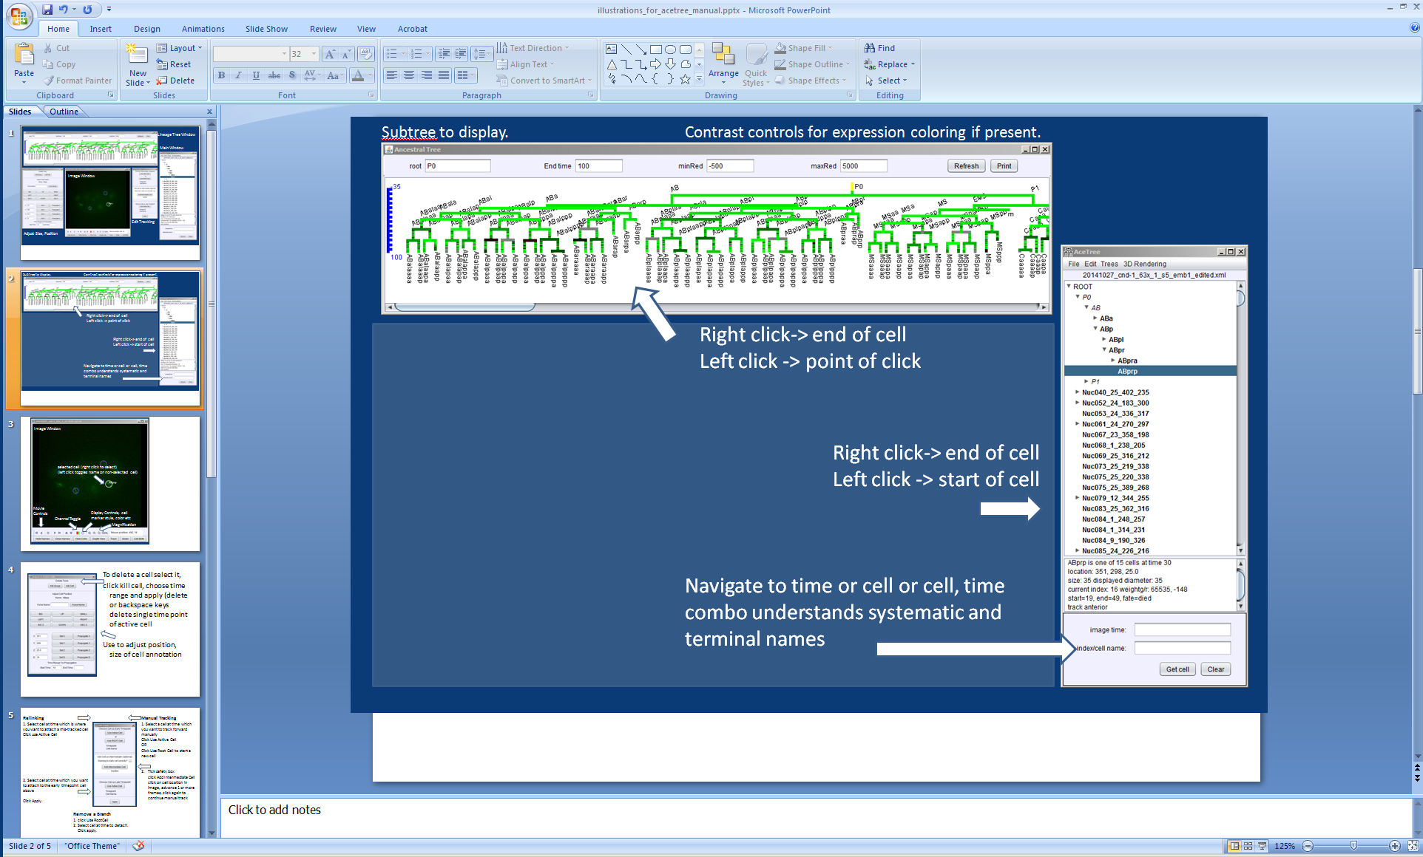

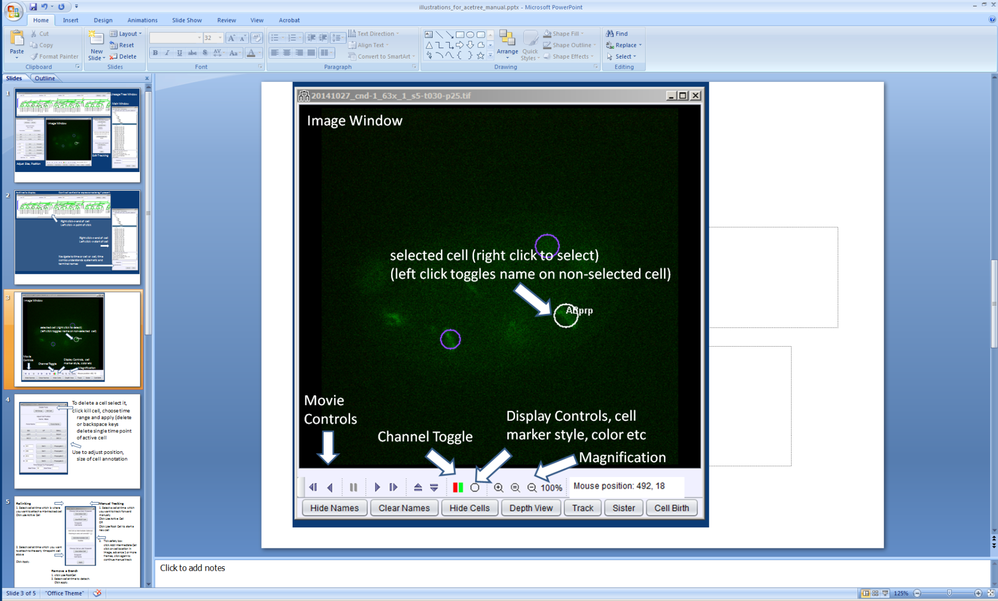

Navigation is done either via the lineage views or by directly moving in space and time in the image window.

Editing. Edit tools are found under the file menu Edit->edit tools

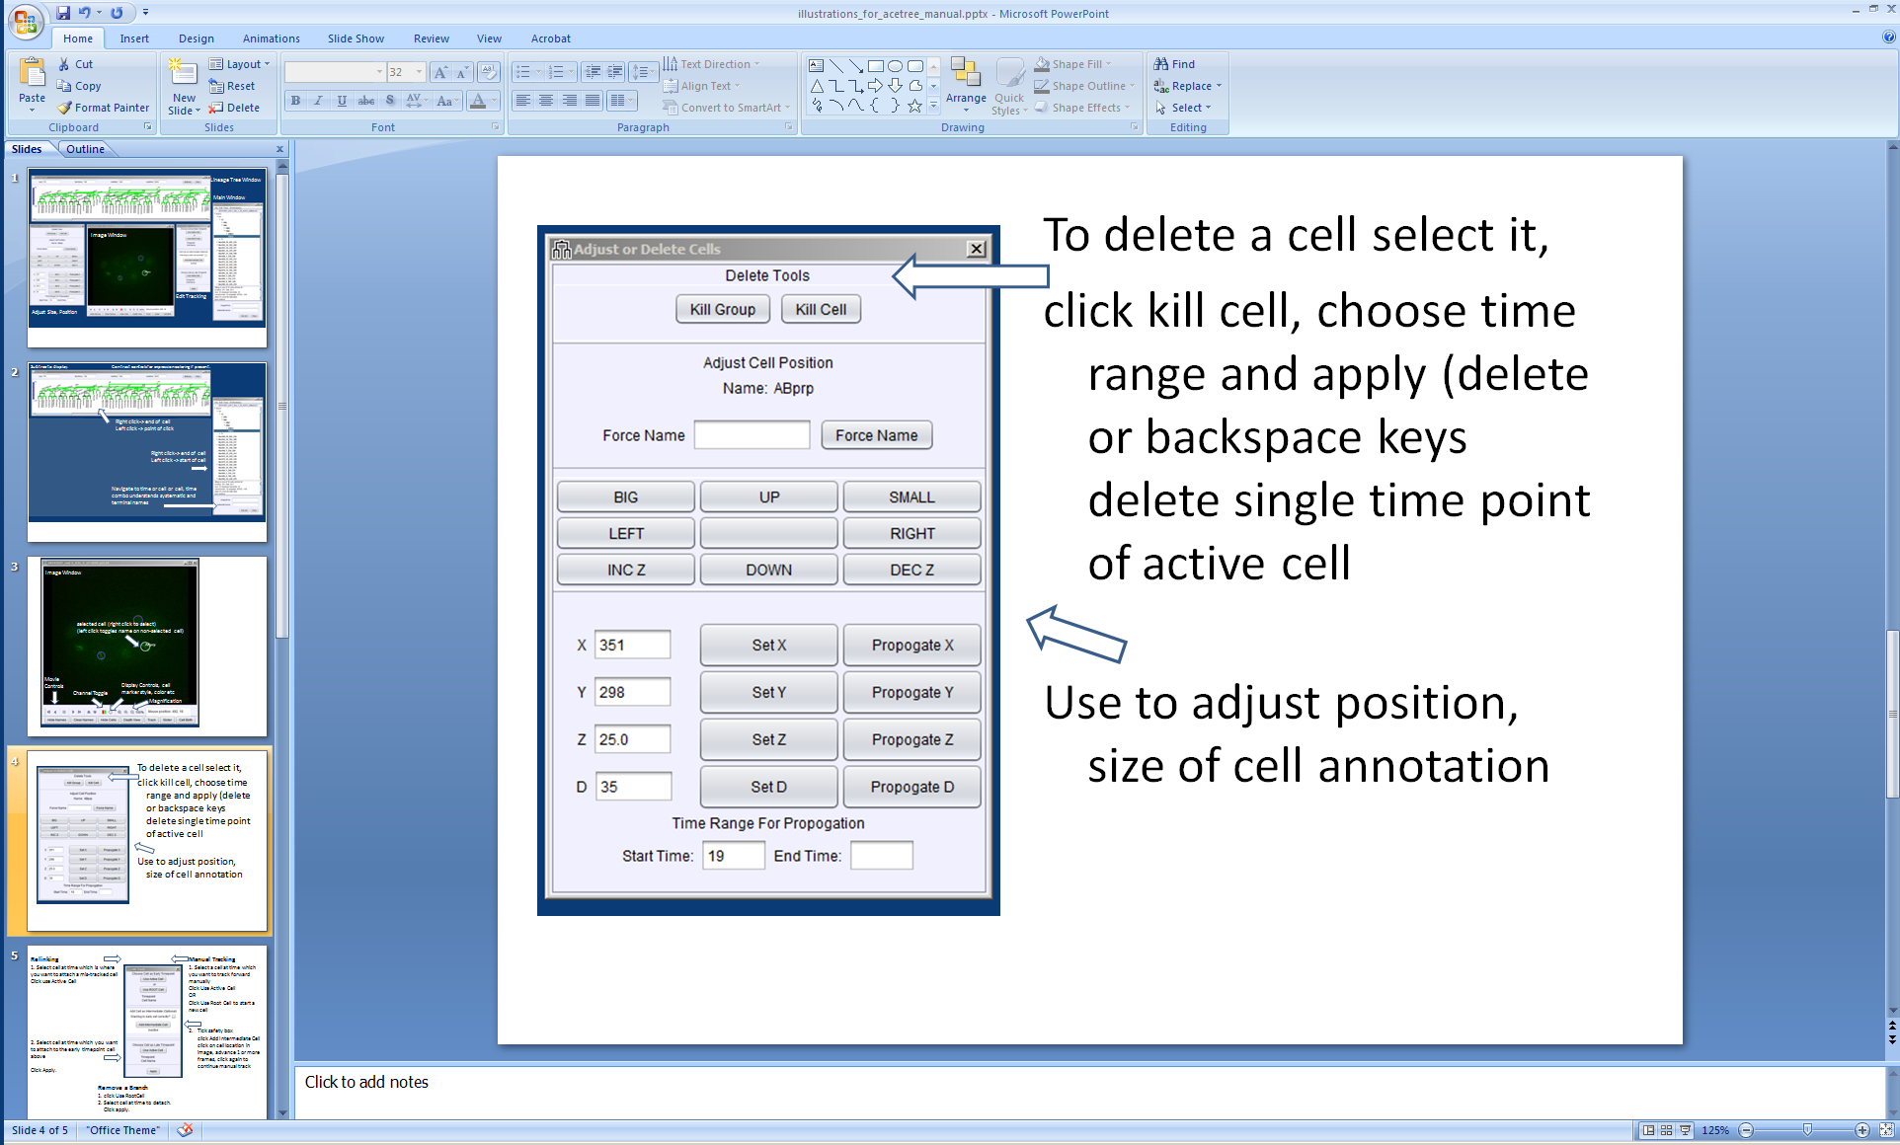

The active cell can be deleted, resize and repositioned using this dialogue

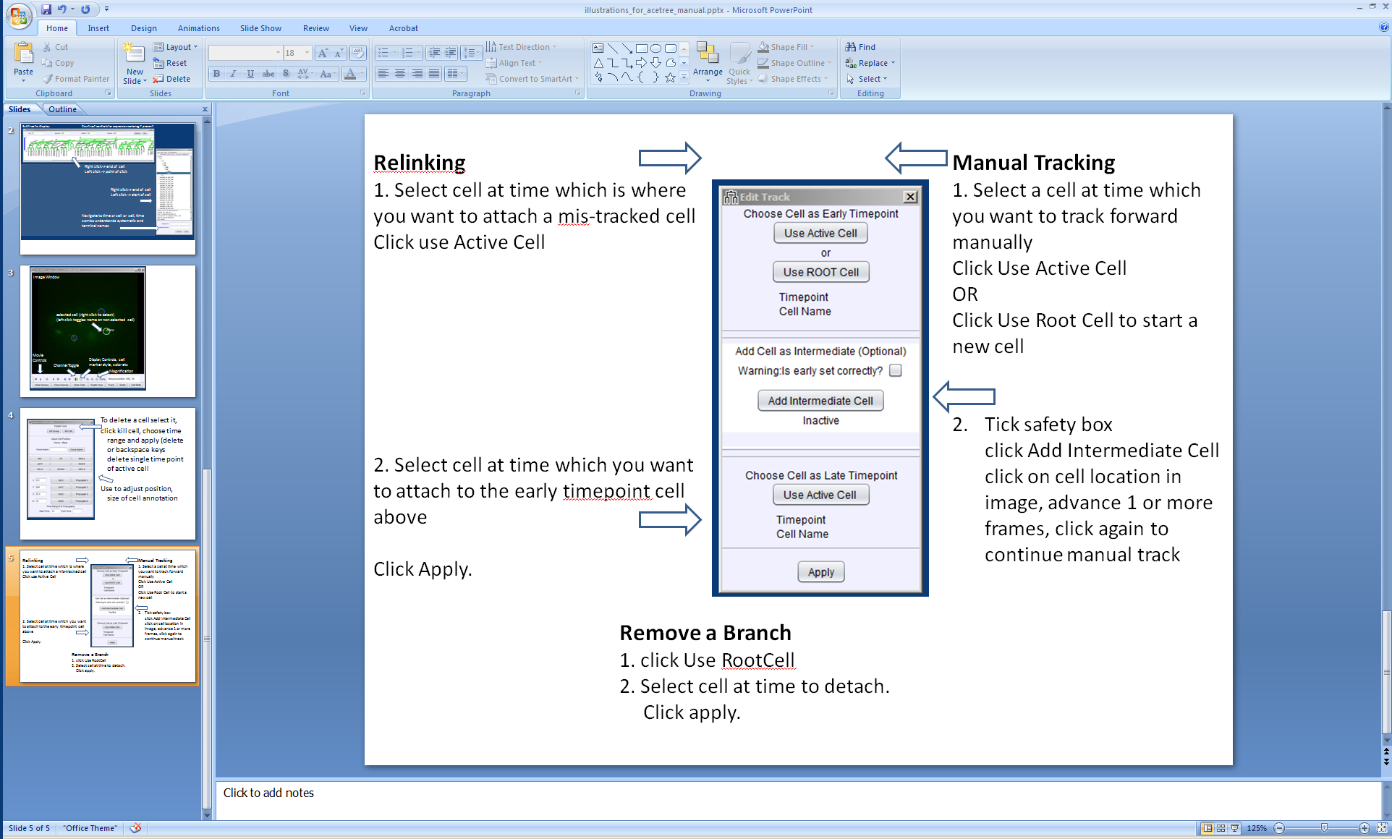

Editing involves searching for errors either via the list of Nuc entries in the main window (each Nuc after the first frame is a cell Starrynite cannot place in the lineage if doing in toto imaging), or looking for topological errors in the Lineage Tree window. Once found these are relinked with the lineage dialogue. Each cell detection (a circle in the image window) can be thought of as a bead that Starrynite has tried to string together with all the others into the complete lineage.

Relinking involves only the top and bottom panels in the Edit Track dialogue, setting the early cell as the last correctly tracked cell, and the late cell as the cell which should be attached to it. If an incorrect cell is attached to the point as well this has to be removed following (before or after) the steps for removing a branch above. If the correct link is made first the result will be a false division in the lineage and the incorrect daughter needs to be removed.

Typically it is simplest to begin in the first frame edit cells found in the Nuc list to a given time point, figuring out where each should go. Then the lineage tree can be checked for implausible divisions or additional lost tracks. This process is then iterated for a later window of time.

Adding a cell manually. Select and choose use active cell in early time box if you want to extend an existing cell manually. Select use root cell in early to start an entirely new cell. Click the safety tick box in the add cell as intermediate (optional) panel, click the add cell button in the same panel. (the panel will read active in red) Move to the location/time you want to add the cell and click in the image window. Move forward in time and repeat as desired.

Visualization   
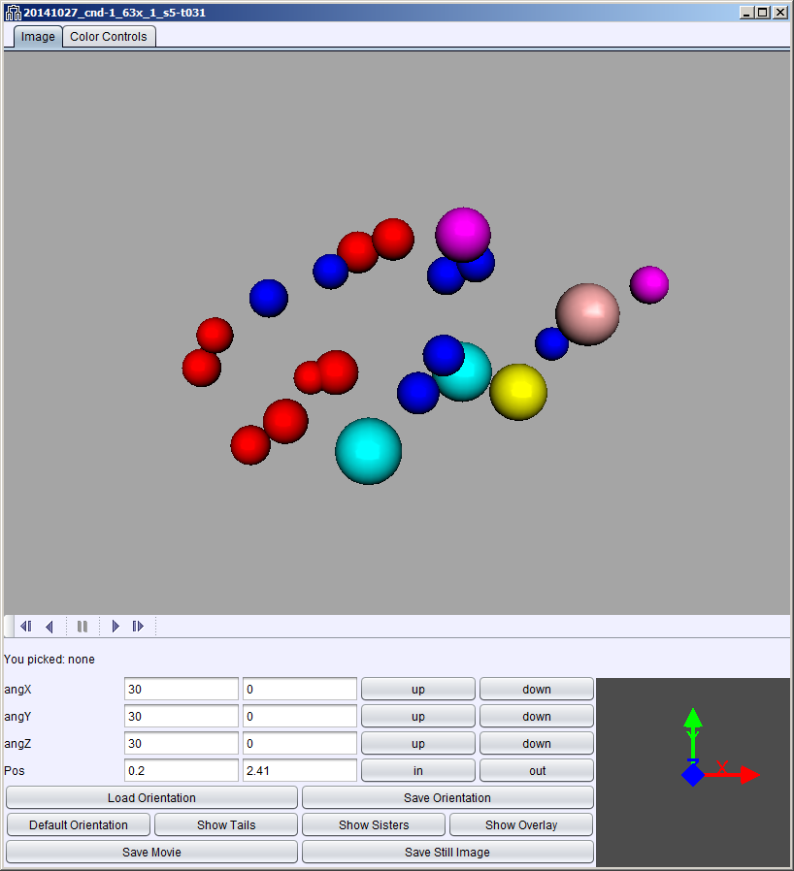 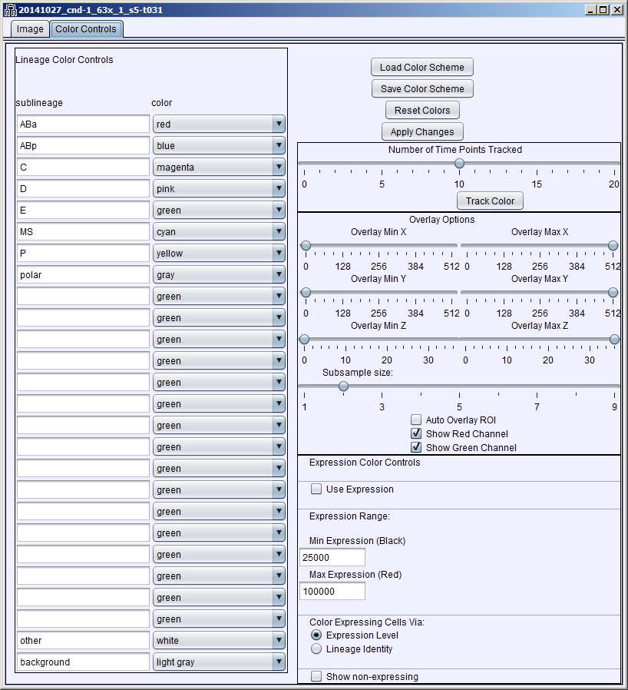

3D window and Color Control tab for 3D window

Controls can load and save color schemes, superimpose image data on the 3D model.

Color control window allows colors to be specified for a sublineage, and to change between lineage and expression data based coloring (when expression information is present in lineage zip file).