EliteFix Solutions: A Full-Stack Web Application with Express.js and MongoDB Integration
[Mohsin Abid 037, M. Abubakar 084], [WEB ENGr], [USKT]
Abstract— This report documents the design and implementation of the complete EliteFix Solutions web application, extending the client-facing single-page application described in the previous deliverable with a full server-side implementation. The system now consists of a Vue 3 frontend and a Node.js/Express.js backend connected to a MongoDB database via Mongoose, communicating through a versioned REST API. The backend introduces persistent storage for quote requests and contact submissions, a password-protected administrative panel secured with JSON Web Token (JWT) authentication and bcrypt password hashing, and full CRUD (Create, Read, Update, Delete) management of the services offered by the company. This report describes the client-server architecture, the technology stack, the MongoDB schema design, the REST API design, the authentication and authorization model, the frontend component and routing structure, and the end-to-end data flow connecting the two halves of the system. The report concludes with an evaluation of the current implementation and recommendations for future work.
Index Terms— Express.js, MongoDB, Mongoose, RESTful API, JSON Web Token (JWT) Authentication, bcrypt, Vue.js, Full-Stack Web Application, Client-Server Architecture.

I. INTRODUCTION
The previous deliverable in this project presented EliteFix Solutions as a client-only single-page application: a Vue 3 frontend that presented the company's six service lines and collected quote requests through forms whose submissions were logged to the browser console rather than persisted anywhere. That implementation demonstrated component-based UI design and client-side routing, but it had no server, no database, and no mechanism for the business to actually review or manage the requests it received.
This deliverable completes the system by introducing a Node.js and Express.js backend connected to a MongoDB database, and by adding a password-protected administrative panel through which staff can review quote requests and contact messages and manage the list of services shown to visitors. The frontend and backend are organized as two sibling directories, /client and /server, within a single repository, communicating exclusively through a REST API over HTTP.
The remainder of this report is organized as follows. Section II describes the overall client-server architecture. Section III details the expanded technology stack. Section IV documents the MongoDB schema design. Section V describes the design of the Express.js REST API. Section VI explains the authentication and authorization model built around JSON Web Tokens. Section VII documents the frontend component design. Section VIII describes the routing structure across both the public site and the administrative panel. Section IX traces the end-to-end data flow that connects the frontend to the database. Section X presents the results, and Section XI concludes with recommendations for future work.
II. SYSTEM ARCHITECTURE
The system follows a conventional three-tier client-server architecture. The presentation tier is a Vue 3 single-page application served by the Vite development server (and, in production, as a static build). The application tier is a Node.js process running an Express.js REST API, responsible for validating requests, enforcing authentication, and mediating all access to the data tier, which is a MongoDB database accessed through the Mongoose object-document mapper. Unlike the previous deliverable, in which components held their own data as hardcoded arrays, all persistent data in the current system originates from the database and reaches the frontend exclusively through HTTP requests to the API.
The two halves of the system are deliberately decoupled: the frontend has no direct knowledge of MongoDB, and the backend has no knowledge of Vue. They agree only on the shape of the JSON payloads exchanged over a small, versioned set of REST endpoints, described in Section V. This separation allows either half to be modified, rebuilt, or even replaced independently, provided the API contract between them is preserved.
A second architectural addition is the administrative panel, which is not a separate application but an authenticated subset of routes within the same Vue application (under the /admin path) that call a protected subset of the same API (under Authorization: Bearer <token>). Section VI describes how this protection is enforced on both sides of the system.
III. TECHNOLOGY STACK
Table I summarizes the technologies used across both halves of the system. The frontend technologies carried over from the previous deliverable; the backend row group is new to this deliverable.
TABLE I
TECHNOLOGY STACK SUMMARY
Layer | Technology | Role in the System
Frontend framework | Vue 3 (Composition API) | Reactive UI rendering and component composition.
Client-side routing | Vue Router | Path-to-view mapping, including navigation guards for admin routes.
HTTP client (admin) | Axios | Requests from the admin panel to the API, with request/response interceptors for JWT handling.
HTTP client (public forms) | Fetch API | Quote and contact form submissions to the API.
UI styling | Scoped CSS; Bootstrap 5 (admin panel) | Component-isolated styling; admin panel tables and forms.
Backend runtime | Node.js | JavaScript execution environment for the server.
Backend framework | Express.js | HTTP routing and middleware pipeline for the REST API.
Database | MongoDB | Document-oriented persistent storage.
Object-document mapper | Mongoose | Schema definition, validation, and querying against MongoDB.
Authentication | jsonwebtoken (JWT) | Stateless, signed tokens identifying an authenticated admin session.
Password hashing | bcrypt | One-way hashing of administrator passwords prior to storage.
Request validation | express-validator | Server-side validation of every write request, independent of client-side checks.
Abuse prevention | express-rate-limit | Request-rate limiting on public forms and, more strictly, on the login endpoint.
Cross-origin access control | cors | Restricts which origins may call the API.

Express.js was selected for its minimal, middleware-oriented design, which maps naturally onto the Model-View-Controller pattern adopted for the backend (Section V). Mongoose was adopted over the native MongoDB driver because its schema layer provides declarative validation, default values, and type coercion at the application boundary, reducing the amount of manual validation logic required in each controller. JSON Web Tokens were chosen over server-side sessions because they allow the API to remain stateless: no session store is required, which simplifies deployment at the scale of this project.
IV. DATABASE DESIGN
The database is organized into four MongoDB collections, each defined through a Mongoose schema: quotes, contacts, admins, and services. All four schemas are configured with Mongoose's automatic timestamps option, so every document records the moment it was created and last modified without any manual bookkeeping in application code.
A. Quotes and Contacts Collections
The quotes collection stores every submission from the public "Request a Quote" form: the customer's name, email, phone number, service location, the selected service (constrained to a fixed enumeration of the company's six service lines), a free-text message, and a status field used internally to track follow-up (new, contacted, or closed). The contacts collection stores general enquiries from the Contact page with a similar shape, but without a location field and with a status vocabulary suited to a simpler enquiry workflow (new, read, or closed). These were kept as two separate collections, rather than a single unified "leads" collection, because they represent two distinct business processes with different required fields and different follow-up semantics; separating them keeps each schema minimal and keeps the corresponding administrative views focused on a single task.
B. Admins Collection
The admins collection stores administrator accounts used to authenticate into the management panel. Each document holds a name, a unique email address, and a hashed password. The password field is marked with Mongoose's select:false option, which excludes it from the result of any query unless explicitly requested, so that an accidental "return the whole document" response can never leak a password hash to the client. A pre-save hook on the schema automatically hashes the password with bcrypt whenever it is set or changed, so plaintext passwords never reach the database in the first place.
C. Services Collection
The services collection stores the list of services displayed to visitors and is the one collection whose contents can be modified directly through the administrative panel rather than only through customer-facing form submissions. Each document holds a name, a description, an icon field that may hold either a Font Awesome icon class or an image URL, and an optional price.
TABLE II
DATABASE SCHEMA SUMMARY
Collection | Key Fields | Notes
quotes | name, email, phone, location, service, message, status | service restricted to a fixed enum; status defaults to "new".
contacts | name, email, phone, service, message, status | Lighter-weight schema for general enquiries.
admins | name, email (unique), password | Password hashed with bcrypt via a pre-save hook; excluded from query results by default.
services | name, description, icon, price | The only collection editable through the admin panel; price is optional.

V. BACKEND API DESIGN
The backend follows a conventional Model-View-Controller organization, adapted for an API with no server-rendered views: models define the Mongoose schemas described in Section IV; controllers contain the business logic for each operation; routes map HTTP verbs and URL paths to controller functions; and middleware functions handle cross-cutting concerns such as validation, authentication, and rate limiting before a request reaches its controller.
A. Request Pipeline
Every incoming request passes through a fixed pipeline before reaching application logic: JSON body parsing, a CORS check against an allow-listed origin, a rate limiter (applied generally to the public quote and contact endpoints, and more strictly to the admin login endpoint to slow down brute-force attempts), and finally route-specific middleware such as field validation or JWT verification. A global error-handling middleware sits at the end of the pipeline, ensuring that unexpected failures return a generic response rather than leaking internal error details or stack traces to the client.
B. Endpoint Design
The API is organized into four resource groups. Table III lists the complete route map, distinguishing endpoints that are open to the public from endpoints that require an authenticated administrator.
TABLE III
REST API ROUTE MAP
Method | Endpoint | Access | Purpose
POST | /api/quotes | Public | Submit a quote request.
GET | /api/quotes | Admin | List quote requests, with optional search.
PATCH / DELETE | /api/quotes/:id | Admin | Update status of, or remove, a quote.
POST | /api/contact | Public | Submit a contact message.
GET / PATCH / DELETE | /api/contact | Admin | Manage contact messages.
POST | /api/admin/login | Public | Authenticate and receive a JWT.
GET | /api/admin/me | Admin | Validate a stored token.
GET | /api/admin/stats | Admin | Aggregate dashboard counts.
GET | /api/services | Public | List services shown on the public site.
POST / PATCH / DELETE | /api/services/:id | Admin | Manage services.

Input validation is performed independently of the frontend, using express-validator rule chains attached to each write endpoint. This is a deliberate defense-in-depth measure: because a client-side form can be bypassed entirely by sending a request directly to the API, every field accepted by a POST or PATCH endpoint is re-validated on the server for presence, type, length, and, where applicable, membership in an allowed set of values.
VI. AUTHENTICATION AND AUTHORIZATION
Access to the administrative panel is protected using JSON Web Tokens, a stateless authentication scheme in which the server signs a compact, tamper-evident token containing the administrator's identifier and an expiry date, rather than storing a session on the server itself.
A. Login Flow
When an administrator submits credentials, the server looks up the corresponding account by email, retrieves its normally-hidden password hash, and compares the submitted password against it using bcrypt's constant-time comparison function. If the credentials are valid, the server signs a JWT containing the administrator's identifier and returns it to the client, which stores it in browser local storage. If they are invalid, the server returns the same generic error message regardless of whether the email or the password was incorrect, which prevents the login form from being used to determine which email addresses have registered accounts.
B. Request Authorization
On every subsequent request to a protected endpoint, the client attaches the stored token in an Authorization header. A dedicated middleware function on the server verifies the token's signature and expiry, loads the corresponding administrator record, and attaches it to the request object for the controller to use; a request with a missing, malformed, expired, or otherwise invalid token is rejected before it reaches any controller logic.
C. Two Layers of Enforcement
Protection is implemented at two layers, and both are necessary. On the client, a navigation guard checks for the presence of a token before rendering an administrative page, which prevents the interface from flashing content the user should not see. On the server, the middleware described above is the actual security boundary: it re-verifies the token on every request regardless of what the client believed, so that even a request sent directly to the API, bypassing the frontend entirely, cannot access protected data without a valid token.
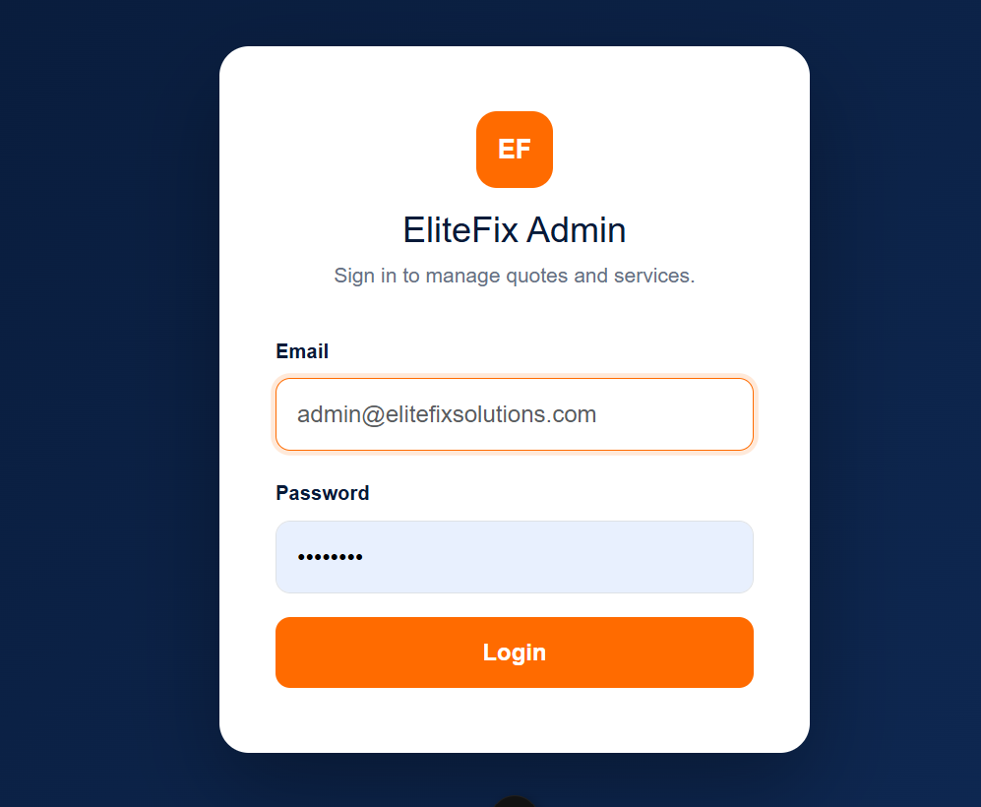
Fig. 1. Admin login screen and, after authentication, the protected dashboard view.
VII. FRONTEND COMPONENT DESIGN
The frontend retains the component structure established in the previous deliverable — reusable presentational components composed into full pages — and extends it with a small set of components specific to the administrative panel.
TABLE IV
SELECTED FRONTEND COMPONENTS
Component | Responsibility
ServicesSection.vue | Homepage service grid; now fetches admin-managed services from the API in addition to the six built-in service lines.
ServiceCard.vue | Reusable, props-driven service card; extended to render a fallback icon when a service has no associated image.
RequestQuoteSection.vue / RequestQuote.vue | Quote-request forms; now submit to the live API instead of logging to the console.
AdminLogin.vue | Credential form; authenticates against the API and stores the returned token.
AdminDashboard.vue | Summary statistics retrieved from the API's aggregate endpoint.
AdminQuotes.vue | Searchable table of submitted quotes, with delete functionality.
AdminServices.vue | Form and grid for creating and deleting services.
AdminSidebar.vue | Persistent navigation for the administrative panel.

The service-calling layer introduced in this deliverable (api.js and axiosClient.js) is the component through which every other component reaches the backend; no view component constructs an HTTP request directly, which keeps the endpoint URLs and authentication logic in one place rather than duplicated across the codebase.
VIII. ROUTING AND PAGE STRUCTURE
Client-side routing continues to use Vue Router's createWebHistory mode. The route table has grown from the twelve public routes documented in the previous deliverable to include four additional administrative routes, three of which are protected by a navigation guard that redirects an unauthenticated visitor to the login page.
TABLE V
ADMINISTRATIVE ROUTE ADDITIONS
Path | Component | Guard
/admin/login | AdminLogin.vue | Redirects to dashboard if already authenticated.
/admin/dashboard | AdminDashboard.vue | Requires a valid session.
/admin/quotes | AdminQuotes.vue | Requires a valid session.
/admin/services | AdminServices.vue | Requires a valid session.

As noted in Section VI, this guard checks only for the presence of a stored token; the validity of that token is re-checked on the server on every API request, and an invalid or expired token is caught there rather than at the routing layer.
IX. SYSTEM INTEGRATION AND DATA FLOW
This section traces two representative request cycles end to end, to illustrate how the previously independent frontend now depends on the backend and database for all persistent data.
A. Quote Submission
A visitor completes the quote-request form, which is bound to a reactive form object through Vue's v-model directive. On submission, the frontend issues an HTTP POST request to the /api/quotes endpoint. The request passes through the server's rate limiter and validation middleware before reaching the quote controller, which persists a new document to the quotes collection with an initial status of "new" and returns the saved record. The frontend then displays a success state and clears the form. This entire flow replaces the previous deliverable's console.log placeholder with genuine persistence.
B. Administrator Managing Services
An authenticated administrator submits a new service through the administrative panel, which sends an authenticated POST request to /api/services. Once persisted, that service becomes visible to the public not through any direct link between the admin panel and the homepage, but because the homepage independently issues its own GET request to the same, publicly accessible /api/services endpoint each time it loads. This indirection — writer and reader never communicating except through the shared database — is characteristic of REST API design and means a newly added service becomes visible to visitors the next time they load or refresh the relevant page.
X. RESULTS
The resulting system delivers a working full-stack application in which every quote request and contact submission is persisted to MongoDB rather than discarded at the browser, and in which a non-technical administrator can review that data and manage the list of services offered on the public site without editing source code. The REST API exposes seventeen endpoints across four resource groups, eight of which require authentication.
During the review that produced this report, one gap was identified and corrected: the contact-message management routes had not been protected by the authentication middleware applied to the equivalent quote and service routes, which would have allowed unauthenticated access to submitted contact details. This has since been corrected, bringing all administrative routes under consistent protection.
The public-facing pages remain visually and structurally consistent with the previous deliverable; the principal change visible to an end user is that the site's service list can now grow beyond the original six entries, and that submitted forms produce a genuine confirmation rather than a browser alert.
XI. CONCLUSION AND FUTURE WORK
This report has described the extension of the EliteFix Solutions system from a client-only prototype into a complete full-stack application, adding an Express.js REST API, a MongoDB database with a four-collection schema, JWT-based authentication, and an administrative panel. The system now demonstrates request validation, stateless authentication, and a clear separation of concerns between presentation, application, and data tiers.
Several improvements are recommended for future iterations:
- Add an administrative interface for reviewing contact messages, which are now stored and protected on the server but not yet exposed in the admin panel's navigation.
- Give services added through the admin panel their own dedicated detail pages, matching the six built-in service lines, rather than linking to the general quote-request form.
- Introduce refresh tokens or a token-revocation mechanism, so an administrator session can be invalidated server-side rather than relying solely on token expiry.
- Adopt Pinia, which remains installed but unused, for shared client-side state such as the authenticated administrator's profile.
- Add automated tests covering the validation rules and authentication middleware described in Sections V and VI.
Implementing these recommendations would further harden the system for production use while preserving the architecture established in this deliverable.
REFERENCES
[1] Vue.js Documentation, "Introduction," Vue.js. [Online]. Available: https://vuejs.org/guide/introduction.html
[2] Vue Router Documentation, "Getting Started." [Online]. Available: https://router.vuejs.org/
[3] Express.js Documentation, "Express - Node.js web application framework." [Online]. Available: https://expressjs.com/
[4] MongoDB, Inc., "MongoDB Documentation." [Online]. Available: https://www.mongodb.com/docs/
[5] Mongoose Documentation, "Guide." [Online]. Available: https://mongoosejs.com/docs/guide.html
[6] Internet Engineering Task Force, "RFC 7519: JSON Web Token (JWT)." [Online]. Available: https://datatracker.ietf.org/doc/html/rfc7519
[7] OWASP Foundation, "Password Storage Cheat Sheet." [Online]. Available: https://cheatsheetseries.owasp.org/cheatsheets/Password_Storage_Cheat_Sheet.html
[8] Font Awesome, "Font Awesome Free." [Online]. Available: https://fontawesome.com/

