第8章 实战2：自动将指定电子邮件标记为已读

Chapter 8 Practice 2: Mark user specific emails as read automatically

8.1 电子邮件

8.1 Mail
电子邮件是互联网时代最受欢迎的沟通渠道之一，很多人每天都会收发邮件。虽然AppStore上有很多优秀的邮件App可供选择，如Sparrow、Inbox等，但论及与iOS的整合度，终究没有原生邮件客户端（以下简称Mail）那样高，因此在笔者的日常使用中，Mail仍是首选。
Email is one of the most popular channels for communication in the era of Internet. Many people send and receive emails every day. Although there are lots of good email Apps on AppStore, such as Sparrow, Inbox, etc, they are not as highly integrated as the stock Mail App (hereafter referred to as Mail). Therefore, Mail is still the top choice during my daily life.
在我们日常收到的邮件里，很大一部分是没有太多价值的“订阅”邮件——它们要么是活动通知，要么是软文广告——这些邮件都是我们在各种网站上无意间勾选“订阅”而收到的，如图8-1所示。
Among all emails we receive every day, most of them are valueless subscription emails like notifications and advertisements, which comes from our inadvertently clicks of subscriptions on various websites, as shown in figure 8-1.
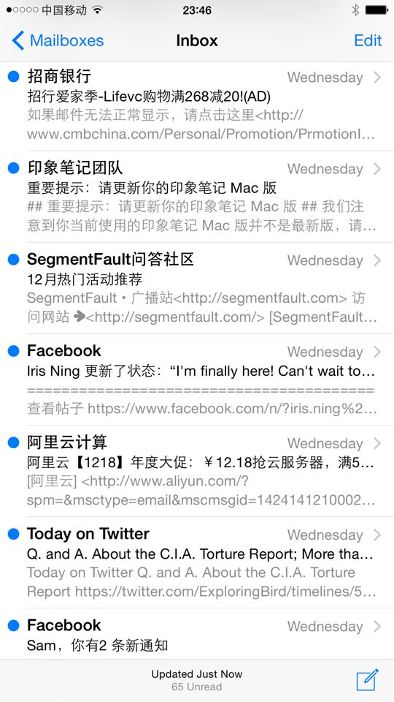
Figure 8- Mail
这类邮件很让人纠结。它们不算严格意义上的垃圾邮件，却容易分散我们的注意力；可是把它们标记为垃圾邮件吧，又有可能错过有价值的信息。那么该怎样处理这一类介于正常邮件和垃圾邮件之间的邮件呢？笔者有一个想法：给Mail加一个白名单功能，把常用联系人加入白名单；来自白名单以外的邮件全都自动标记为已读，这样就能在不遗漏信息的情况下突出重点，如图8-2所示。
These emails always make me entangled. If we are kind enough to not think of them as spam messages, they are actually distracting our attention. However, if we mark them as spam messages, we may miss some useful information. So how to deal with these messages can be a real headache. I have an idea that we can add a whitelist feature for Mail, which contains our frequent contacts. Other emails outside whitelist will be marked as read automatically. With this solution, we can highlight the most valuable messages while not missing any useful information, as shown in figure 8-2.
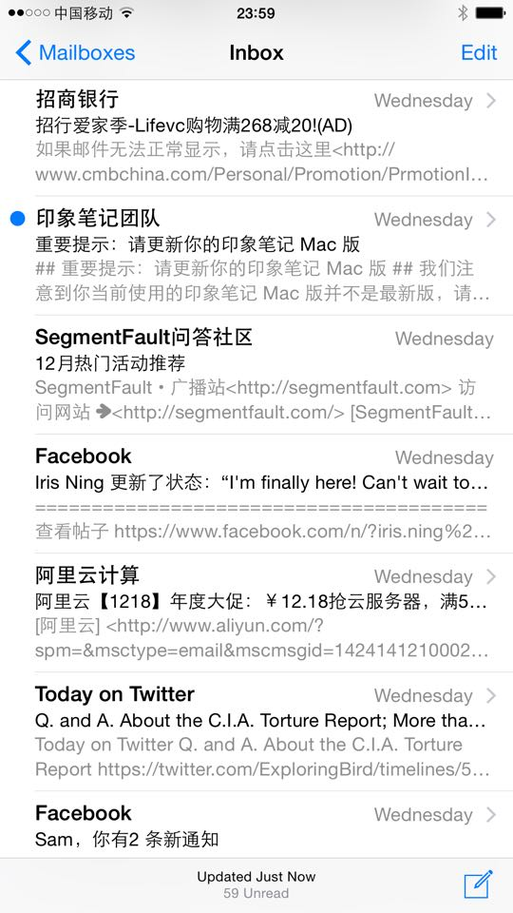
Figure 8- Mark messages outside whitelist as read
把这个想法给具体化，就是本章的任务：
Our task for this chapter is to finish this tweak. We can divide the task into following steps.
（1）在Mail界面上的某个地方加个按钮，点击后出现可编辑的白名单列表，以便进行添加、删除白名单操作。
Add a button on the Mail UI and present an editable whitelist after pressing the button in order to add or delete items in whitelist.
（2）每次Mail的收件箱刷新后，自动把白名单以外的邮件标记为已读。
明确了本章的任务，接下来就一步步地实现目标。下面的操作在iPhone 5，iOS 8.1.1中完成。
Every time the inbox get refreshed, mark all emails outside whitelist as read.
Simple and clear, let’s get started. All operations in this chapter are carried out on iPhone 5, iOS 8.1.1.

8.2 搭建tweak原型

8.2 Tweak prototyping
Mail的初始界面如图8-3所示。
The initial view of Mail is shown in figure 8-3.
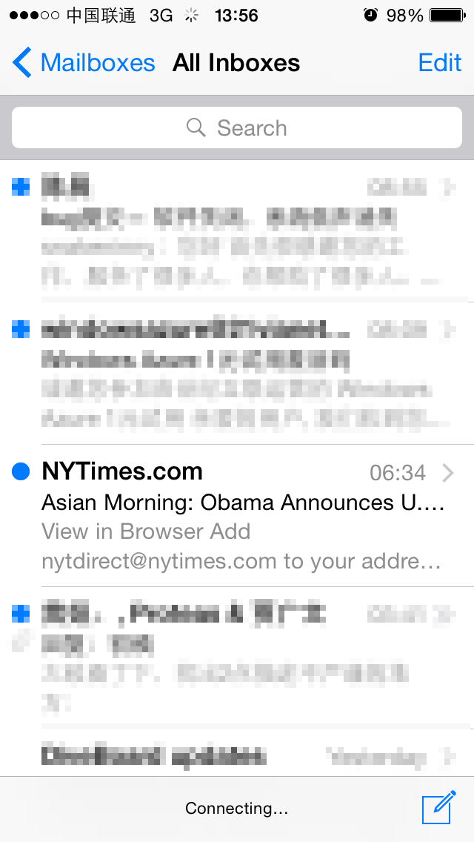
Figure 8- Initial view of Mail
把白名单按钮添加在哪个位置比较直观呢？在图8-3所示的All Inboxes界面中，可以看到，其左下角是空缺的，或许可以把按钮添加在这里，试试看效果吧，如图8-4所示。
So where should the whitelist button be placed for a better user-experience? In the All Inboxes view in figure 8-3, we can see that the left bottom corner is blank; maybe we can put the button here. Let’s try it out and the result is shown in figure 8-4.
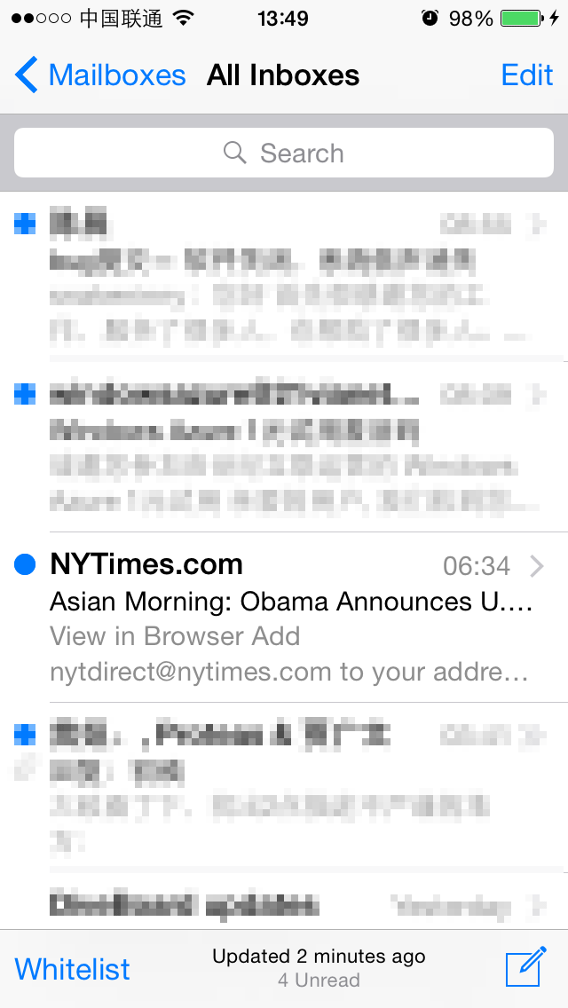
Figure 8- Add whitelist button at the left bottom corner
虽然添加的白名单按钮与右下方的“编写”按钮在方位上对齐了，但前者是文字，后者是图标，形式不统一，不够美观，可见，左下角不适合添加文字按钮。如果改成一个图标按钮呢？可能也会有问题，因为“白名单”没有约定俗成的图形表达方式，找不到一个比较有代表性的图标来表示白名单，所以用图标按钮表示白名单不够直观。直观、美观不可兼得，看来在这个界面上不大适合添加白名单按钮。点击左上角的“Mailboxes”，去上一级界面看看，如图8-5所示。
Although the whitelist button is aligned with the compose button in right bottom corner, the former is text and the latter is an icon. They are in different forms and looks inharmonious. Therefore, we can see the left bottom corner is not suitable for text button. How about changing it to an icon? The problem is that there isn’t an accustomed icon to represent whitelist, a random one may cause confusion. So in this view, no matter icon or text we use, we cannot get both understandability and harmony. Let’s click “Mailboxes” and go back to the upper view, as shown in figure 8-5.
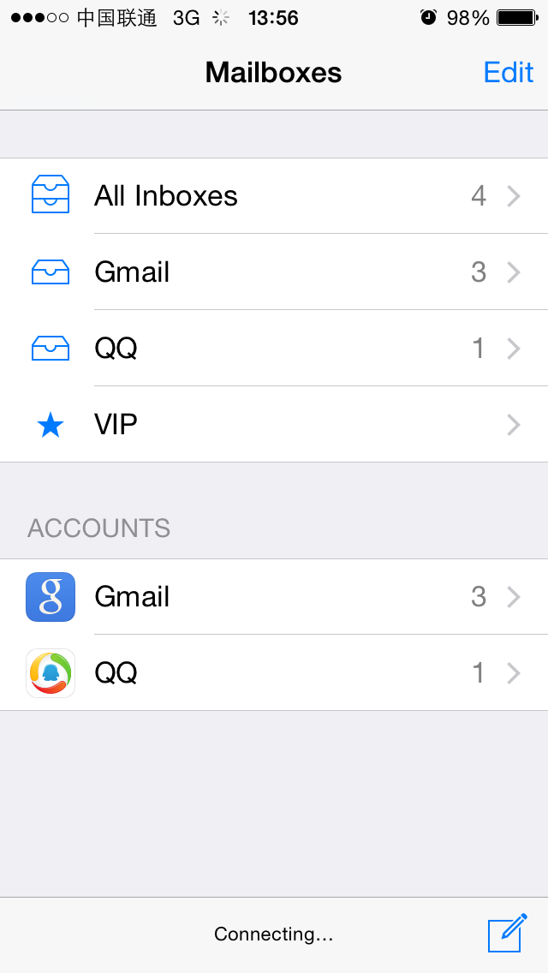
Figure 8- Mailboxes
图8-5所示的界面左上和左下均是空着的，其中左下不适合添加白名单按钮，刚才已经讨论过了。把按钮添加在左上看看效果，如图8-6所示。
The top left and bottom left areas are both empty, as shown in figure 8-5. The bottom left is not suitable for the whitelist button as we’ve discussed just now. So let’s put the button on top left corner to see how it looks, as shown in figure 8-6.
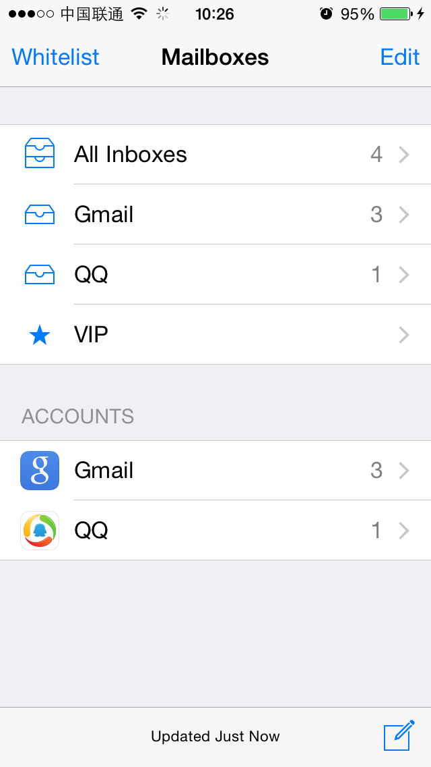
Figure 8- Add whitelist button at top left corner
看起来效果还不错，就把白名单按钮放在这里吧！要达到图8-6所示的效果，只需要找到Mailboxes界面的controller，然后通过[controller.navigationItem setLeftBarButtonItem:]来添加白名单按钮就可以了。通过V找C的过程前面已经重复过很多遍，是可行的。搞定了按钮，接下来就是白名单工作逻辑的梳理了，可以分为3步：
Not bad, this is it. To customize the view like figure 8-6, we just need to find the controller of Mailboxes view and then add the button by calling [controller.navigationItem setLeftBarButtonItem:]. We have repeated the process of finding C from V for many times previously and it has been proved as a feasible solution. After we know how to add the button, we can try to implement the function of whitelist. It can be divided into three steps.
- 拿到所有邮件；
Get all emails.
- 提取出它们的地址；
Extract their email address.
- 根据白名单决定是否将它们标记为已读。
Mark them as read according to whitelist.
下面来一步步分析，一起来思考：
Let’s analyze it step by step, hope you can still catch up.
- 要怎么样才能拿到所有邮件呢？图8-3所示的界面可以下拉刷新收件箱，如图8-7所示。
How can we get all emails? As we know, we can pull to refresh the inbox, as shown in figure 8-7.
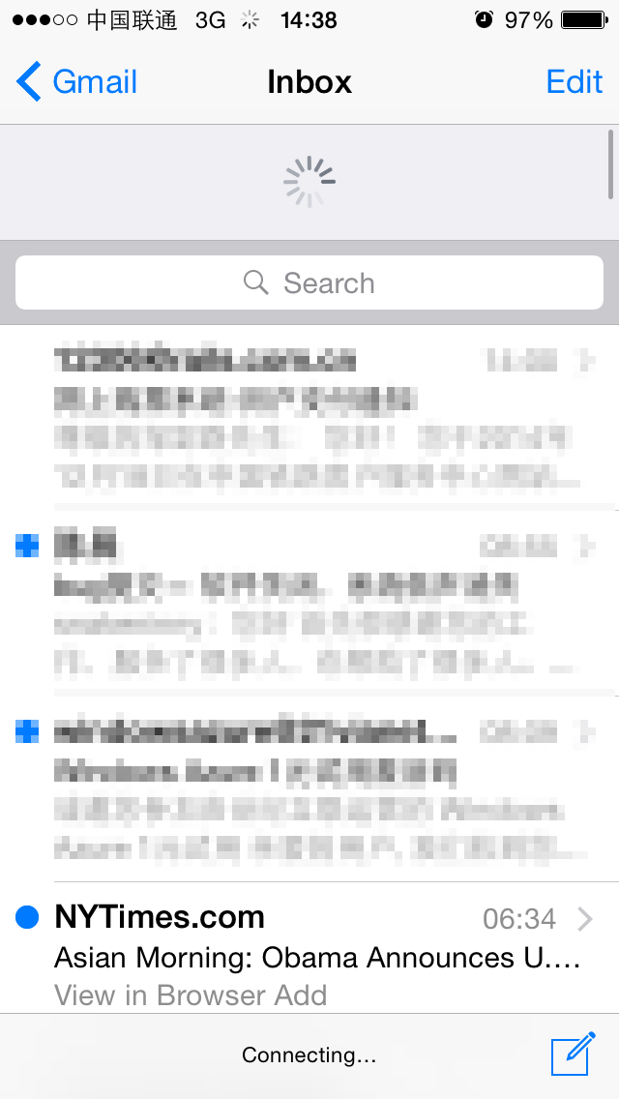
图8- 下拉刷新
Figure 8-7 Pull to refresh
在刷新的过程中，Mail会去邮件服务器上获取最新邮件；刷新完成后，界面恢复到图8-3所示的样子，此时收件箱里存放的就是所有邮件。如果能捕获“刷新完成”事件，然后读取收件箱，就可以拿到所有邮件了。因此，“拿到所有邮件”可以分为2步：一是捕获“刷新完成”事件；二是读取收件箱。其中，“刷新完成”的响应函数一般是定义在protocol里的，在分析class-dump头文件的时候，要留意各种protocol里有没有出现didRefresh、didUpdate、didReload之类名字中含有完成时态动词的函数，钩住（hook）它，然后寻找读取收件箱的方法，从而拿到所有邮件。
During refreshing, Mail will fetch all latest emails from mail servers. After refreshing, the UI will restore to the normal state as shown in figure 8-3, and at this time, we’ve got all emails. As long as we can catch the refresh completion event and read the inbox after that, we can get all emails. Therefore, we can divide “getting all emails” into 2 steps: first, try to capture the refresh completion event; second, read the inbox. Normally, the refresh completion event handler would be a callback method in some protocols. So when analyzing the class-dump headers, we should pay attention to whether there are protocol methods with keywords like “didRefresh”, “didUpdate” or “didReload” in their names. By hooking such methods and read the inbox after their execution, we’ll be able to get all emails.
- 一封邮件就是一个对象，它一般会用一个类来表示，从这个类中可以提取出邮件的收件人、发件人、标题、内容和是否已读等信息。如果能拿到邮件对象，就可以一石二鸟，完成后2步操作。
An email is an object and it is generally abstracted as a class. From this class, we can extract information like the receiver, sender, title, content and whether it is read. If we can get this object, we can finish the second and third step together.
看上去整体思路并不复杂，下面就来各个击破。
The overall idea is not complicated, let’s realize them one by one.

8.2.1 定位Mail的可执行文件并class-dump它

8.2.1 Locate and class-dump Mail’s executable
通过ps命令很容易就能定位到Mail的可执行文件“/Applications/MobileMail.app/MobileMail”。因为MobileMail是iOS原生系统App，没有加壳，所以不需要砸壳，直接class-dump即可：
We can easily locate the execute of Mail, “/Applications/MobileMail.app/MobileMail”, using “ps”. Since Mail is a stock App on iOS, it is not encrypted and we can class-dump it directly without decryption:
snakeninnys-MacBook:~ snakeninny$ class-dump -S -s -H /Users/snakeninny/Code/iOSSystemBinaries/8.1.1_iPhone5/MobileMail.app/MobileMail -o /Users/snakeninny/Code/iOSPrivateHeaders/8.1.1/MobileMail
程序执行后，共得到393个头文件，如图8-8所示。
There’re 393 headers in total, as shown in figure 8-8.
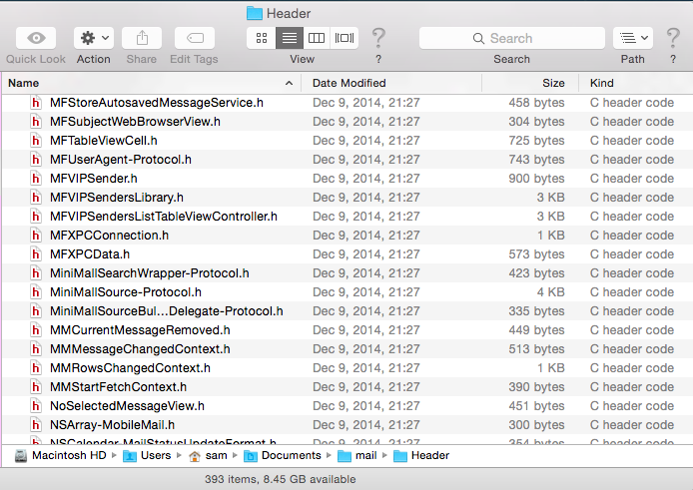
Figure 8- class-dump headers

8.2.2 把头文件导入Xcode

8.2.2 Import headers into Xcode
Xcode自带的查找功能和代码高亮显示能够较为美观整洁地展示大量头文件，如图8-9所示。
The search and code highlighting features in Xcode are competent to present lots of headers, as shown in figure 8-9.
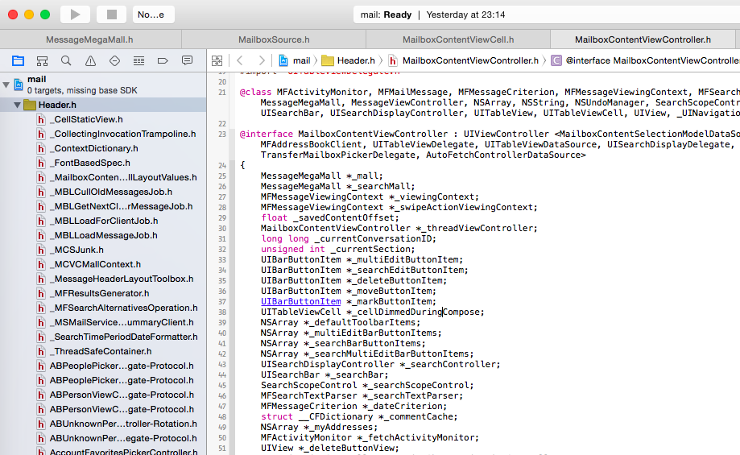
Figure 8- Import headers into Xcode
接下来，开始寻找线索，从App切入代码。
Next, let’s start to find the point to cut into code from UI.

8.2.3 用Cycript找到Mailboxes界面的controller

8.2.3 Find the controller of “Mailboxes” view using Cycript
首先用recursiveDescription打印出Mailboxes界面的UI布局，如下所示：
Firstly, use recursiveDescription to print out the view hierarchy of Mailboxes, as shown below:
FunMaker-5:~ root# cycript -p MobileMail
cy# ?expand
expand == true
cy# [[UIApp keyWindow] recursiveDescription]
@"<UIWindow: 0x156bffe0; frame = (0 0; 320 568); gestureRecognizers = <NSArray: 0x156bd390>; layer = <UIWindowLayer: 0x156c1be0>>
| <UIView: 0x15611490; frame = (0 0; 320 568); autoresize = W+H; gestureRecognizers = <NSArray: 0x15618e70>; layer = <CALayer: 0x15611420>>
| | <UIView: 0x15611210; frame = (0 0; 320 568); layer = <CALayer: 0x15611280>>
| | | <_MFActorItemView: 0x15614660; frame = (0 0; 320 568); layer = <CALayer: 0x15614840>>
| | | | <UIView: 0x156150f0; frame = (-0.5 -0.5; 321 569); alpha = 0; layer = <CALayer: 0x15615160>>
| | | | <_MFActorSnapshotView: 0x15614bb0; baseClass = UISnapshotView; frame = (0 0; 320 568); clipsToBounds = YES; hidden = YES; layer = <CALayer: 0x15614e00>>
| | | | | <UIView: 0x15614f40; frame = (-1 -1; 322 570); layer = <CALayer: 0x15614fb0>>
| | | | <UILayoutContainerView: 0x1572ec40; frame = (0 0; 320 568); clipsToBounds = YES; autoresize = LM+W+RM+TM+H+BM; layer = <CALayer: 0x1572ecc0>>
| | | | | <UIView: 0x1683d890; frame = (0 0; 320 0); layer = <CALayer: 0x16848140>>
| | | | | <UILayoutContainerView: 0x157246b0; frame = (0 0; 320 568); clipsToBounds = YES; gestureRecognizers = <NSArray: 0x156088e0>; layer = <CALayer: 0x15724890>>
……
| | | | | | | | | | <MailboxTableCell: 0x1572ad50; baseClass = UITableViewCell; frame = (0 28; 320 44.5); autoresize = W; layer = <CALayer: 0x168299f0>>
| | | | | | | | | | | <UITableViewCellContentView: 0x16829b70; frame = (0 0; 286 44); gestureRecognizers = <NSArray: 0x1682b060>; layer = <CALayer: 0x16829be0>>
| | | | | | | | | | | | <UILabel: 0x1682b0a0; frame = (55 12; 84.5 20.5); text = 'All Inboxes'; userInteractionEnabled = NO; layer = <_UILabelLayer: 0x1682b160>>
……
其中，最下方的这个UILabel上的文字是“All Inboxes”，其对应的MailboxTableCell自然就是图8-5中最上面的一个cell了。连续调用nextResponder，找出这个界面的controller：
The text of the UILabel at the bottom is “All Inboxes”, indicating its corresponding MailBoxTableCell is the top one in figure 8-5. Keep calling nextResponder until we get the controller:
cy# [#0x1572ad50 nextResponder]
#"<UITableViewWrapperView: 0x1572fe60; frame = (0 0; 320 568); gestureRecognizers = <NSArray: 0x15730370>; layer = <CALayer: 0x157301a0>; contentOffset: {0, 0}; contentSize: {320, 568}>"
cy# [#0x1572fe60 nextResponder]
#"<UITableView: 0x1585a000; frame = (0 0; 320 568); clipsToBounds = YES; autoresize = W+H; gestureRecognizers = <NSArray: 0x1572fa20>; layer = <CALayer: 0x1572f540>; contentOffset: {0, -64}; contentSize: {320, 371}>"
cy# [#0x1585a000 nextResponder]
#"<MailboxPickerController: 0x156e9260>"
很轻松地拿到了MailboxPickerController。试试看用它能不能添加一个leftBarButtonItem，如下所示：
Aha. It’s very easy to get MailboxPickerController. Let’s try whether we can add a leftBarButtonItem:
cy# #0x156e9260.navigationItem.leftBarButtonItem = #0x156e9260.navigationItem.rightBarButtonItem
#"<UIBarButtonItem: 0x15729f00>"
效果如图8-10所示。
The effect is shown in figure 8-10.
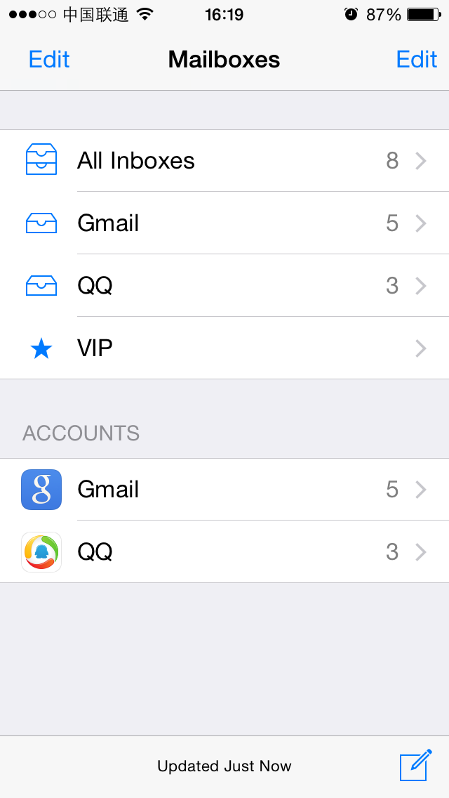
Figure 8- After setLeftBarButtonItem:
没有问题，MailboxPickerController就是Mailboxes界面的controller，可以通过它添加白名单按钮。
No problem! We’ve successfully added the button. Therefore, we can confirm that MailboxPickerController is the controller of Mailboxes.

8.2.4用Reveal和Cycript找到All Inboxes界面的delegate

8.2.4 Find the delegate of “All Inboxes” view using Reveal and Cycript
搞定了白名单按钮，就要开始梳理白名单的工作逻辑了，先看看如何捕获“刷新完成”事件。因为“刷新完成”是直观表现在All Inboxes界面上的，所以“刷新完成”的响应函数很可能定义在这个界面的delegate中。转战到图8-3所示的All Inboxes界面，这里不再重复8.2.3节的方法，而是先通过Reveal定位这个界面的cell，再用Cycript找出它所在的UITableView，从而得知其delegate。
After adding the whitelist button, we need to implement the function of it. First let’s take a look at how to capture the refresh completion event. Since the event is straightly showed on “All Inboxes” view, it is very likely that the callback method is defined in the delegate of this view. Now let’s turn to “All Inboxes” view in figure 8-3 and use Reveal rather than repeating what we’ve done with Cycript in section 8.2.3, to locate a cell of this view and then find its associated UITableView as well delegate through Cycript.
下面就用Reveal查看Mail，很容易就可以定位到最上方的那个cell，如图8-11所示。
With Reveal, we can easily locate the top cell, as shown in figure 8-11.
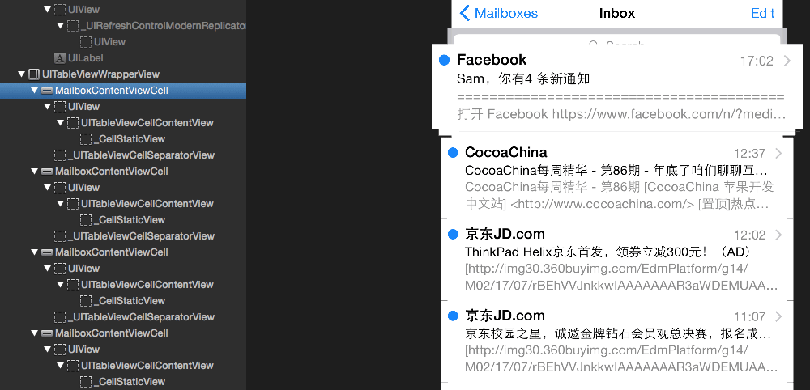
Figure 8- See the view hierarchy using Reveal
MailboxContentViewCell就是显示邮件发件人、标题和摘要的cell。接着用Cycript找出它所在的UITableView：因为我们知道当前界面一定存在MailboxContentViewCell对象，所以可以尝试通过choose命令获取这些对象，而不用劳烦recursiveDescription她老人家了：
MailboxContentViewCell is the cell class to show the receiver, title and summary of an email. Next, we use Cycript to find its associated UITableView. Since we know there must be at least one MailboxContentViewCell object in current view, we can try to find these cells through command “choose” without using recursiveDescription.
FunMaker-5:~ root# cycript -p MobileMail
cy# choose(MailboxContentViewCell)
[#"<MailboxContentViewCell: 0x161f4000> cellContent",#"<MailboxContentViewCell: 0x1621c400> cellContent",#"<MailboxContentViewCell: 0x1621d000> cellContent",#"<MailboxContentViewCell: 0x16234800> cellContent",#"<MailboxContentViewCell: 0x1623ee00> cellContent",#"<MailboxContentViewCell: 0x1623f200> cellContent",#"<MailboxContentViewCell: 0x159c2c00> cellContent"]
choose命令返回了一个由MailboxContentViewCell对象组成的NSArray，从中随便挑选一个MailboxContentViewCell对象，对其连续调用nextResponder：
“choose” has returned an NSArray of MailboxContentViewCell objects. Pick anyone and keep calling nextResponder on it.
cy# [choose(MailboxContentViewCell)[0] nextResponder]
#"<UITableViewWrapperView: 0x15660b80; frame = (0 0; 320 612); gestureRecognizers = <NSArray: 0x16855170>; layer = <CALayer: 0x16888f20>; contentOffset: {0, 0}; contentSize: {320, 612}>"
cy# [#0x15660b80 nextResponder]
#"<MFMailboxTableView: 0x16095000; baseClass = UITableView; frame = (0 0; 320 568); clipsToBounds = YES; autoresize = W+H; gestureRecognizers = <NSArray: 0x15607850>; layer = <CALayer: 0x16838210>; contentOffset: {0, -64}; contentSize: {320, 52364}>"
它所在的UITableView是一个MFMailboxTableView对象，看看它的delegate是什么：
Its associated UITableView is an MFMailboxTableView object. Let’s take a look at its delegate.
cy# [#0x16095000 delegate]
#"<MailboxContentViewController: 0x16106000>"
它的delegate是MailboxContentViewController。继续调用nextResponder，看看它的controller又是什么：
Its delegate is MailboxContentViewController. Keeping calling nextResonder and find what its controller is.
cy# [#0x16095000 nextResponder]
#"<MailboxContentViewController: 0x16106000>"
也就是说，MFMailboxTableView的controller和delegate均是MailboxContentViewController。简单验证一下controller的正确性，如下：
From the output, we can see that both the controller and delegate of MFMailboxTableView are MailboxContentViewController. Let’s validate the controller as below.
cy# [#0x16106000 setTitle:@"iOSRE"]
效果如图8-12所示。
The effect is shown in 8-12.
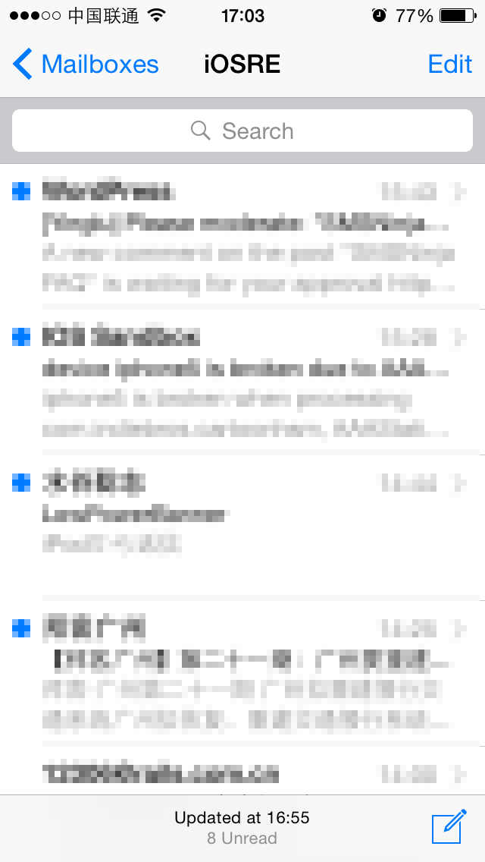
Figure 8- After setTitle:
这个结果说明上述一系列推导没有问题，MailboxContentViewController中很可能既含有“刷新完成”的响应函数，又能找到读取收件箱的蛛丝马迹，接下来就把焦点放在它身上了。
So far, we can confirm that our deduction is correct. Playing 2 important roles at the same time, it is very likely that we can find both the refresh completion event handler and inbox reading method in MailboxContentViewController. Let’s focus on this class from now on.

8.2.4在MailboxContentViewController中定位“刷新完成”的响应函数

8.2.4 Locate the refresh completion callback method in MailboxContentViewController
跟第7章一样，先来看看MailboxContentViewController实现了哪些protocol，能不能在其中找到可疑的响应函数：
Like what we did in Chapter 7, we should take a look at what protocol does MailboxContentViewController confirm to at first and then try to find our target method.
@interface MailboxContentViewController : UIViewController <MailboxContentSelectionModelDataSource, MFSearchTextParserDelegate, MessageMegaMallObserver, MFAddressBookClient, MFMailboxTableViewDelegate, UIPopoverPresentationControllerDelegate, UITableViewDelegate, UITableViewDataSource, UISearchDisplayDelegate, UISearchBarDelegate, TransferMailboxPickerDelegate, AutoFetchControllerDataSource>
先从名字上来做一次简单的排查，MFSearchTextParserDelegate、MFAddressBookClient、UIPopoverPresentationControllerDelegate、UITableViewDelegate、UITableViewDataSource、UISearchDisplayDelegate、UISearchBarDelegate看起来跟“刷新完成”没什么关系，可以直接排除。剩下的MailboxContentSelectionModelDataSource、MessageMegaMallObserver、MFMailboxTableViewDelegate、TransferMailboxPickerDelegate和AutoFetchControllerDataSource还不好说，那就挨个过一遍。先看MailboxContentSelectionModelDataSource.h，内容如下：
We can exclude MFSearchTextParserDelegate, MFAddressBookClient, UIPopoverPresentationControllerDelegate, UITableViewDelegate, UITableViewDataSource, UISearchDisplayDelegate and UISearchBarDelegate just by name, because they seemingly have no relation with refresh completion. The rest protocols, MailboxContentSelectionModelDataSource, MessageMegaMallObserver, MFMailboxTableViewDelegate, TransferMailboxPickerDelegate and AutoFetchControllerDataSource are hard to determine by names. Let’s check them one by one from MailboxContentSelectionModelDataSource.
@protocol MailboxContentSelectionModelDataSource <NSObject>
- (BOOL)selectionModel:(id)arg1 deleteMovesToTrashForTableIndexPath:(id)arg2;
- (void)selectionModel:(id)arg1 getConversationStateAtTableIndexPath:(id)arg2 hasUnread:(char *)arg3 hasUnflagged:(char *)arg4;
- (void)selectionModel:(id)arg1 getSourceStateHasUnread:(char *)arg2 hasUnflagged:(char *)arg3;
- (id)selectionModel:(id)arg1 indexPathForMessageInfo:(id)arg2;
- (id)selectionModel:(id)arg1 messageInfosAtTableIndexPath:(id)arg2;
- (id)selectionModel:(id)arg1 messagesForMessageInfos:(id)arg2;
- (BOOL)selectionModel:(id)arg1 shouldArchiveByDefaultForTableIndexPath:(id)arg2;
- (id)selectionModel:(id)arg1 sourceForMessageInfo:(id)arg2;
- (BOOL)selectionModel:(id)arg1 supportsArchivingForTableIndexPath:(id)arg2;
- (id)sourcesForSelectionModel:(id)arg1;
@end
这个protocol的作用看上去是读取数据源，跟“刷新数据源”没太大关系。接着看MessageMegaMallObserver.h，内容如下：
It looks like the function of this protocol is to read the data source rather than refresh it. Let’s move on to MessageMegaMallObserver, its contents are as below:
@protocol MessageMegaMallObserver <NSObject>
- (void)megaMallCurrentMessageRemoved:(id)arg1;
- (void)megaMallDidFinishSearch:(id)arg1;
- (void)megaMallDidLoadMessages:(id)arg1;
- (void)megaMallFinishedFetch:(id)arg1;
- (void)megaMallGrowingMailboxesChanged:(id)arg1;
- (void)megaMallMessageCountChanged:(id)arg1;
- (void)megaMallMessagesAtIndexesChanged:(id)arg1;
- (void)megaMallStartFetch:(id)arg1;
@end
这个类中的不少函数名含有完成时态动词，同时，从“LoadMessages”、“FinishedFetch”、“MessageCountChanged”等函数的名字上来看，它可能会在刷新完成的前后得到调用。接下来用LLDB在这3个函数的开头部分下断点，然后下拉刷新收件箱，看看它们的调用情况。首先用LLDB附加MobileMail，查看其ASLR偏移：
There are many perfect tense verbs in the method names. Meanwhile, judging from the name like “LoadMessages”, “FinishedFetch” and “MessageCountChanged”, we guess that they may get called before or after refresh completion. So let’s set breakpoints at the beginning of these three methods using LLDB and pull to refresh the inbox to check if these methods are called. In the first place, attach LLDB to MobileMail and inspect its ASLR offset.
(lldb) image list -o -f
[ 0] 0x000b2000 /private/var/db/stash/_.lnBgU8/Applications/MobileMail.app/MobileMail(0x00000000000b6000)
[ 1] 0x003b7000 /Library/MobileSubstrate/MobileSubstrate.dylib(0x00000000003b7000)
[ 2] 0x090d1000 /Users/snakeninny/Library/Developer/Xcode/iOS DeviceSupport/8.1 (12B411)/Symbols/usr/lib/libarchive.2.dylib
[ 3] 0x090c3000 /Users/snakeninny/Library/Developer/Xcode/iOS DeviceSupport/8.1.1 (12B435)/Symbols/System/Library/Frameworks/CloudKit.framework/CloudKit
……
可以看到，ASLR偏移是0x000b2000。然后把MobileMail拖进IDA，待初始分析完成后，查看[MailboxContentViewController megaMallDidLoadMessages:]、[MailboxContentViewController megaMallFinishedFetch:]和[MailboxContentViewController megaMallMessageCountChanged:]的基地址，如图8-13、图8-14和图8-15所示。
We can see the ASLR offset is 0x000b2000. Then drag and drop MobileMail into IDA and after the initial analysis has been finished, check the base addresses of [MailboxContentViewController megaMallDidLoadMessages:], [MailboxContentViewController megaMallFinishedFetch:] and [MailboxContentViewController megaMallMessageCountChanged:], as shown in figure 8-13, 8-14 and 8-15.
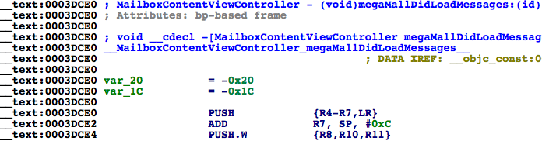
Figure 8- [MailboxContentViewController megaMallDidLoadMessages:]
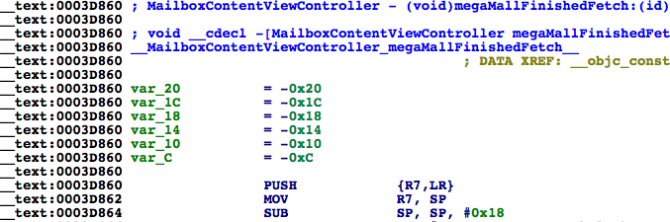
Figure 8- [MailboxContentViewController megaMallFinishedFetch:]
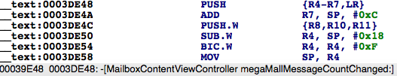
Figure 8- [MailboxContentViewController megaMallMessageCountChanged:]
它们的基地址分别是0x3dce0、0x3d860和0x3de48。用LLDB在这些地址上下断点，然后下拉刷新，触发断点：
Their base addresses are 0x3dce0, 0x3d860 and 0x3de48 respectively. Set breakpoints on these addresses by LLDB and refresh the inbox to trigger the breakpoints:
(lldb) br s -a '0x000b2000+0x3dce0'
Breakpoint 1: where = MobileMail`___lldb_unnamed_function992$$MobileMail, address = 0x000efce0
(lldb) br s -a '0x000b2000+0x3d860'
Breakpoint 2: where = MobileMail`___lldb_unnamed_function987$$MobileMail, address = 0x000ef860
(lldb) br s -a '0x000b2000+0x3de48'
Breakpoint 3: where = MobileMail`___lldb_unnamed_function993$$MobileMail, address = 0x000efe48
可能有读者在这里会碰到跟笔者相同的情况：三个断点一个也没有触发。从事过网络编程的朋友可能会猜到原因——为了减轻邮件服务器的负担，节省iOS流量，并不是每次下拉刷新都会去服务器取数据。如果刷新时间间隔不长，收件箱的数据源就会是本地缓存，不会调用MessageMegaMallObserver中的方法。为了验证这个猜测，我们往自己的邮箱发一封邮件，然后下拉刷新，看看断点触发情况：
Some of you may meet the same problem as me, which is none of three breakpoints get triggered. If you have experience in network development, you may have the idea that in order to reduce the burden of servers and save the network traffic of iOS, Mail may not fetch emails remotely on every refresh. If the time interval between two refreshes is very short, it will use cached content as data source of inbox; and as a result, methods in MessageMegaMallObserver will not get called. In order to validate our assumption, send an email to yourself and refresh to check whether breakpoints get triggered:
Process 73130 stopped
* thread #44: tid = 0x14c10, 0x000ef860 MobileMail`___lldb_unnamed_function987$$MobileMail, stop reason = breakpoint 2.1
frame #0: 0x000ef860 MobileMail`___lldb_unnamed_function987$$MobileMail
MobileMail`___lldb_unnamed_function987$$MobileMail:
-> 0xef860: push {r7, lr}
0xef862: mov r7, sp
0xef864: sub sp, #24
0xef866: movw r1, #44962
(lldb) c
Process 73130 resuming
Process 73130 stopped
* thread #44: tid = 0x14c10, 0x000ef860 MobileMail`___lldb_unnamed_function987$$MobileMail, stop reason = breakpoint 2.1
frame #0: 0x000ef860 MobileMail`___lldb_unnamed_function987$$MobileMail
MobileMail`___lldb_unnamed_function987$$MobileMail:
-> 0xef860: push {r7, lr}
0xef862: mov r7, sp
0xef864: sub sp, #24
0xef866: movw r1, #44962
(lldb) c
Process 73130 resuming
Process 73130 stopped
* thread #1: tid = 0x11daa, 0x000efe48 MobileMail`___lldb_unnamed_function993$$MobileMail, queue = 'MessageMiniMall.0x157c2d90, stop reason = breakpoint 3.1
frame #0: 0x000efe48 MobileMail`___lldb_unnamed_function993$$MobileMail
MobileMail`___lldb_unnamed_function993$$MobileMail:
-> 0xefe48: push {r4, r5, r6, r7, lr}
0xefe4a: add r7, sp, #12
0xefe4c: push.w {r8, r10, r11}
0xefe50: sub.w r4, sp, #24
(lldb)
Process 73130 resuming
Process 73130 stopped
* thread #1: tid = 0x11daa, 0x000efe48 MobileMail`___lldb_unnamed_function993$$MobileMail, queue = 'MessageMiniMall.0x157c2d90, stop reason = breakpoint 3.1
frame #0: 0x000efe48 MobileMail`___lldb_unnamed_function993$$MobileMail
MobileMail`___lldb_unnamed_function993$$MobileMail:
-> 0xefe48: push {r4, r5, r6, r7, lr}
0xefe4a: add r7, sp, #12
0xefe4c: push.w {r8, r10, r11}
0xefe50: sub.w r4, sp, #24
(lldb)
Process 73130 resuming
Process 73130 stopped
* thread #44: tid = 0x14c10, 0x000ef860 MobileMail`___lldb_unnamed_function987$$MobileMail, stop reason = breakpoint 2.1
frame #0: 0x000ef860 MobileMail`___lldb_unnamed_function987$$MobileMail
MobileMail`___lldb_unnamed_function987$$MobileMail:
-> 0xef860: push {r7, lr}
0xef862: mov r7, sp
0xef864: sub sp, #24
0xef866: movw r1, #44962
(lldb) c
Process 73130 resuming
果不其然，megaMallFinishedFetch:和megaMallMessageCountChanged:被交替调用。从名字上来看，一封邮件就是一个message，megaMallFinishedFetch:应该会在iOS成功地从服务器取回邮件之后得到调用，而megaMallMessageCountChanged:应该会在邮件数量发生变动，即收邮件和删邮件时得到调用，两者自然都会在“刷新完成”时得到调用，都可以看作“刷新完成”的响应函数。两者随便选其一，这里选择megaMallMessageCountChanged:，接下来的任务是寻找拿到所有邮件的方法。
As expected, megaMallFinishedFetch: and megaMallMessageCountChanged: are called alternately. From their names we can see that an email is a message, megaMallFinishedFetch: will be called when iOS has fetched emails from server successfully, and megaMallMessageCountChanged: will get called when email counts change, i.e. when we receive or delete emails. These two methods will definitely get called after refreshing; we can choose either one as the refresh completion callback method. We’ll take megaMallMessageCountChanged: in this chapter and our next task is to find the method for getting all emails.

8.2.5 从MessageMegaMall中拿到所有邮件

8.2.5 Get all emails from MessageMegaMall
还记得第7章中说过的“协议方法被调用，一般是因为方法名中提到的那个事件发生了；而那件事发生的对象，一般是协议方法的参数”吗？删掉前2个断点，保留第3个，也就是megaMallMessageCountChanged:上的断点，看看它的参数是什么：
Do you still remember the saying in chapter 7 that “The reason a protocol method gets called is generally that the corresponding event mentioned in the method name happened. And the thing that triggers the event is usually the method’s arguments”? So let’s delete the first two breakpoints and keep the last one on megaMallMessageCountChanged, and take a look at its argument:
Process 73130 stopped
* thread #1: tid = 0x11daa, 0x000efe48 MobileMail`___lldb_unnamed_function993$$MobileMail, queue = 'MessageMiniMall.0x157c2d90, stop reason = breakpoint 3.1
frame #0: 0x000efe48 MobileMail`___lldb_unnamed_function993$$MobileMail
MobileMail`___lldb_unnamed_function993$$MobileMail:
-> 0xefe48: push {r4, r5, r6, r7, lr}
0xefe4a: add r7, sp, #12
0xefe4c: push.w {r8, r10, r11}
0xefe50: sub.w r4, sp, #24
(lldb) po $r2
NSConcreteNotification 0x157e8af0 {name = MegaMallMessageCountChanged; object = <MessageMegaMall: 0x1576c320>; userInfo = {
"added-message-infos" = (
"<MFMessageInfo: 0x157c86d0> uid=1185, conversation=2777228998582613276"
);
destination = "{(\n)}";
inserted = "{(\n <NSIndexPath: 0x157e8ac0> {length = 2, path = 0 - 0}\n)}";
relocated = "{(\n)}";
updated = "{(\n)}";
}}
可以看到，参数是一个NSConcreteNotification对象。查看其头文件，可知它继承自NSNotification。它的name是MegaMallMessageCountChanged，object是一个MessageMegaMall对象，userInfo是一些改动信息。“MegaMall”这个名字很值得玩味，“大型购物中心”，看似与邮件毫不相关，却又与“Message”寸步不离，与8.2.4节分析的MessageMegaMallObserver遥相呼应，疑似为一个存储“Message”的类。打开MessageMegaMall.h，看看它的内容：
We can see that the argument is an NSConcreteNotification object. Checking its header file, we can learn that it inherits from NSNotification. Its name is MegaMallMessageCountChanged, object is MessageMegaMall and userInfo is its changelog. The thing that interests us is the name “MegaMall”, which seemingly has nothing to do with emails but is always next to “Message”, so I guess it’s a mega mall for emails instead of merchandises. Let’s see what’s in MessageMegaMall.h:
@interface MessageMegaMall : NSObject <MessageMiniMallObserver, MessageSelectionDataSource>
……
- (id)copyAllMessages;
@property (retain, nonatomic) MFMailMessage *currentMessage;
- (void)loadOlderMessages;
- (unsigned int)localMessageCount;
- (unsigned int)messageCount;
- (void)markAllMessagesAsNotViewed;
- (void)markAllMessagesAsViewed;
- (void)markMessagesAsNotViewed:(id)arg1;
- (void)markMessagesAsViewed:(id)arg1;
……
@end
线索有些明朗了：复制所有邮件、当前邮件、读取早期邮件、本地邮件计数、邮件计数、标为已读……MessageMegaMall应该就是一个管理所有邮件对象的M，它被苹果形象地比喻为“大型购物中心”。那么到底能不能通过copyAllMessages 拿到所有的邮件呢？在LLDB里试一下：
We’ve got some new clues: copyAllMessages, currentMessage, loadOlderMessages, localMessageCount, messageCount, markAllMessagesAsViewed, etc. From these methods and properties, we can confirm that MessageMegaMall is a model class in charge of all emails; a mega mall is a vivid analogy from Apple for its responsibility. So, can we get all emails with copyAllMessages? Let’s try it out in LLDB:
Process 73130 stopped
* thread #1: tid = 0x11daa, 0x000efe48 MobileMail`___lldb_unnamed_function993$$MobileMail, queue = 'MessageMiniMall.0x157c2d90, stop reason = breakpoint 3.1
frame #0: 0x000efe48 MobileMail`___lldb_unnamed_function993$$MobileMail
MobileMail`___lldb_unnamed_function993$$MobileMail:
-> 0xefe48: push {r4, r5, r6, r7, lr}
0xefe4a: add r7, sp, #12
0xefe4c: push.w {r8, r10, r11}
0xefe50: sub.w r4, sp, #24
(lldb) po [[$r2 object] copyAllMessages]
{(
<MFLibraryMessage 0x15612030: library id 89, remote id 13020, 2014-11-25 20:32:16 +0000, 'Cydia/APT(A): LowPowerBanner (1.4.5)'>,
<MFLibraryMessage 0x1572ef10: library id 604, remote id 12718, 2014-10-01 21:34:28 +0000, 'Asian Morning: Told to End Protests, Organizers in Hong Kong Vow to Expand Them'>,
<MFLibraryMessage 0x168bd170: library id 906, remote id 13142, 2014-12-17 22:34:30 +0000, 'Asian Morning: Obama Announces U.S. and Cuba Will Resume Relations'>,
……
)}
(lldb) p (int)[[[$r2 object] copyAllMessages] count]
(int) $7 = 580
(lldb) p (int)[[$r2 object] localMessageCount]
(int) $8 = 580
(lldb) p (int)[[$r2 object] messageCount]
(int) $0 = 553
(lldb) po [[[$r2 object] copyAllMessages] class]
__NSSetM
copyAllMessages返回了一个NSSet，其中含有580个MFLibraryMessage对象，MFLibraryMessage对象中含有邮件摘要信息，且NSSet中对象的个数与localMessageCount的值相同。这个结果很好理解：为了节省带宽流量和本地空间，iOS没有必要一次性下载邮件服务器上的所有邮件，因此会先存储个百十来封，用户如果要看更多的邮件，再去服务器获取（即loadOlderMessages）。因此，copyAllMessages就是拿到所有邮件的方法，第二目标达成！同时，留意[MessageMegaMall markMessagesAsViewed:]函数，如果不出意外，它就是把邮件标记为已读的方法，而参数则很有可能是一个含有MFLibraryMessage对象的NSArray或者NSSet。到底是不是这样呢？我们马上就会验证。
copyAllMessages has returned an NSSet with 580 MFLibraryMessage objects. There is an email summary in each MFLibraryMessage object and the count of this NSSet is the same to localMessageCount. Actually, 580 is far less than all email count, but this number is reasonable that to save network traffic and local storage, iOS doesn’t have to really fetch all emails and store them locally, several hundreds of emails would be enough. If users want to read more, iOS will fetch more with loadOlderMessages. Therefore, copyAllMessages can be considered the right method for getting all emails. Aha, we have achieved our 2nd goal. For the 3rd goal, we should pay attention to [MessageMegaMall markMessagesAsViewed:]. If nothing goes wrong, this is the method for marking emails as read and its argument seems to be an NSArray or NSSet with MFLibraryMessage object. Is that so? We’ll see shortly.

8.2.6 从MFLibraryMessage中提取发件人地址，用MessageMegaMall标记已读

8.2.6 Get sender address from MFLibraryMessage and mark email as read using MessageMegaMall
从8.2.4节的分析可知，一封邮件就是一个MFLibraryMessage对象，它的description里显示的正是邮件摘要。不过，在MobileMail的头文件中是找不到它的身影的，想必你也能猜到大致原因——MFLibraryMessage来自一个外部dylib。在iOS 8的所有class-dump头文件里搜索MFLibraryMessage，发现它来自Messages私有库，如图8-16所示。
From the analysis in section 8.2.4, we can see that an email is an MFLibraryMessage object, whose description contains the summary of that email. However, you can’t find MFLibraryMessage.h in MobileMail headers. Why? Because it comes from an external dylib. Search “MFLibraryMessage” in iOS 8 class-dump headers, you will find it Messages.framework, as shown in 8-16.
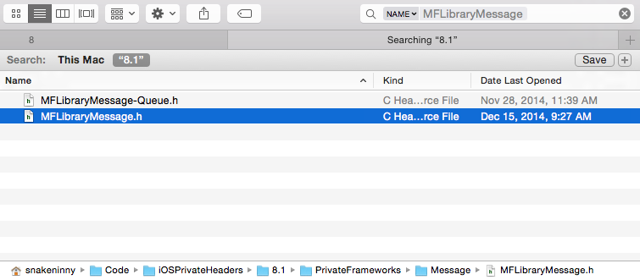
Figure 8- Find MFLibraryMessage
看看MFLibraryMessage.h的内容：
Take a look at MFLibraryMessage.h:
@interface MFLibraryMessage : MFMailMessage
……
- (id)copyMessageInfo;
……
- (void)markAsNotViewed;
- (void)markAsViewed;
- (id)account;
……
- (unsigned long long)uniqueRemoteId;
- (unsigned long)uid;
- (unsigned int)hash;
- (id)remoteID;
- (void)_updateUID;
- (unsigned int)messageSize;
- (id)originalMailboxURL;
- (unsigned int)originalMailboxID;
- (unsigned int)mailboxID;
- (unsigned int)libraryID;
- (id)persistentID;
- (id)messageID;
@end
MFLibraryMessage.h里充斥着各种ID，但没有我们要找的发件人地址等信息。这个结果不正常：我们已经在MFLibraryMessage的description里看到了邮件摘要信息，却没有在MFLibraryMessage.h里找到读取摘要信息的方法，说明分析过程有遗漏。重新审视MFLibraryMessage.h，这时，copyMessageInfo进入了我们的视线，看看它返回的“邮件信息”里会有什么数据：
In MFLibraryMessage.h, there are various IDs, but our target information seems to be missing. This doesn’t make sense: we have already found the email summary in the description of MFLibraryMessage, but haven’t found the corresponding methods to read the summary in MFLibraryMessage.h. Therefore, something must be ignored in our analysis. Recheck MFLibraryMessage.h, we notice that there is a method called copyMessageInfo. Let’s take a look at it.
Process 73130 stopped
* thread #1: tid = 0x11daa, 0x000efe48 MobileMail`___lldb_unnamed_function993$$MobileMail, queue = 'MessageMiniMall.0x157c2d90, stop reason = breakpoint 3.1
frame #0: 0x000efe48 MobileMail`___lldb_unnamed_function993$$MobileMail
MobileMail`___lldb_unnamed_function993$$MobileMail:
-> 0xefe48: push {r4, r5, r6, r7, lr}
0xefe4a: add r7, sp, #12
0xefe4c: push.w {r8, r10, r11}
0xefe50: sub.w r4, sp, #24
(lldb) po [[[[$r2 object] copyAllMessages] anyObject] copyMessageInfo]
<MFMessageInfo: 0x157c8040> uid=89, conversation=594030790676622907
从中拿到了一个8.2.5节出现过的MFMessageInfo对象，马上去看看MFMessageInfo.h里有没有邮件摘要信息：
We’ve got an object of MFMessageInfo, which has been mentioned in section 8.2.5. Is email summary in MFMessageInfo.h? Let’s try it.
@interface MFMessageInfo : NSObject
{
unsigned int _flagged:1;
unsigned int _read:1;
unsigned int _deleted:1;
unsigned int _uidIsLibraryID:1;
unsigned int _hasAttachments:1;
unsigned int _isVIP:1;
unsigned int _uid;
unsigned int _dateReceivedInterval;
unsigned int _dateSentInterval;
unsigned int _mailboxID;
long long _conversationHash;
long long _generationNumber;
}

+ (long long)newGenerationNumber;
@property(readonly, nonatomic) long long generationNumber; // @synthesize generationNumber=_generationNumber;
@property(nonatomic) unsigned int mailboxID; // @synthesize mailboxID=_mailboxID;
@property(nonatomic) long long conversationHash; // @synthesize conversationHash=_conversationHash;
@property(nonatomic) unsigned int dateSentInterval; // @synthesize dateSentInterval=_dateSentInterval;
@property(nonatomic) unsigned int dateReceivedInterval; // @synthesize dateReceivedInterval=_dateReceivedInterval;
@property(nonatomic) unsigned int uid; // @synthesize uid=_uid;
- (id)description;
- (unsigned int)hash;
- (BOOL)isEqual:(id)arg1;
- (int)generationCompare:(id)arg1;
- (id)initWithUid:(unsigned int)arg1 mailboxID:(unsigned int)arg2 dateReceivedInterval:(unsigned int)arg3 dateSentInterval:(unsigned int)arg4 conversationHash:(long long)arg5 read:(BOOL)arg6 knownToHaveAttachments:(BOOL)arg7 flagged:(BOOL)arg8 isVIP:(BOOL)arg9;
- (id)init;
@property(nonatomic) BOOL isVIP;
@property(nonatomic, getter=isKnownToHaveAttachments) BOOL knownToHaveAttachments;
@property(nonatomic) BOOL uidIsLibraryID;
@property(nonatomic) BOOL deleted;
@property(nonatomic) BOOL flagged;
@property(nonatomic) BOOL read;

@end
MFMessageInfo中含有已读信息，但不含有邮件摘要信息，说明我们的分析仍不够严密。再回过头仔细观察MFLibraryMessage.h，发现它继承自MFMailMessage，从名字上看，MailMessage用来代表邮件显然比LibraryMessage更贴切。打开MFMailMessage.h，看看它的内容：
MFMessageInfo can tell if an email is read, but it still doesn’t contain the summary. Go back to MFLibraryMessage.h again, we see it inherits from MFMailMessage. Judging from its name, MailMessage is certainly more appropriate to represent an email than LibraryMessage. Take a look at MFMailMessage.h:
@interface MFMailMessage : MFMessage
……
- (BOOL)shouldSetSummary;
- (void)setSummary:(id)arg1;
- (void)setSubject:(id)arg1 to:(id)arg2 cc:(id)arg3 bcc:(id)arg4 sender:(id)arg5 dateReceived:(double)arg6 dateSent:(double)arg7 messageIDHash:(long long)arg8 conversationIDHash:(long long)arg9 summary:(id)arg10 withOptions:(unsigned int)arg11;
- (id)subject;
@end
summary、subject、sender、cc、bcc等邮件常用词汇出现在我们面前，但除了subject，MFMailMessage.h中只出现了setter，而不见getter。还记得刚才我们的注意力是怎么从MFLibraryMessage.h转移到MFMailMessage.h上的吗？想必你一定也注意到了MFMailMessage的父类MFMessage。在查看它的头文件前，先用LLDB看看[MFMailMessage subject]的返回，验证一下我们到目前为止的分析：
summary, subject, sender, cc, bcc and some other frequently used phrases in emails come into our eyes. However, except subject, most of them are only setters, where are the getters? If you still remember how we’ve shifted our attention from MFLibraryMessage.h to MFMailMessage.h, you will notice that MFMailMessage inherits from MFMessage. Before inspecting MFMessage.h, let’s take a look at the return value of [MFMailMessage subject] through LLDB to verify the analysis by now.
Process 73130 stopped
* thread #1: tid = 0x11daa, 0x000efe48 MobileMail`___lldb_unnamed_function993$$MobileMail, queue = 'MessageMiniMall.0x157c2d90, stop reason = breakpoint 3.1
frame #0: 0x000efe48 MobileMail`___lldb_unnamed_function993$$MobileMail
MobileMail`___lldb_unnamed_function993$$MobileMail:
-> 0xefe48: push {r4, r5, r6, r7, lr}
0xefe4a: add r7, sp, #12
0xefe4c: push.w {r8, r10, r11}
0xefe50: sub.w r4, sp, #24
(lldb) po [[[[$r2 object] copyAllMessages] anyObject] subject]
Asian Morning: Told to End Protests, Organizers in Hong Kong Vow to Expand Them
可以看到，[MFMailMessage subject]返回的正是邮件的标题。打开MFMessage.h（注意，MFMessage是MIME.framework里的类），看看它的内容：
We can see that the return value of [MFMailMessage subject] is the email title. Take a look at MFMessage.h (Attention, MFMessage is a class in MIME.framework).
@interface MFMessage : NSObject <NSCopying>
……
- (id)headerData;
- (id)bodyData;
- (id)summary;
- (id)bccIfCached;
- (id)bcc;
- (id)ccIfCached;
- (id)cc;
- (id)toIfCached;
- (id)to;
- (id)firstSender;
- (id)sendersIfCached;
- (id)senders;
- (id)dateSent;
- (id)subject;
- (id)messageData;
- (id)messageBody;
- (id)headers;
……
@end
其中，邮件的收件人、发件人、标题、内容等信息一应俱全。用LLDB简单看看它们的返回值：
to, sender, subject, messageBody, all email information are available now. It’s time to check their values with LLDB.
Process 73130 stopped
* thread #1: tid = 0x11daa, 0x000efe48 MobileMail`___lldb_unnamed_function993$$MobileMail, queue = 'MessageMiniMall.0x157c2d90, stop reason = breakpoint 3.1
frame #0: 0x000efe48 MobileMail`___lldb_unnamed_function993$$MobileMail
MobileMail`___lldb_unnamed_function993$$MobileMail:
-> 0xefe48: push {r4, r5, r6, r7, lr}
0xefe4a: add r7, sp, #12
0xefe4c: push.w {r8, r10, r11}
0xefe50: sub.w r4, sp, #24
(lldb) po [[[[$r2 object] copyAllMessages] anyObject] firstSender]
NYTimes.com <nytdirect@nytimes.com>
(lldb) po [[[[$r2 object] copyAllMessages] anyObject] sendersIfCached]
<__NSArrayI 0x16850850>(
NYTimes.com <nytdirect@nytimes.com>
)

(lldb) po [[[[$r2 object] copyAllMessages] anyObject] senders]
<__NSArrayI 0x16850850>(
NYTimes.com <nytdirect@nytimes.com>
)

(lldb) po [[[[$r2 object] copyAllMessages] anyObject] to]
<__NSArrayI 0x16850840>(
snakeninny@gmail.com
)

(lldb) po [[[[$r2 object] copyAllMessages] anyObject] dateSent]
2014-10-01 21:30:32 +0000
(lldb) po [[[[$r2 object] copyAllMessages] anyObject] subject]
Asian Morning: Told to End Protests, Organizers in Hong Kong Vow to Expand Them
(lldb) po [[[[$r2 object] copyAllMessages] anyObject] messageBody]
<MFMimeBody: 0x16852fc0>
打印的信息含义都很明显，想必不用解释了。其中，firstSender返回了一个发件人，而sendersIfCached和senders都返回了一个NSArray，说明默认情况下，在iOS中一封邮件是有可能存在多个发件人的。尽管多个发件人的情况在现实生活中不常见（笔者没见过），但为了避免遗漏，这里仍采用senders函数来提取一封邮件的所有可能发件人地址。最后的任务就是把邮件标记为已读——还记得8.2.5节末尾出现的[MessageMegaMall markMessagesAsViewed:]吗？它是不是把邮件标为已读的方法呢？在这个方法上下一个断点，看看在把一封邮件标记为已读时，它会不会得到调用。
Everything is too distinct to explain. firstSender returns a single sender, while sendersIfCached and senders both return an NSArray, which means on iOS, there could be multiple senders in an email. Although this situation is quite rare (at least for me, I have never seen multiple senders), to avoid missing any sender, I’ll still use “senders” to get all possible senders. The final task is to mark messages as read; do you still remember [MessageMegaMall markMessagesAsViewed:] in section 8.2.5? Is it the right method for marking messages as read? Let’s set a breakpoint on this method and check whether it will be called when we mark an email as read.
先在IDA里定位到[MessageMegaMall markMessagesAsViewed:]，看看它的基地址，如图8-17所示。
At first, we need to locate [MessageMegaMall markMessagesAsViewed:] in IDA and check its base address, as shown in figure 8-17.
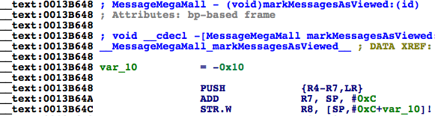
Figure 8- [MessageMegaMall markMessagesAsViewed:]
它的基地址是0x13b648。因为已知MobileMail的ASLR偏移是0xb2000，所以可以直接下断点：
Its base address is 0x13b648. Since the ASLR offset of MobileMail is 0xb2000, we can set a breakpoint like this:
(lldb) br s -a '0x000b2000+0x0013B648'
Breakpoint 4: where = MobileMail`___lldb_unnamed_function7357$$MobileMail, address = 0x001ed648
Process 103910 stopped
* thread #1: tid = 0x195e6, 0x001ed648 MobileMail`___lldb_unnamed_function7357$$MobileMail, queue = 'com.apple.main-thread, stop reason = breakpoint 4.1
frame #0: 0x001df648 MobileMail`___lldb_unnamed_function7357$$MobileMail
MobileMail`___lldb_unnamed_function7357$$MobileMail:
-> 0x1ed648: push {r4, r5, r6, r7, lr}
0x1ed64a: add r7, sp, #12
0x1ed64c: str r8, [sp, #-4]!
0x1ed650: mov r8, r0
(lldb) po $r2
{(
<MFLibraryMessage 0x157b70b0: library id 906, remote id 13142, 2014-12-17 22:34:30 +0000, 'Asian Morning: Obama Announces U.S. and Cuba Will Resume Relations'>
)}
(lldb) po [$r2 class]
__NSSetI
LLDB的输出验证了之前的猜测，[MessageMegaMall markMessagesAsViewed:]就是把邮件标为已读的方法，且其参数是一个由MFLibraryMessage对象组成的NSSet。至此，我们成功地在界面上添加了白名单按钮，捕获到了“刷新完成”事件，拿到了所有邮件，提取了其中的发件人地址，并能将它们标为已读。tweak原型搭建完毕，在写代码前，先整理一下逆向结果。
The output of LLDB validates our assumption. [MessageMegaMall markMessagesAsViewed:] is the right method for marking messages as read and its argument is an NSSet of MFLibraryMessage objects. Till now, we have successfully added the whitelist button, captured the refresh completion event, got all emails and their senders, as well marked them as read. Tweak prototyping comes to an end, let’s comb our thoughts before writing code.

8.3逆向结果整理

8.3 Result interpretation
本章的实例模块划分明显，任务分工明确，搭建tweak原型时的思路非常清晰，如下所示。
The practice in this chapter is highly modularized; every part in Mail has a clear division of work, which speeds up our tweak prototyping.

在界面上寻找添加白名单按钮的地方和方法

Find the place and method for adding whitelist button
本着既要直观又要美观的原则，我们在简单尝试了几种方案之后，决定把白名单按钮添加在Mailboxes界面的左上角。通过Cycript拿到MailboxPickerController的套路已是驾轻就熟，在导航栏添加按钮自然是水到渠成。
Sticking to the principle of both understandability and harmony, we have tried several solutions and finally decided to put the whitelist button at the top left corner of Mailboxes view. We are all familiar with the pattern to get MailboxPickerController with Cycript, so there is no difficulty for us to add a button on its navigation bar.

在protocol里寻找“刷新完成”的响应函数

Find the refresh completion callback methods in protocol
同第7章“寻找实时监测字数变化”的方法一脉相承，本章以MailboxContentViewController.h中的protocol为线索，通过遍历头文件，猜测关键词的方法，找到了“刷新完成”的响应函数。经过测试，megaMallMessageCountChanged:会在邮件数量发生变化时得到调用，符合条件。
Again in this chapter, we’ve used the protocols in MailboxContentViewController.h as clues, walked through all corresponding headers and guessed the keywords, then finally found the refresh completion callback method, just like what we’ve done in “find a method to monitor note text changes in real time”, chapter 7. After testing, megaMallMessageCountChanged: is called when email count changes, thus meet our requirements.

从MessageMegaMall中拿到所有邮件

Get all emails from MessageMegaMall.
根据“协议方法被调用，一般是因为方法名中提到的那个事件发生了；而那件事发生的对象，一般是协议方法的参数”的经验，我们在megaMallMessageCountChanged:的参数中发现了MessageMegaMall这个类。“大型购物中心”的名字很隐晦，通过对它的调查，发现它就是一个保存了所有邮件的M。调用[MessageMegaMall copyAllMessages]，可以拿到所有邮件。
According to the experience that “The reason a protocol method gets called is generally that the corresponding event mentioned in the method name happened. And the thing that triggers the event is usually the method’s arguments”, we’ve found class MessageMegaMall from the argument of megaMallMessageCountChanged:. The name, MegaMall, is very obscure. With wild guesses and programmatic checks, we’ve discovered that it is the model for email managements. By calling [MessageMegaMall copyAllMessages], we can get all emails.

从MFLibraryMessage中提取发件人地址

Get the sender’s address from MFLibraryMessage
通过[MessageMegaMall copyAllMessages]拿到的邮件类型是MFLibraryMessage。通览MFLibraryMessage及相关头文件，用LLDB测试几个可疑的property和函数，很容易就可以从中提取发件人地址。
[MessageMegaMall copyAllMessages] returns an array of MFLibraryMessage objects. By inspecting MFLibraryMessage.h and related headers, as well testing some suspicious properties and methods, we can easily get the sender’s addresses from this class.

用MessageMegaMall将邮件标记为已读

Mark emails as read with MessageMegaMall
在调查MessageMegaMall时，就已经注意到了可疑的markMessagesAsViewed:，几乎不需要测试就能肯定它是将邮件标记为已读的函数，当然，LLDB的测试结果也直接证明了这个结论的正确性。
When we were studying MessageMegaMall.h, we have noticed the uncertain target method, markMessagesAsViewed:. We could even say for sure it was what we were looking for without any test. Of course, the result from LLDB proved our conclusion directly.
注意：为了简化示例，8.4节的白名单仅含有一个邮箱地址，以UIAlertView的形式展现给用户。作为练习，你可以把它扩充成一个UITableView，让它变得更实用。
Attention: In order to simplify the example, the whitelist in section 8.4 consists of only one single email address, and it’s presented as a UIAlertView. As an exercise, it’s your turn to extend it with more addresses and use a UITableView to present it, make this practice more useful.

8.4 编写tweak

8.4 Tweak writing
在搭建tweak原型的阶段，所有的难点都已被一一攻破，正式编写tweak时只需要简单地整理一下8.3节的结论，就可以得出的漂亮的代码了。
All difficulties have been overcome during the stage of prototyping. Now we just need to follow the conclusion we get in section 8.3 and write the tweak with elegant code.

用Theos新建tweak工程“iOSREMailMarker”

Create tweak project “iOSREMailMarker” using Theos
新建iOSREMailMarker工程的命令如下：
The Theos commands are as follows:
hangcom-mba:Documents sam$ /opt/theos/bin/nic.pl
NIC 2.0 - New Instance Creator
------------------------------
[1.] iphone/application
[2.] iphone/cydget
[3.] iphone/framework
[4.] iphone/library
[5.] iphone/notification_center_widget
[6.] iphone/preference_bundle
[7.] iphone/sbsettingstoggle
[8.] iphone/tool
[9.] iphone/tweak
[10.] iphone/xpc_service
Choose a Template (required): 9
Project Name (required): iOSREMailMarker
Package Name [com.yourcompany.iosremailmarker]: com.iosre.mailmarker
Author/Maintainer Name [sam]: sam
[iphone/tweak] MobileSubstrate Bundle filter [com.apple.springboard]: com.apple.mobilemail
[iphone/tweak] List of applications to terminate upon installation (space-separated, '-' for none) [SpringBoard]: MobileMail
Instantiating iphone/tweak in iosremailmarker/...
Done.

2. 构造iOSREMailMarker.h

2. Compose iOSREMailMarker.h
编辑后的iOSREMailMarker.h内容如下：
The finalized iOSREMailMarker.h looks like this:
@interface MailboxPickerController : UITableViewController
@end

@interface NSConcreteNotification : NSNotification
@end

@interface MessageMegaMall : NSObject
- (void)markMessagesAsViewed:(NSSet *)arg1;
- (NSSet *)copyAllMessages;
@end

@interface MFMessageInfo : NSObject
@property (nonatomic) BOOL read;
@end

@interface MFLibraryMessage : NSObject
- (NSArray *)senders;
- (MFMessageInfo *)copyMessageInfo;
@end
这个头文件的所有内容均摘自类对应的头文件，构造它的目的仅仅是通过编译，避免出现任何报错信息和警告。
This header is composed by picking snippets from other class-dump headers. The existence of this header is simply for avoiding any warnings or errors when compiling the tweak.

8.4.3 编辑Tweak.xm

8.4.3 Edit Tweak.xm
编辑后的Tweak.xm内容如下：
The finalized Tweak.xm looks like this:
#import "iOSREMailMarker.h"

%hook MailboxPickerController
%new
- (void)iOSREShowWhitelist
{
UIAlertController *alertController = [UIAlertController alertControllerWithTitle:@"Whitelist" message:@"Please input an email address" preferredStyle:UIAlertControllerStyleAlert];
UIAlertAction *okAction = [UIAlertAction actionWithTitle:@"OK" style:UIAlertActionStyleDefault handler:^(UIAlertAction * action) {
UITextField *whitelistField = alertController.textFields.firstObject;
if ([whitelistField.text length] != 0) [[NSUserDefaults standardUserDefaults] setObject:whitelistField.text forKey:@"whitelist"];
}];
UIAlertAction *cancelAction = [UIAlertAction actionWithTitle:@"Cancel" style:UIAlertActionStyleCancel handler:nil];
[alertController addAction:okAction];
[alertController addAction:cancelAction];
[alertController addTextFieldWithConfigurationHandler:^(UITextField *textField) {
textField.placeholder = @"snakeninny@gmail.com";
textField.text = [[NSUserDefaults standardUserDefaults] objectForKey:@"whitelist"];
}];
[self presentViewController:alertController animated:YES completion:nil];
}

- (void)viewWillAppear:(BOOL)arg1
{
self.navigationItem.leftBarButtonItem = [[[UIBarButtonItem alloc] initWithTitle:@"Whitelist" style:UIBarButtonItemStylePlain target:self action:@selector(iOSREShowWhitelist)] autorelease];
%orig;
}
%end

%hook MailboxContentViewController
- (void)megaMallMessageCountChanged:(NSConcreteNotification *)arg1
{
%orig;
NSMutableSet *targetMessages = [NSMutableSet setWithCapacity:600];
NSString *whitelist = [[NSUserDefaults standardUserDefaults] objectForKey:@"whitelist"];
MessageMegaMall *mall = [arg1 object];
NSSet *messages = [mall copyAllMessages]; // Remember to release it later
for (MFLibraryMessage *message in messages)
{
MFMessageInfo *messageInfo = [message copyMessageInfo]; // Remember to release it later
for (NSString *sender in [message senders]) if (!messageInfo.read && [sender rangeOfString:[NSString stringWithFormat:@"<%@>", whitelist]].location == NSNotFound) [targetMessages addObject:message];
[messageInfo release];
}
[messages release];
[mall markMessagesAsViewed:targetMessages];
}
%end

8.4.4 编辑Makefile以及control

8.4.4. Edit Makefile and control files
编辑后的Makefile内容如下：
The finalized Makefile looks like this:
THEOS_DEVICE_IP = iOSIP
ARCHS = armv7 arm64
TARGET = iphone:latest:8.0

include theos/makefiles/common.mk

TWEAK_NAME = iOSREMailMarker
iOSREMailMarker_FILES = Tweak.xm
iOSREMailMarker_FRAMEWORKS = UIKit

include $(THEOS_MAKE_PATH)/tweak.mk

after-install::
install.exec "killall -9 MobileMail"

编辑后的control内容如下：
The finalized control looks like this:
Package: com.iosre.mailmarker
Name: iOSREMailMarker
Depends: mobilesubstrate, firmware (>= 8.0)
Version: 1.0
Architecture: iphoneos-arm
Description: Mark non-whitelist emails as read!
Maintainer: sam
Author: sam
Section: Tweaks
Homepage: http://bbs.iosre.com

8.4.5 测试

8.4.5 Test
将写好的tweak编译打包安装到iOS后，打开Mail，因为还没配置iOSREMailMarker，所以Mail跟以前没什么两样。此时，收件箱里一共有44封未读邮件，如图8-18所示。
Compile the tweak and install it on iOS. Open Mail and seems nothing changed. That is because we haven’t configured iOSREMailMarker yet. As shown in figure 8-18, currently there are 44 unread messages.
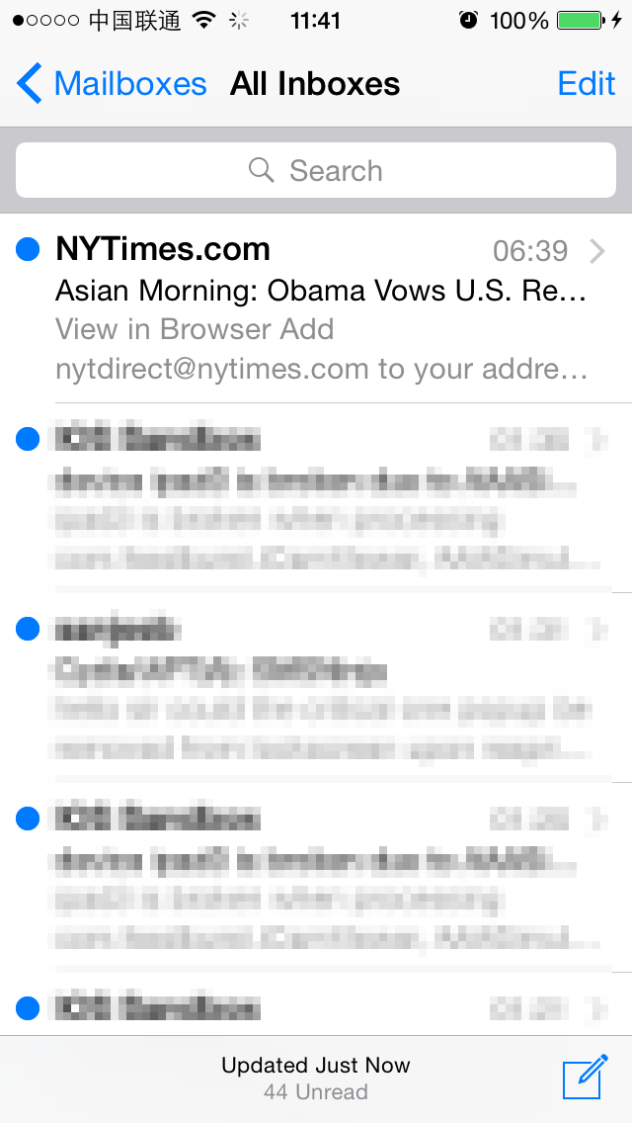
Figure 8- 44 unread emails
进入Mailboxes界面，左上角新增了一个“Whitelist”按钮。点击它，弹出一个白名单编辑对话框，如图8-19所示。
After entering the “Mailboxes” view, there is a new whitelist button on the left side of navigation bar. Press it and a new whitelist dialog will pop up, as shown in 8-19.
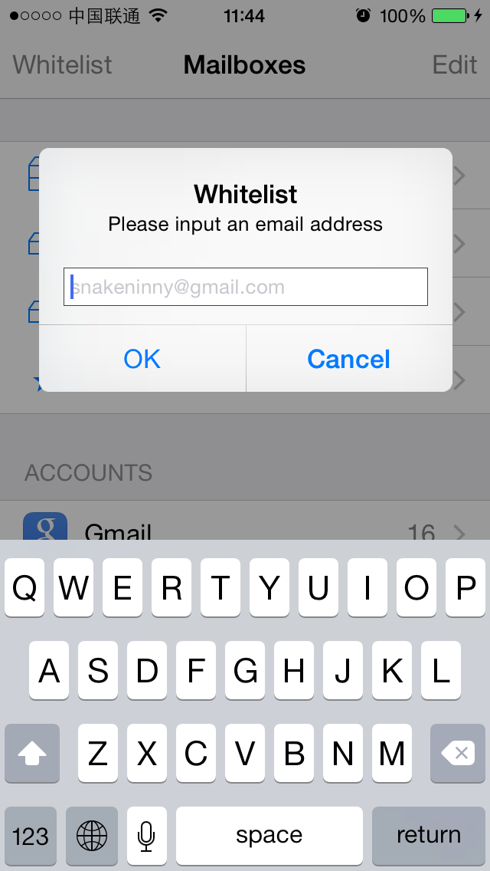
Figure 8- Whitelist dialog
笔者订阅了一份纽约时报，每天都会花上15分钟左右了解当日时事。把纽约时报的订阅邮箱地址加入白名单，如图8-20所示。
I’ve subscribed a copy of NYTimes and spend about 15 minutes on it every day. Let’s add NYTimes into whitelist, as shown in figure 8-20.
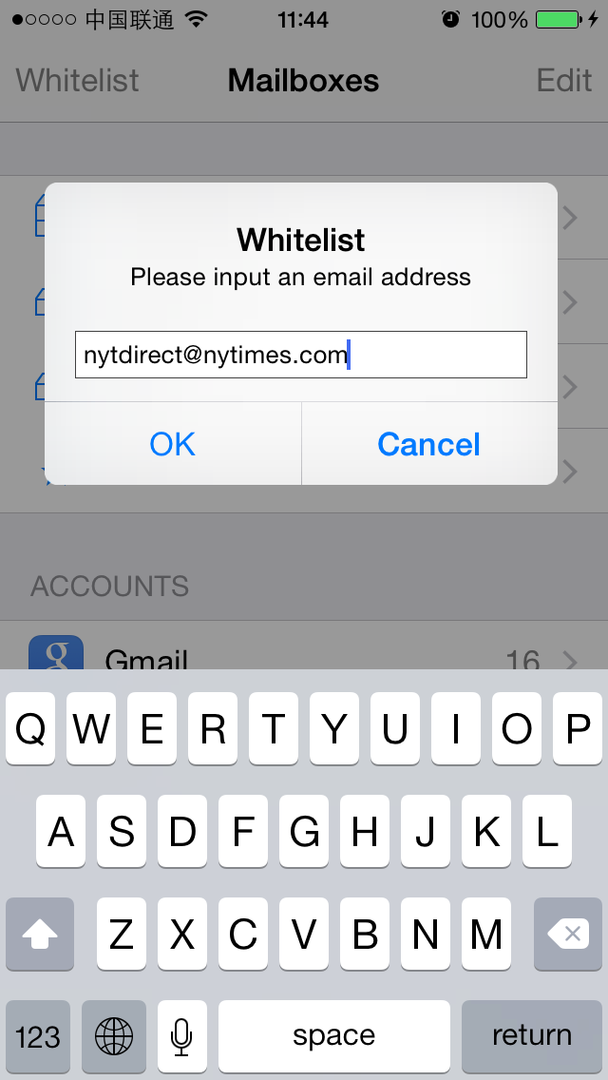
Figure 8- Add NYTimes into whitelist
最后给自己发一封邮件，触发megaMallMessageCountChanged:函数。在成功收到这封邮件后，除了纽约时报以外的所有邮件均被标记为已读，收件箱里只剩1封来自纽约时报的未读邮件，如图8-21所示。
At last, send an email to myself to trigger megaMallMessageCountChanged:. After receiving the email, all emails except NYTimes are marked as read, as shown in 8-21.
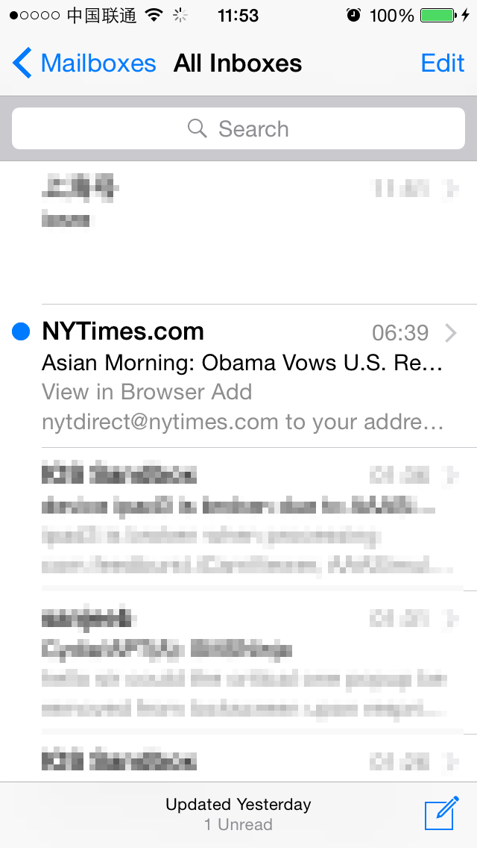
Figure 8-21 iOSREMailMarker marked all emails except NYTimes as read
本章任务圆满结束。
So far, we have achieved all of our goals successfully.

8.5 小结

Conclusion
本章以Mail为目标，给它添加了白名单以外的邮件均自动标记为已读的功能，能够从一定程度上突出收件箱中的重点内容。iOSREMailMarker的过滤条件略显简单，将邮件直接标记为已读的方案也不一定适合所有人，希望读者能够在阅读过程中举一反三，模仿本章思路打造属于自己的独一无二的Mail插件，然后来http://bbs.iosre.com分享你的成果。经过两章实战，相信大家也有跟我一样的体会：在iOS逆向工程中，需要工具未动，思想先行。只有在前期对目标的分析过程中下足功夫，后期的tweak编写才会如鱼得水。逆向工程行业的前辈TiGa曾说：“A reverser should know how/what is done before grabbing tools to complete the tasks automatically”，相信大家在不断的逆向求索中也会逐渐感悟这句话的涵义。
In this chapter, we’ve taken Mail as an example and added a feature that can automatically mark emails outside whitelist as read, which helps us highlight the important emails. The filter condition of iOSREMailMarker is somewhat simple, and it may not be a good solution for everyone to simply mark emails as read. So I hope you can learn this chapter by analogy and intimidate the idea to make your own unique tweak. Of course, you are welcome to share your work on our website.
So far, we have gone through 2 practices. I hope everyone enjoyed them and had the feeling that our brains should keep one step ahead of our hands in iOS reverse engineering. Only when you get fully prepared during early stage analysis can you write an excellent tweak later. TiGa, a veteran reverse engineer, once said “A reverser should know how/what is done before grabbing tools to complete the tasks automatically.” I believe that everyone will gradually realize the meaning of this sentence during continuously studying reverse engineering.

