**Intel® System Studio**

**Intel® VTune™ Amplifier - Platform Profiler**

**Prerequisite:**

<WINDOWS>

Open Windows command prompt: cmd.exe

cd C:\IntelSWTools\system_studio_2019\VTune_Amplifier_2019\vpp\server>

\vpp\server>vpp-server-vars.cmd

\vpp\server>vpp-server.exe config

Wait around 5 min to complete a cofiguration.

<LINUX>

sudo apt-get update

sudo apt install dstat

source <VPP_INSTALL_DIR>/server/vpp-server-vars.sh

( e.g., source /home/<user>/system_studio_2019/vtune_amplifier_2019.3.0.590814/vpp/server/vpp-server-vars.sh )

vpp-server-config

**Part 1: Intel® VTune™ Amplifier-Platform Profiler: Get Started**

Compile the sample using different optimization options to create different optimized executables:

|  |  |
| --- | --- |
| About this Lab | Configure and run the Intel® VTune™ Amplifier-Platform Profiler. |
| Estimated Duration | 10min |
| Learning Objectives | After you complete this Lab, you should be able to:   * Start Platform Profiler. * Collect and open Profiling data. * Use GUI (zoom) to analysis it. |

< WINDOWS >

\vpp\server>vpp-server-start

Launching influxdb in background

Initializing data repository...

Launching server in background

--------------------------------------------------------------------------------

Server is running. Browse to

<http://localhost:6543>

\vpp\server>cd ../collector

\vpp\collector>vpp-collect-vars.cmd

\vpp\collector>vpp-collect-start

Initializing collection. Please wait...

C:\IntelSWTools\system_studio_2019\VTune_Amplifier_2019\vpp\collector>Collection has started. You may now use vpp-collect-mark to label timestamps in your collection.

Hit Enter to continue...

\vpp\collector>vpp-collect-stop

C:\IntelSWTools\system_studio_2019\VTune_Amplifier_2019\vpp\collector>Emon collector successfully stopped.

Hit Enter to continue...

.

Stopped gathering system data. Result is saved in C:\IntelSWTools\system_studio_2019\VTune_Amplifier_2019\vpp\collector\PARKJON-MOBL1-20190331-2113

Generating common metrics

Computed 98 metrics from 111 events among 25 rows.

Processing complete! Output file : C:\IntelSWTools\system_studio_2019\VTune_Amplifier_2019\vpp\collector\PARKJON-MOBL1-20190331-2113\emon_results_metrics.csv

Post-processing topology data

Finished processing metrics

Compressing and removing result directory

Collection done, hit Enter to continue...

vpp-server-start

Launching influxdb in background

Initializing data repository...

Launching server in background

--------------------------------------------------------------------------------

Server is running. Browse to

<http://localhost:6543>

source <VPP_INSTALL_DIR>/collector/vpp-collect-vars.sh

(e.g., source /home/<user>/system_studio_2019/vtune_amplifier_2019.0.1.564228/vpp/collector/vpp-collect-vars.sh)

vpp-collect-start

vpp-collect-stop

< LINUX >

Go to <http://localhost:6543> in Chrome.

Click View Results.

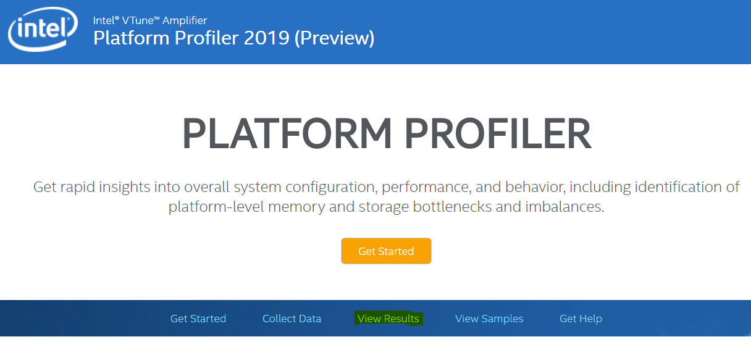

Click Upload and find the Collection results are available in a compressed file in the current directory (<machine-name>_<datetime>.tgz/zip).

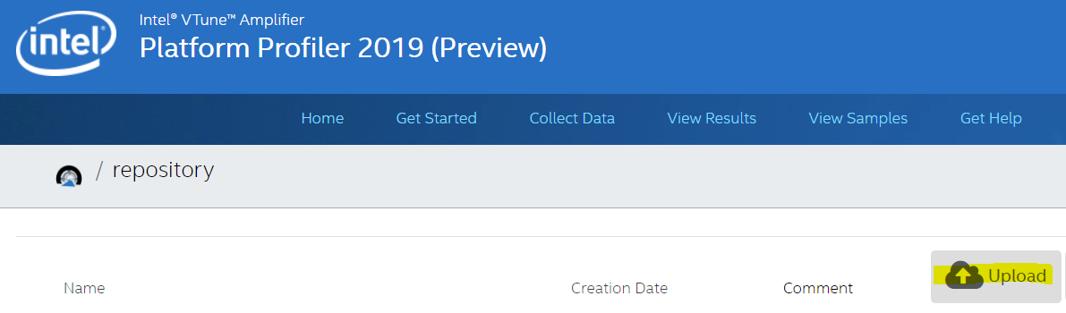

Click the uploaded result and verify the result.

Move mouse pointer over each metric data and verify the details of metric.

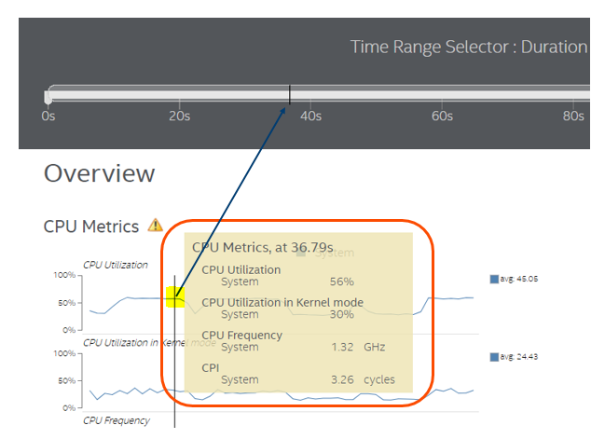

You can change views in Select View.

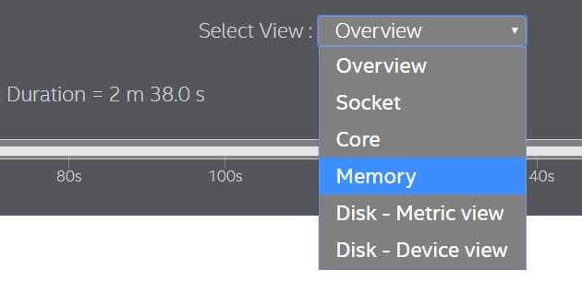

Drag your mouse at the metric timeline to zoom.

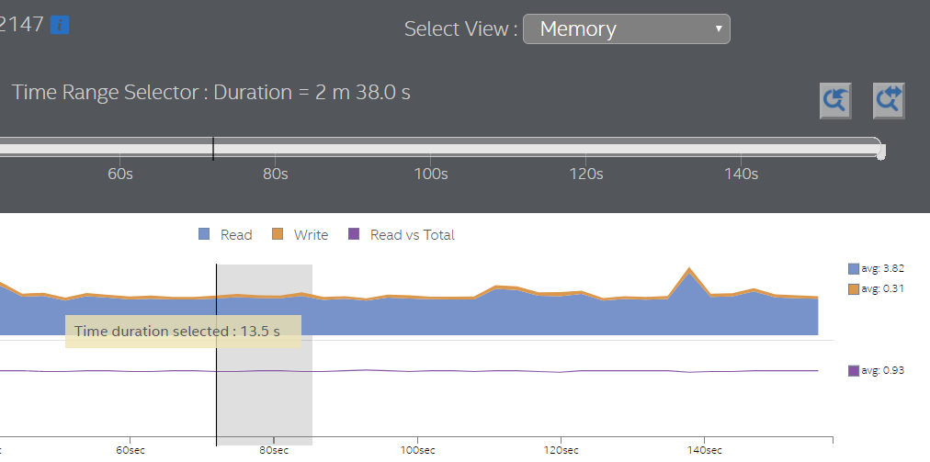

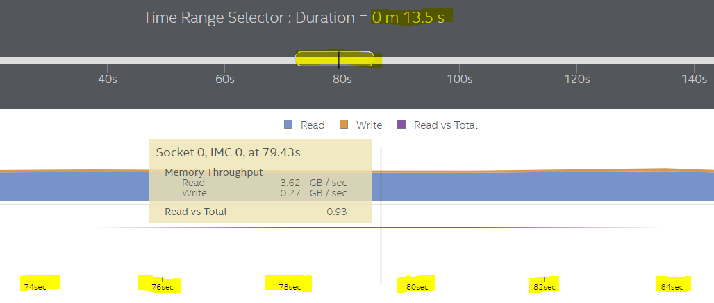

You can zoom by moving the edge of bar and undo/reset zoom.

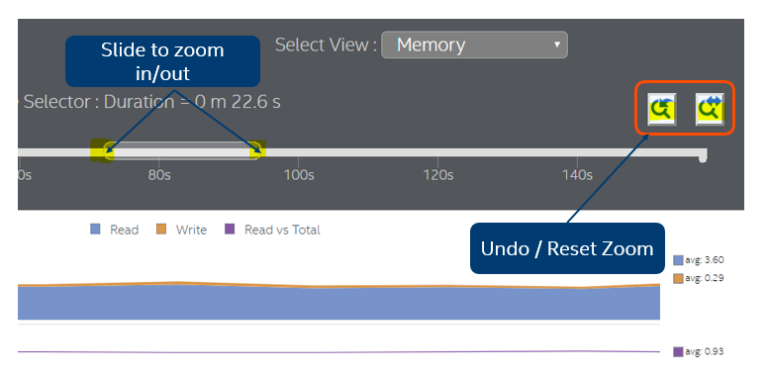

**Part 2: Intel® VTune™ Amplifier-Platform Profiler: Add memory workload with VPP comments**

|  |  |
| --- | --- |
| About this Lab | Run Platform Profiler with memory workload and add comments |
| Estimated Duration | 10 min |
| Learning Objectives | After you complete this Lab, you should be able to:   * Use a memory and CPU metric to identify system workload. * Add comments into VPP result. * Use zoom |

< Windows >

Unzip mlc_v3.6.zip and open cmd.exe. Go to the mlc_v3.6 unzipped folder.

< Linux >

Unzip mlc_v3.6.tgz

Go to <http://localhost:6543> in Chrome.

vpp-collect-start

Add DRAM access workloads.

mlc --loaded_latency

And add comments.

vpp-collect-mark "mlc workload start"

Wait a min.

CTRL+C to stop workload.

Add comments.

vpp-collect-mark "mlc workload stop"

vpp-collect-stop

Click Upload and find the Collection results are available in a compressed file in the current directory (<machine-name>_<datetime>.tgz/zip).

Click the uploaded result.

## Go to yellow mark and see the ‘mlc workload start’ and ‘mlc workload stop’. And verify the high utilization of CPU utilization and memory throughput with mlc workload (memory read).

## 

## 

## Go to Select View and choose memory and see the peak memory throughput.

## 

**Part 3: Intel® VTune™ Amplifier-Platform Profiler: Add network workload with VPP comments (Linux Only)**

|  |  |
| --- | --- |
| About this Lab | Run Platform Profiler with network workload and add VPP comments |
| Estimated Duration | 10 min |
| Learning Objectives | After you complete this Lab, you should be able to:   * Use a network metric to identify network workload. |

< Linux >

If you don’t have iperf3 in your Linux server, install it to add network loads.

sudo apt install iperf3

Open up one terminal and run below command to start a server listen to a default port:

Iperf3 –s

Open up another terminal and run below commands:

Ifconfig -> to get ip address of the machine

vpp-collect-start

Wait around 30 seconds.

vpp-collect-mark "iperf3 workload start"

Iperf3 –c <ip-address>

Vpp-collect-stop

Go to <http://localhost:6543> in Chrome.

Click Upload and find the Collection results are available in a compressed file in the current directory (<machine-name>_<datetime>.tgz/zip).

Click the uploaded result.

Move mouse to CPU Metrics timeline.

## 

## Around 50s, it has a low CPU utilization.

Scroll down and verify network send / receive throughput after your mark - "iperf3 workload start" and "iperf3 workload end"

## 

## 

## Drag wlan0 timeline to zoom it and move over the peak throughput.

## 

## 

## You can see details on each metric when you move your mouse pointer over it.

## 

**Part 4: Intel® VTune™ Amplifier-Platform Profiler: Monitor CPU frequency from SST-BF testing workload**

## <Linux>

## Run high performance workload (load is 2.9 million packets/second), SST-BF is disabled. Packets will be dropped.

cd ${git_base_path}/scripts

./trex-load-64byte-high.sh

## Wait for 30 seconds

## Vpp-collect-start –c “highPerformanceWorkload”

## Wait for 1 minute

## Enable SST-BF

cd ${git_base_path}/scripts

./sstbf.py –a

Mark VPP profiling with a new comment

Vpp-collect-mark “sst-bfEnabled”

Wait for 1 minute

Vpp-collect-stop

Overall CPU metrics

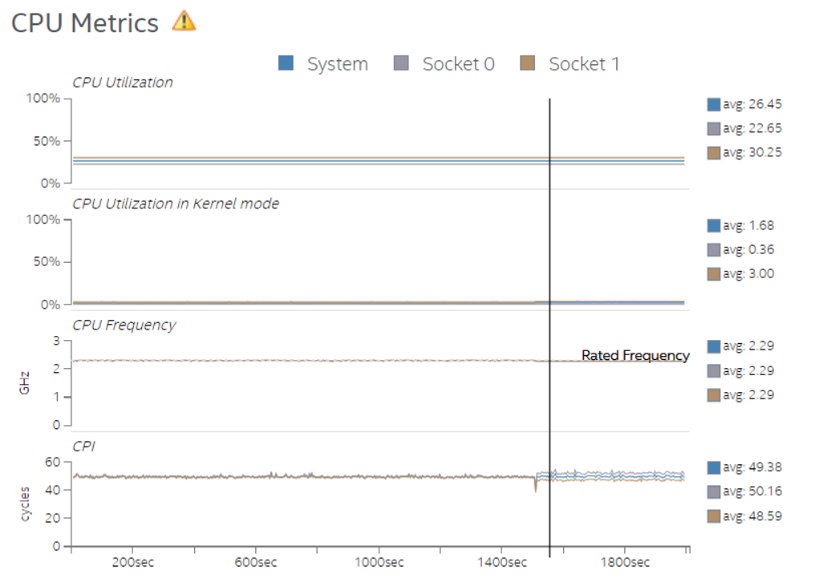

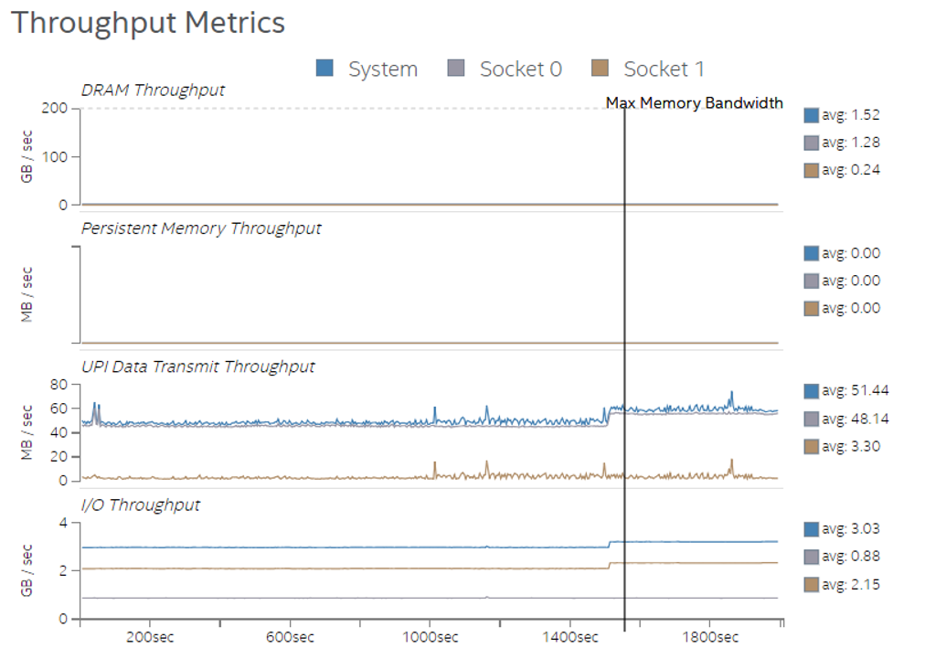

Power Metrics

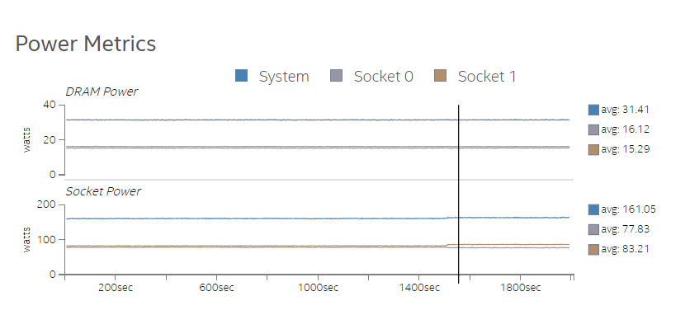

CPU metrics per core on socket 0

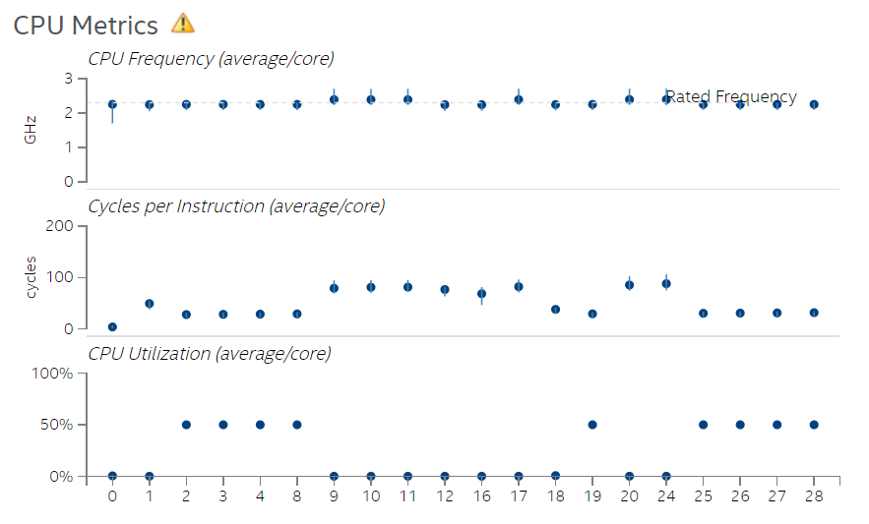

Instructions Types executed. Correlate Instruction mix metric with CPU utilization per core metric.

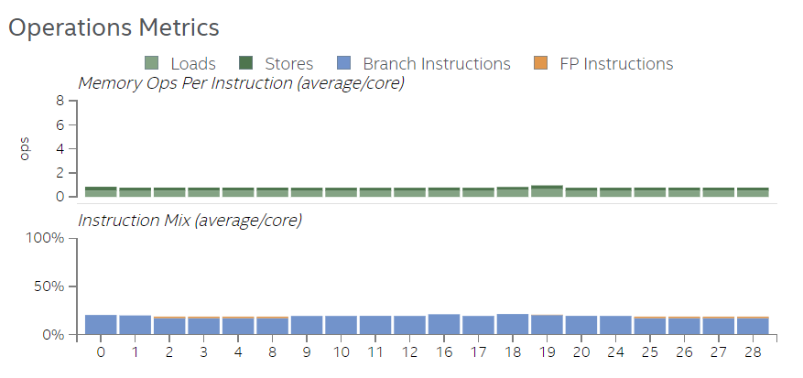

CPU frequency and CPI on Core 2

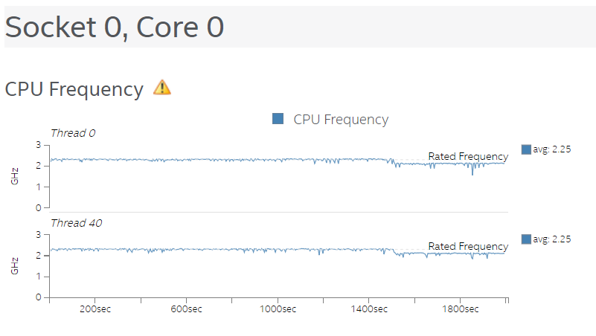

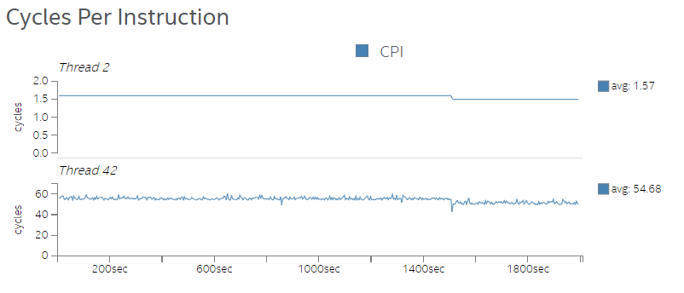

CPU frequency and CPI on Core 9

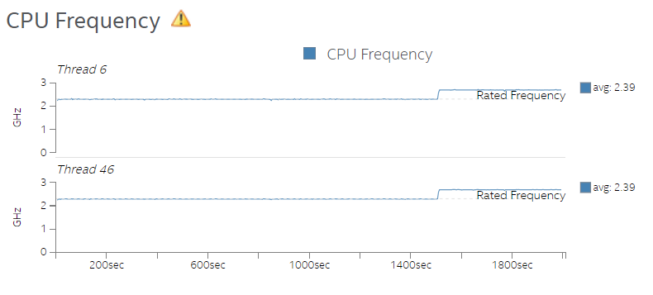

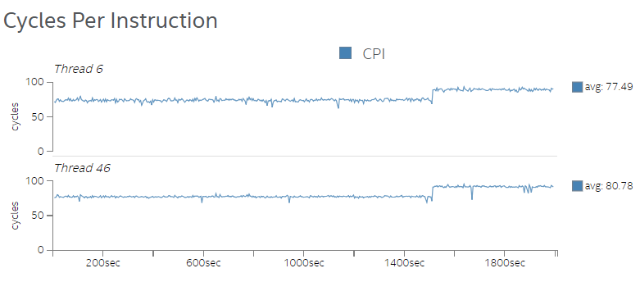

DRAM traffic per channel

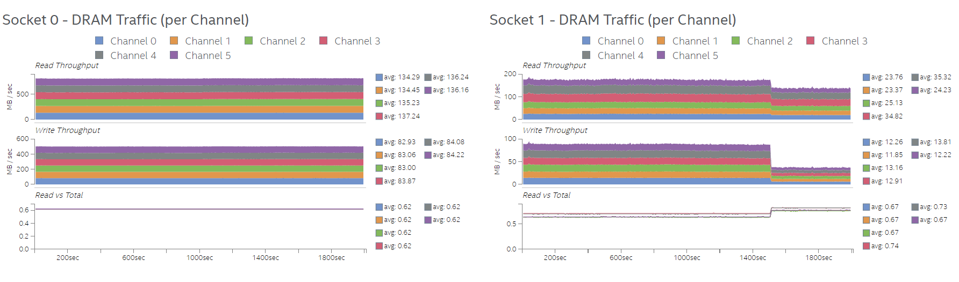

UPI data transmit throughput per socket

## 

## I/O bandwidth per socket

## 

## Network Throughput

## 

## Next Steps

* Consider whether an upgrade to hardware components (CPU, memory, storage, network) would improve performance. After new hardware is installed, re-run Platform Profiler and compare performance between the older and newer components.
* Analyze the collected data to determine where the performance bottleneck is most prevalent and which components are impacted. If a specific portion of the workload is causing performance issues, consider running the following analysis types using Intel® VTune™ Amplifier using a targeted collection interval (seconds instead of hours):
  + **Microarchitecture Exploration**: Identify issues with CPU utilization, cache, or memory
  + **Memory Access**: Identify memory issues
  + **Input and Output**: Identify storage usage issues

<References>

HOW TO ANALYZE & OPTIMIZE LONG WORKLOAD RUNS WITH PLATFORM PROFILER: <https://techdecoded.intel.io/quickhits/how-to-analyze-optimize-long-workload-runs-with-platform-profiler/#gs.2w5cfd>

Get Started with Intel® VTune™ Amplifier Platform Profiler for Windows*: <https://software.intel.com/en-us/get-started-with-platform-profiler-windows>

Intel® VTune™ Amplifier - Platform Profiler Overview : <https://software.intel.com/en-us/articles/intel-system-studio-intel-vtune-amplifier-platform-profiler-overview>

**<The end>**