SOFTWARE REQUIREMENTS SPECIFICATION

( SRS DOCUMENT )

FOR

<NEXUS>

VER. 1.0

BY

LEADER NAME : RUDRAAKSHYA(20/ICS/056)

MEMBER NAME 1: VANSHIKA (20/BIT/041)

MEMBER NAME 2: VAIBHAV (20/ICS/075)



**REPORTED BY : TEAM NEXUS**

**_____PROBLEM STATEMENT_____**

**WE HAVE BROUGHT TO YOU THE NEXUS MUSIC WEB BASED APPLICATION.**

**LEADING APPLICATIONS CONTAINS ADS AND ARE REQUIRED PREMIUM WHICH CAN BE IRRITATING AT TIMES TO A USER**

**KEEPING IN MIND NEXUS IS CREATED.**

**NEXUS HERE ITSELF IS FREE AND SAME FOR ALL.**

**____REQUIREMENTS____**

**HARDWARE REQUIRED :**

1. SMART DEVICE THAT SUPPORTS INTERNET
2. INTERNET CONNECTIVITY

**SOFTWARE REQUIRED :**

1. **BROWSER**

**( BECAUSE NEXUS IS CURRENTLY SUPPORTS ONLY WEB PLATFORM )**

**\**

**____TECHNOLOGIES USED____**

**LANGUAGES USED:-**

**HTML , CSS , JAVASCRIPT**

**SOFTWARE USED :-**

**MICROSOFT VISUAL STUDIO CODE**

**FLUENTILA**

**ADOBE PHOTOSHOP**

___PROJECT DESCRIPTION___

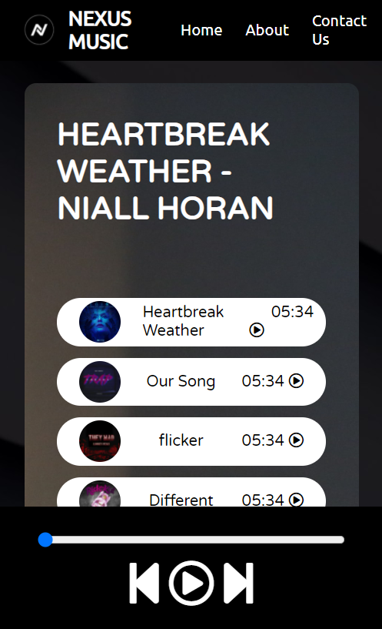 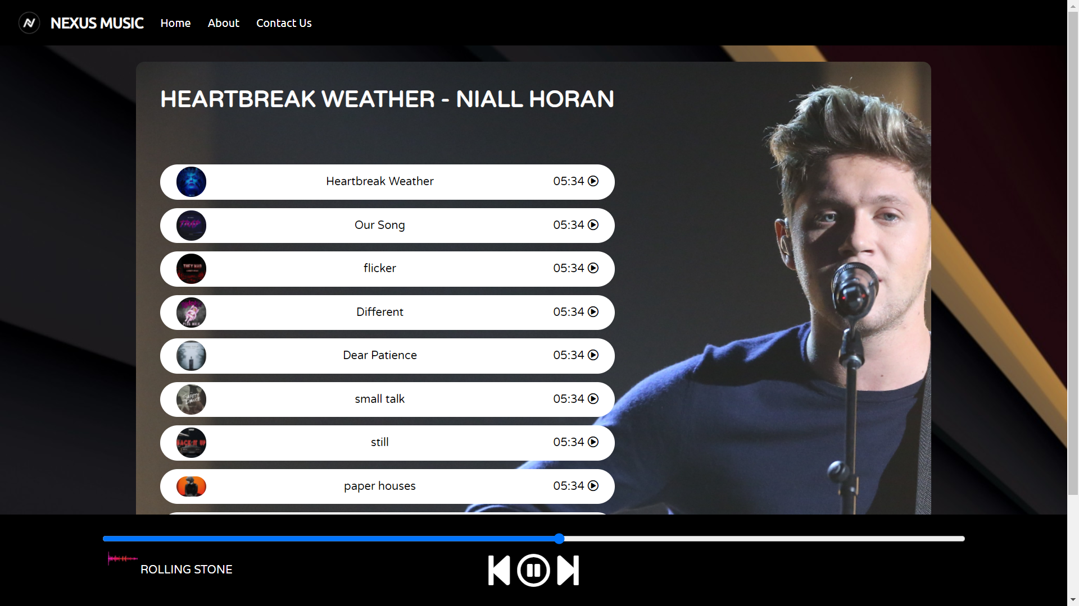

NEXUS MUSIC IS A WEB BASED APPLICATION THAT RUN SMOOTHLY

FREE OF COST

NO PREMIUM REQUIRED

TOTALLY ADD FREE

THIS IS CREATED WITH USING WEB DEVELOPMENT LANGUAGES LIKE HTML,CSS,JS

THIS APPLICATION CAN BE OPENED AND STREAMED IN ANY DEVICE

IRRESPECTIVE OF DEVICE’S DIMENSION

CONTAINS ANIMATIONS AND CURENTLY WORKS ON DARK MODE

FUTURE UPDATES WOULD CONTAIN BUG FIXES AND IMPROVED PERFORMANCE.

___SCOPE___

TEAM NEXUS HAVE ONLY ONE GOAL TO PROVIDE MAXIMUM PERFORMANCE AND LAG FREE ENVIRONMENT TO THE USER,

SIMPLISTIC USER INTERFACE MAKES IT LOOK CLEANER

FUTURE UPDATE WOULD INCLUDES EVEN ADJUSTABLE VIEW MODE

AND CAN BE ACCESSED ON INTERNET FROM ANYWHERE IN NEAR FUTURE WITH EVEN SEARCH OPTION TO WIDE RANGE OF SONGS //.

**____CHALLENGES FACED____**

**ANIMATION THE PLAY PAUSE BUTTON IN JS WAS A TASK THAT REALLY TOOK TIME , BECAUSE EVEN WITH A SMALLER CHANGE IN CODE WAS AFFECTING THE OUTPUT**

**\*THE GLITCH WAS LATER FIXED\***

**WERE NEW TO JS SO THINGS ARE DEFINATELY CHALLENGING TO US.**

**____CONCLUSION____**

**AFTER CHALLENGES**

**AT THE END WE HAPPILY PRESENTING TO YOU THE**

**NEXUS MUSIC**



**HAPPY NEXUS LIFE**

**REGARDS TEAM NEXUS**