Decomposing fungi: diversity, taxonomy and phylogeny (Georgia, 16 pt, bold)

ABSTRACT
Mycological research in tropical countries remains underrepresented in global scientific output. In this context, Brazil stands out as a megadiverse territory whose scientific production in mycology has grown substantially, yet its development has not been systematized or critically assessed. In this study, we present the first comprehensive bibliometric analysis of Brazilian mycology, integrating publication data from the Web of Science (1945-2023) with researcher profiles from the national Lattes Platform. Our analysis reveals a significant increase in fungal studies over recent decades, predominantly concentrated in the Southeast and South regions, with the Universidade de São Paulo (USP) acting as the central hub of national collaborations. Despite this growth, spatial asymmetries persist, with underrepresentation of certain regions, such as those encompassing the Amazon and Cerrado biomes, raising concems about gaps in mycological documentation. Additionally, our findings reveal gender disparities among national research fellows and a marked predominance of studies focusing on Ascomycota and Basidiomycota, limiting the exploration of lesser-known fungal phyla. This work not only highlights the scientific potential and existing challenges of Brazilian mycology but also serves as a critical baseline for promoting equitable research efforts and more comprehensive fungal biodiversity assessments in tropical countries.

Keywords - Fungal research output, knowledge gaps, scientific collaboration, spatial scientometrics, tropical mycobiota.

INTRODUCTION (UPPERCASE, Georgia, 12 pt, bold)

Citations are listed in chronological order [1], [2], [3], [4]. The introduction should briefly review the topic being investigated and present the objectives of the study. [Note: ‘&’ not ‘and’; no comma after authors; comma to separate citations] (Georgia, 12 pt)

MATERIALS AND METHODS (UPPERCASE, Georgia, 12 pt, bold)

Isolates and morphology (subheadings: Lowercase, Georgia, 12 pt, bold)

The methods should be adequately detailed or referenced in other work (Tab. 1) (Tabs. 1, 3, 5).

RESULTS (UPPERCASE, Georgia, 12 pt, bold)

This can have subheadings (Fig. 1). There should be no reference citations in the results (Figs. 2, 3, 6–8). (Georgia, 12 pt)

Phylogenetic analyses (subheadings: Lowercase, Georgia, 12 pt, bold)

The results section should only include the results of this study and no comparison with other studies. Never use the term etc. in the text. For new species and genera, use the format below.

Taxonomy (subheadings: Lowercase, Georgia, 12 pt, bold)

Delortia palmicola Pat. & Gaillard, Bull. Soc. Mycol. Fr. 4(2): 43 (1888) Figs 12–18
≡ Homotypic synonym (if any)
= Heterotypic synonym (if any)

MycoBank: XXXX

Etymology: In reference to the Palmae substrate found.

Description: Conidiomata sporodochial, gelatinous, up to 1 cm diam., white on the substrate, composed of septate, branched, and hyaline hyphae. Conidiophores straight to flexuous, branched or not, 2–8 septate, up to 125 μm long, 1.5–2.5 μm wide, hyaline. Conidia tightly coiled, U- or horseshoe-shaped, the distal end rounded, and the proximal end attenuated, surrounded by a hyaline gelatinous sheath, 2–3 septate, 17.5–25 μm diam., 7.5–12.5 μm wide of filament, basal scar 1.5–2 μm diam., hyaline.

Habitat/Substrate/host: Saprotrophic species are mainly found on decaying palm petioles, rachis, and fronds; submerged leaves, twigs, and wood.

Known distribution: Widespread in tropical and subtropical regions.

IUCN status: indicate the IUCN status according to https://www.iucnredlist.org/ (example: VU, IUCN LINK). If the species has not yet been categorised, register it at https://redlist.info/iucn/about/ (Suggested as VU, IUCN LINK).

Material examined: Country, Province, Town, place, on substrate, (date) 15 Jul 2009, (collector) PJ Smith, collectors’ number (herbarium, state if holotype or other type) – ex-type culture in CBC

Notes: The connection….

DISCUSSION (UPPERCASE, Georgia, 12 pt, bold)

This is where you compare your work with other research and put forward and discuss your major findings (Table 1). There must be adequate comparison and references to previous work. (Georgia, 12 pt)

Table 1. Ecological indices...

 | Hymenaea courbaril |  | Ziziphus joazeiro
 | Stage I* | Stage II* | Stage I* | Stage II*
Species richness | 33 | 31 | 8 | 3
Species evenness | 95 | 32 | 22 | 12
Shannon indices | 2.73 | 2.8 | 2.45 | 2.2
Shannon evenness | 0.70 | 0.80 | 0.90 | 0.9

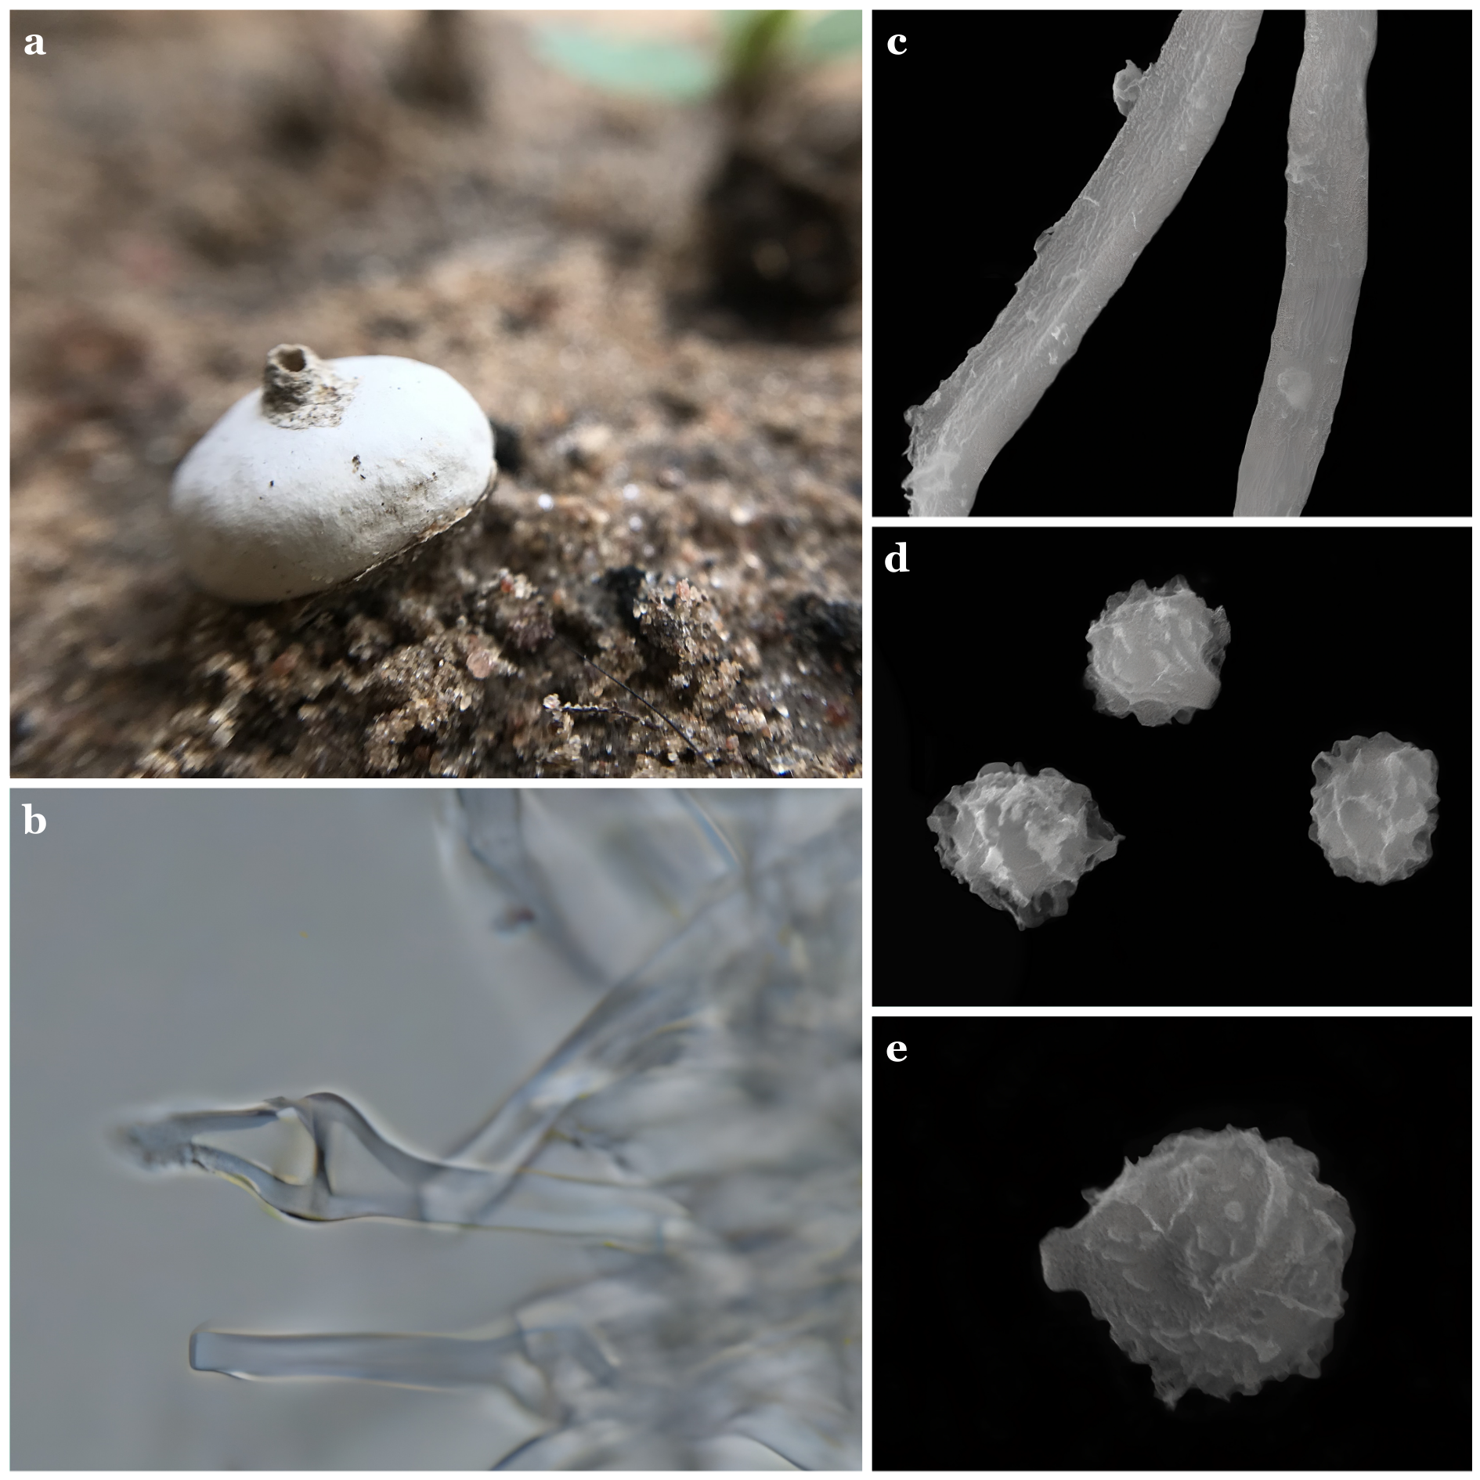

Figure 1. Tulostoma irregulireticulatum Dourado-Barbosa, Ren.L. Oliveira, A.A. Lima, Baseia & R. Cruz a. Detail of the slightly projected tubular mouth. b. Detail of inflated septa in the endoperidium hyphae. c. Capillitium under SEM. d–e. Surface irregularly reticulate of the basidiospores under SEM. Scale bar: a. 5 mm; b. 5 μm; c–d. 5 μm; e. 1 μm. (Note: Images should be in bold and contain lowercase letters, Georgia font, and size 12). [Photographs: 300 dpi (ex.: macro, microscopy, MEV, field pictures); Combined figures: 600 dpi (ex.: picture + text, graphics); Line drawings: 1000–1200 dpi (ex.: drawings, vectorial illustration, phylogenetic tree)]

CONCLUSION (UPPERCASE, Georgia, 12 pt, bold)
Based on results obtained…. (Georgia, 12 pt)

ACKNOWLEDGEMENTS (UPPERCASE, Georgia, 12 pt, bold)

We thank NAME for helping in the collection of the material …. (Georgia, 12 pt)

CONFLICT OF INTEREST (UPPERCASE, Georgia, 12 pt, bold)

The authors have declared that no competing interests exist. (Georgia, 12 pt)

USE OF IA (UPPERCASE, Georgia, 12 pt, bold)

Not applicable. (Georgia, 12 pt)

ETHICAL APPROVAL AND ADHERENCE TO NATIONAL AND INTERNATIONAL REGULATIONS (UPPERCASE, Georgia, 12 pt, bold)

Not applicable. (Georgia, 12 pt).
Collection permit number XXXX.
SISGEN number XXXXX
SISBIO number XXXX

CONSENT TO PUBLISH (UPPERCASE, Georgia, 12 pt, bold)

All authors consent to publish the data presented in the paper. (Georgia, 12 pt)

AUTHOR CONTRIBUTIONS (UPPERCASE, Georgia, 12 pt, bold)

All authors contributed to the study conception and design. Material preparation, data collection, and analysis were performed by NAME ACRONYM, NAME ACRONYM. The first draft of the manuscript was written by NAME ACRONYM, and all authors commented on previous versions of the manuscript. Conceptualization: NAME ACRONYMmethodology: NAME ACRONYM, formal analysis and investigation: NAME ACRONYM, writing original draft preparation: NAME ACRONYM, writing—review and editing: NAMES, methodology: NAME ACRONYM, funding acquisition: NAME ACRONYM, resources: NAME ACRONYMSupervision: NAME ACRONYM. All authors read and approved the final manuscript. (Georgia, 12 pt)

AUTHOR ORCIDS (UPPERCASE, Georgia, 12 pt, bold)

Author name https://orcid.org/0000-????-????-????

DATA AVAILABILITY STATEMENT (UPPERCASE, Georgia, 12 pt, bold)

Datasets generated during and/or analyzed during the current study are available at (inform the repository) or from the corresponding author upon request. (Georgia, 12 pt)

FUNDING (UPPERCASE, Georgia, 12 pt, bold)

Conselho Nacional de Desenvolvimento Científico e Tecnológico (CNPq)... (Georgia, 12 pt)

SUPPLEMENTERY MATERIAL (UPPERCASE, Georgia, 12 pt, bold)

Below is the link to the electronic supplementary material.... (Georgia, 12 pt)

(LINK)

REFERENCES (UPPERCASE, Georgia, 12 pt, bold)

[1] Alfaro ME, Zoller S, Lutzoni F. 2003 – Bayes or bootstrap? A simulation study comparing the performance of Bayesian Markov chain Monte Carlo sampling and bootstrapping in assessing phylogenetic confidence. Molecular Biology and Evolution 20, 255–266. (10.5943/35093875975/X/X/X)
[2] Anon. 2001–2009 – NZFungi database of New Zealand fungi. Landcare Research, New Zealand. http://nzfungi.landcareresearch.co.nz (Accessed on May 14, 2013).
[3] Arx JA von. 1981 – The Genera of Fungi Sporulating in Pure Culture. J. Cramer, Vaduz.
[4] Piasai O, Manoch L. 2009a – Coprophilous ascomycetes from Phu Luang Wildlife Sanctuary and Khao Yai National Park in Thailand. Kasetsart Journal (National Sciences) 43, 34–40.
[5] Piasai O, Manoch L. 2009b – Diversity of microfungi from animal excrement at Ko Samaesarn and Mu Ko Angthong National Park; 35th Congress on Science and Technology of Thailand. Department of Plant Pathology, Faculty of Agriculture, Kasetsart University, Bangkok.

Note: Page margins must be 0.8"/2.03 cm each side
Page size must be A4
Single spacing

