**MappervSSSTipoBien.cs**

public IEnumerable<vSSSTipoBien> GetAll()

{

string strSQL = "";

_listaResultados = new List<vSSSTipoBien>();

try

{

strSQL = "select distinct no_clasif_bien, no_ssubtipo, no_sssubtipo, desc_sssubtipo from V_TIPO_BIEN ";

strSQL += "order by desc_sssubtipo";

using (_connection = new OleDbConnection(StringConnection))

{

_connection.Open();

var lista = Dapper.SqlMapper.Query<vSSSTipoBien>(

_connection,

strSQL,

null,null,commandType: CommandType.Text

);

_listaResultados = lista.ToList();

}

}

catch (OleDbException ex)

{

throw ex;

}

return _listaResultados;

}

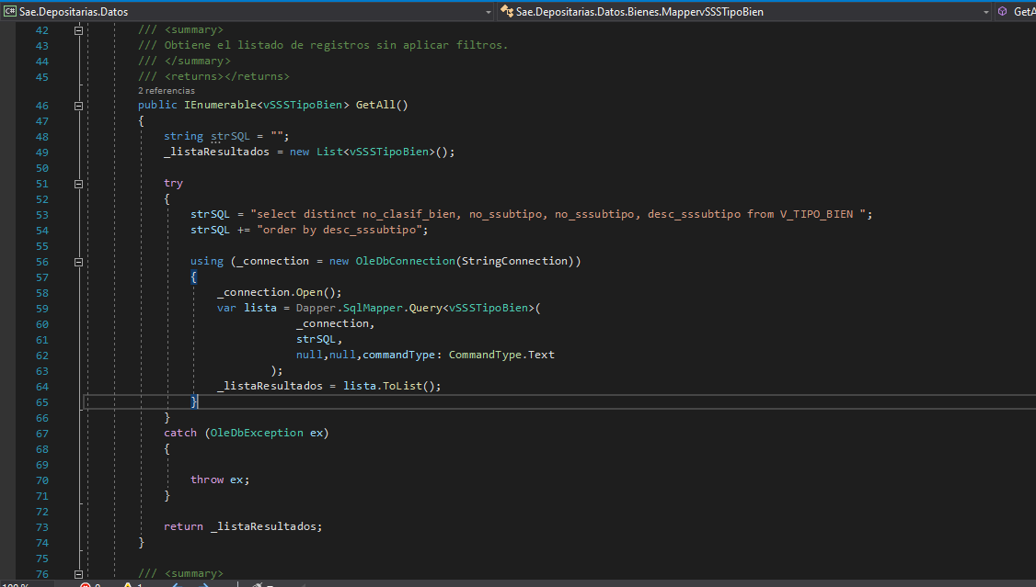

public IEnumerable<vSSSTipoBien> GetByParam(vSSSTipoBien item)

{

string strSQL = "";

string strFileName = System.Web.HttpContext.Current.Server.MapPath(@"~/Operacion/Bienes/QUERYSOleDb.TXT");

string strCommand = "";

try

{

strCommand = GetCommand.getQuery(strFileName, "63");

strSQL = "select distinct no_clasif_bien, no_ssubtipo, no_sssubtipo, desc_sssubtipo ";

strSQL += "from V_TIPO_BIEN ";

strSQL += "where ";

if (item.no_tipo != 0)

strSQL += " no_tipo = " + item.no_tipo.ToString();

if (item.no_subtipo != 0)

strSQL += " and no_subtipo = " + item.no_subtipo.ToString();

if (item.no_ssubtipo != 0)

strSQL += " and no_ssubtipo = " + item.no_ssubtipo.ToString();

strSQL += " order by desc_sssubtipo";

//if (strCommand.Trim() != "")

// strSQL = strCommand;

using (_connection = new OleDbConnection(StringConnection))

{

_connection.Open();

var lista = Dapper.SqlMapper.Query<vSSSTipoBien>(

_connection,

strSQL,

null, null, commandType: CommandType.Text

);

_listaResultados = lista;

}

}

catch (OleDbException ex)

{

throw ex;

}

return _listaResultados;

}

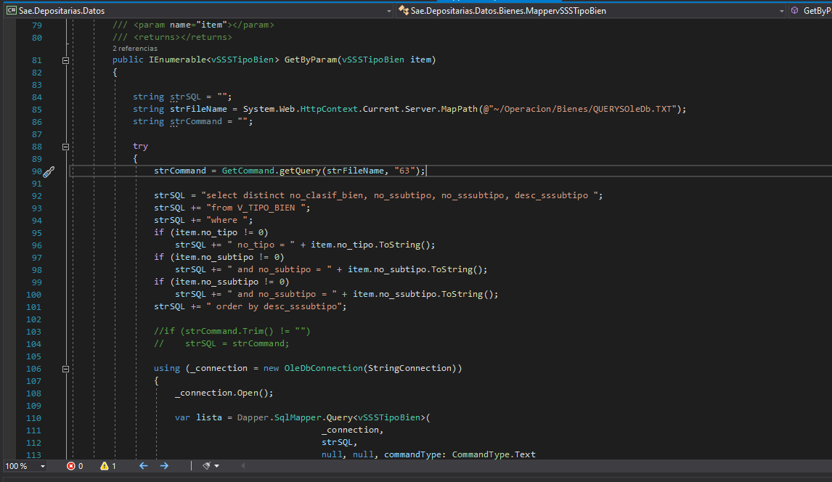

**MappervSSTipoBien.cs**

public IEnumerable<vSSTipoBien> GetAll()

{

string strSQL = "";

_listaResultados = new List<vSSTipoBien>();

try

{

strSQL = "select distinct no_subtipo,no_ssubtipo, desc_ssubtipo from V_TIPO_BIEN ";

strSQL += "order by desc_ssubtipo";

using (_connection = new OleDbConnection(StringConnection))

{

_connection.Open();

var lista = Dapper.SqlMapper.Query<vSSTipoBien>(

_connection,

strSQL,

null,null,commandType: CommandType.Text

);

_listaResultados = lista.ToList();

}

}

catch (OleDbException ex)

{

throw ex;

}

return _listaResultados;

}

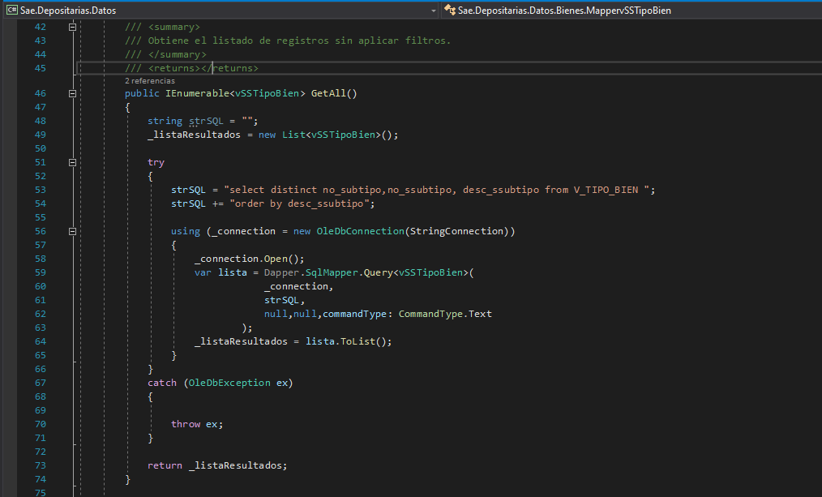

public IEnumerable<vSSTipoBien> GetByParam(vSSTipoBien item)

{

string strSQL = "";

string strFileName = System.Web.HttpContext.Current.Server.MapPath(@"~/Operacion/Bienes/QUERYSOleDb.TXT");

string strCommand = "";

try

{

strCommand = GetCommand.getQuery(strFileName, item.no_subtipo.ToString() + "2");

strSQL = "select distinct no_subtipo,no_ssubtipo, desc_ssubtipo ";

strSQL += "from V_TIPO_BIEN ";

strSQL += " where ";

if (item.no_tipo != 0)

strSQL += " no_tipo = " + item.no_tipo.ToString();

if (item.no_subtipo != 0)

strSQL += " and no_subtipo = " + item.no_subtipo.ToString();

strSQL += " order by desc_ssubtipo";

if (strCommand.Trim() != "")

strSQL = strCommand;

using (_connection = new OleDbConnection(StringConnection))

{

_connection.Open();

var lista = Dapper.SqlMapper.Query<vSSTipoBien>(

_connection,

strSQL,

null, null, commandType: CommandType.Text

);

_listaResultados = lista;

}

}

catch (OleDbException ex)

{

throw ex;

}

return _listaResultados;

}

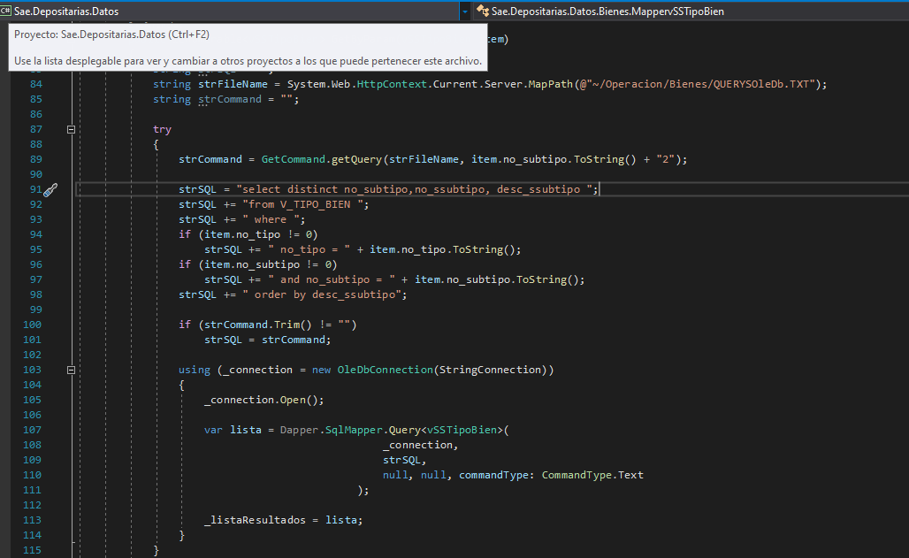

**MappervSTipoBien.cs**

public IEnumerable<vSTipoBien> GetAll()

{

string strSQL = "";

_listaResultados = new List<vSTipoBien>();

try

{

strSQL = "select distinct no_subtipo, desc_subtipo from V_TIPO_BIEN ";

strSQL += "order by desc_subtipo";

using (_connection = new OleDbConnection(StringConnection))

{

_connection.Open();

var lista = Dapper.SqlMapper.Query<vSTipoBien>(

_connection,

strSQL,

null,null,commandType: CommandType.Text

);

_listaResultados = lista.ToList();

}

}

catch (OleDbException ex)

{

throw ex;

}

return _listaResultados;

}

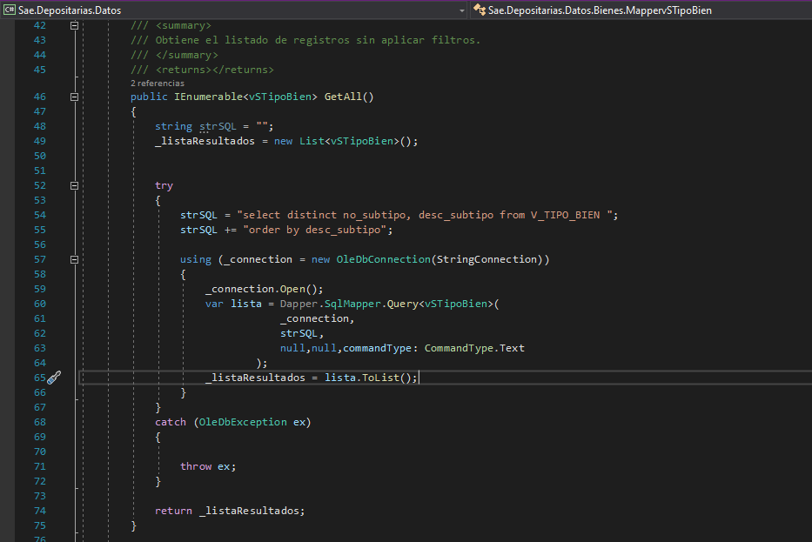

**MappervTipoBien.cs**

public IEnumerable<vSTipoBien> GetByParam(vSTipoBien item)

{

string strSQL = "";

string strFileName = System.Web.HttpContext.Current.Server.MapPath(@"~/Operacion/Bienes/QUERYSORACLE.TXT");

string strCommand = "";

try

{

strCommand = GetCommand.getQuery(strFileName, item.no_tipo.ToString()+ "1");

strSQL = "select distinct no_subtipo, desc_subtipo from V_TIPO_BIEN ";

if (item.no_tipo != 0)

strSQL += " where no_tipo = " + item.no_tipo.ToString();

strSQL += " order by desc_subtipo";

if (strCommand.Trim() != "")

strSQL = strCommand;

using (_connection = new OleDbConnection(StringConnection))

{

_connection.Open();

var lista = Dapper.SqlMapper.Query<vSTipoBien>(

_connection,

strSQL,

null, null, commandType: CommandType.Text

);

_listaResultados = lista;

}

}

catch (OleDbException ex)

{

throw ex;

}

return _listaResultados;

}

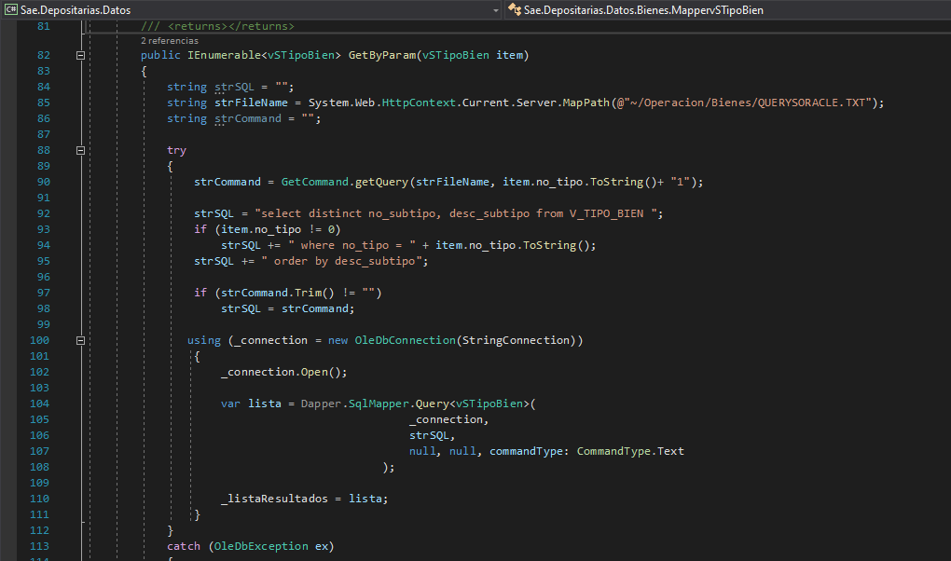

public IEnumerable<vTipoBien> GetAll()

{

_listaResultados = new List<vTipoBien>();

string strSQL = "";

string strFileName = System.Web.HttpContext.Current.Server.MapPath(@"~/Operacion/Bienes/QUERYSORACLE.TXT");

string strCommand = "";

try

{

strCommand = GetCommand.getQuery(strFileName, "10");

strSQL = "select distinct no_tipo, desc_tipo from V_TIPO_BIEN order by desc_tipo";

if (strCommand.Trim() != "")

strSQL = strCommand;

using (_connection = new OleDbConnection(StringConnection))

{

//_connection = new OracleConnection(StringConnection);

_connection.Open();

var lista = Dapper.SqlMapper.Query<vTipoBien>(

_connection,

strSQL,

null, null, commandType: CommandType.Text

);

_listaResultados = lista.ToList();

}

}

catch (OleDbException ex)

{

throw ex;

}

//catch (OracleException ex)

//{

// throw ex;

//}

return _listaResultados;

}

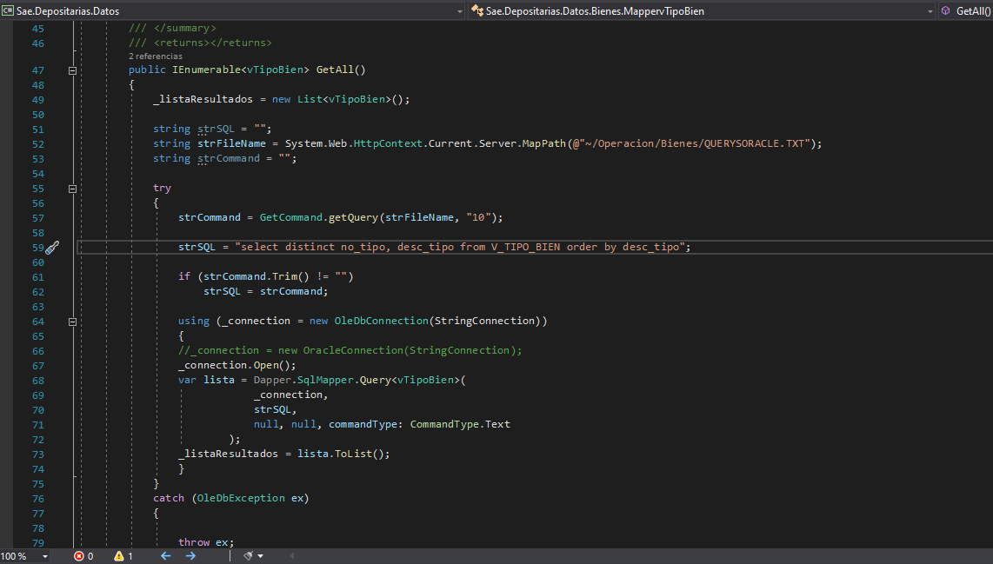

**QuerysOracle.txt**

10:select distinct no_tipo, desc_tipo from V_TIPO_BIEN where no_tipo in (5,6) order by desc_tipo

51:select distinct no_subtipo, desc_subtipo from V_TIPO_BIEN where no_tipo = 5 and no_subtipo in (17,21,6,20,18) order by desc_subtipo

61:select distinct no_subtipo, desc_subtipo from V_TIPO_BIEN where no_tipo = 6 and no_subtipo in (1) order by desc_subtipo

63:select distinct no_clasif_bien, no_ssubtipo, no_sssubtipo, desc_sssubtipo from V_TIPO_BIEN where no_clasif_bien in (1369,1371,1373,1374,1375,1377,1379,1381,1383,1385,1386,1389,1391,1393,1395,1400,1404,1412,1413,1414,1418,1420,1422,503,506) order by desc_sssubtipo

64:select OTCLAVE, OTVALOR from CAT_ENTFED

**MapperMENAJE.cs**

public IEnumerable<MENAJE> GetByParam(MENAJE item)

{

string strSQL = "";

try

{

strSQL = "SELECT MEN.NO_BIEN, MEN.NO_BIEN_MENAJE, MEN.NO_REGISTRO, BIEN.DESCRIPCION ";

strSQL += "FROM MENAJE MEN ";

strSQL += "LEFT JOIN BIENES BIEN ON BIEN.NO_BIEN = MEN.NO_BIEN_MENAJE ";

strSQL += "WHERE MEN.NO_BIEN = '" + item.NO_BIEN.ToString() + "'";

using (_connection = new OleDbConnection(StringConnection))

{

_connection.Open();

var lista = Dapper.SqlMapper.Query<MENAJE>(

_connection, strSQL,

null, null, commandType: CommandType.Text

);

_listaResultados = lista;

}

}

catch (OleDbException ex)

{

throw ex;

}

return _listaResultados;

}

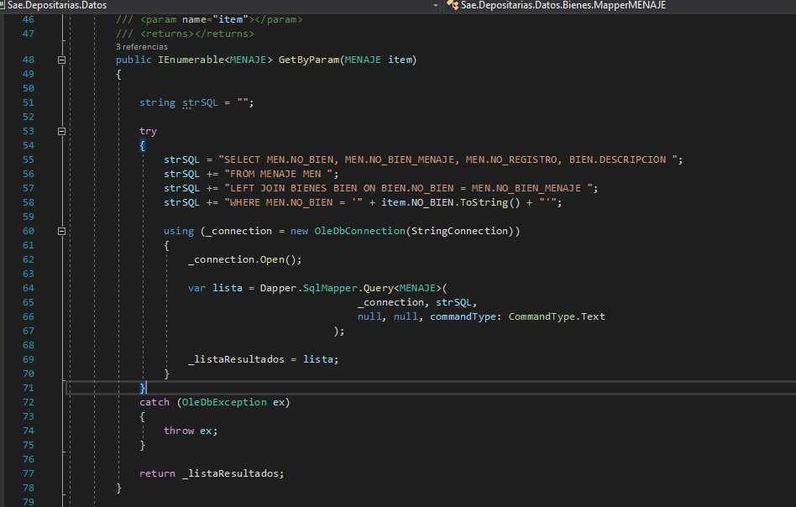

public IEnumerable<MENAJE> GetByParam(MENAJE item)

{

string strSQL = "";

try

{

strSQL = "SELECT MEN.NO_BIEN, MEN.NO_BIEN_MENAJE, MEN.NO_REGISTRO, BIEN.DESCRIPCION ";

strSQL += "FROM MENAJE MEN ";

strSQL += "LEFT JOIN BIENES BIEN ON BIEN.NO_BIEN = MEN.NO_BIEN_MENAJE ";

strSQL += "WHERE MEN.NO_BIEN = '" + item.NO_BIEN.ToString() + "'";

using (_connection = new OleDbConnection(StringConnection))

{

_connection.Open();

var lista = Dapper.SqlMapper.Query<MENAJE>(

_connection, strSQL,

null, null, commandType: CommandType.Text

);

_listaResultados = lista;

}

}

catch (OleDbException ex)

{

throw ex;

}

return _listaResultados;

}

public string GetClaves(MENAJE item)

{

string strSQL = "";

string strRes = "";

try

{

strSQL = "SELECT MEN.NO_BIEN, MEN.NO_BIEN_MENAJE, MEN.NO_REGISTRO, BIEN.DESCRIPCION ";

strSQL += "FROM MENAJE MEN ";

strSQL += "LEFT JOIN BIENES BIEN ON BIEN.NO_BIEN = MEN.NO_BIEN_MENAJE ";

strSQL += "WHERE MEN.NO_BIEN = '" + item.NO_BIEN.ToString() + "'";

using (_connection = new OleDbConnection(StringConnection))

{

_connection.Open();

var lista = Dapper.SqlMapper.Query<MENAJE>(

_connection, strSQL,

null, null, commandType: CommandType.Text

);

List<MENAJE> _listaRes = lista.ToList();

for (int iX = 0; iX < _listaRes.Count; iX++)

{

if (iX > 0)

strRes += ", ";

strRes += _listaRes[iX].NO_BIEN_MENAJE.ToString();

}

}

}

catch (OleDbException ex)

{

throw ex;

}

return strRes;

}

**MapperPA_BIENESDEPOSITARIA.cs**

strSQL = "SELECT BIEN, ESTATUS_BIEN, PROCESO_EXT_DOM, DESCRIPCION_BIEN, DESTINO, SS_TIPO_BIEN, S_TIPO_BIEN, COORD_ADMIN, TIPO_BIEN, UBICACION_ALMACEN ";

strSQL += ", (SELECT COUNT(1) FROM MENAJE MEN WHERE MEN.NO_BIEN = BIEN) AS MENAJE ";

strSQL += "FROM Z_CENTRO_OPERACION_REGIONAL Z ";

if (item.P_BIEN > 0)

strSQL += "WHERE BIEN = '" + item.P_BIEN.ToString() + "'";

else

{

strSQL += "WHERE ESTATUS_BIEN = 'ADM' ";

strSQL += "AND CLASIF IN('" + item.P_CLASIF + "') ";

if (item.P_ENTFED > 0 && item.Tipo_Bien != 6)

strSQL += "AND ALMACEN_ID_ENTFED = " + item.P_ENTFED;

if (item.P_ENTFED > 0 && item.Tipo_Bien == 6)

{

strSQL += " AND EXISTS (SELECT 1 FROM BIENES WHERE NO_BIEN = Z.BIEN ";

strSQL += "AND DECODE (VAL4, 'DISTRITO FEDERAL','CIUDAD DE MEXICO', ";

strSQL += "VAL4) IN (SELECT OTVALOR FROM CAT_ENTFED WHERE OTCLAVE = " + item.P_ENTFED.ToString().Trim() + "))";

}

}

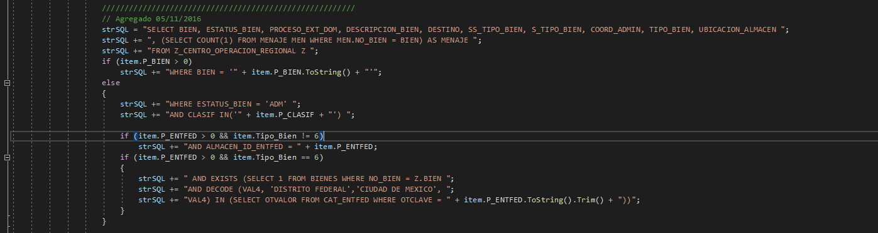

strSQL = "SELECT BIEN, ESTATUS_BIEN, PROCESO_EXT_DOM, DESCRIPCION_BIEN, DESTINO, SS_TIPO_BIEN, COORD_ADMIN ";

strSQL += ", (SELECT COUNT(1) FROM MENAJE MEN WHERE MEN.NO_BIEN = BIEN) AS MENAJE ";

strSQL += "FROM Z_CENTRO_OPERACION_REGIONAL ";

strSQL += "WHERE BIEN = " + item.P_BIEN ;

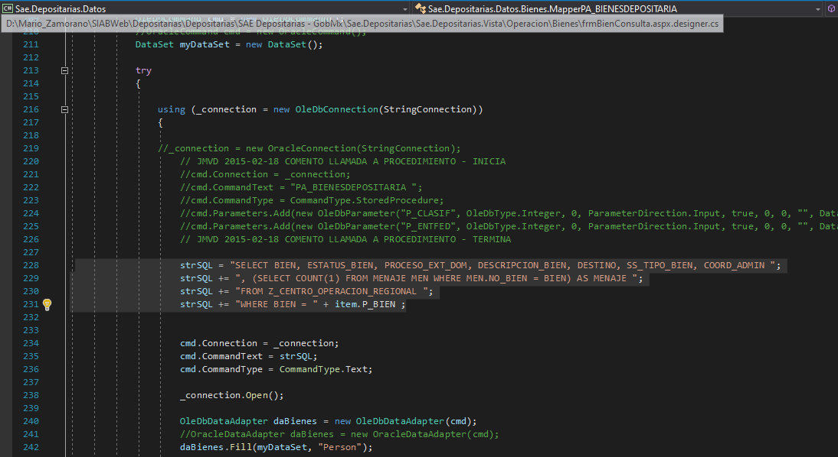

La pantalla de búsqueda muestra las siguientes opciones

