**727721EUIT057-Day4-ClassExercise**

**Task-01:Selenese Commands**

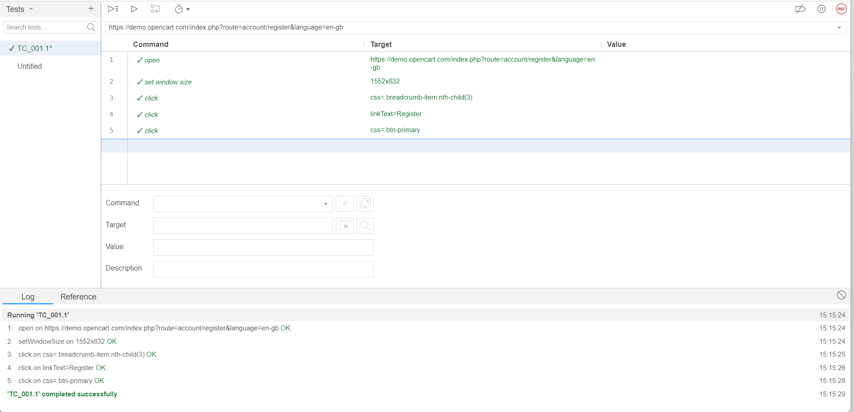

**TASK-02:Locators**

**Code:-**

WebDriverManager.*chromedriver*().setup();

ChromeOptions co=**new** ChromeOptions();

co.addArguments("--remote-allow-origins=*");

WebDriver driver=**new** ChromeDriver(co);

driver.get("https://demo.opencart.com/index.php?route=account/register&language=en-gb");

driver.manage().window().maximize();

WebElement fn = driver.findElement(By.*id*("input-firstname"));

System.***out***.println(fn);

WebElement ln = driver.findElement(By.*id*("input-lastname"));

System.***out***.println(ln);

WebElement email = driver.findElement(By.*id*("input-email"));

System.***out***.println(email);

WebElement pw = driver.findElement(By.*id*("input-password"));

System.***out***.println(pw);

WebElement sub = driver.findElement(By.*id*("input-newsletter-yes"));

System.***out***.println(sub);

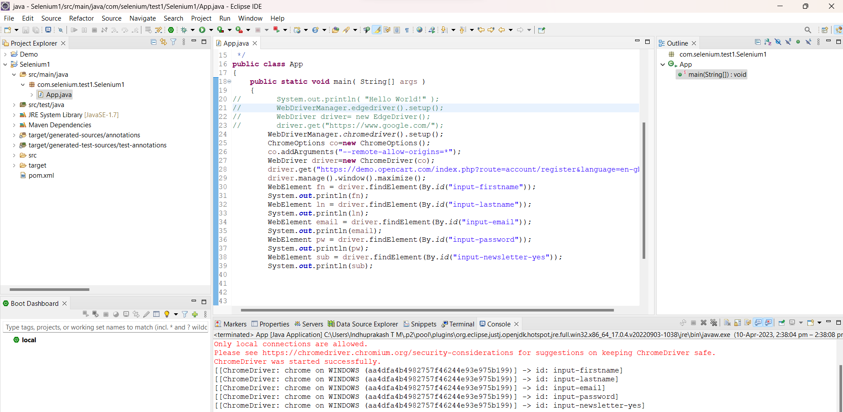

**TASK-03: Locate the Below elements with XPath.**

**Code:-**

WebDriverManager.*chromedriver*().setup();

ChromeOptions co=**new** ChromeOptions();

co.addArguments("--remote-allow-origins=*");

WebDriver driver=**new** ChromeDriver(co);

driver.get("https://demo.opencart.com/index.php?route=checkout/voucher&language=en-gb");

driver.manage().window().maximize();

WebElement name = driver.findElement(By.*xpath*("//*[@id=\"input-to-name\"]"));

System.***out***.println(name);

WebElement email = driver.findElement(By.*xpath*("//*[@id=\"input-to-email\"]"));

System.***out***.println(email);

WebElement message = driver.findElement(By.*xpath*("//*[@id=\"input-message\"]"));

System.***out***.println(message);

WebElement urname = driver.findElement(By.*xpath*("//*[@id=\"input-from-name\"]"));

System.***out***.println(urname);

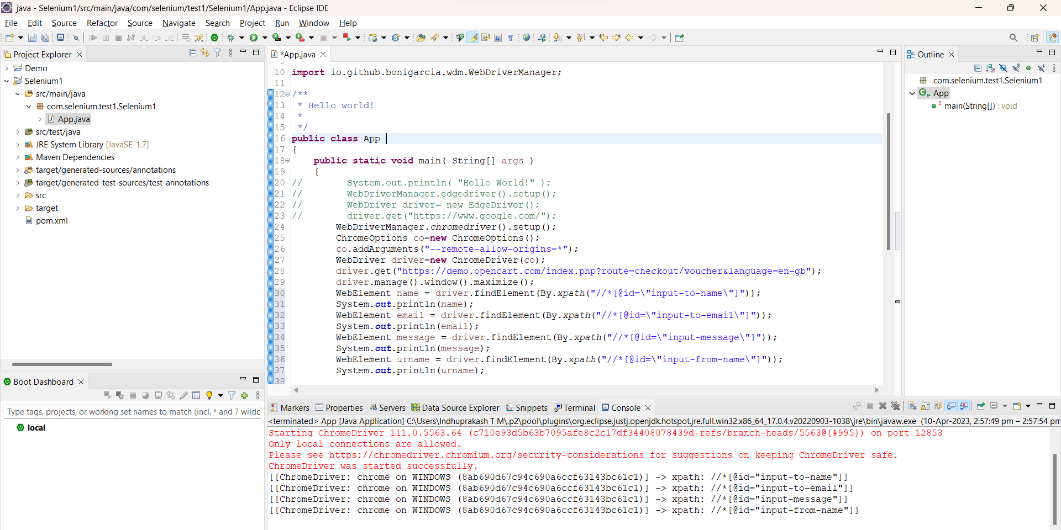

**Task-04:Web Navigation Commands**

**Code:-**

WebDriverManager.*chromedriver*().setup();

ChromeOptions co=**new** ChromeOptions();

co.addArguments("--remote-allow-origins=*");

WebDriver driver=**new** ChromeDriver(co);

driver.get("https://j2store.net/free/");

driver.manage().window().maximize();

JavascriptExecutor js = (JavascriptExecutor) driver;

js.executeScript("window.scrollBy(0,1000)","");

driver.findElement(By.*linkText*("Clothing (5)")).click();

driver.navigate().back();

driver.navigate().forward();

driver.navigate().refresh();

driver.quit();

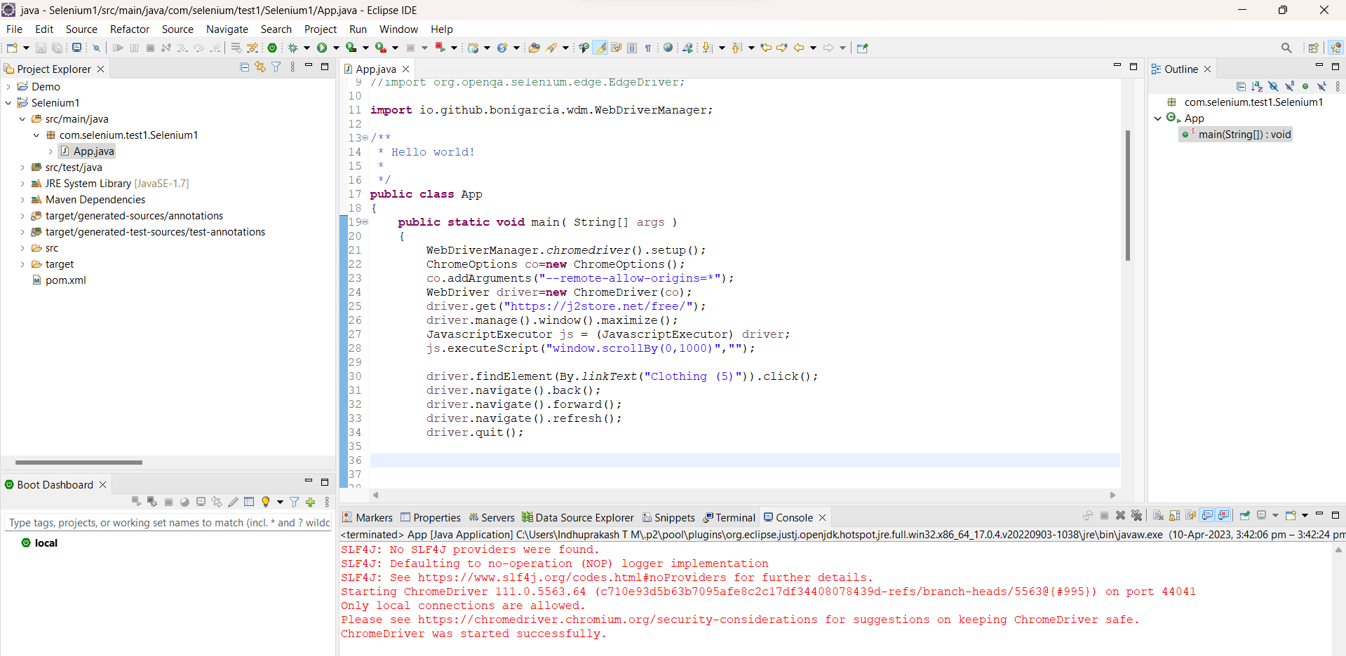

**TASK-05.1:Web Driver Commands**

**Code:-**

WebDriverManager.*chromedriver*().setup();

ChromeOptions co=**new** ChromeOptions();

co.addArguments("--remote-allow-origins=*");

WebDriver driver=**new** ChromeDriver(co);

driver.get("https://j2store.net/free/");

driver.manage().window().maximize();

JavascriptExecutor js=(JavascriptExecutor) driver;

js.executeScript("window.scrollBy(0,1000)","");

String url1="https://j2store.net/free/";

String url2="";

url2=driver.getCurrentUrl();

**if**(url1.equals(url2))

System.***out***.println("Correct 1st page");

driver.findElement(By.*linkText*("Clothing (5)")).click();

url1=driver.getCurrentUrl();

**if**(url1.equals("https://j2store.net/free/index.php/shop?filter_catid=11"));

System.***out***.println("Correct 2nd page");

driver.navigate().back();

driver.navigate().forward();

driver.navigate().refresh();

driver.quit();

**TASK-05.2:Web Driver Commands**

**Code:-**

WebDriverManager.*chromedriver*().setup();

ChromeOptions co=**new** ChromeOptions();

co.addArguments("--remote-allow-origins=*");

WebDriver driver=**new** ChromeDriver(co);

driver.get("https://j2store.net/free/");

driver.manage().window().maximize();

JavascriptExecutor js = (JavascriptExecutor) driver;

js.executeScript("window.scrollBy(0,1000)","");

driver.findElement(By.*linkText*("Clothing (5)")).click();

Thread.*sleep*(5000);

List<WebElement> li=driver.findElements(By.*xpath*("//h2[@class='product-title']"));

**for**(WebElement link:li) {

System.***out***.println(link.getText());

}

