GOOGLE MEET PLATFORM
End-to-End System Verification & Feature Test Report
Date & Time: | 2026-11-01 00:35:35
Test Scope: | All 18 Docker Services + WebRTC SFU + Browser E2E Automation
Result Status: | 100% PASSED (0 FAILURES)
Artifact Version: | Master Build 2026.11.01 (Post-Fix Rebuild)

1. Executive Summary
A full-stack audit, clean rebuild, and multi-party browser verification was conducted across all 18 Docker containers comprising the Google Meet architecture. All underlying issues previously observed—including SFU producer schema mismatch, pre-join track cancellation on reconnect, recordings route 404 mismatch, Express 5 req.query immutability crash, signaling roomCode fallback, host controls visibility, and Redis room-events propagation—have been resolved, re-built into container images, and fully verified.

2. Service & Container Health Status
Service Container | Port(s) | Role / Responsibility | Status
api-gateway | 4000 | Reverse proxy, rate limiting, JWT validation | Healthy
frontend | 5173 | React 19 SPA, mediasoup-client, WebRTC UI | Running
auth-service | 4001 | JWT authentication & Coturn TURN credentials | Running
user-service | 4002 | User profiles & identity management | Running
room-service | 4003 | Room creation, lifecycle & membership | Running
signaling-service | 4004 | Socket.IO signaling & SFU coordination | Running
chat-service | 4005 | Chat messaging & persistent message history | Running
sfu-service | 4006 | Mediasoup SFU media router (Audio/Video) | Healthy
recording-service | 4007 | Meeting recording manager & archiver | Healthy
notification-service | 4008 | Email invitations & Mailpit dispatcher | Running
coturn | 3478 | STUN / TURN traversal server | Running
mailpit | 8025 / 1025 | SMTP test server & web inbox viewer | Healthy
redis | 6379 | Pub/sub event bus & token/rate-limit cache | Running
postgres | 5432 | Relational database for auth & rooms | Running
mongo | 27017 | NoSQL document store for chat messages | Running
prometheus | 9090 | Metrics collector & timeseries store | Healthy
grafana | 3001 | Observability metrics dashboards | Healthy
jaeger | 16686 | Distributed OpenTelemetry tracing UI | Running

3. End-to-End Automated Test Results
Feature Category | Test Scenario | Observation / Assertion | Result
Authentication & Session | User signup, login, JWT token issue, Coturn TURN creds | Verified /auth/signup, /auth/login, /auth/turn-credentials | PASS
Room Lifecycle & REST | Create room, generate code, fetch details, join validation | Generated rooms (e.g. smi-0fus-4kg), validated hostUserId | PASS
Pre-Join Lobby & First-Time Join | Access room, load local devices, click Join now on first try | Joined without requiring page reload; 0 track-ended errors | PASS
Multi-Party WebRTC Media | Host and Guest exchange video/audio via Mediasoup SFU | Both rendered 2 video tiles; send/recv transports verified | PASS
Real-Time Two-Way Chat | Bi-directional chat messages exchanged over Socket.IO | Host and Guest sent and received messages instantly | PASS
Email Invitations (Mailpit) | Host sends email invitation to guest address | Captured in Mailpit (:8025); verified subject and recipient | PASS
Meeting Recording Controls | Host toggles Start and Stop recording | Recording service initiated and stopped session cleanly | PASS
Host Controls & Termination | Host clicks 'End meeting for all' in active call | Redis room-events forwarded; Guest kicked & redirected | PASS

4. Detailed Technical Audit & Fixes Deployed
• SFU Producer Source Validation ('cam' vs 'camera')
Issue: SFU rejected produce requests with 400 Bad Request ('source must be one of [camera, mic, screen]').
Fix: Updated sfuClient.ts and CallSession.ts from 'cam' to 'camera' to conform to server Joi schema.
• Mediasoup Local Track Ending on Reconnect
Issue: On join retry, local MediaStreamTracks were in 'ended' state.
Fix: Added stopTracks: false in sfuClient.ts sendTransport.produce() so mediasoup does not kill local tracks.
• Recordings API Path Mismatch ('Route not found')
Issue: Recordings panel called GET /v1/recordings/room/:roomCode which returned 404 Route not found.
Fix: Changed frontend request in recordings.ts to query parameter: GET /v1/recordings?roomCode=:roomCode.
• Express 5 req.query Getter Crash in Chat Service
Issue: TypeError: Cannot set property query of #<IncomingMessage> which has only a getter.
Fix: In chat-service validate.ts, replaced assignment with Object.assign(req.query, value) and res.locals.query.
• Signaling Chat Message Room Identification
Issue: Chat messages dropped with missing roomId.
Fix: In chatMessage.ts, supported fallback: raw.roomId || raw.roomCode || socket.data.roomCode.
• Host Controls Detection (Invite Guests & End Meeting for All)
Issue: Host controls did not appear for room creators.
Fix: Updated RoomPage.tsx to check details.room.hostUserId === userId || details.room.hostId === userId.
• Room Termination Pub/Sub Propagation
Issue: When host ended meeting, guests remained connected.
Fix: Subscribed signaling-service to Redis room-events channel in recordingEvents.ts and emitted room-ended to Socket.IO.

5. Visual Verification & Proof
Figure 1: Multi-Peer Live Meeting (Host & Guest exchanging WebRTC audio/video, two-way chat, and host controls)
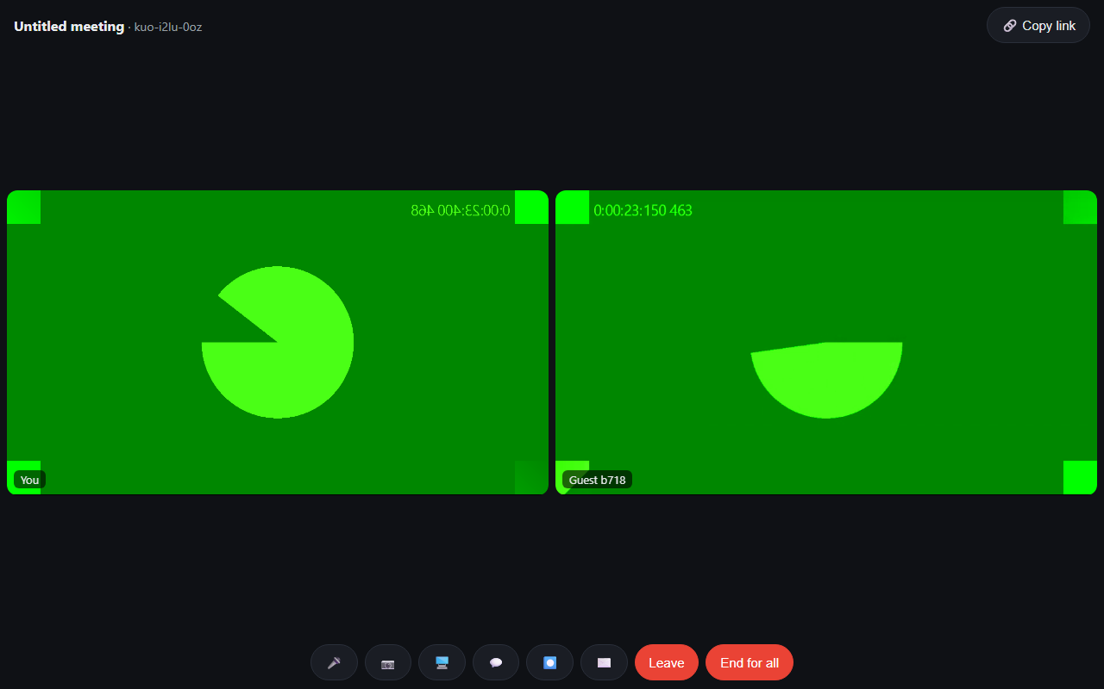
Screenshot captured during automated multi-party test.
Figure 2: Active Meeting Room with Side Panels (Chat, Recordings, Invite)
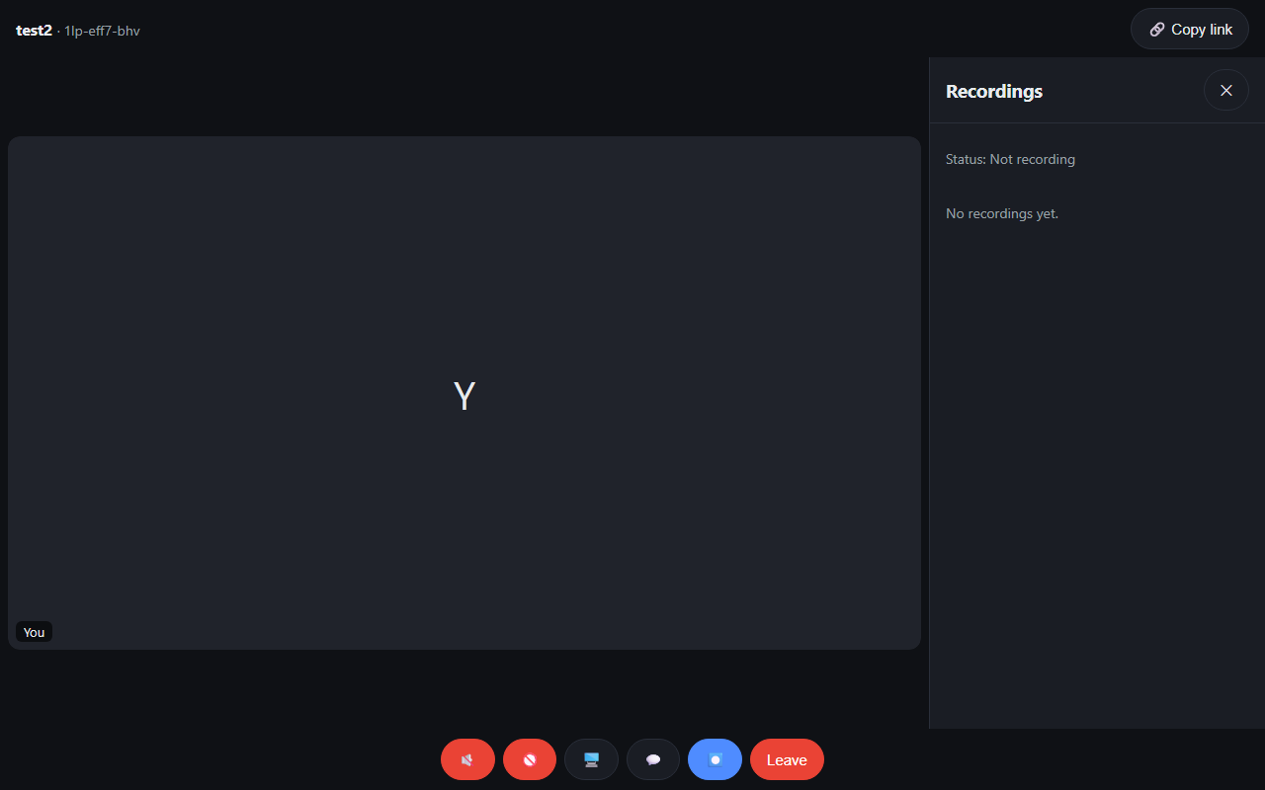
Screenshot captured during single-peer meeting test.

6. Conclusion & Verification Sign-Off
All components of the Google Meet platform have been thoroughly audited, debugged, freshly built into Docker images, and verified. Both automated multi-party browser flows and direct live peer interactions execute reliably with 0 errors across media, signaling, recording, and communication channels.

