Develop a code for converting currencies to US dollar.
Currency Converter in JavaScript

In this article, we will implement a currency converter that simply converts the currency into any other country’s currency.
Pre-requisites:
- Basic HTML, CSS, JavaScript.
Approach:
- HTML code is implemented for GUI for user entries of the amount and two currencies.
- Select the currency, Convert button displays the converted amount.
- The Reset button resets the data.
- JavaScript functions and custom methods are used for implementing currency conversion like addEventListener().
- Currency exchange API is used in the script file.
HTML code: The following HTML code implements the GUI for user entries like amount and both the currencies for which the conversion needs to take place.
Add code in index.html.
CSS code: The following is the content for the file “style.css”.
JavaScript code: The following is the content for the file “script.js” used in the above HTML code.
- HTML
- CSS
- Javascript
<!DOCTYPE html>
<html lang="en">
<head>
<meta charset="UTF-8">
<meta http-equiv="X-UA-Compatible" content="IE=edge">
<meta name="viewport" content="width=device-width, initial-scale=1.0">
<title>Currency Converter</title>
<link rel="stylesheet"
href=
"https://maxcdn.bootstrapcdn.com/bootstrap/4.5.2/css/bootstrap.min.css">
<script src=
"https://ajax.googleapis.com/ajax/libs/jquery/3.5.1/jquery.min.js">
</script>
<script src=
"https://cdnjs.cloudflare.com/ajax/libs/popper.js/1.16.0/umd/popper.min.js">
</script>
<script src=
"https://maxcdn.bootstrapcdn.com/bootstrap/4.5.2/js/bootstrap.min.js">
</script>

<link rel="preconnect"
href=
"https://fonts.gstatic.com">
<link href=
"https://fonts.googleapis.com/css2?family=Amiri&family=Lobster&family=Pacifico&display=swap"
rel="stylesheet">
<!-- linking style.css file-->
<link rel="stylesheet" href="style.css">
</head>

<body>
<!-- Currency Converter -->
<h1 class="heading text-center display-2">
Currency Converter
</h1>
<hr>
<div class="container">
<div class="main">
<div class="form-group">
<label for="oamount">
Amount to Convert :
</label>
<input type="text" class="form-control searchBox" placeholder="0.00" id="oamount">
</div>
<div class="row">
<div class="col-sm-6">
<div class="input-group mb-3">
<div class="input-group-prepend">
<span class="input-group-text">From</span>
</div>
<select class="form-control from" id="sel1">
<option value="">Select One …</option>
<option value="INR">INR</option>
<option value="ISK">ISK</option>
<option value="JPY">JPY</option>
<option value="ZAR">ZAR</option>
</select>
</div>
</div>

<div class="col-sm-6">
<div class="input-group mb-3">
<div class="input-group-prepend">
<span class="input-group-text">To</span>
</div>
<select class="form-control to" id="sel2">
<option value="">Select One …</option>
<option value="USD">USD</option>
<option value="DKK">DKK</option>
<option value="DOP">DOP</option>
<option value="EGP">EGP</option>
<option value="EUR">EUR</option>
</select>
</div>
</div>
</div>

<div class="text-center">

<!-- convert button -->
<button class="btn btn-primary convert m-2" type="submit">
Convert
</button>
<!-- reset button -->
<button class="btn btn-primary m-2" onclick="clearVal()">
Reset
</button>
</div>

</div>

<div id="finalAmount" class="text-center">

<!-- Display the converted amount -->
<h2>Converted Amount :
<span class="finalValue" style="color:green;">
</span>
</h2>
</div>
</div>

<!-- linking script.js file -->
<script src="script.js"></script>
</body>
</html>
Output: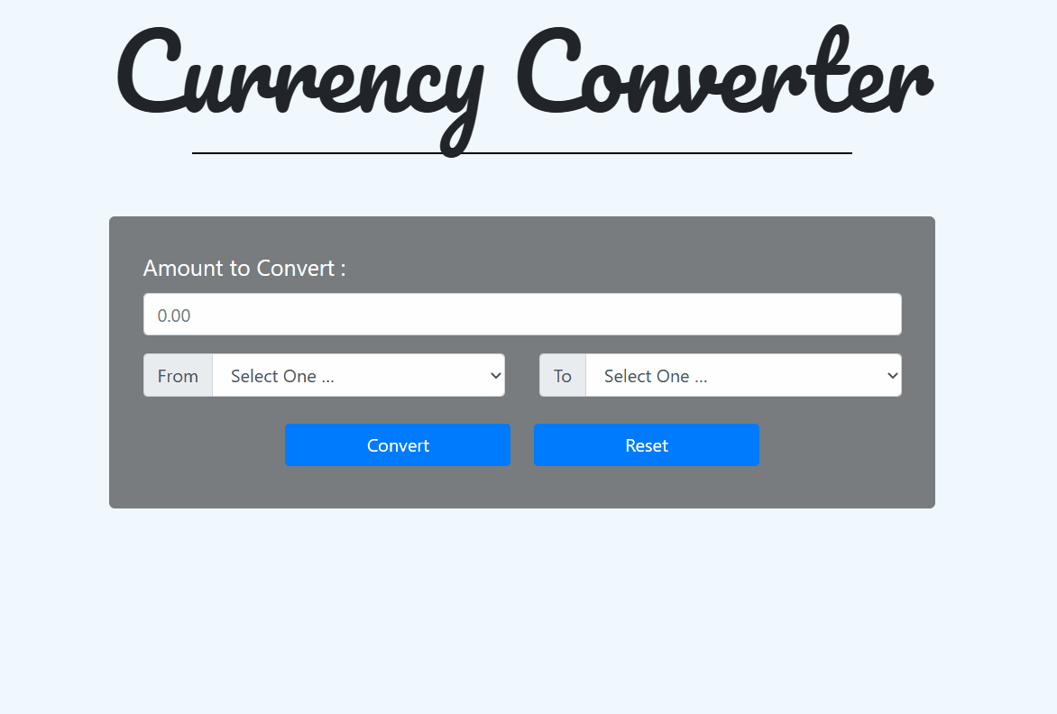

Illustrate the principles of cookies and explain with an example.

Cookies in Servlet
A cookie is a small piece of information that is persisted between the multiple client requests.
A cookie has a name, a single value, and optional attributes such as a comment, path and domain qualifiers, a maximum age, and a version number.

How Cookie works
By default, each request is considered as a new request. In cookies technique, we add cookie with response from the servlet. So cookie is stored in the cache of the browser. After that if request is sent by the user, cookie is added with request by default. Thus, we recognize the user as the old user.
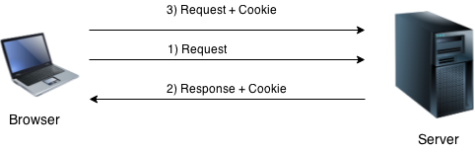

Types of Cookie
There are 2 types of cookies in servlets.
- Non-persistent cookie
- Persistent cookie

Non-persistent cookie
It is valid for single session only. It is removed each time when user closes the browser.

Persistent cookie
It is valid for multiple session . It is not removed each time when user closes the browser. It is removed only if user logout or signout.

Advantage of Cookies
- Simplest technique of maintaining the state.
- Cookies are maintained at client side.

Disadvantage of Cookies
- It will not work if cookie is disabled from the browser.
- Only textual information can be set in Cookie object.

Note: Gmail uses cookie technique for login. If you disable the cookie, gmail won't work.

Cookie class
javax.servlet.http.Cookie class provides the functionality of using cookies. It provides a lot of useful methods for cookies.

Constructor of Cookie class
Constructor | Description
Cookie() | constructs a cookie.
Cookie(String name, String value) | constructs a cookie with a specified name and value.

Useful Methods of Cookie class
There are given some commonly used methods of the Cookie class.
Method | Description
public void setMaxAge(int expiry) | Sets the maximum age of the cookie in seconds.
public String getName() | Returns the name of the cookie. The name cannot be changed after creation.
public String getValue() | Returns the value of the cookie.
public void setName(String name) | changes the name of the cookie.
public void setValue(String value) | changes the value of the cookie.

Other methods required for using Cookies
For adding cookie or getting the value from the cookie, we need some methods provided by other interfaces. They are:
- public void addCookie(Cookie ck):method of HttpServletResponse interface is used to add cookie in response object.
- public Cookie[] getCookies():method of HttpServletRequest interface is used to return all the cookies from the browser.

How to create Cookie?
Let's see the simple code to create cookie.

- Cookie ck=new Cookie("user","sonoo jaiswal");//creating cookie object
- response.addCookie(ck);//adding cookie in the response

How to delete Cookie?
Let's see the simple code to delete cookie. It is mainly used to logout or signout the user.

- Cookie ck=new Cookie("user","");//deleting value of cookie
- ck.setMaxAge(0);//changing the maximum age to 0 seconds
- response.addCookie(ck);//adding cookie in the response

How to get Cookies?
Let's see the simple code to get all the cookies.

- Cookie ck[]=request.getCookies();
- for(int i=0;i<ck.length;i++){
- out.print("<br>"+ck[i].getName()+" "+ck[i].getValue());//printing name and value of cookie
- }

Simple example of Servlet Cookies
In this example, we are storing the name of the user in the cookie object and accessing it in another servlet. As we know well that session corresponds to the particular user. So if you access it from too many browsers with different values, you will get the different value.
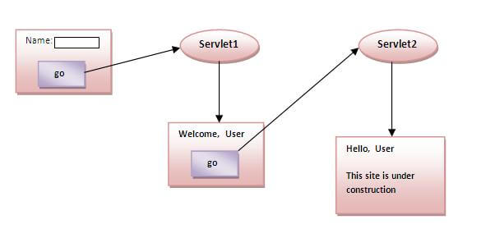

a. | Explain in detail about JSP actions and templates.  JSP Actions lets you perform some action.  Directives vs Actions  - Directives are used during translation phase while actions are used during request processing phase.  - Unlike Directives Actions are re-evaluated each time the page is accessed.  The following are the action elements used in JSP:  1. <jsp:include> Action  Like include page directive this action is also used to insert a JSP file in another file.  <jsp:include> vs include directive :  It has the same difference which I mentioned at the beginning of the article (directive vs action). In <jsp:include> the file is being included during request processing while in case of include directive it has been included at translation phase.  Syntax of <jsp:include> :  <jsp:include page="page URL" flush="Boolean Value" />  Here page URL is: the location of the page needs to be included & flush value can be either true or false (Boolean value).  Example:  <html><head><title>Demo of JSP include Action Tag</title></head><body><h3>JSP page: Demo Include</h3><jsp:include page="sample.jsp" flush="false" /></body></html>  page: Page value is sample.jsp which means this is the page needs to be included in the current file. Just the file name mentioned which shows that the sample.jsp is in the same directory.  flush: Its value is false, which means resource buffer has not been flushed out before including to the current page.  Read more: jsp include action tag.  2. <jsp:forward> Action  <jsp:forward> is used for redirecting the request. When this action is encountered on a JSP page the control gets transferred to the page mentioned in this action.  Syntax of <jsp:forward> :  <jsp:forward page="URL of the another static, JSP OR Servlet page" />  Example:  first.jsp  <html><head><title>Demo of JSP Forward Action Tag</title></head><body><h3>JSP page: Demo forward</h3><jsp:forward page="second.jsp" /></body></html>  Now when JSP engine would execute first.jsp (the above code) then after action tag, the request would be transferred to another JSP page (second.jsp).  Note: first.jsp and second.jsp should be in the same directory otherwise you have to specify the complete path of second.jsp.  Read more: JSP forward action tag.  3. <jsp:param> Action  This action is useful for passing the parameters to Other JSP action tags such as JSP include & JSP forward tag. This way new JSP pages can have access to those parameters using request object itself.  Syntax of <jsp:param>:  <jsp: param name="param_name_here" value="value_of_parameter_here" />  Now considers the same above example –  first.jsp  <html><head><title>Demo of JSP Param Action Tag</title></head><body><h3>JSP page: Demo Param along with forward</h3><jsp:forward page="second.jsp">  <jsp:param name ="date" value="20-05-2012" />  <jsp:param name ="time" value="10:15AM" />  <jsp:param name ="data" value="ABC" /></jsp:forward></body></html>  In the above example first.jsp is passing three parameters (data, time & data) to second.jsp and second.jsp can access these parameters using the below code –  Date:<%= request.getParameter("date") %>Time:<%= request.getParameter("time") %>My Data:<%= request.getParameter("data") %>  4. <jsp:useBean> Action  Read more here – <jsp:useBean>, <jsp:setProperty> and <jsp:getProperty> in detail.  This action is useful when you want to use Beans in a JSP page, through this tag you can easily invoke a bean.  Syntax of <jsp:useBean>:  <jsp: useBean id="unique_name_to_identify_bean" class="package_name.class_name" />  Example of <jsp:useBean>, <jsp:setProperty> & <jsp:getProperty>:  Once Bean class is instantiated using above statement, you have to use jsp:setProperty and jsp:getProperty actions to use the bean’s parameters. we will see both setProperty and getProperty after this action tag.  EmployeeBeanTest.jsp  <html>  <head>  <title>JSP Page to show use of useBean action</title>  </head>  <body>  <h1>Demo: Action</h1>  <jsp:useBean id="student" class="javabeansample.StuBean"/>  <jsp:setProperty name="student" property="*"/>  <h1>  name:<jsp:getProperty name="student" property="name"/><br>  empno:<jsp:getProperty name="student" property="rollno"/><br>  </h1>  </body></html>  StudentBean.java  package javabeansample;public class StuBean {  public StuBean() {  }  private String name;  private int rollno;  public void setName(String name)  {  this.name=name;  }  public String getName()  {  return name;  }  public void setRollno(int rollno)  {  this.rollno=rollno;  }  public int getRollno()  {  return rollno;  }}  5. <jsp:setProperty> Action  This action tag is used to set the property of a Bean, while using this action tag, you may need to specify the Bean’s unique name (it is nothing but the id value of useBean action tag).  syntax of <jsp:setProperty>  <jsp: useBean id="unique_name_to_identify_bean" class="package_name.class_name" />  ....  ....<jsp:setProperty name="unique_name_to_identify_bean" property="property_name" />  OR  <jsp: useBean id="unique_name_to_identify_bean" class="package_name.class_name">  ....  ....<jsp:setProperty name="unique_name_to_identify_bean" property="property_name" /></jsp:useBean>  In property_name, you can also use ‘*’, which means any request parameter which matches to the Bean’s property will be passed to the corresponding setter method.  6. <jsp:getProperty> Action  It is used to retrieve or fetch the value of Bean’s property.  syntax of <jsp:getProperty>  <jsp: useBean id="unique_name_to_identify_bean" class="package_name.class_name" />  ....  ....<jsp:getProperty name="unique_name_to_identify_bean" property="property_name" />  OR  <jsp: useBean id="unique_name_to_identify_bean" class="package_name.class_name">  ....  ....<jsp:getProperty name="unique_name_to_identify_bean" property="property_name" /></jsp:useBean>  Other Action Tags  The below action tags are not frequently used so I haven’t covered them in detail.  7. <jsp:plugin> Action  This tag is used when there is a need of a plugin to run a Bean class or an Applet.  http://docs.oracle.com/javase/7/docs/technotes/guides/plugin/developer_guide/jsp.html  8. <jsp:body> Action  9. <jsp:element> Action  10. <jsp:text> Action  11. <jsp:attribute> Action  JSP TEMPLATE:  JSP Templates  WebLogic Portal provides a set of perdefined JSP templates that you can use in your applications. You can either use the templates exactly as BEA provides them or you can modify them to meet your specific needs; for example by applying your own skins and layouts. This section lists the templates available.  This section includes information on the following subjects:  - Template Location  - Commerce Templates  - Campaign Templates  - Catalog Templates  - Catalog and Campaign Includes  - Order Templates  - Registration Templates  - User Templates  Template Location  All templates are located in the following directory:  <BEA_HOME>\weblogic700\portal\samples\portal\wlcsDomain\  beaApps\wlcsApp\wlcs\commerce  Commerce Templates  Table A-1 lists the templates used for developing commerce services.  Table A-1 /commerce Templates  Campaign Templates  Table A-2 lists the JSP templates available for setting up Campaign services.  Table A-2 /commerce/campaignTemplates  Catalog Templates  Table A-3 Describes the JSP templates available for setting up a Catalog service  .  Table A-3 /CatalogTemplates  Catalog and Campaign Includes  Table A-4 describes the JSP include templates available for setting up a Catalog or Campaign service.  Table A-4 Catalog and Campaign include Templates  Order Templates  Table A-5 decribes the templates available for setting up an Order service.  Table A-5 /Order Templates  Registration Templates  Table A-6 describes the JSP Templates available for setting up a Registration service.  Table A-6 Register Templates  User Templates  Table A-7 describes the JSP templates available for setting up a user.  Table A-7 User Templates
  main.jsp | Anonymous main home - start page.
  login.jsp | Provides form-based submission of username and password to gain access to account, and a link to create a new user.
  badlogin.jsp | Similar to login.jsp, displays an error message (includes login.jsp).
  configurationerror.jsp | Used when there is an error in the webflow configuration or pipeline.
  newuserforward.jsp | Redirects to the user/newusercreation.jsp.
  servererror.jsp | All-purpose 403, 404, 405, 500 server error page.
  sessiontimeout.jsp | Session timeout page.
  shoppingcart.jsp | Presents the items ordered; user may change quantities, delete, continue.
  contractor_journal.jsp | Sample offsite page associated with a campaign example.
  fixup_channel.jsp | Sample offsite page associated with a campaign example.
  browse.jsp | Successive drill-downs via browse of the catalog. Same template applied for subcategories and sub-sub-categories.
  details.jsp | Displays all the selected metadata for a single item; includes backtrack nav to parent category.
  search.jsp | Power search page; includes power search results.
  searchresults.jsp | Results from a quick keyword search conducted anywhere in the site.
  category.jsp | Creates the list of subcategories, and presents the item summary of any items at the parent (current) category level. If there are more than x-number, the list is continued with "next" and "previous" pages.
  itemdetails.jsp | An include module that contains the item details presentation.
  itemsummary.jsp | An include module that allows the repeat of multiple items on a search or browse page.
  navigation.jsp | An include module providing "back-track" ("breadcrumbs") navigation in the browse interface.
  navigation2.jsp | An include module providing "back-track" ("breadcrumbs") navigation in the browse interface.
  admin.inc | Used on all pages and presents the top red-and-black banner with links to the main Administration screen, to this template index, and to a *.jsp.html file for the current template.
  header.inc | Used on all pages and presents a Home link. Depending on the page that included header.inc, also presents links for Search, View Cart, Log In (for users who have not logged in yet), or Log Out (for authenticated users).
  footer.inc | Used on all pages.
  leftside.inc | Presents quick look-up and a promotional ad; for authenticated users, also presents a personalized message to the user, customer profile link, order history link, and payment history link.
  stylesheet.inc | Used in all pages, this is a cascading stylesheet that defines global paragraph and text styles for the site.
  states.inc | Used in all forms where US states are listed as options in an input pop-up.
  countries.inc | Used in all forms where countries are listed as options in an input pop-up.
  editaddresstemplate.inc | Used in profile and order forms where the user can edit an existing shipping address.
  editcctemplate.inc | Used in profile and order forms where the user can edit an existing credit card.
  newaddresstemplate.inc | Used in profile and order forms where the user can supply a new shipping destination address.
  newcctemplate.inc | Used in profile and order forms where the user can supply a new credit card for payment.
  newdemographictemplate.inc | Included into register/newuser.jsp and user/editdemographics.jsp; presents a form that allows user to enter or update demographic information. The demographic details provided can then be used by campaign-related features.
  selectaddress.jsp | Existing destination address(es) presented; user may choose, edit, add new.
  addaddress.jsp | If user does not find the desired shipping address in selectaddress.jsp - includes newaddresstemplate.jsp.
  shipping.jsp | Choices for express, airmail, ups, etc., presented; user may also add special shipping instructions.
  selecttaxaddress.jsp | Conditional upon certain jurisdictions; user may select a county, etc.; then continue with checkout.
  payment.jsp | Choices for which (credit card) account to use for this transaction; user may choose, edit, add new.
  paymentnewcc.jsp | User may supply new credit account info - includes newcctemplate.inc.
  paymenteditcc.jsp | User may change the credit account info as selected in payment.jsp - includes editcctemplate.inc.
  checkout.jsp | Entire transaction with items, address, shipping choice, account, tax and totals presented for final charge authorization.
  confirmorder.jsp | After successful checkout, summary printed to confirm receipt of order.
  orderhistory.jsp | User may view a summary of past or pending orders; may select one to view its contents, shipping dates, and other details.
  paymenthistory.jsp | User may view a summary of past orders organized by payment.
  orderstatus.jsp | Individual orders are displayed with their items, costs, status, shipping address and other details.
  systemerror.jsp | Displays an error due to service system failure in the transaction components.
  newuser.jsp | Empty profile fields for all personal information. Also includes a demographic survey to record user profile information. If you are using the full WebLogic Portal license (which includes campaign services) this data can be used by campaigns.
  viewprofile.jsp | Presents the known personal information for the logged-in user, with buttons for modifying and adding information.
  editdemographics.jsp | Allows registered user to change demographic information that was entered previously.
  editprofile.jsp | Change personal info (name, billing address, phones, email).
  changepassword.jsp | User may change their password.
  profilenewcc.jsp | User may supply new credit account info - includes newcctemplate.inc.
  profileeditcc.jsp | User may change the credit account info as selected in payment.jsp - includes editcctemplate.inc.
  profilenewaddress.jsp | User may supply an additional new shipping address - includes newaddresstemplate.inc.
  profileeditaddress.jsp | User may modify an existing shipping address in profile - includes editaddresstemplate.inc.
  newusercreation.jsp | Displayed after the user registers successfully - provides links to view cart, check out, and return home.
  secureMain.jsp | A secure page that simply forwards the successfully logged-in user back to main.jsp.
  usercreationforward.jsp | Used to redirect the newusercreation.jsp page after creating the user. This is done because the request does not contain the user information unless you do a redirect via the response object to the proper URL. This usercreationforward.jsp creates a new request that has the authenticated user's information, which allows the campaigns to start.
Or

