**Autumn Internship Project Report**

**Visualizing Internship Program 2025**

**Visualizing Global Temperature Trends**

INDRADEEP GHATAK

SECTION 1

BANGABASI COLLAGE

**Period of Internship: 25th August 2025 - 19th September 2025**

Report submitted to: IDEAS – Institute of Data Engineering, Analytics and Science Foundation, ISI Kolkata 

# Abstract

This project explores time-series data analysis using two datasets: global temperature anomalies from GCAG and GISTEMP sources, and synthetic monthly revenue data for the USA. Through data preprocessing, visualization, and smoothing techniques, we uncovered seasonal patterns and long-term trends. Visualizations such as line charts, moving averages, and heatmaps helped reveal underlying patterns. The findings highlight consistent seasonal variations and gradual increases in both global mean temperature and revenue trends. The methodology demonstrated how Python-based data analysis can effectively reveal insights across domains.

**Introduction**

Time-series data is essential for analyzing phenomena recorded over time, such as climate, revenue, or energy usage. This project focused on two datasets: global temperature data to understand seasonal variation and long-term warming patterns, and USA monthly revenue data to study economic cycles.  
**Relevance**

- Climate change remains one of the most pressing global challenges.  
- Revenue cycle analysis provides valuable insights into economic health and policy impact.

**Technology Used**

Python with Pandas, NumPy, Matplotlib, Seaborn, Plotly

**Procedure**

Data collection, cleaning, aggregation, and chronological sorting followed by visualization using multiple techniques to highlight seasonal and long-term patterns.

**Purpose**

To explore how time-series visualization can reveal insights across domains.

# Project Objectives

* To analyse global temperature and USA national revenue trends using time-series datasets.
* To visualize seasonal variations across years in both climate and economic domains.
* To apply moving average techniques for smoothing fluctuations and identifying long-term patterns.
* To compare and interpret trends in climate change with revenue cycles of the USA.
* To highlight the impact of seasonality, external factors, and policy on both datasets.
* To demonstrate the applicability of time-series methods across diverse fields such as environment and economy.
* To draw insights and recommendations based on observed patterns for future studies.

# Methodology

**1. Data Collection:**  
- Global temperature dataset (GCAG, GISTEMP).  
- Synthetic/public dataset for USA monthly revenue.  
  
**2. Data Preprocessing:**  
- Converted Date column to datetime.  
- Extracted Year and Month.  
- Sorted data chronologically.  
  
**3. Visualization Techniques:**  
- Line Chart: Monthly means over time.  
- 12-month Moving Average: Smoothed data to reduce seasonal noise.  
- 24-month Moving Average: Long-term smoothing on global temperature.  
- Heatmap: Seasonal variation shown across months and years.  
- Alternative Visualization: Line plot of average monthly cycle.  
  
**4. Tools Used:**- Python, Pandas, Matplotlib, Seaborn, Plotly.

# Data Analysis and Results

## Part A: Global Temperature Analysis

- Line Plot: Both GCAG and GISTEMP show an increasing trend.  
- 12-month Moving Average: Revealed a clear long-term warming trend.  
- 24-month Moving Average: Even stronger smoothing showed persistent warming.  
- Heatmap (50 years, 20 years): Seasonal patterns intact, baseline temperatures rising.  
- Seasonal Line Plot: Warmer months consistently hotter, trend rising.

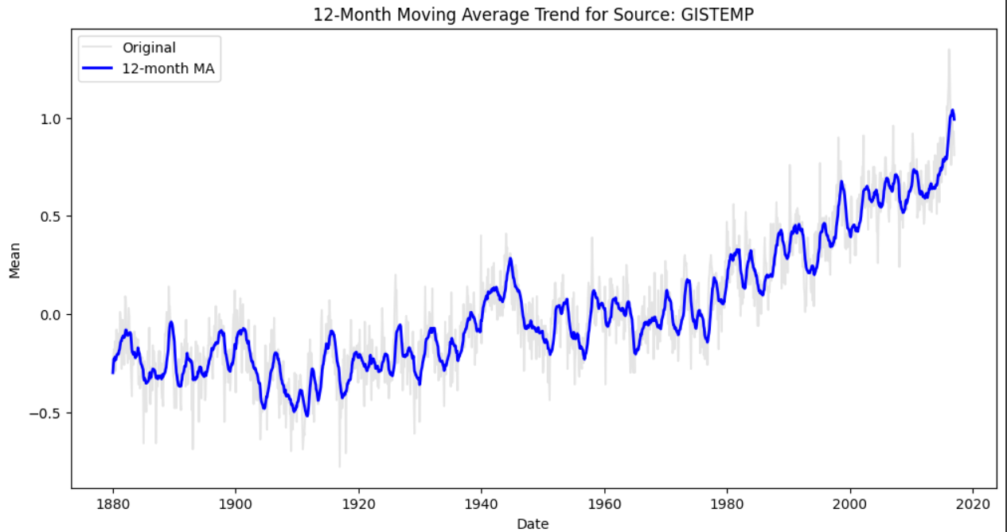

12-Month Moving Average

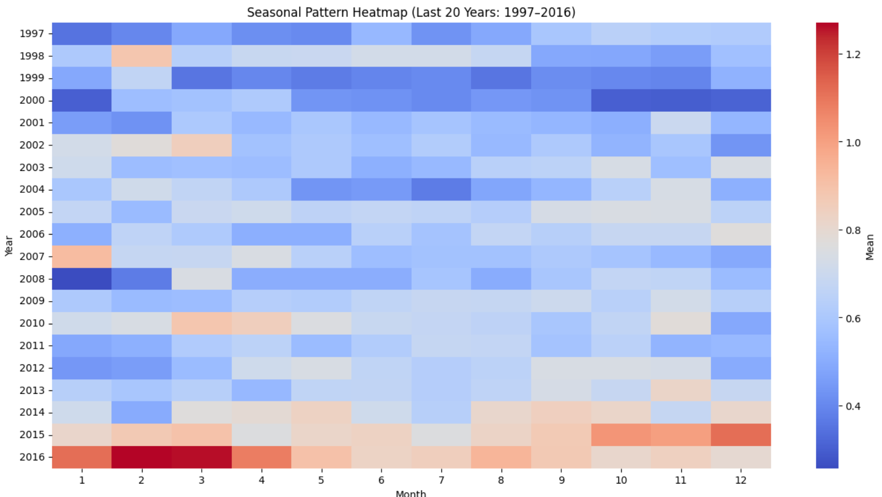

20 years Seasonal Heatmap

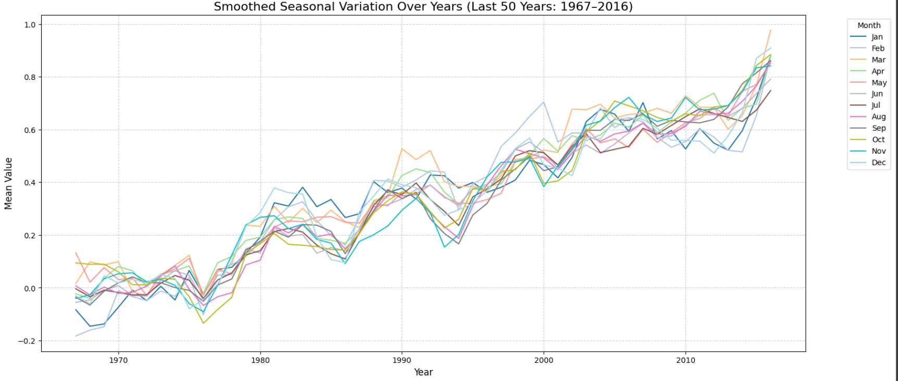

Smoothed Seasonal variation of last 50 years

**Assignment:**

## Part B: USA National Revenue Analysis

- Line Plot: Monthly revenue showed fluctuations with seasonal peaks.  
- 12-month Moving Average: Smoothed out volatility and revealed long-term revenue growth.  
- Grouped Bar Chart: Yearly averages by sector.  
- Pie Chart: Sectoral distribution of revenue in 2024.

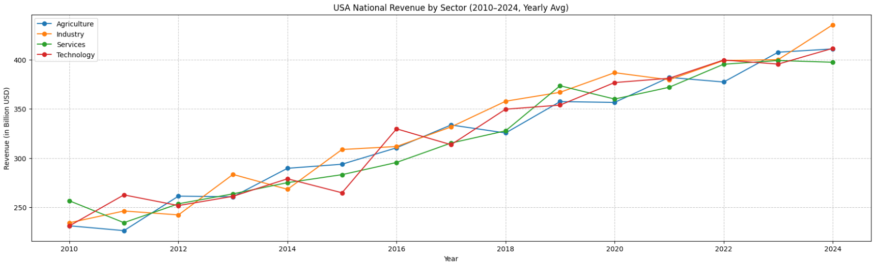

Figure 1: USA National Revenue Trends by Sector (2010–2024)

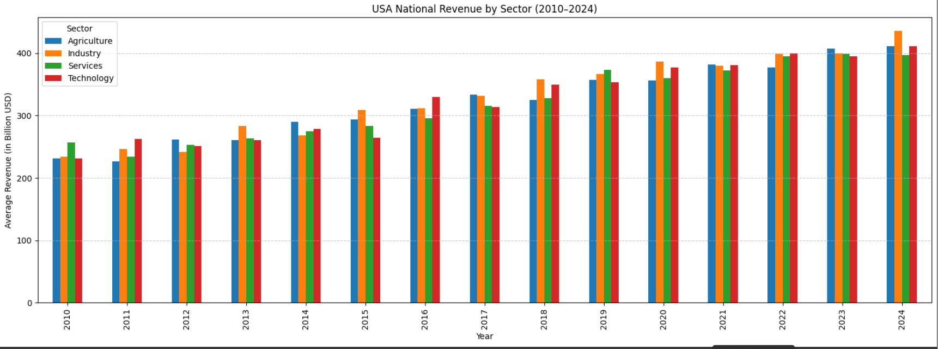

Figure 2: Smoothed 12-Month Moving Average of USA Revenue

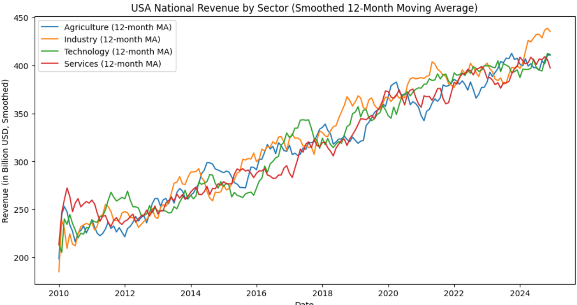

Figure 3: USA Revenue Distribution by Sector (2024)

# 

# Conclusion

The analysis confirmed a gradual and consistent rise in global mean temperatures and an upward trend in USA revenue cycles. Seasonal cycles remain intact (warmer summers, cooler winters; festive revenue peaks), but overall baselines are increasing. Time-series visualization proved effective for identifying both short-term fluctuations and long-term patterns.

**APPENDICES**

**DATA SOURCE:**

**<https://www.kaggle.com/>**

**PROJECT LINK:**

[**https://colab.research.google.com/drive/1CBSuYmZfWOhnoW2TQVyQ2pjpDx9-OU5L?usp=sharing**](https://colab.research.google.com/drive/1CBSuYmZfWOhnoW2TQVyQ2pjpDx9-OU5L?usp=sharing)

**GITHUB LINK:**

[**https://github.com/INDRO98/Visualizing-Global-Temperature-Trends/blob/main/README.md?plain=1**](https://github.com/INDRO98/Visualizing-Global-Temperature-Trends/blob/main/README.md?plain=1)