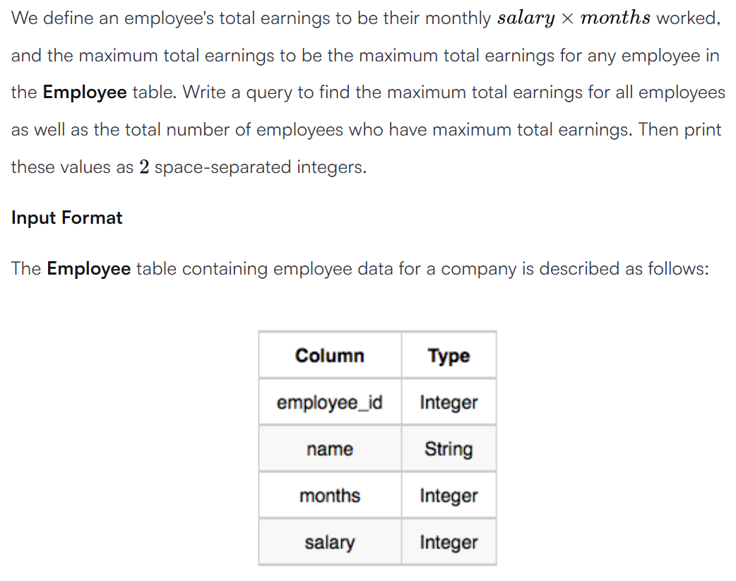



SELECT (months*salary) AS earnings, COUNT(*) FROM Employee GROUP BY (months*salary) ORDER BY (months*salary) DESC LIMIT 1 ;

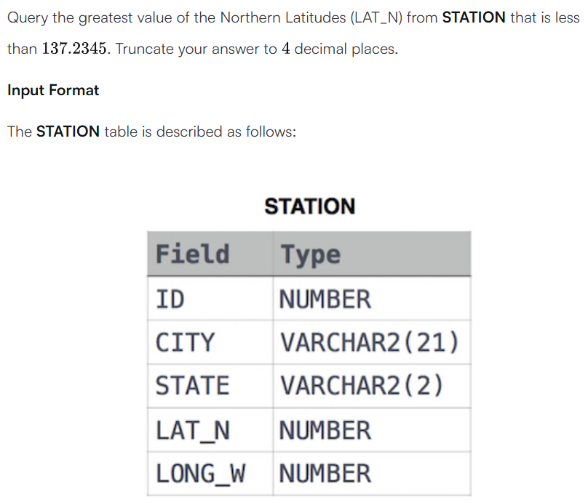



SELECT ROUND(MAX(LAT_N),4) FROM STATION WHERE LAT_N < 137.2345;

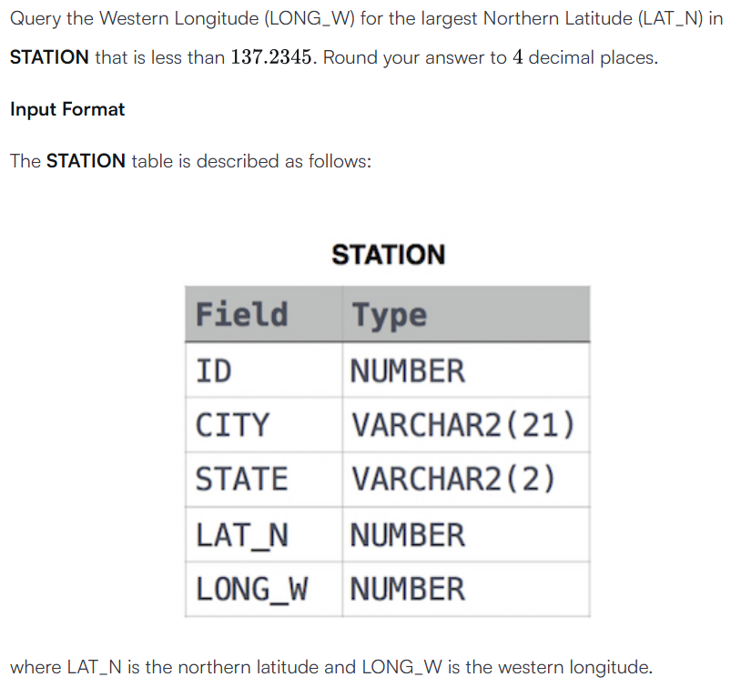



SELECT ROUND((LONG_W),4) FROM STATION WHERE ROUND((LAT_N),4) < 137.2345 ORDER BY ROUND((LAT_N),4) DESC LIMIT 1;

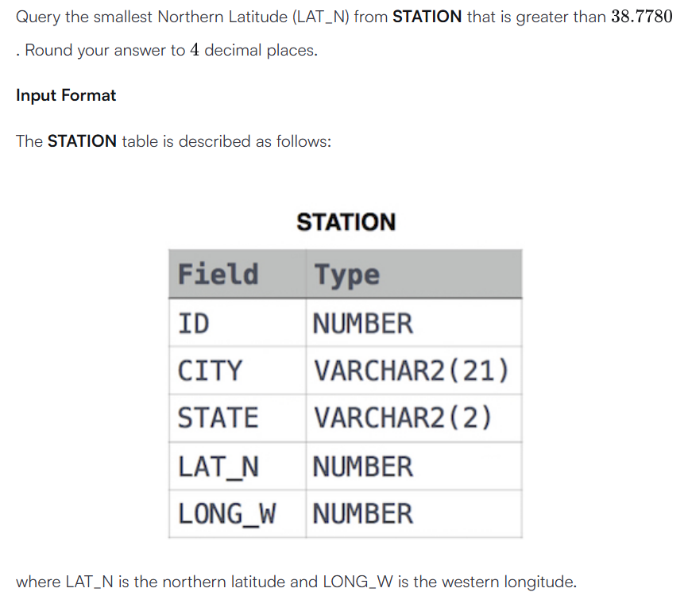



SELECT ROUND(MIN(LAT_N),4) FROM STATION WHERE LAT_N > 38.7780;





SELECT

e.roll_number,

s.name

FROM

student_information AS s RIGHT JOIN examination_marks AS e

ON s.roll_number = e.roll_number

WHERE (subject_one + subject_two + subject_three) < 100

GROUP BY e.roll_number;

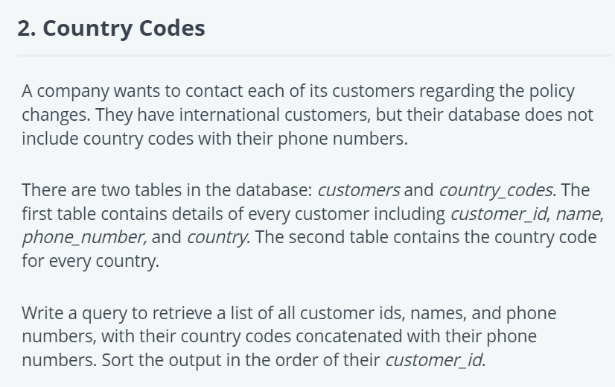



SELECT

c.customer_id ,

c.name,

CONCAT("+", b.country_code,a.phone_number)

FROM

customers AS c LEFT JOIN country_codes AS co

ON c.country = co.country

ORDER BY c.customer_id;

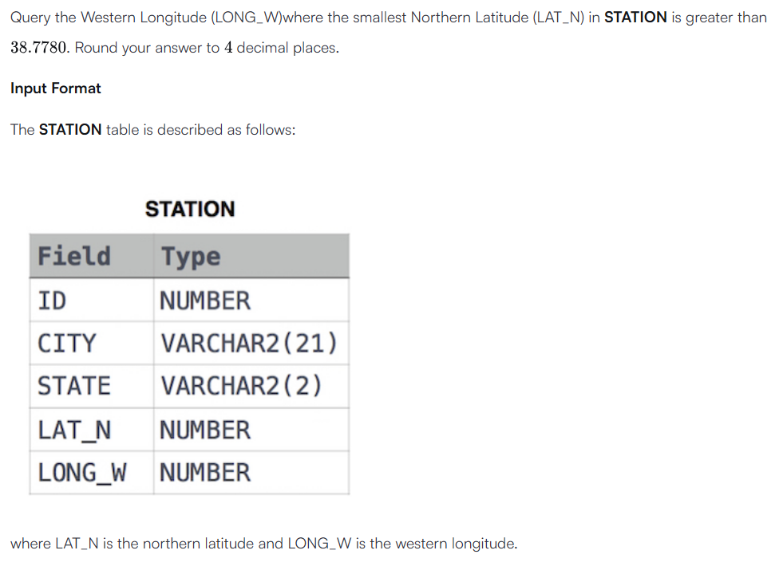



SELECT

ROUND(LONG_W,4)

FROM STATION

WHERE LAT_N > 38.7780

ORDER BY LAT_N ASC LIMIT 1;

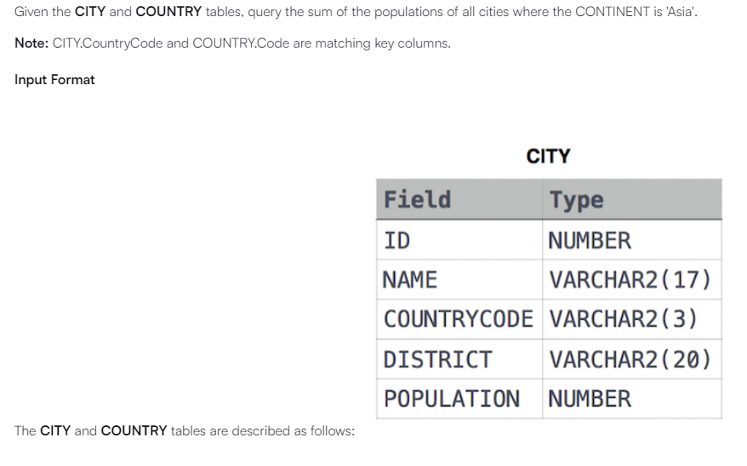

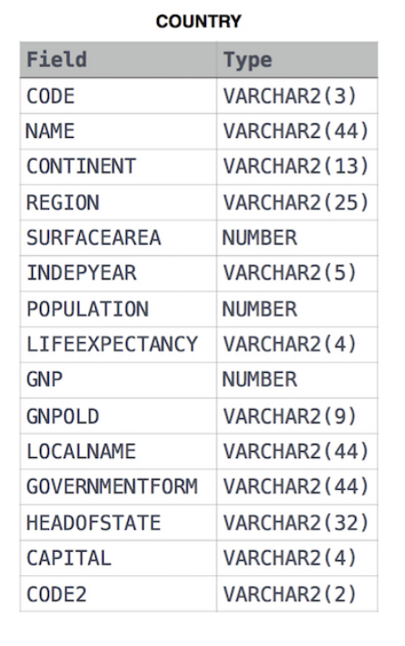



SELECT

SUM(c.POPULATION)

FROM CITY AS c

LEFT JOIN COUNTRY AS co

ON c.COUNTRYCODE = co.CODE

WHERE co.CONTINENT = "Asia";

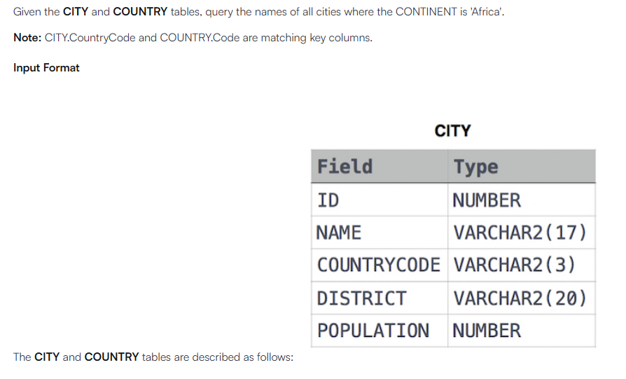





SELECT

c.NAME

FROM CITY AS c

LEFT JOIN COUNTRY AS co

ON c.COUNTRYCODE = co.CODE

WHERE co.CONTINENT = "Africa";

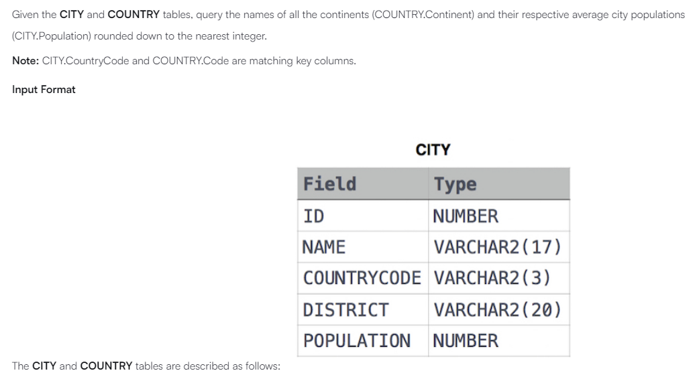





SELECT

co.CONTINENT,

FLOOR(AVG(c.POPULATION))

FROM

CITY AS c JOIN COUNTRY AS co

ON c.COUNTRYCODE = co.CODE

GROUP BY co.CONTINENT;