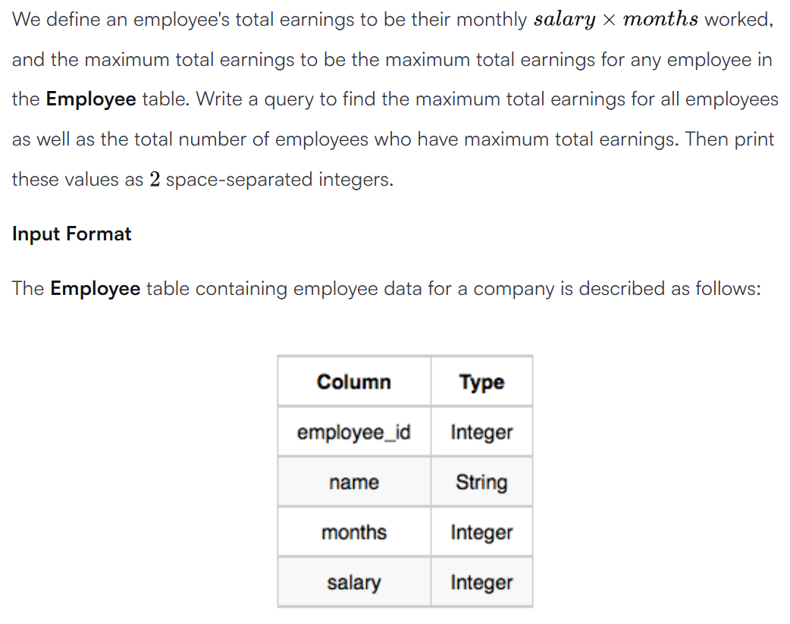



SELECT (months*salary) AS earnings, COUNT(*) FROM Employee GROUP BY (months*salary) ORDER BY (months*salary) DESC LIMIT 1 ;

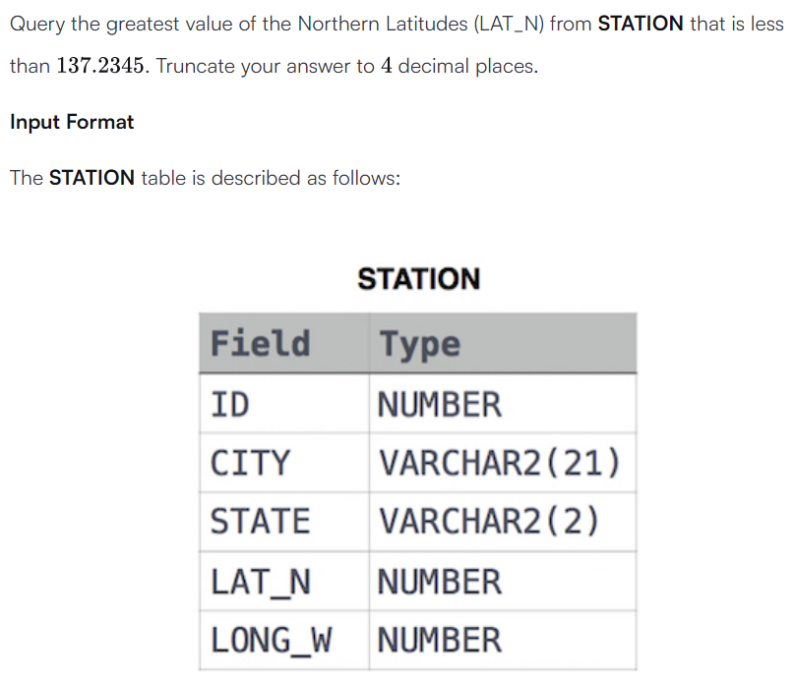



SELECT ROUND(MAX(LAT_N),4) FROM STATION WHERE LAT_N < 137.2345;

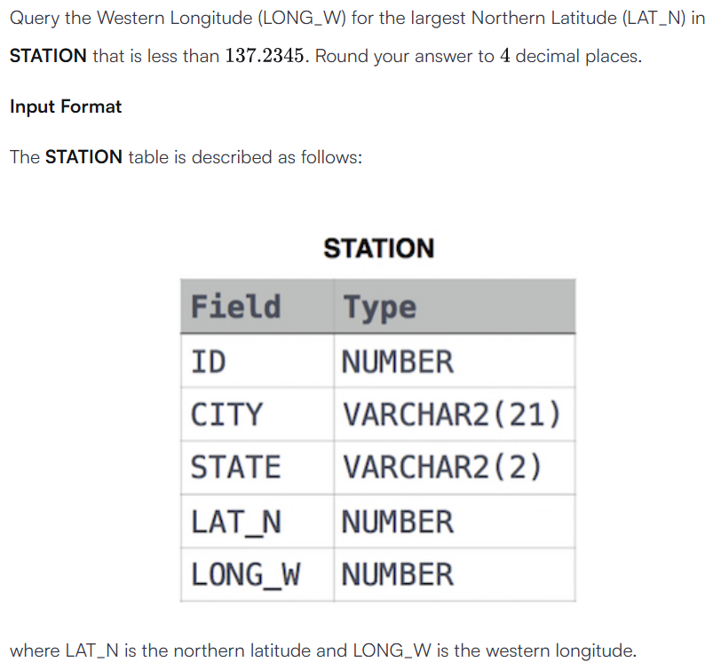



SELECT ROUND((LONG_W),4) FROM STATION WHERE ROUND((LAT_N),4) < 137.2345 ORDER BY ROUND((LAT_N),4) DESC LIMIT 1;

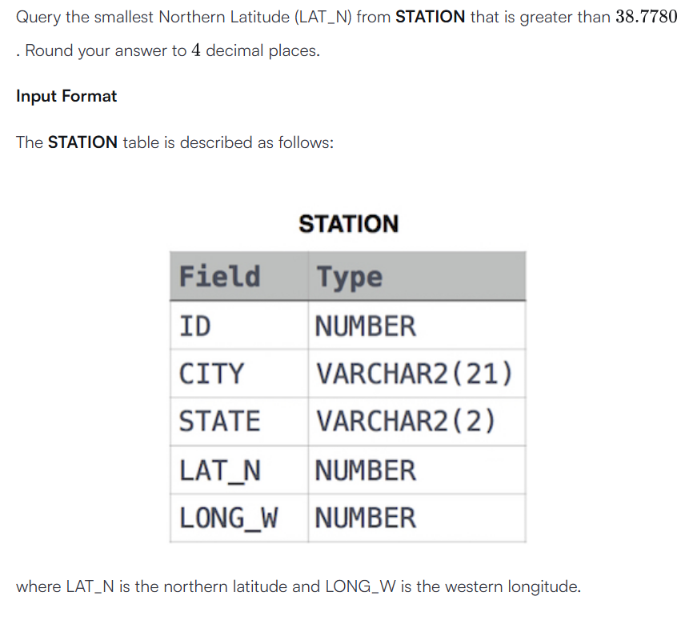



SELECT ROUND(MIN(LAT_N),4) FROM STATION WHERE LAT_N > 38.7780;