BESANT TECHNOLOGIES

BTM LAYOUT

DAILY ASSIGNMENTS

# **NAME:** M. INDU PRIYA

# **COURSE:** POWERBI

# **TRAINER:** PRIYANKA

DAY – 01

# ASSIGNMENT – 01/09/2025

**Question** : Visualize the total units sold by country.

**Chart Type:** Clustered Column Chart.

**x-axis:** Country

**y-axis:** Sum of Units Sold

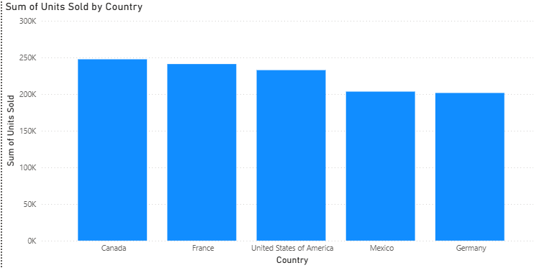

**Insights:**

* The chart represents the sum of units sold by country.
* X-axis includes the countries like Canada,France,United States of America,Mexico and Germany.
* Y-axis includes the sum of units sold ranging from 0k to 300k with the threshold of 50k.
* Canada is the leading country with the sales of ~250k units.
* The second highest is the France with slight difference from Canada’s units sold.
* The third highest is the United States of America again with a slight difference.
* The least high are Mexico and Germany almost with same number of units sold.
* Meanwhile Mexico and Germany are the countries with least number of units sold.

**DAY – 02**

**02-09-2025**

# CHARTS WITH FORMATS:

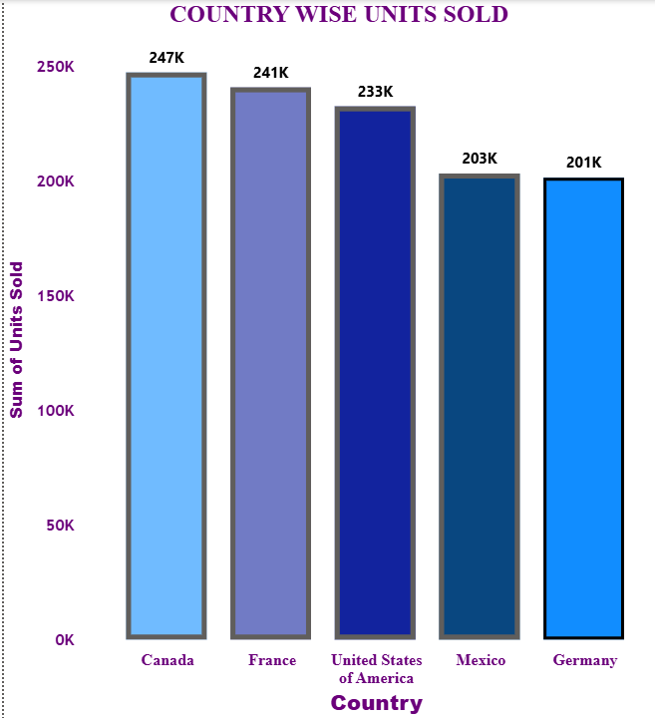

QUESTION: Generate the chart to represent the total units sold by country.

STEPS:

1. Started by understanding the problem statement and suitable charts for the problem statement and objective, here we need to find out the country wise units sold.
2. The data in this case includes both categorical (Country) and numerical (Units sold) so in the situation like this we can proceed with bar and column charts.
3. My choice here was stacked column chart and the categorical data always goes on the x-axis with numerical data on the y-axis in bar chart it’s vice versa.
4. As a first step go to the visualization pane present in the report view (charts and visuals are generated here) and select the stacked column chart the chart appears with all the necessary fields.
5. Drag and drop values to the axis categorical in x-axis and numerical in y-axis.
6. Now the chart has a default title and representation we can customize it based on our needs or choices.
7. Select the chart and new panes appear in the visualization pane with the name build visual, go to build visual and it contains two sections namely visuals and general.
8. In general section we can customize the title of the chart like size, style and other formatting like position of the title.
9. In visuals section we customize most of the chart segments.
10. The sections include x-axis inside that we have title formatting, values formatting and value overlapping.
11. The next section is y-axis inside that we format the title, values, value range like thousands/millions/trillions.
12. Then next we customize gridlines mostly turn it off, then turn on the data fields and we can position the data labels like inside end/inside base/outside end.
13. Next section is columns, we can change the color of each column individually or we can either change the color of all the columns at once.
14. Then in the same column section we can add borders to the columns customize the color of the border and the width of the border.
15. In this chart we customized each column individually.

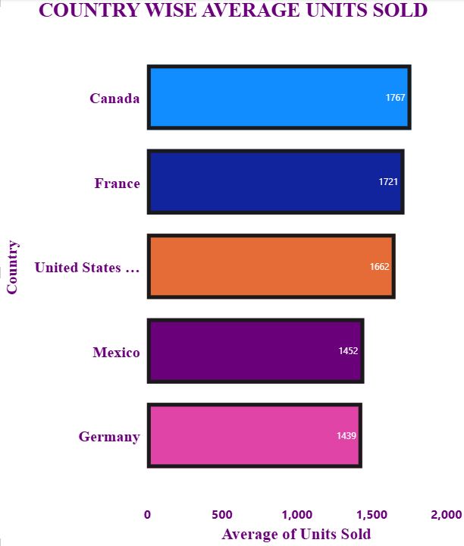

QUESTION: Generate the chart to represent the average units sold by country.

STEPS:

1. Started by understanding the problem statement and suitable charts for the problem statement and objective, here we need to find out the country wise units sold.
2. The data in this case includes both categorical (Country) and numerical (Average of Units sold) so in the situation like this we can proceed with bar and column charts.
3. My choice here was stacked bar chart and the categorical data always goes on the x-axis with numerical data on the y-axis in bar chart it’s vice versa.
4. As a first step go to the visualization pane present in the report view (charts and visuals are generated here) and select the stacked column chart the chart appears with all the necessary fields.
5. Drag and drop values to the axis categorical in x-axis and numerical in y-axis.
6. Now the chart has a default title and representation we can customize it based on our needs or choices.
7. Select the chart and new panes appear in the visualization pane with the name build visual, go to build visual and it contains two sections namely visuals and general.
8. In general section we can customize the title of the chart like size, style and other formatting like position of the title.
9. In visuals section we customize most of the chart segments.
10. The sections include x-axis inside that we have title formatting, values formatting and value overlapping.
11. The next section is y-axis inside that we format the title, values, value range like thousands/millions/trillions.
12. Then next we customize gridlines mostly turn it off, then turn on the data fields and we can position the data labels like inside end/inside base/outside end.
13. Next section is columns, we can change the color of each column individually or we can either change the color of all the columns at once.
14. Then in the same column section we can add borders to the columns customize the color of the border and the width of the border.
15. In this chart we customized all columns at once from the data pane just drag and drop categorical data(country) in legend field and the color changes automatically to the default color.

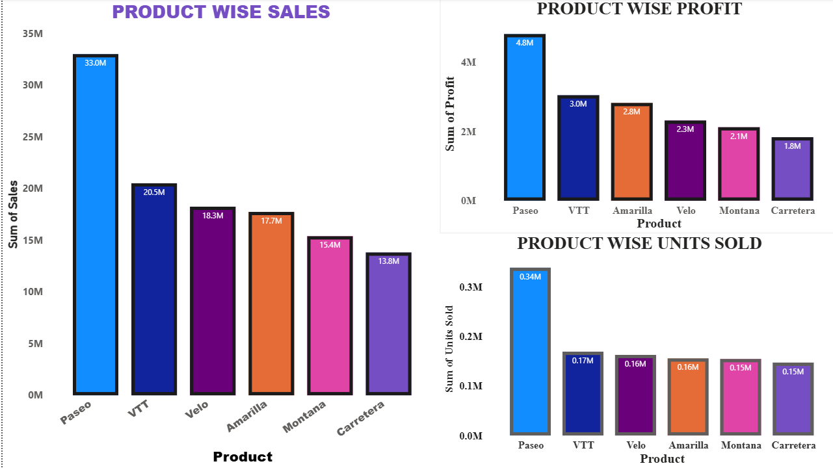

QUESTION: Does the product with highest sales has the highest profit and highest units sold.

1. Firstly, I generated three charts one for product wise sales, one for product wise profit, last for the product wise units sold.
2. Customized the charts.
3. Compare the charts product wise sales and product wise profit, it is not compulsory that the product with highest sales need to be having the highest profit.
4. But sometimes the product with high sales can be having high profit but not every time.
5. Now, comparing the charts product wise sales and product wise units sold, by analyzing we can conclude that the products with highest sales will be having the highest units of products sold.

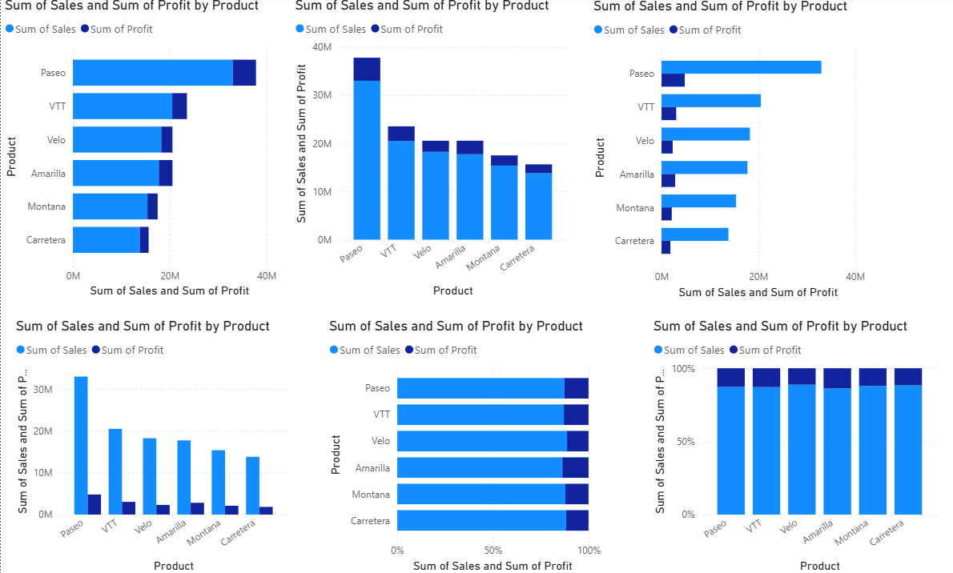

QUESTION: When we need to visualize both the product wise sales and product wise profit in the same chart, then what is the suitable chart and why?

* Sales and profit are two different measures, but they belong to the same product.
* A clustered chart places them side by side for each product, so you can directly compare how much profit was made for the sales generated.
* Example: If Paseo has high sales but low profit, you can easily spot that mismatch.
* In stacked charts, values get piled up making it hard to see individual contributions.
* In pie or donut charts, showing two measures together is confusing.
* Clustered columns avoid overlap, keeping both sales and profit values clearly visible and distinct.
* The chart focuses on products as categories.
* Even if the dataset grows with more products, the chart remains readable and professional.
* You can easily extend it to new categories without losing clarity.
* In real-world dashboards and reports, clustered column/bar charts are a common and trusted choice.
* Managers, stakeholders, and analysts are comfortable reading them, so insights are understood faster without needing extra explanation.
* Example insight: Paseo shows the highest sales and profit, while Carretera shows low sales and low profit.
* These patterns are immediately visible, helping decision-makers take action.