Debug DUMP:

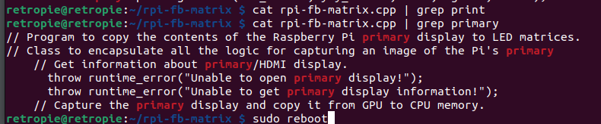

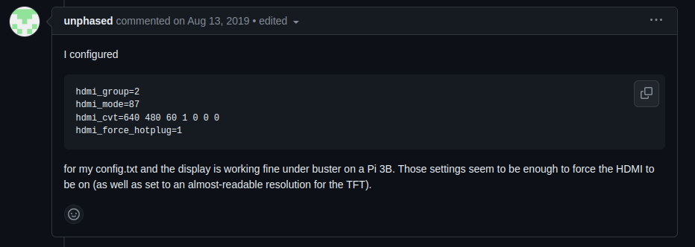
https://github.com/juj/fbcp-ili9341/issues/100

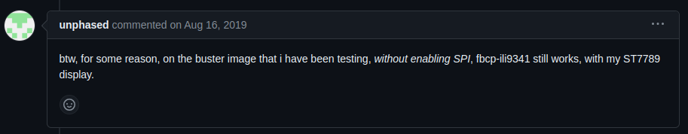
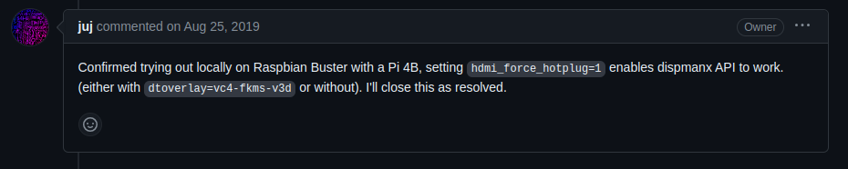
Maybe got something to do with Raspi OS 12
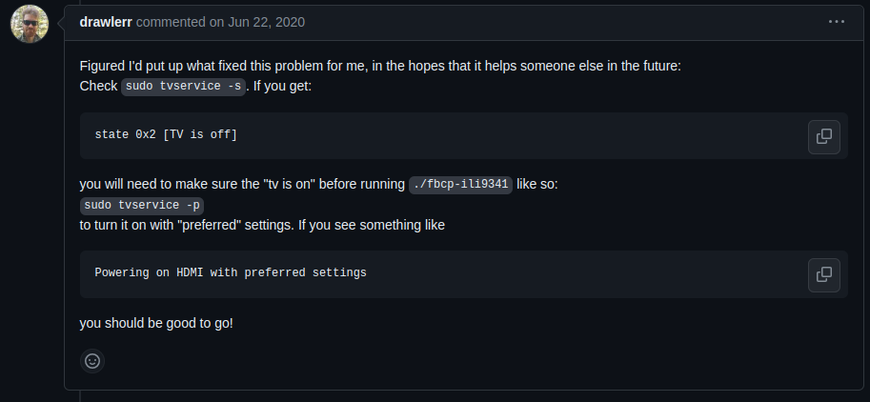

Worth a shot too

https://github.com/raspberrypi/userland/issues/461

Raspian 11 Bullseye
installation nach https://learn.adafruit.com/raspberry-pi-led-matrix-display/software
→ Instant worked

Installed newest version of python
https://aruljohn.com/blog/python-raspberrypi/

