P1 is basic team info as required by prof

p2

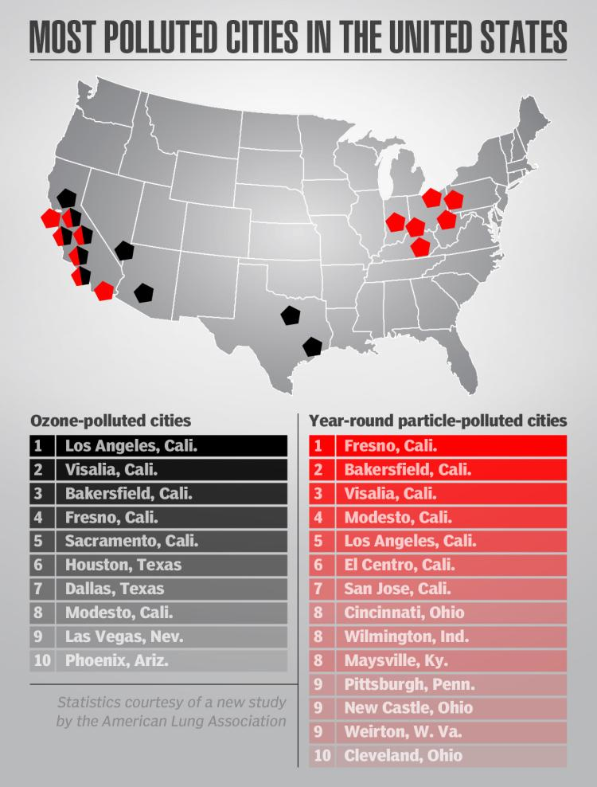

http://www.nydailynews.com/life-style/health/pollution-dangerous-breathe-report-article-1.2204916

(picture above circle out 3 x LA in the above picture)

(fact + LA is one of the most air polluted city in USA, and…)

p3

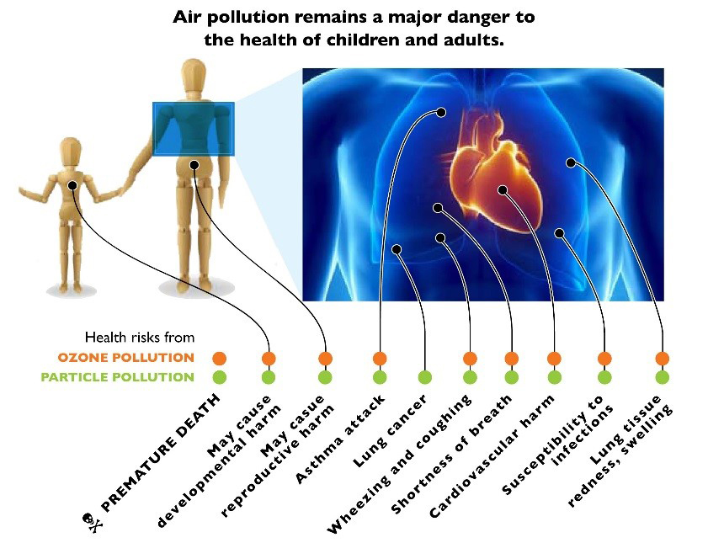

https://www.pinterest.com/pin/149392912619093176/10

briefly describe this pic

**10 words**: Air quality of our city is close related to our health.

**Why is your visualization important**: (Health is one of the most important considerations of everybody. Aside from the long term effort of environment restoration, the simplest thing we can do is to) know about the pollution condition around us and protect ourselves accordingly.

P4

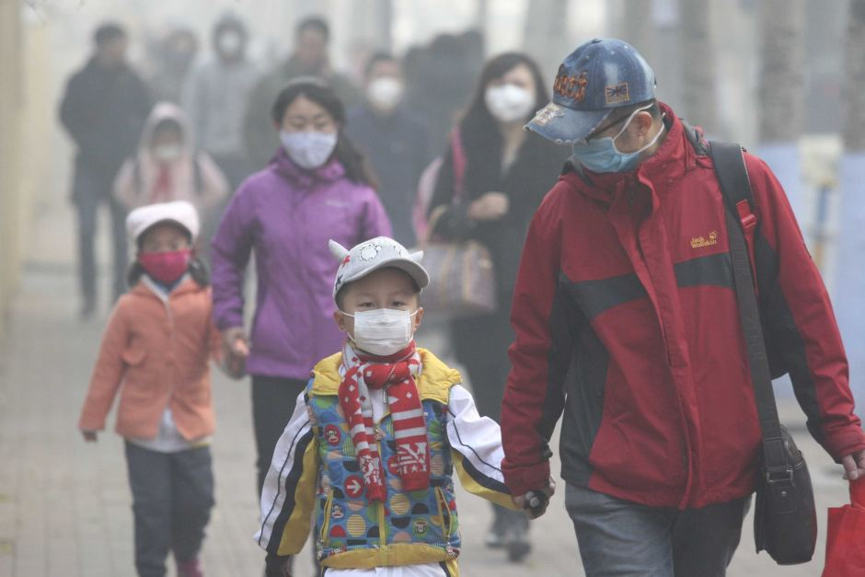

http://www.chiangraitimes.com/beijing-issue-second-red-alert-closing-schools-over-chocking-pollution.html

**who is your audience**: Everyone, especially groups are sensitive to air pollution, like senior citizens, people with certain diseases, families have young children or babies, etc.

They may particularly interested in questions like: which part of the city has highest air pollution level? What’s the peak time of air pollutants? What is the major pollutant near you? How each pollutant does harm to your body?

**How is your visualization useful**: Our visualizations can offer answers to these questions. Based on them, people can make decisions such as: Where to live in this city? Which time period I should avoid staying outside? When I need to wear mask?

P5

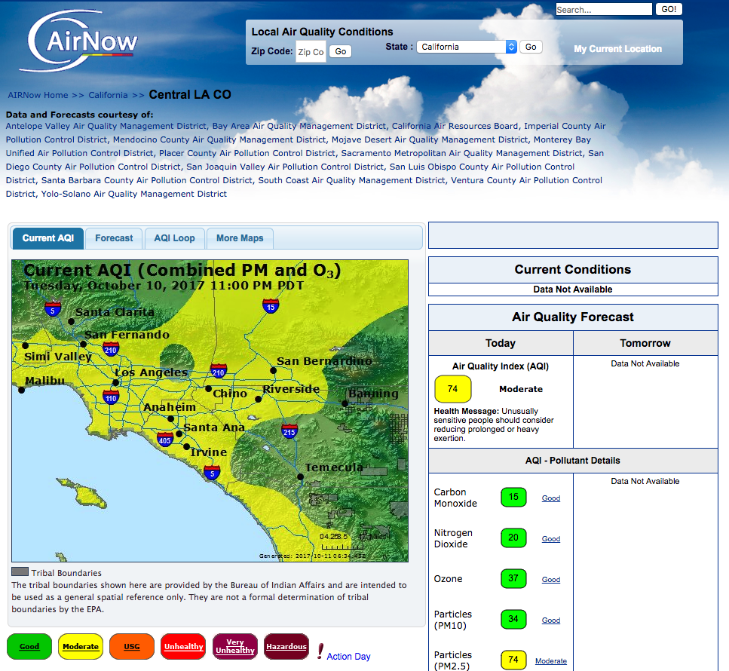

Data source:www.airnow.gov

(A bit explanation: hourly real time, 12 stations, 3 categories of pollutants (O3, pm2.5, pm10))

P6

**What are you telling with your visualization? What is the story?**

**Our story** (this part spreads multiple slides):

Begins with 12 monitoring stations. **P6**

Each station sensors 3 kinds of pollutants every hour. **P7**

We impute the pollution condition all over the city and visualize via heat map. **P8**

Further analyze how each environmental factor affects the read. **P9**

Finally offer people suggestions how air pollution affects your body parts. (just talk)

**How do you plan to use interactive visuals**:

(explain it while walking through)

Select the particular pollutant you want to see (different pollutant different heat map / lines).

Select the station to see it’s read.

Select a certain point on the map to get the read. (can do with imputation?)

Select the particular hour you want see, and see how pollution heat map change over time.

See the factors that influence air quality.

See how each pollutant does harm to our body.

**What are your design considerations?**

Elaborate when introducing each pic.

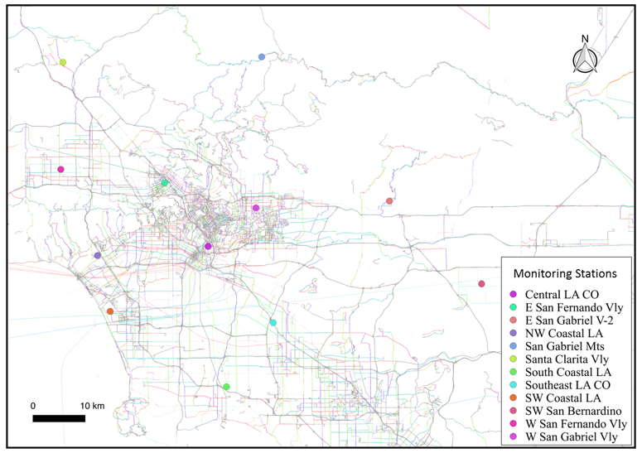

P7

(need to split the following pic into two halves to fit in a page)

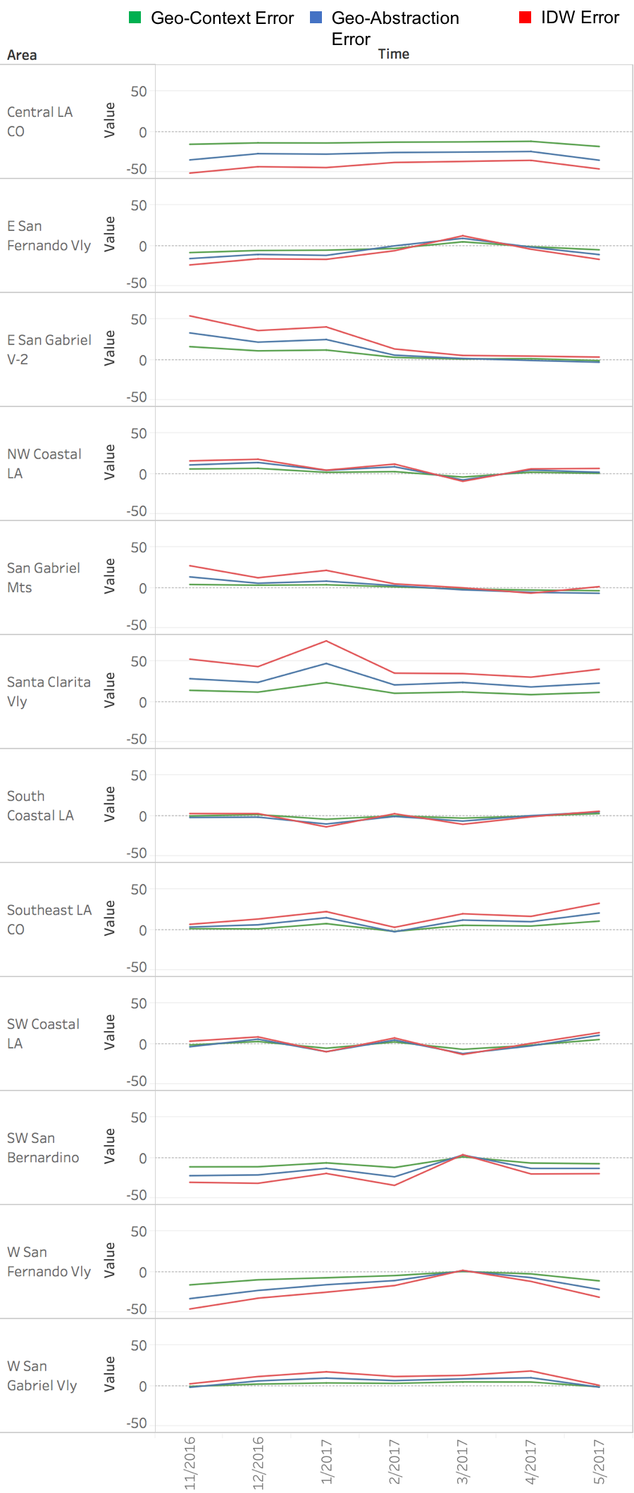

P8 (bigger pic)

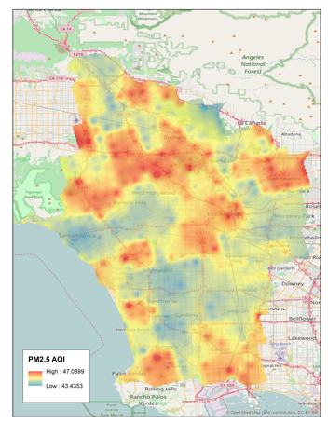

P9

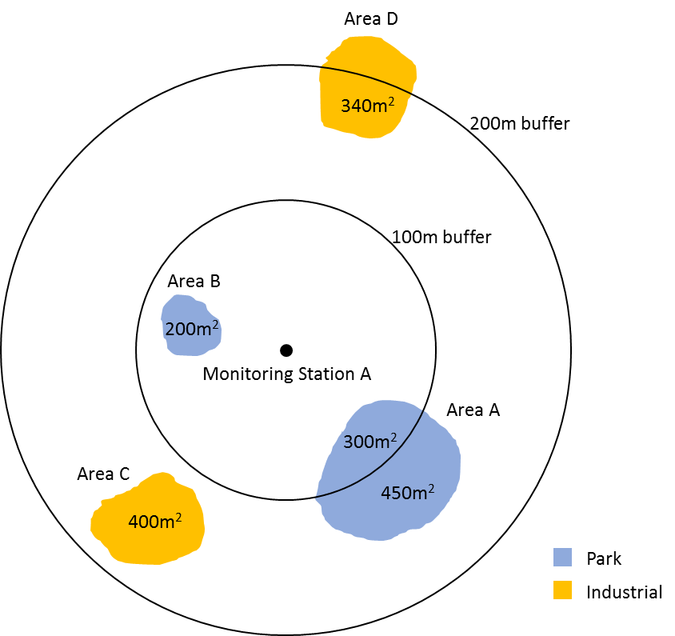

P10

**Cool & interesting**

**What are the components that make your visualization cool?**

Interactivity, real time heat map and line plots

**Why is your project interesting?**

Particular days: Holidays

Factor analysis: Surroundings

Imputation in every part of the city (can do?) and visualize in heat map

P11

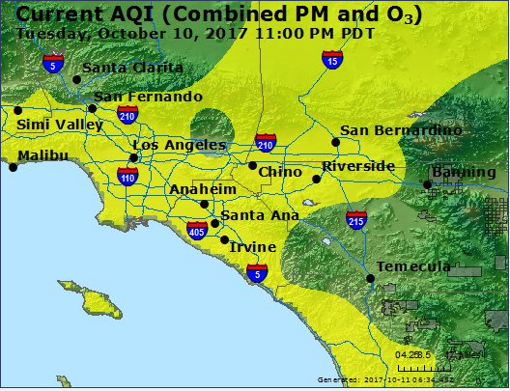

**How does your visualization compare to what others have done**:

(compare to visualizations on AirNow) We have interactivity. We can click on stations or places (can do?) on the map to reveal the readings.

P12

**How are you going to design, build, and evaluate?**

P13

**What are the technologies you plan to use?**

Fan’s tech + vis tech + data pipeline

**What are your deliverables?**

Web page

P14

**Timeline**

P15

**Team and job division / how do you work together**

Haotian Zhang: Team leader, visualization programming, and data pipeline.

Jing Peng: Visualization programming and web technical developments.

Fan Pan: Data science modeling and visualization programming.

Gabrielle You: Aesthetics design, visualization programming, and deliverables.

A bit declaration of the related paper and Fan’s project.