Fragmented History, Divided Programs: Educating Archivists on   
Teaching with Primary Source Material

Ana E. Corral

Wayne State University, School of Information Sciences

Abstract

This research proposal seeks to address the lack of pedagogical training on primary source material present in US archival programs. Data will be gathered through survey questionnaires, job market and syllabi analysis, to address research questions about the correlation between course offerings and current demands in the archival field and community. The span of the study should cover two years after which the author will thoroughly analyze data gathered to determined what suggestions can be offered to current and post-graduate archival students and new professionals and lay the groundwork for future studies in this topic.

Keywords: primary source material, archival material, primary source literacy, information literacy, archival history, archivists, surveys, archival curricula, pedagogy

Fragmented History, Divided Programs: Educating Archivists on   
Teaching with Primary Source Material

# Background

Teaching with primary source material in universities is a relatively new topic[1] that is gaining traction in the field and is situated within the broader context of archival education and accredited archival programs in the United States. The thoroughness and relevancy of courses that educate archivists on teaching with primary sources varies depending on the school, program, specialization and even instructor. Within accredited archival programs in the United States, a disconnect exists in the curricula, goals, and aims of that has deep roots in the fragmented history of archives and archival education. Archivists prior to the 1970s and arguably today are educated within the field of history or are professional historians (Cox, 2014). The archival field is fraught with tension and disputes concerning the placement of archival graduate education in library and information science (LIS) or history programs, and to-date, there has been no consensus on the issue (Turrini, 2007, Cox et al., 2001). Archival students are taught to work with primary source material; to conserve, preserve, organize, and store the material but rarely taught to instruct with it, despite growing demands for archivist instruction in the field (OCLC, 2019).

# Problem Significance and Purpose

Primary source material or archival material can and should be used by archivists to teach undergraduate students. LIS students, professionals, and the institutions they work in could benefit greatly from a thorough analysis of methods, use, and suggestions for inclusions and promotion of primary source material instruction. Anderberg et al. (2018) inform readers that there is no requisite course that provides pedagogical training for primary source instruction and very few programs in the US and Canada offer primary source pedagogical training. By analyzing the current field literature, along with a survey questionnaire, job market analysis, and curricula analysis, the research study will attempt to both educate the field and provide a list of resources that current graduate students or newly graduated students can reference when they are called upon to teach with primary sources.

# Definitions

Before progressing further, several key concepts will be addressed and defined in relation to this study: primary sources, instructional methods using primary source materials, and primary source literacy. Primary sources are generally defined as non-secondary sources, that is, material “that serves as original evidence documenting a time period, event, people, idea, or work” (ACRL & RBMS-SAA Joint Task Force, 2018, pp. 11–12).

The ACRL & RBMS-SAA Joint Task Force defines primary source literacy as “the range of knowledge, skills, and abilities required to effectively use primary sources” (2018, p. 1). “They require critical analysis due to their creators’ intents and biases; the variety of context in which they have been created, preserved, and made accessible, and the gaps, absences, and silences that may exist in the materials” (2018, p. 1). Instruction with primary source material consists of the addition of archival material to a course to encourage critical thinking, research skills, and appreciation and use of archival repositories. Archival material can be the main focus of the course or provide support on a chosen topic, such as using Renaissance manuscripts in an English class or the original journals of Charles Darwin used in a biology course.

# Research Questions

This study seeks to address the following questions: a) what is the relationship between accredited archival programs and courses that include teaching with primary source material; b) is there a correlation between ranking and course amount; c) how satisfied are students (before and after) pedagogical training (if any) on teaching with primary source material; and d) what is the correlation between job descriptions and coursework in accredited programs?

The questions are meant to explore the topic of teaching with primary source material more in depth and open a dialogue as to how it relates to archival programs and the job market. By gathering data to address these questions, a baseline for assessment could potentially be established with which to further study the topic in depth and provide a list of resources for archivists that with instruct using primary source material.

# Framework

The theoretical framework for this study is a deductive, scientific method of research. Once the topic of teaching with primary source material was identified, a working hypothesis was tentatively established. The hypothesis on the value of teaching with primary source material, was then restructured to a causal hypothesis, given that there is a relationship between what is taught in archival programs and the ability for librarians to have primary source literacy and teaching with primary sources (Connaway & Powell, 2010). Working from this hypothesis, data was gathered with the purpose of answering the research questions, addressing the problem statement, and applying the results in suggestion and idea form for the archival field (Cibagu, 2010). The graduate student survey, syllabi review, and analysis of job postings will be employed in an attempt to address the issue of lack of training of archivists on teaching with primary source material. The data gathered seeks to prove the hypothesis and address the research questions and not vice versa (Cibagu, 2010).

# Assumptions and Limitations

For the purposes of this study, the title of ‘archivist’ will be applied to any of the graduate students that are enrolled in archival programs, regardless of if they are designated librarians or historians. The survey will be sent out to both ALA- and SAA-accredited programs on the assumption that graduate students will enroll an archival programs even they are not listed in the SAA directory of archival programs. There were few programs that were listed on the ALA directory and not with the SAA and the author thought it best to have as large and inclusive of a sampling size as possible.

The study is limited to data from archival graduate students in the US and will include data gathered over the span of one year, not including the follow-up survey. The sampling size and type can be generalizable, but as with statistical sampling, it cannot fully encompass the entire population of graduate students and programs. The data will reflect a specific time frame, and as the field is shifting and growing, programs that offer courses that include teaching with primary source material could be modified, added, or removed from the program and course listings.

The survey and data specifically focus on teaching with primary source material, they do not encompass other instructional methods taught to archivists. Certain programs might not teach specifically regarding primary source material or primary literacy and instead focus on information literacy or other types of slow-learning pedagogical methods which are not within the constraints of this study.

The survey questionnaires are designed with current students and practitioners in mind and as such do not include program administrators or instructors. The addition of staff and instructors is recommended for future studies to gain a more comprehensive understanding of archival education as relating to instruction on primary source materials. A survey questionnaire was selected over face-to-face or telephone interviews because their ability to gather in-depth data but would have been too specific and not as far-reaching as an easily distributable questionnaire would be. There is the potential for a sampling error because of the survey design, which is intended to be sent out while the participants are enrolled in archival programs and then post-graduation. Even after consent is received to contact the participants for the follow-up survey, there is still the possibility that participants will decline or be unavailable.

Another threat to reliability would be the difference between the whole population and a sampling of the population. Much of the literature and research encompasses US and Canadian students and programs, and while there are similarities in the Canadian and US programs, the study will only encompass US schools (Anderberg et al., 2018). There is no discernable method that encompass the entirety of archival programs and their students in US and Canada all at once and a sampling can be representative *of* a population but not of the *entire* population.

# Literature Review

The following literature review is conceptual in nature, intending to outline the history and background on archivists teaching with primary source material; the history behind archival education, the growth of the topic, implementations through the form of case study, and potential solutions. This review is intended to be a selection of the literature reviewed for this research proposal and is not intended to be exhaustive in nature, but instead provide an overview of the literature available.

## History of Archival Education – Readings from the US and Canada

Archival education has a relatively new history as compared to the rest of the archival field, in the US and internationally. The first signs of archival courses appear in the 1970s and much of the “training” that archivists had was either hands-on, on the job or informal (Galloway, 2014). Cox, et al. (2001) detail the growth of archival education in the US as slow and graduate, especially post 1940s.

Prior to the 1940s, the curriculum was individualized and dominated by professional, field training instead of formal, pedagogical training. Cox et al. (2001) provide an overview of archival education and argue that many of the disputes surrounding curricula and programs are connected to the decades-old competition between establishing the programs in the context of history or library science. Cox (2014) examines the career of Lester J. Cappon, an archivist with a historian background to explore the history of archival education more in depth. By following Cappon’s career, Cox demonstrates the historical foundation upon which archival education has been forged has become more muddied and confused “as archival education has become more ensconced in library, information science, and information schools (2014, p. 327). Despite the progress being made in archival programs, “there is [still] confusion or lack of understanding about the archival field…as well as a lack of commitment by archival professional associations to advocate for specific changes in archival education” (Cox et al., 2001, p. 141).

## The Importance of Teaching with Primary Source Materials

This fragmented commitment and lack consensus among instructors, programs, and curricula is reflected in the lack of education and coursework that educates archivists on how to teach with primary source material. In their survey, Anderberg et al. (2018) determined that graduate programs are divided among theoretical or practical frameworks and do not truly reflect the needs of archivists out in the field and that these needs or desires, are “found not only in the professional literature, but in the job market as well” (p. 193). The survey results demonstrated that “most archives graduate programs in the United States and Canada do not have concentrations or certifications that include teaching with primary sources as part of the curriculum” and including primary source material instruction in archival curricula “will ensure archivists-in-training are exposed to skills that they will likely need in their careers” (p. 201).

Weber (2017) emphasizes the value and importance of archivists teaching with primary source material in her OCLC research and learning agenda that discusses “current and emerging needs in the community…and addresses areas of inquiry and potential research and learning opportunities” (p. 6). The changes in library instruction are also reflected in archives and special collections with a shift from protection of national treasures “to a pedagogical approach that leverages primary source materials to engage students” (Weber, p. 10). Indeed, a recent webinar presented by the OCLC (2019) discussed the “pedagogically-grounded approach” of connecting students and archives as a way to demonstrate the value of archives and focus on mindful thinking. There has been an increase in jobs in the field that require teaching and a desire to “advance the pedagogical use of archives” in academic archives and special collections (OCLC, 2019).

Carini (2009) writes that teaching with primary source material offers archivists the opportunity to connect with students and faculty and promote both primary source and information literacy. Robyns (2001) writes that “critical thinking skills are fundamental components of research in primary sources” and that provided their amount of training and expertise, archivist “can make a real difference in education by guiding students through the process of critical analysis, making the archives not only a repository of the past but also a challenging center of critical inquiry” (p.364–365).

## Case Studies

In “Exploring the digitizing immigrant letters project as a teaching tool” article, Cancian and Wegge (2014) combine digitized material with biographic material to address gender and international migration in an undergraduate course. Student engagement with primary and secondary source material as a way to both educate and introduce students not just to the course topic but to connect real world implementation into the broader narrative of archival access and preservation and how it can inform undergraduate learning.

Boone and Satterfield (2010) pick up the common thread of education through the use of primary source material in undergraduate courses, this one being a “first-year writing course” at Dartmouth College (p. 97). A librarian and instructor worked together to hone in on research abilities and improve critical thinking through primary and secondary narratives to create an “active learning environment” and “expanding the students’ range of intellectual inquiry” (p. 101). Through a closer, critical analysis of novels, the instructors introduce primary source analysis and research. Along the same vein, Sutton (2010) promotes the concept of the “archival laboratory”, where faculty and librarians collaborate to offer students a setting similar to a scientific laboratory where they can “conduct original research, make discoveries, and test hypotheses” (p. 175). Continuing the use of archival material as encouraging and fostering original research. These case studies carry on the common themes of original research through the analysis and examination of primary source material and interdepartmental collaboration. No course was the sole creation of an instructor or librarian, but instead a close partnership to create syllabi and learning outcomes that would reflect both course topics and educate on the archival topics of preservation, access, and value.

## Solutions and Recommendations

Both the “Framework for information literacy” and “Guidelines for primary source literacy” offer concepts, practices, and core ideas for archivists to use when teaching with primary source material. They can be “used as whole or in part” and “may be applied differently in different contexts,” and include analytical, ethical, theoretical, and practical considerations that archivists can focus on when teaching with primary source material (ACLR, 2018, p. 1). The ACRL (2015) offers six frames with which instructors can “infuse information literacy concepts and skills into their curricula” and focuses on a set of core values that can also be implemented partially, depending on the goals and context.

Hauck & Robinson (2018) take it a step further, buy providing examples of how to implement the 2018 Guidelines. Because of how recent the Guidelines are, Hauck & Robinson are among the first professionals to report on the effectiveness of the Guidelines. Hauck & Robinson distributed a survey before and after an undergraduate course, accompanied with student and research observations. Students’ work was critically analyzed all throughout the semester, including the final papers, to determine if their information literacy improved and how well students were able to define, identify, and work with primary sources. They advocate for “librarian-led instruction sessions” and further assessment on the new primary source literacy guidelines (2018, p. 218).

# Methods: Research Design

The topic itself is not new but not a lot of research has been conducted on this specific topic and the room for growth is undeniable. The research design would be best considered an exploratory study, which “occur in areas for which little, if anything, is known. These studies might be less structured and more flexible…One goal of such a study might be to determine how fertile an area might be for future research” (Hernon & Schwartz, 2009, p. 1). There are opportunities for progress, to explore the topic through the lens of current and new graduated students. The ACRL & RBMS-SAA Joint Task Force Guidelines are so new that the effects of the Guidelines and how to implement them is still unknown; professionals are presently studying, researching, and implementing them. The research study performed would also be considered a cohort study since it collects data from the sample population more than once and aims for real world applicability (Connoway & Powell, 2010).

# Methods: Context, Population, and Sampling

The surveys will be sent out to students both ALA- and SAA-accredited archival programs. There is no fixed number of graduate students that will be sampled because there is the possibility that not all students will have the time or be receptive to the survey request. The population studied would a sampling of archival graduate students in the US along with a selection of job postings and syllabi. The set of recommendations to potentially be provided at the conclusion of the survey have the principal audience of graduate students and newly graduated students. Although a good part of the literature covers archival programs or current professionals, a lot of the recommendations can still be applied to graduate students. The entire population of current and recently graduated archival students is currently not knowable, given the amount of time and resources available, a sampling of students would be feasible.

# Instruments

The research instruments to be used in this study are survey questionnaires, one during the program and the other after graduation and ideally, employment. The survey has 10 questions that are a mix of textboxes, matrix questions, multiple choice, and yes and no questions. Course syllabi will be reviewed in comparison to the Information Literacy Framework and Primary Source Guidelines. Job market analysis will be performed through database entry of job postings gathered from Archives Gig, SAA, ALA and ARL listservs in a Google form customized for job position description entry. A waiver for distribution prior to issuance of the surveys will be created based on the CITI Program “Basic/refresher course – Human subjects research.” Once the data has been gathered and analyzed, an open list of suggestions will be included as an appendix to the research paper.

# Procedures

The steps to performing the survey and the accompanying research are as follows:

1. Creation of waivers.
2. Contact school program administrators.
3. Contact graduate students for survey.
4. Distribution of waivers.
5. Survey distribution.
6. Analysis of course syllabi.
7. Analysis of job postings for one year.
8. Survey data analysis.
9. Compilation of results.
10. Repeat steps three through eight.
11. Compile and compare data.
12. Issuance of study results and recommendations.

# Data Analysis

Analysis of the survey data will be performed through SurveyMonkey, which has different filters and rules to perform data analysis, depending on how you would like the results to be displayed. Once the results are gathered from the surveys, syllabi, and job postings, inferential statistics will be used to perform a more in-depth analysis, to “help one to make inferences and judgements about what exists on the basis of only partial evidence” (Connoway & Powell, 2010). The data will be analyzed within the broader context of the research questions written above and will be used to shape the suggestions for graduate students and the archival field at large.

# Summary

The disjointed history of archival education and the archival field influences archival programs, including their curricula and priorities in educating future archivists. Something as valuable and useful as primary source literacy and teaching with primary source materials is not taught consistently does not reflect the current needs of archivists, communities and employers. There is a growing amount of research and interest in the field about teaching with primary source material and the disconnect as to why archival programs are not training archivist to do so is very concerning. This study is meant to gather data and address the pressing questions as to why the disconnect is still present and in doing so, hopes to create a path for further research in this topic.

References

ACRL. (2015). Framework for information literacy in higher education. Retrieved from http://www.ala.org/acrl/standards/ilframework

ACRL & RBMS-SAA Joint Task Force. (2018). Guidelines for primary source literacy, 1–18. Retrieved from https://www2.archivists.org/standards/guidelines-for-primary-source-literacy

Anderberg, L., Katz, R. M., Hayes, S., Stankrauff, A., Hodgetts, M. M., Hurtado, J., Nye, A., & Todd-Diaz, A. (2018). Teaching the teacher: Primary source instruction in American and Canadian archival graduate programs. *The American Archivist, 81*(1), 188–215. Retrieved from https://doi.org/10.17723/0360-9081-81.1.188

Boone, S. & Satterfield, J. (2010). A novel approach: Teaching research through narrative. In *Past or portal? Enhancing undergraduate learning through special collections and archives*, (pp. 97–102). Chicago, IL: Association of College and Research Libraries.

Cancian, S. & Wegge, S. A. (2014). Exploring the digitizing immigrant letters project as a teaching tool. *Journal of American Ethnic History, 33*(4), 34–40. Retrieved from https://www.jstor.org/stable/10.5406/jamerethnhist.33.4.0034

Carini, P. (2009). Archivists as educators: Integrating primary sources into the curriculum. *Journal of Archival Organization, 7*(1-2), 41–50. doi:10.1080/15332740902892619

Cibagu, S. K. (2010). Paradigms, methodologies, and methods. *Library and Information Science Research, 32*, 177–178. doi:10.1016/j.lisr.2010.03.006

CITI Program (2019). Basic/refresher course – Human subjects research. Retrieved from https://about.citiprogram.org/en/homepage/

Connaway, L. S., & Powell, R. R. (2010). *Basic research methods for librarians*, (5th ed.). Retrieved from <https://ebookcentral.proquest.com>

Cox, R. J. (2014). Lester J. Cappon, an unwritten textbook, and early archival education in the United States. *Information & Culture, 49*(3), 327–350. Retrieved from https://www.jstor.org/stable/43737396

Cox, R. J., Yakel, E., Wallace, D., Bastian, J. A., & Marshall, J. (2011). Archival education in North American library and information science schools. *The Library Quarterly: Information, Community, Policy, 71*(2), 141–194. Retrieved from https://www.jstor.org/stable/4309505

Galloway, P. (2014). From archival management to archival enterprise to the information domain: David Gracy and the development of archival education at the University of Texas. *Information & Culture: A Journal of History, 49*(1), 3–33. Retrieved from https://doi.org/10.1353/lac.2014.0005

Hauck, J. & Robinson, M. (2018). Of primary importance: Applying the new literacy guidelines. *Reference Services Review, 46*(2), 217–241. Retrieved from https://doi.org/10.1108/RSR-03-2018-0025

Hernon, P. & Schwartz, C. (2009). Procedures: Research design. Library & Information Science Research, 31, 1–2. doi: 10.1016/j.lisr.2008.10.005

OCLC. (Producer). (2013). *Engaging the archives – collaborating with faculty for robust undergraduate learning* [Video webinar]. Retrieved from https://www.oclc.org/research/events/2019/041819-engaging-archives-collaborating-with-faculty-for-learning.html

Robyns, M. C. (2001). The archivist as educator: Integrating critical thinking skills into historical research methods instruction. *The American Archivist, 64*(2), 363–384. Retrieved from https://www.jstor.org/stable/40294177

Sutton, S. C. (2010). The special collections laboratory: Integrating archival research into undergraduate courses in psychology and music. In Mitchell, E., Seiden, P., & Taraba, S. (Eds.), *Past or portal? Enhancing undergraduate learning through special collections and archives*, (pp. 175–178). Chicago, IL: Association of College and Research Libraries.

Taylor, H. A. (1972). Clio in the raw: Archival materials and the teaching of history. *The American Archivist, 35*(3/4), 317–330. Retrieved from https://www.jstor.org/stable/40291435

Turrini, J. M. (2007). The historical profession and archival education. *Perspectives on History*, (May), 47-49. Available from: http://www.historians.org/publications-and-directories/perspectives-on-history/may-2007

Weber, C. S. (2017). Research and learning agenda for archives, special, and distinctive collections in research libraries. *OCLC Research*, 1–22. doi:10.25333/C3C34Fvbg34

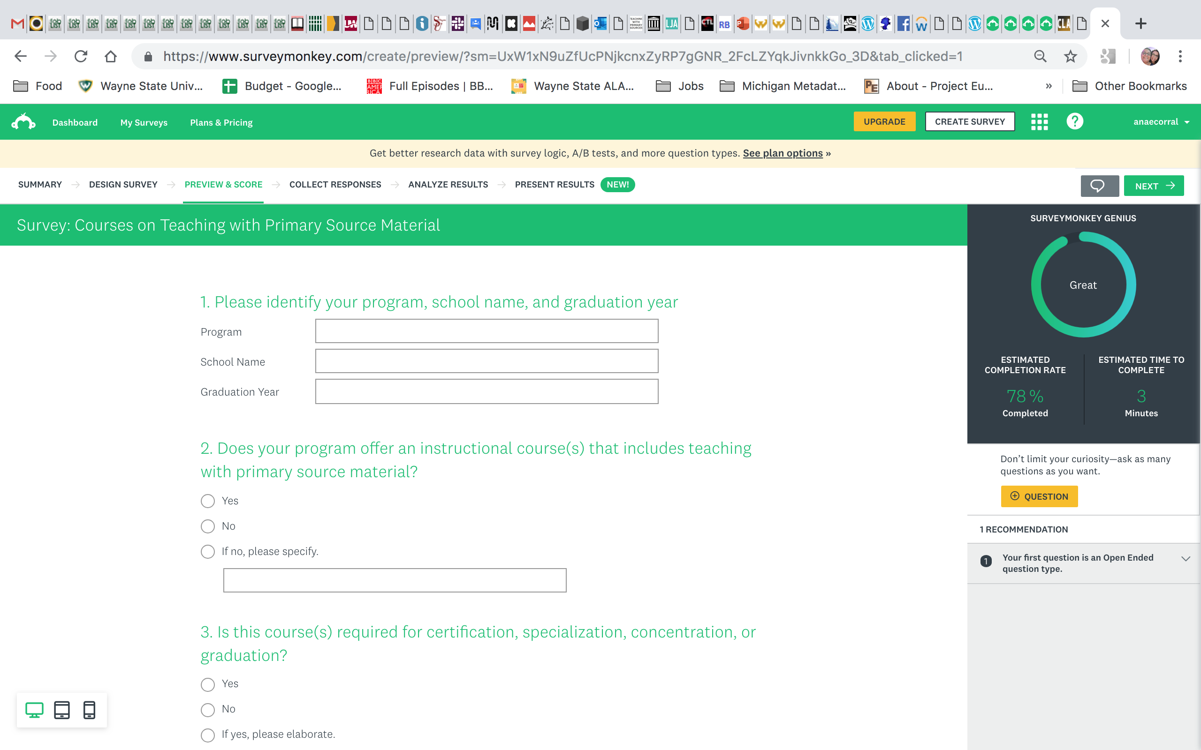Figures

Figure 1. First two questions of the survey. Without upgrading the SurveyMonkey subscription to paid, there was no option of downloading an entire survey as a pdf or just downloading the survey.

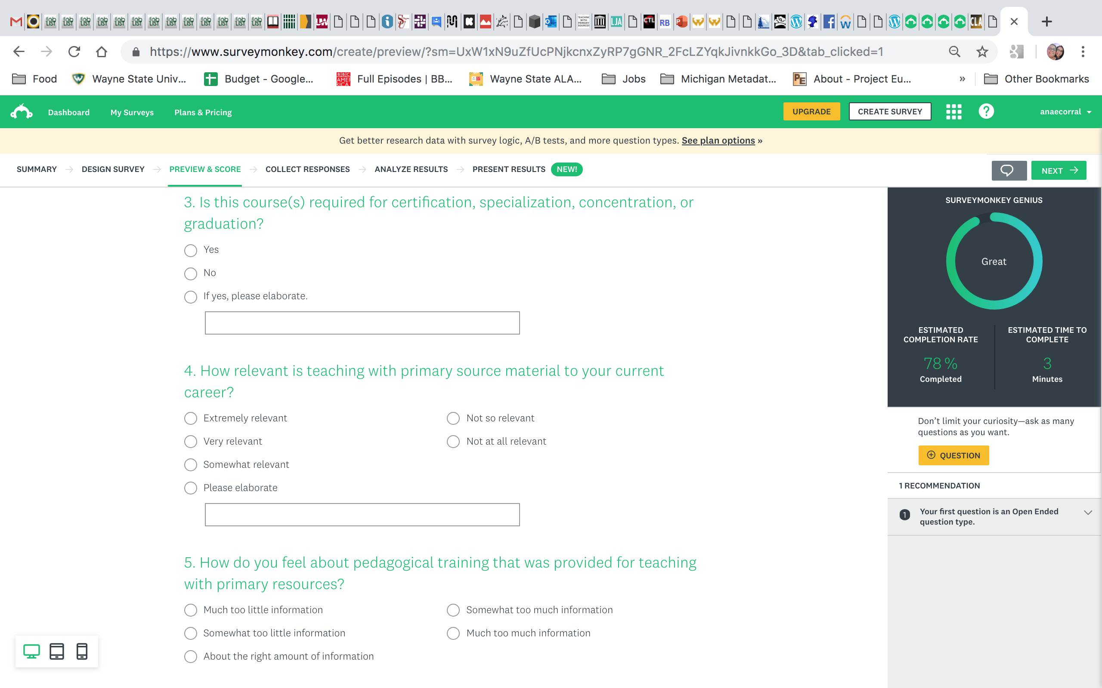*Figure 2.* Questions three through five from the survey.

*Figure 3.* Questions six through eight from the survey.

Figures 4. Questions nine through ten from the survey.

|  |  |  |  |
| --- | --- | --- | --- |
| 1. | Alabama, University of (ALA) | 28. | St. John's University (SAA, ALA) |
| 2. | Auburn University (SAA, ALA) | 29. | Temple University (SAA, ALA) |
| 3. | Catholic University of America (SAA, ALA) | 30. | Tennessee, University of (ALA) |
| 4. | Clarion University of Pennsylvania (ALA) | 31. | The University of Texas at Austin (SAA, ALA) |
| 5. | Clayton State University (SAA, ALA) | 32. | University at Albany, State University of New York (SAA, ALA) |
| 6. | Denver, University of (ALA) | 33. | University of Akron (SAA, ALA) |
| 7. | Dominican University (SAA, ALA) | 34. | University of Arizona (SAA, ALA) |
| 8. | Drexel University (SAA, ALA) | 35. | University of California, Los Angeles (SAA, ALA) |
| 9. | East Tennessee State University (SAA, ALA) | 36. | University of California, Riverside (SAA, ALA) |
| 10. | Emporia State University (SAA, ALA) | 37. | University of Hawai'i at Manoa (SAA, ALA) |
| 11. | Indiana University (SAA, ALA) | 38. | University of Illinois at Urbana-Champaign (SAA, ALA) |
| 12. | Johns Hopkins University (SAA, ALA) | 39. | University of Maryland (SAA, ALA) |
| 13. | Kent State University (SAA, ALA) | 40. | University of Massachusetts Boston (SAA, ALA) |
| 14. | Long Island University (SAA, ALA) | 41. | University of Michigan (SAA, ALA) |
| 15. | Louisiana State University (SAA, ALA) | 42. | University of Missouri (SAA, ALA) |
| 16. | Loyola University Chicago (SAA, ALA) | 43. | University of North Carolina at Chapel Hill (SAA, ALA) |
| 17. | McGill University (ALA) | 44. | University of North Texas (SAA, ALA) |
| 18. | Middle Tennessee State University-Murfreesboro (SAA, ALA) | 45. | University of Oklahoma (SAA, ALA) |
| 19. | New York University (SAA, ALA) | 46. | University of Pittsburgh (SAA, ALA) |
| 20. | North Carolina Central University (ALA) | 47. | University of South Carolina (SAA, ALA) |
| 21. | Pratt Institute (SAA, ALA) | 48. | University of Southern Mississippi (SAA, ALA) |
| 22. | Queens College, City University of New York (SAA, ALA) | 49. | University of Wisconsin-Madison (SAA, ALA) |
| 23. | Rutgers, The State University of New Jersey (ALA) | 50. | University of Wisconsin-Milwaukee (SAA, ALA) |
| 24. | San José State University (SAA, ALA) | 51. | Wayne State University (SAA, ALA) |
| 25. | Simmons College (SAA, ALA) | 52. | Western Washington University (SAA, ALA) |
| 26. | South Florida, University of (ALA) | 53. | Wright State University (SAA, ALA) |
| 27. | St. Catherine University (ALA) |  |  |

*Figure 5.* Table of survey school distribution list. The list of schools was compiled from both the SAA and ALA directories and the accreditation of each school is in parenthesis. Only US schools were included in the distribution list. Compiled from https://www2.archivists.org/dae and http://www.ala.org/educationcareers/accreditedprograms/directory.

1. One of the most well-known mentions of teaching with primary source materials is Hugh A. Taylor’s 1972 article, *Clio in the Raw: Archival Materials and the Teaching of History*, in which he advocates for increased use and access of archival material to undergraduate students. The introduction of primary source material instruction predates Taylor’s article, but until several years ago, research and interest were not as prominent.