The Impact of J Dilla

Jamie Ackerson, Josh Griffiths, Marissa Kelley, Evan James, Cole Gendelman

University of Colorado Boulder

Abstract

In this study, we drew from existing work on networking J Dilla’s influence among the rap community and created a network via NetworkX [1], HoloViews [2], and Bokeh [3] to understand the amount of influence he has provided. After using NetworkX to create a spring layout of a sample work of data, we tackle the larger amount of data to create an *interactive* version of the spring layout. Our network visualizations show that J Dilla’s music has spread beyond the hip hop world into songs that are even being written and produced to this day. We believed that these networks can show the power that music has to culturally, morally, and emotionally influence our society.

Our results showed

**Keywords**: music, network analysis, sampling, musicology analysis, soundcloud, network, hip-hop, J Dilla

# Introduction

Music is a timeless piece of our lives that has the ability to constantly change. It’s therapeutic, can make your heart race, and is truly all our own. We chose to look at the influence that J Dilla had on the music industry, since we were most interested in exploring how music from different eras and genres have influenced the current music space- which in today’s 21st century is pop culture. We chose to look at the single producer, J Dilla and his reach in hip-hop but expanded our end product to allow for visualizing any artist’s influence on the condition that all goes well.

J Dilla’s work has impacted a countless number of people and his legacy built on helping others, especially people with illness, and kids who were musically gifted but had little hope due to poverty. By showing the impact J Dilla has had on artists around the world, we are hoping to show the influence that one artist can have on multiple communities. These networks can show the power that music has to culturally, morally, and emotionally influence our society.

In this paper, we draw from existing work on music sampling to present an appeal for a visualization that marks how vastly the influence of a single producer can grow to be.

# Related Work

This article [citation eventually] takes a deeper look into the musical influence networks and ranks of sample- based music presented with WhoSampled.com data. Within the music information retrieval community, this has led to the creation of artist collaboration, recommendation, similarity, and influence networks. Empirical results found on constructed network graphs suggest musical influence-based networks follow a power-law degree distribution; heavy influence of funk, soul, and disco music on modern hip-hop, R&B, and electronic music; and various other anecdotal discussions of the unique corpus.

## Process

Our original plan for this project was to collect data from [random users] in SoundCloud to determine what the network of sampled music looked like.  In this project we scraped data from whoSampled.org of all of J Dilla’s work. From this, we were able to obtain a sample of data to use as a trial run for the larger network of data. Following…

# Discussion

Lorem ipsum dolor sit amet, consectetuer adipiscing elit, sed diam nonummy nibh euismod tincidunt ut laoreet dolore magna aliquam erat volutpat. Ut wisi enim ad minim veniam, quis nostrud exercit­ation ullamcorper suscipit lobortis nisl ut aliquip ex ea commodo consequat. Duis autem vel eum iriure dolor in hendrerit in vulpu-tate velit esse molestie consequat, vel illum dolore eu feugiat nulla facilisis at vero eros et accumsan et iusto odio dignissim qui blan-dit praesent luptatum zzril delenit augue duis dolore te feugait nulla facilisi.

## Genre

J Dilla’s main genre of music was soul. However, his influence spanned further than soul, into genres like classic rock, electronic, funk, jazz and soul. Looking into the genres of the different sampled music allowed us to gain an understanding of not only how many artists used J Dilla’s work, but *how* they used it.

Figure 1: Genre Distribution of J Dilla Samples

## Year

J Dilla began creating music in 199__. From then until 2006, his sampled music led him to become one of the greatest legends in the Detroit area. He later became a freelance producer making tracks and remixes for artists like Janet Jackson, Busta Rhymes and Daft Punk. Even his track, “So Far” anticipated Kanye West’s early work. In the years 1973 and 1975, the number of records using J Dilla’s sampled work shot up to ___. When J Dilla passed away in 2006, a vacuum of power and influence was created despite his hundreds of unpublished sounds floating around. Many new and upcoming rappers in the Detroit area began adding onto the legend’s work, making it into their own style.

Show the years of music he was sampling. Sample dates AND J Dilla’s dates

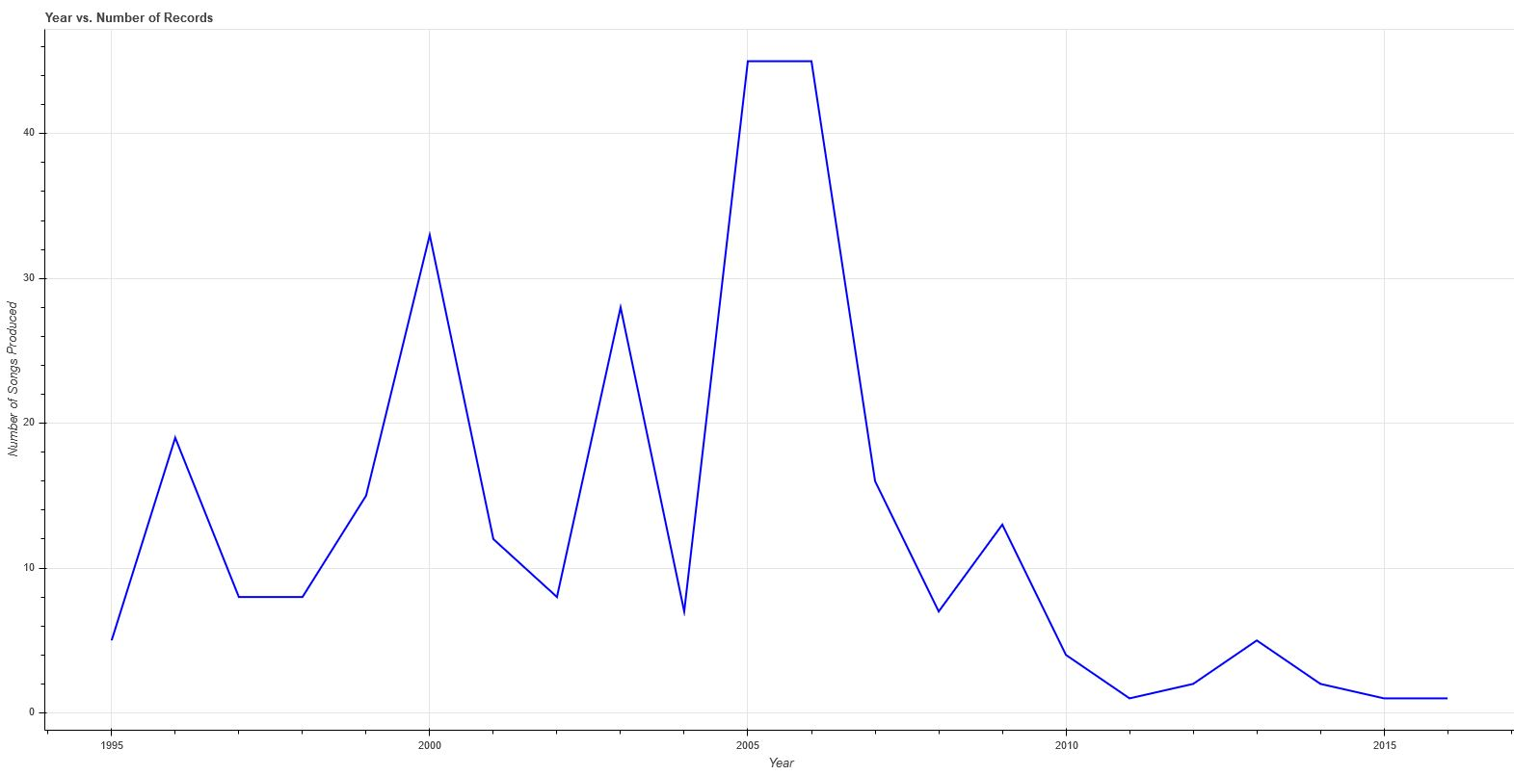

Figure 3: The Distribution of J Dilla’s Samples

## Overall Relationship

Lo

# Conclusion

In this study, we looked into the both the song and human network of J Dilla. Previous research has shown the importance of of location in Electronic Music such as SoundCloud, as well as social network analysis applications liked linkedjazz.org that combines automation and crowdsourcing to extract relationship information or the lost voices project that reconstructs different vocal parts.

References

1. Giannetti, F. (2016). A Review of Network Approaches in Music Studies. *Music Reference Services Quarterly*, *19*(2), 156-163. doi:10.1080/10588167.2016.1166842
2. Acciari, M. (2014). British Asian music and its networks: Notes from a music-making workshop at the Apache Indian Music Academy, Handsworth, UK. *South Asian Popular Culture*, *12*(3), 181-188.
3. Bruner, R. (2018). How Rap Ascended (Again) to Become the Sound of the Mainstream. *Time*, *191*(4), 43-45.
4. Warren, A., & Evitt, R. (2010). Indigenous Hip-hop: overcoming marginality, encountering constraints. *Australian Geographer*, *41*(1), 141-158
5. Washington, A. R. (2018). Integrating Hip-Hop Culture and Rap Music Into Social Justice Counseling With Black Males. *Journal Of Counseling & Development*, *96*(1), 97-105.
6. Bryan, N.J., & Wang, G. (2011). Musical Influence Network Analysis and Rank of Sample-Based Music. *ISMIR*.
7. Fisher, M. (2009). Mama said knock you out. *New Statesman*, *138*(4956), 44-45.
8. Allington, D., Dueck, B., & Jordanous, A. (2015). Networks of value in electronic music: SoundCloud, London, and the importance of place. *Cultural Trends*, *24*(3), 211-222.
9. Hsu, H. (2017, June 18). A New Vision of J Dilla. Retrieved from https://www.newyorker.com/magazine/2016/04/18/j-dillas-the-diary
10. Jun, S., Kim, D., Jeon, M., Rho, S., & Hwang, E. (2015). Social mix: automatic music recommendation and mixing scheme based on social network analysis. *Journal Of Supercomputing*, *71*(6), 1933-1954.
11. Als, H. (2017, June 18). Madlib's Genealogy of Hip-Hop. Retrieved from https://www.newyorker.com/magazine/2016/02/08/the-waves-critic-at-large-hilton-als
12. Balaji, M. (2012). The Construction of “Street Credibility” in Atlanta's Hip-Hop Music Scene: Analyzing the Role of Cultural Gatekeepers. *Critical Studies In Media Communication*, *29*(4), 313-330.
13. WATSON, A. (2012). The world according to iTunes: mapping urban networks of music production. *Global Networks*, *12*(4), 446-466.
14. Emms, R., & Crossley, N. (2018). Translocality, Network Structure, and Music Worlds: Underground Metal in the United Kingdom. *Canadian Review Of Sociology*, *55*(1), 111-135.