1.

cd /usrs/homework/problem1

2.

cd ~/datasets/activedata

ls -la

3.

Navigates to the home folder

Creates a folder called problem_set_1

Creates a text file named submission.txt in the problem_set_1 folder

Goes back to the home folder

Prints the home path

4.

cd ~

cp config.txt /

mkdir /preferences

cp ~/prefs.txt /preferences

head config.txt

head /~preferences/config.txt

tail config.txt

tail ~/preferences/cofig.txt

5.

a. mv ~/Documents/datafile.csv .

b. cp ~/Documents/datafile.csv .

c. mv datafile.csv ~/Documents/

6. This python file takes an image file named octocat.png and converts it into ascii art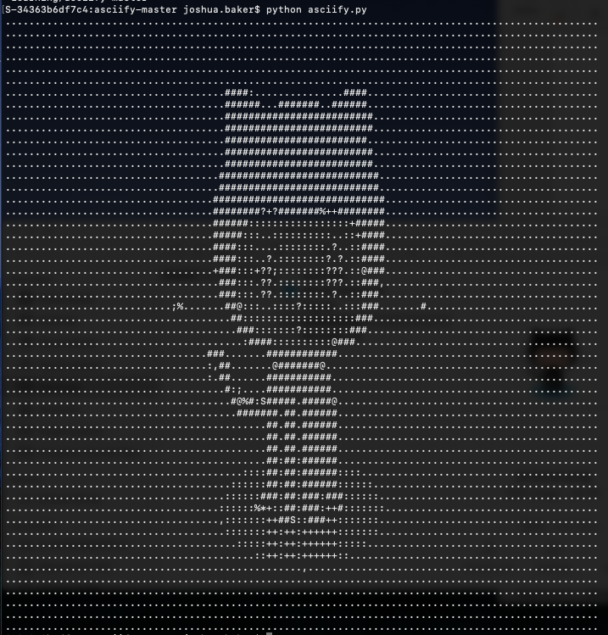

7.

Delorean(datetime=datetime.datetime(2020, 1, 29, 12, 38, 25, 694604), timezone='US/Eastern')

8.

wget <https://finances.worldbank.org/api/views/yu93-ayrw/rows.csv?accessType=DOWNLOAD>

mv rows.csv?accessType=DOWNLOAD rows.csv

9.

grep -h Total rows.csv > distilledExpenditures