Steven Yatko

Problem Set 2

1. /usrs/homework/problem1
2. Cd ~/datasets/activedata

ls -l -activedata

cd ~ Go to home Directory

mkdir ./problem_set_1 Create a directory

touch submission.txt Creates a file called submission.txt

cd .. Goes back to the root directory

pwd /usrs/~

4.

cp /usrs/config.txt /

Cd /

Mkdir ./preferences

Cp /usrs/preferences/pref.txt /preferences

Head -n 10 /usrs/config.txt

Tail -n 10 /usrs/config.txt

Head -n 10 /config.txt

Tail -n 10 /config.txt

5.

Command I used to move:

mv ~/Documents/datafile.csv cd

Command I should’ve used:

cp

Command to undo it:

mv ./datafile.csv ~/documents/datafile.csv, just move it back to the directory it was in

6. Prints ASCII art into the terminal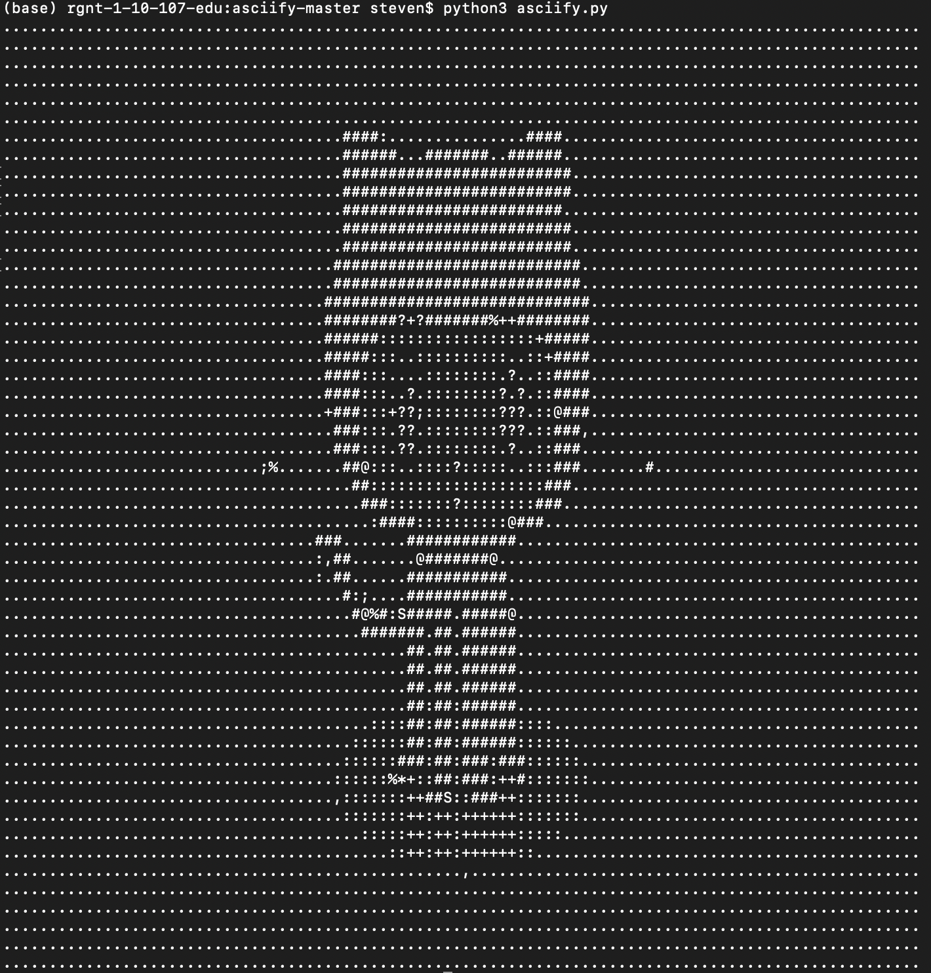

7. Pip install delorean

python

from delorean import Delorean

EST = "US/Eastern"

d = Delorean(timezone=EST)

print(d)

Delorean(datetime=datetime.datetime(2020, 2, 10, 12, 46, 16, 527093), timezone='US/Eastern')

8. Wget <https://finances.worldbank.org/api/views/yu93-ayrw/rows.csv?accessType=DOWNLOAD>

9. Grep Total World_Bank_Expenditures_by_Organizational_Unit.csv -c

10. Grep Total World_Bank_Expenditures_by_Organizational_Unit.csv > distilledExpenditures.csv