System introduction

With the systematization of teaching management and the network of computer, as well as the acceleration of the reform of credit system and optional course teaching, the student course selection system has become an important part of teaching administration management. It is very important for students to choose their own courses in a certain range and make the best use of educational resources. Based on the function of course selection in Colleges and universities, our software links the content of campus courses with the content of work through the information of the current situation of students' work in the past, which can provide more reference information when students choose courses.

This system realizes the basic information of students' course selection and course selection. Including students' course selection, viewing their own course selection information, scores of various courses and total GPA, etc.; school information, college information, course information, etc.; basic information of on-the-job students' course selection and work, including course scores, job positions, salaries, working hours, etc.; connecting the course selection information and work information of on-the-job students as the basic attribute of the course to obtain courses and work Make relevant data to help college students have a further understanding of the curriculum, so as to help students choose the ideal curriculum based on their own needs.

System analysis

Student users can search for courses to get basic information about courses and choose courses.

Search for courses: Student users can search for courses by course Id, course Name and instructor name.

Course information: Course information includes basic course information, student evaluation of the instructor, evaluation of the course, and specific information about past students. View the class status of past students: class time, class results. And current jobs, salary and other information.

Course selection system: students choose a course to generate a course selection list, including the selected course information and time. You can select, withdraw, and clear the list of courses.

Course selection list: The specific course selection table generated by students according to the course selection includes course content, basic information of the students' courses, and course grades.



System design

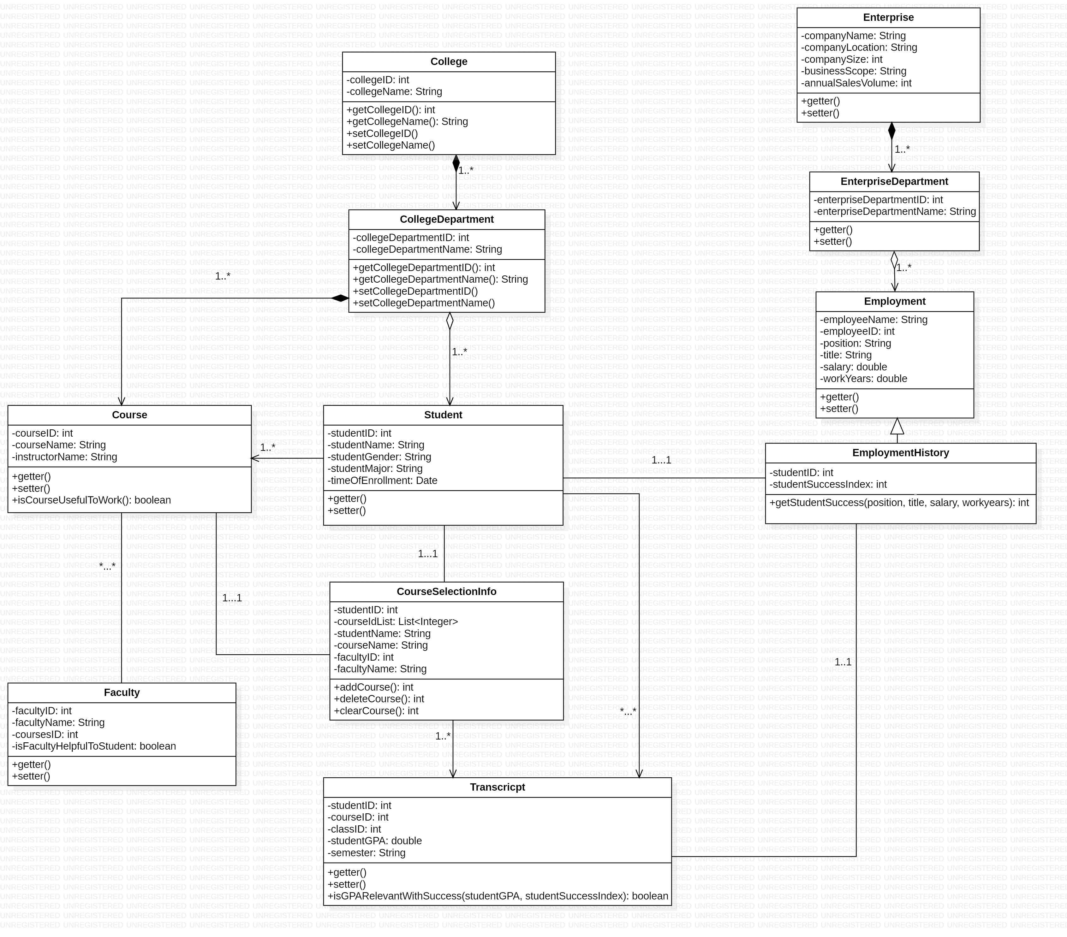

Class diagram description:

1. Collge class:

College class and CollegeDepartment class have a compositionrelationship, and a college corresponds to multiple departments.

getCollegeID () is used to get the id of the college;

setCollegeID () is used to set the id of the college;

1. CollegeDepartment class:

CollegeDepartment class and Course class have a composition relationship, and a College Department corresponds to multiple courses;

The CollegeDepartment class and Student have an Aggregation relationship. A department contains multiple students;

1. Student class:

The Student class and CourseSelecitonInfo class have an Association relationship.A student corresponds to a course selection table, a plurality of transcricpts, and a course.

1. Course class:

A course corresponds to multiple faculty, with different teachers to teach.

Method: isCourseUsefulToWork () determines whether faculty is suitable for this course, and evaluates the relationship between professor and course.

1. CourseSelecitonInfo class:

It is related to students. One course selection table corresponds to one student and corresponds to multiple transcripts.

(6) Faculty class:

One faculty corresponds to one course.

(7) Transcricpt class:

One transcript corresponds to one elective schedule, one student.

Method: isGPARelevantWithSuccess () determines whether the student's GPA is related to success after work. Use the success index to represent the degree of success.

(8) Enterpirse class:

Enterpirse class and EnterpriseDepartment class have a Composition relationship;

An enterprise corresponds to multiple departments.

(9) EnterpriseDepartment class:

The EnterpriseDepartment class and the Employment class have a composition relationship, and a department corresponds to multiple employees.

(10) Employment class:

The Employment class and EmploymentHistory class are Generalization relationships.

Method: getStudentSuccess () is used to obtain the success index of the employee, which is used to indicate the degree of success at work.

(11) EmploymentHistory class:

An EmploymentHistory contains a student, corresponding to multiple transcripts, and the methods in the related transcripts are used to show the relationship between GPA and success index.

Summary

This system is mainly used in the university course selection system based on the credit system. In order to enable students to choose the course that suits them through the course information and evaluation, teacher information and evaluation, and the correlation between the curriculum and employment.

Based on the relatively inadequate educational resources in developing countries, we can also put this system in the K12 education system, so that students can better understand the curriculum and knowledge about the content and purpose of the curriculum. By linking the learning situation of the past students to the future situation, the students can learn more suitable courses and have clear learning goals.

UI & Dashboard

