**1. Abstract**

The project is a part of skunkworks hyperparameters project. The project has two main parts where part one is dedicated to create a database that store the metadata and data set details of Melbourne Housing Data. Part two is to store evaluation and hyperparameters that are used to perform algorithms on data in part one.

As a part of the DMDD team we created a conceptual model and stored all the data into a physical database by going through the following procedures

• Scraped JSON files and stores the data in dataframes further saving them in CSV Format.

• Created a conceptual model of the database.

• Perform database normalization – 1NF, 2NF, 3NF.

• Created tables as per the requirement.

• Inserted data into the respective tables from the file which is generated and stored by the Data Science member.

• Queried database using SQL, created Views (virtual tables) and Functions for various use cases of the database.

• Performed analytics on the database using queries e.g. getting the best value for the hyperparameter from the database.

## 2. Explain Data Source

Data related to Melbourne Housing is obtained from [Kaggle.com](https://www.kaggle.com/harlfoxem/housesalesprediction). This data is validated and preprocessed to assure the credibility and integrity. Data for machine learning models will be generated by our group. The output file containing the hyperparameters information is provided by the data science group as JSON files which we parse to obtain the required information to populate the database tables.

## 3. Conceptual Schema

## 4. ER Diagram

**5. Normalization (till 3NF)**

**1NF**

**Requirement:**

1. No repeating groups
2. Atomic
3. Each field has a unique name
4. Primary key

**2NF**

**Requirement:**

1. Already 1NF
2. No partial dependencies
3. No calculated data

**3NF**

**Requirement:**

1. Already 2NF
2. No transitive dependencies

*Table 1: Dataset*

This table has one primary key(Dataset_ID), and several non-key attributes. All non-key attributes are based on and only on primary key. It is in 3NF.

*Table 2: Dataset_Description*

This table has one primary key(Column_ID), and several non-key attributes. All non-key attributes are based on and only on primary key. It is in 3NF.

*Table 3: Model_Runtime*

This table has one primary key(Runtime_ID), and several non-key attributes. All non-key attributes are based on and only on primary key. It is in 3NF.

*Table 4: Model*

This table has one primary key(Model_name), and several non-key attributes. All non-key attributes are based on and only on primary key. It is in 3NF.

*Table 5: Model_Metrics*

This table has one primary key(Model_ID), and several non-key attributes. All non-key attributes are based on and only on primary key. It is in 3NF.

*Table 6: Algorithm*

This table has one primary key(Algorithm_ID), and several non-key attributes. All non-key attributes are based on and only on primary key. It is in 3NF.

*Table 7: GBM_Hyperparameters*

This table has one primary key(Model_name), and several non-key attributes. All non-key attributes are based on and only on primary key. It is in 3NF.

*Table 8: GLM_Hyperparameters*

This table has one primary key(Model_name), and several non-key attributes. All non-key attributes are based on and only on primary key. It is in 3NF.

*Table 9: DRF_Hyperparameters*

This table has one primary key(Model_name), and several non-key attributes. All non-key attributes are based on and only on primary key. It is in 3NF.

*Table 10: XRT_Hyperparameters*

This table has one primary key(Model_name), and several non-key attributes. All non-key attributes are based on and only on primary key. It is in 3NF.

**6. Physical model**

Physical model is created using MySQL database

The [SQL files](https://github.com/INFO6105-Spring19/hyperparameter-db-project-db08/tree/master/SQL) contains all the SQL physical model information.

## 7. Use Cases

[Use cases](https://github.com/INFO6105-Spring19/hyperparameter-db-project-db08/blob/master/SQL/Hyper_usecases.sql) contains the use cases SQL queries.

#1. Find the best model amongst all the models of GBM algorithm

SELECT Model_name FROM model_metrics

WHERE RMSE=(SELECT MIN(RMSE) FROM model_metrics a JOIN GBM_Hyperparameters b ON a.Model_name=b.Model_name)



#2. Count the number of models formed for runtime 500s

SELECT count(Model_name) FROM Model a, Model_Runtime b

WHERE a.runtime_ID=b.runtime_ID AND b.Run_Time =500



#3. For what runtime is the best model generated?

SELECT run_time, rmse FROM model_runtime a, model_metrics b, model c

WHERE a.runtime_ID=c.runtime_ID AND b.model_name = c.model_name AND b.rmse=(SELECT MIN(RMSE) FROM model_metrics )



#4. How many DRF models are generated for a particular runtime?

SELECT b.Model_name FROM model_runtime a, model_metrics b, model c

WHERE a.runtime_ID=c.runtime_ID AND b.model_name = c.model_name AND a.run_time=500 AND b.model_name LIKE "DRF%"



#5. Find average of RMSE and count of model runs for all model runs of GBM Models for run time 500s

SELECT avg(rmse), count(a.model_name) FROM model_metrics a, model_runtime b, model c

WHERE b.runtime_ID=c.runtime_ID AND a.model_name = c.model_name AND b.run_time=500 AND a.model_name LIKE "GBM%"



#6. What is the Maximum RMSE value for GLM model?

SELECT MAX(RMSE) FROM model_metrics

WHERE RMSE=(SELECT MAX(RMSE) FROM model_metrics a JOIN GLM_Hyperparameters b ON a.Model_name=b.Model_name) LIMIT 1



#7. List the number of GBM models which has distribution=”gaussian”?

SELECT COUNT(model_Name) FROM GBM_Hyperparameters

WHERE distribution LIKE 'gaussian%' AND model_name LIKE "GBM%"



#8. what should be the seed value to get best rmse for GLM?

SELECT seed FROM GLM_Hyperparameters a, model_metrics b

WHERE a.model_name=b.model_name AND b.rmse =(SELECT MIN(RMSE) FROM model_metrics a JOIN GLM_Hyperparameters b ON a.Model_name=b.Model_name)

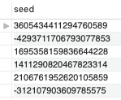

#9. Which model has maximum accuracy?

SELECT model_name FROM model_metrics ORDER BY rmse LIMIT 1



#10. Display how many models were created for each runtime?

SELECT a.run_time as 'Runtime', COUNT( b.model_name) as 'No of models' FROM model_runtime a, Model_metrics b, model c

WHERE a.runtime_ID=c.runtime_ID AND b.model_name = c.model_name GROUP BY a.run_time

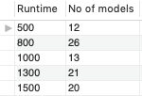

## 8. Views

[Views](https://github.com/INFO6105-Spring19/hyperparameter-db-project-db08/blob/master/SQL/hyper_views.sql) contain the Views SQL queries.

1) Display performance measures of all the models present in the database for a particular Algorithm-Type (GBM/GLM/Linear etc.)

Create view Models_for_algos AS

select M.Model_name, A.Algorithm_Name, MM.Mean_Residual_Deviance, MM.RMSE, MM.MSE, MM.MAE, MM.RMSLE

from Algorithm A

join Model M on A.Algorithm_ID = M.Algorithm_ID

join Model_Metrics MM on MM.Model_Name = M.Model_Name

where A.Algorithm_Name ="GBM";

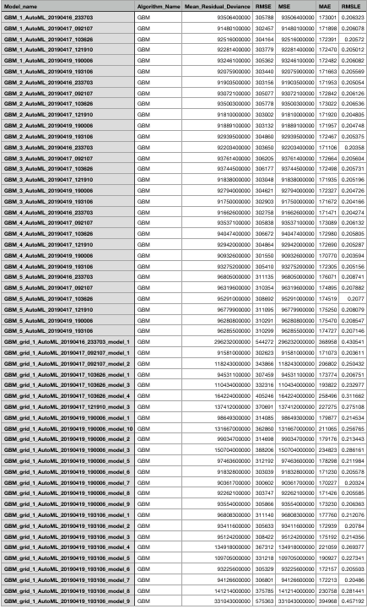

2) Display all the performance measures for all the models of a particular run

Create view Models_for_runtime AS

select M.Model_name, R.Run_Time, MM.Mean_Residual_Deviance, MM.RMSE, MM.MSE, MM.MAE, MM.RMSLE

from Model_Runtime R

join Model M on R.Runtime_ID = M.Runtime_ID

join Model_Metrics MM on MM.Model_Name = M.Model_Name

where R.Run_Time=1000;

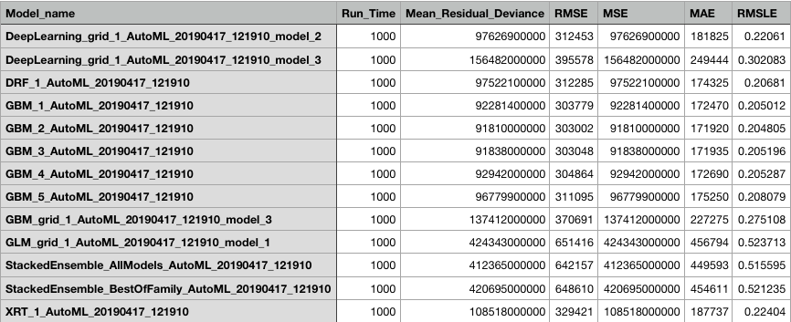

3) Create view for 50 best models of all algorithms

Create view 50_best_models AS

select M.Model_name, MM.Mean_Residual_Deviance, MM.RMSE, MM.MSE, MM.MAE, MM.RMSLE

from Model M

join Model_Metrics MM on MM.Model_Name = M.Model_Name

ORDER BY rmse , mse

LIMIT 50;

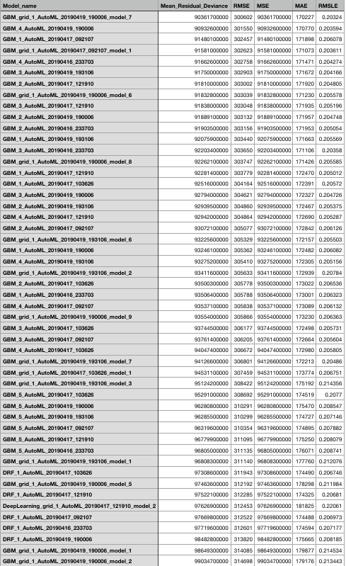

4) Create view for models of all algorithms and performance measure

Create view Model_algo_info AS

select M.Model_name, A.Algorithm_Name, MM.Mean_Residual_Deviance, MM.RMSE, MM.MSE, MM.MAE, MM.RMSLE

from Model M

join Algorithm A on M.Algorithm_ID = A.Algorithm_ID

join Model_Metrics MM on MM.Model_Name = M.Model_Name;

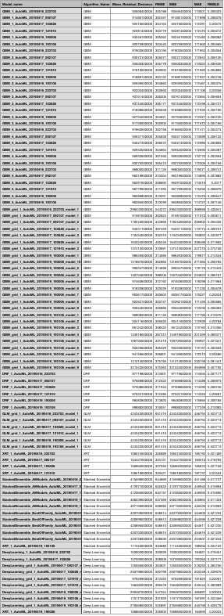

## 9. Funtions

[Functions](https://github.com/INFO6105-Spring19/hyperparameter-db-project-db08/blob/master/SQL/Hyper_Functions.sql) contain the Views SQL queries.

1) #no of models created for a runtime

DELIMITER $$

CREATE FUNCTION no_of_models(runtime INT) RETURNS INT

DETERMINISTIC

BEGIN

DECLARE models INT ;

SET models = ( select Models_generated FROM Model_Runtime WHERE Run_Time =runtime);

RETURN models;

END$$

DELIMITER ;

2) #no of ntrees <50 from DRF

DELIMITER $$

CREATE FUNCTION ntrees(no_of_ntrees INT) RETURNS INT

DETERMINISTIC

BEGIN

DECLARE lessthan50 INT ;

SET lessthan50= ( select count(ntrees) FROM DRF_Hyperparameters WHERE ntrees<=no_of_ntrees);

RETURN lessthan50;

END$$

DELIMITER ;

3) #Type of prediction

DELIMITER $$

CREATE FUNCTION dataset_type(name VARCHAR(255)) RETURNS VARCHAR(255)

DETERMINISTIC

BEGIN

DECLARE dtype VARCHAR(255) ;

SET dtype= ( select Prediction_Type FROM Dataset WHERE Data_Set_Name LIKE name);

RETURN dtype;

END$$

DELIMITER ;

4) #pass datased_id to get number of columns

DELIMITER $$

CREATE FUNCTION no_of_columns(data_id INT) RETURNS VARCHAR(255)

DETERMINISTIC

BEGIN

DECLARE dcolumn INT ;

SET dcolumn = ( select Total_Columns FROM Dataset WHERE Dataset_ID = data_id);

RETURN dcolumn;

END$$

DELIMITER ;

## 10. Indexes

[Index](https://github.com/INFO6105-Spring19/hyperparameter-db-project-db08/blob/master/SQL/Hyper_Index.sql) contain the Views SQL queries.

USE hyperparameter;

ALTER TABLE Algorithm

ADD INDEX ind_Algorithm(Algorithm_ID);

ALTER TABLE Dataset

ADD INDEX ind_Dataset(Dataset_ID);

ALTER TABLE DataSet_Description

ADD INDEX ind_DataSet_Description(Column_ID);

ALTER TABLE DRF_Hyperparameters

ADD INDEX ind_DRF_Hyperparameters(Model_name);

ALTER TABLE GBM_Hyperparameters

ADD INDEX ind_GBM_Hyperparameters(Model_name);

ALTER TABLE GLM_Hyperparameters

ADD INDEX ind_GLM_Hyperparameters(Model_name);

ALTER TABLE XRT_Hyperparameters

ADD INDEX ind_XRT_Hyperparameters(Model_name);

ALTER TABLE Model

ADD INDEX ind_Model(Model_name);

ALTER TABLE Model_Metrics

ADD INDEX ind_Model_Metrics(Model_name);

ALTER TABLE Model_Runtime

ADD INDEX ind_Model_Runtime(Runtime_ID);

## 11. Citations and References

Thanks to Prof.Brown, Prabhu, Chitra and Ami for the guidance.

1. Prof.Brown [Github](https://github.com/nikbearbrown/INFO_6210)
2. [Project Sample](https://github.com/prabhuSub/Hyperparamter-Samples) by Prabhu
3. [JSON Library](https://docs.python.org/3.7/library/json.html)
4. [Data Source](https://www.kaggle.com/anthonypino/melbourne-housing-market)
5. [H2O Documentation](http://docs.h2o.ai/h2o/latest-stable/h2o-docs/index.html)

## 12. License

Copyright <2019> <Yadukrishnan Sethumadhavan> <Bhavana Shanmugam>

Permission is hereby granted, free of charge, to any person obtaining a copy of this software and associated documentation files (the "Software"), to deal in the Software without restriction, including without limitation the rights to use, copy, modify, merge, publish, distribute, sublicense, and/or sell copies of the Software, and to permit persons to whom the Software is furnished to do so, subject to the following conditions:

The above copyright notice and this permission notice shall be included in all copies or substantial portions of the Software.

THE SOFTWARE IS PROVIDED "AS IS", WITHOUT WARRANTY OF ANY KIND, EXPRESS OR IMPLIED, INCLUDING BUT NOT LIMITED TO THE WARRANTIES OF MERCHANTABILITY, FITNESS FOR A PARTICULAR PURPOSE AND NONINFRINGEMENT. IN NO EVENT SHALL THE AUTHORS OR COPYRIGHT HOLDERS BE LIABLE FOR ANY CLAIM, DAMAGES OR OTHER LIABILITY, WHETHER IN AN ACTION OF CONTRACT, TORT OR OTHERWISE, ARISING FROM, OUT OF OR IN CONNECTION WITH THE SOFTWARE OR THE USE OR OTHER DEALINGS IN THE SOFTWARE.