Real Estate Company Process Improvement

Macro Setup Steps

April 11, 2020, v1

Contents

Introduction 2

Prerequisites 2

Why – the new formatting method 2

How To – Steps to set up Formatting Macro on a new system 2

Windows -- Downloading and saving the macro 2

MacOS -- Downloading and saving the macro 3

Windows -- Setting up the macro on your MS Excel 3

MacOS -- Setting up the macro on your MS Excel 5

# Introduction

This purpose of this document is to help the Financial Analysts at the Real Estate Management company set up the macro for the Monthly File formatting process on any new system smoothly.

# Prerequisites

Hang on, before we jump on setting up the macro, let’s talk about the prerequisites for the setting up the Macro on your system:

* Working and licensed copy of MS Excel installed on the system

# Why – the new formatting method

Well, this efficient new process of formatting the Monthly file through macro helps you to:

* **Be efficient**, saving almost 70% of the manual efforts on the Monthly Formatting process
* **Be accurate**, reducing the risks for manual errors

# How To – Steps to set up Formatting Macro on a new system

This section describes steps to set up the macro on a system.

## Windows -- Downloading and saving the macro

1. Download the latest working copy of the Monthly Formatting macro shared by the Smart IT Technologies team from GitHub at <https://github.com/INFO7245-AGILE-TEAM7/finalproject_realestate_consulting/tree/master/Part1-FormattingMacro>
2. Download the **XLSTART.zip** file.
3. Identify the path where the macro needs to be saved and used for formatting.
   1. In the File explorer, navigate to **C:\Users**.
   2. Open the folder with your *username*, the URL on the address bar should look like example below:



*Example screenshot of the how the path would look on a system*

* 1. Copy the text **\AppData\Roaming\Microsoft\Excel** and paste in the address bar. The final path on the address bar should look like one below:



* 1. Note, if you haven’t worked on the macros before, this path might be empty.

1. Extract the downloaded file and copy the **XLSTART** folder.
2. Paste the **XLSTART** folder in the **C:\Users\<username>\AppData\Roaming\Microsoft\Excel** directory.
3. Your **XLSTART** folder should look like the following with the **PERSONAL.XLSB** file:

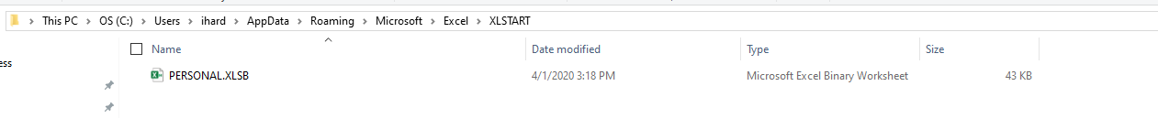

## MacOS -- Downloading and saving the macro

1. Download the latest working copy of the Monthly Formatting macro shared by the Smart IT Technologies team from GitHub at <https://github.com/INFO7245-AGILE-TEAM7/finalproject_realestate_consulting/tree/master/Part1-FormattingMacro>
2. Download the **XLSTART.zip** file and extract the **PERSONAL.XLSB** file from the folder.
3. Identify the path where the macro needs to be saved and used for formatting.
   1. In the Finder window, search for the **Users** folder and click on the folder with your username. For example, **~Users/<username>**.
   2. Identify the **Library** folder. If you cannot see it, press the **Command** + **Shift** + **Period** (**CMD** + **Shift** + **.**) shortcut.
4. Once you see the **Library** folder, go to the **~/Library/Group Containers/UBF8T346G9.Office/User Content/Startup/Excel** folder. The final path should **~Users/<username>/Library/Group Containers/UBF8T346G9.Office/User Content/Startup/Excel** folder.
5. Copy the downloaded **PERSONAL.XLSB** file and paste in the **Excel** folder.

## Windows -- Setting up the macro on your MS Excel

Once the **PERSONAL.XLSB** file has been saved to your **XLSTART** folder, follow the below steps to add the macro to your MS Excel:

1. Open a new sheet on MS Excel and right-click on the ribbon and select **Customize the Ribbon**.

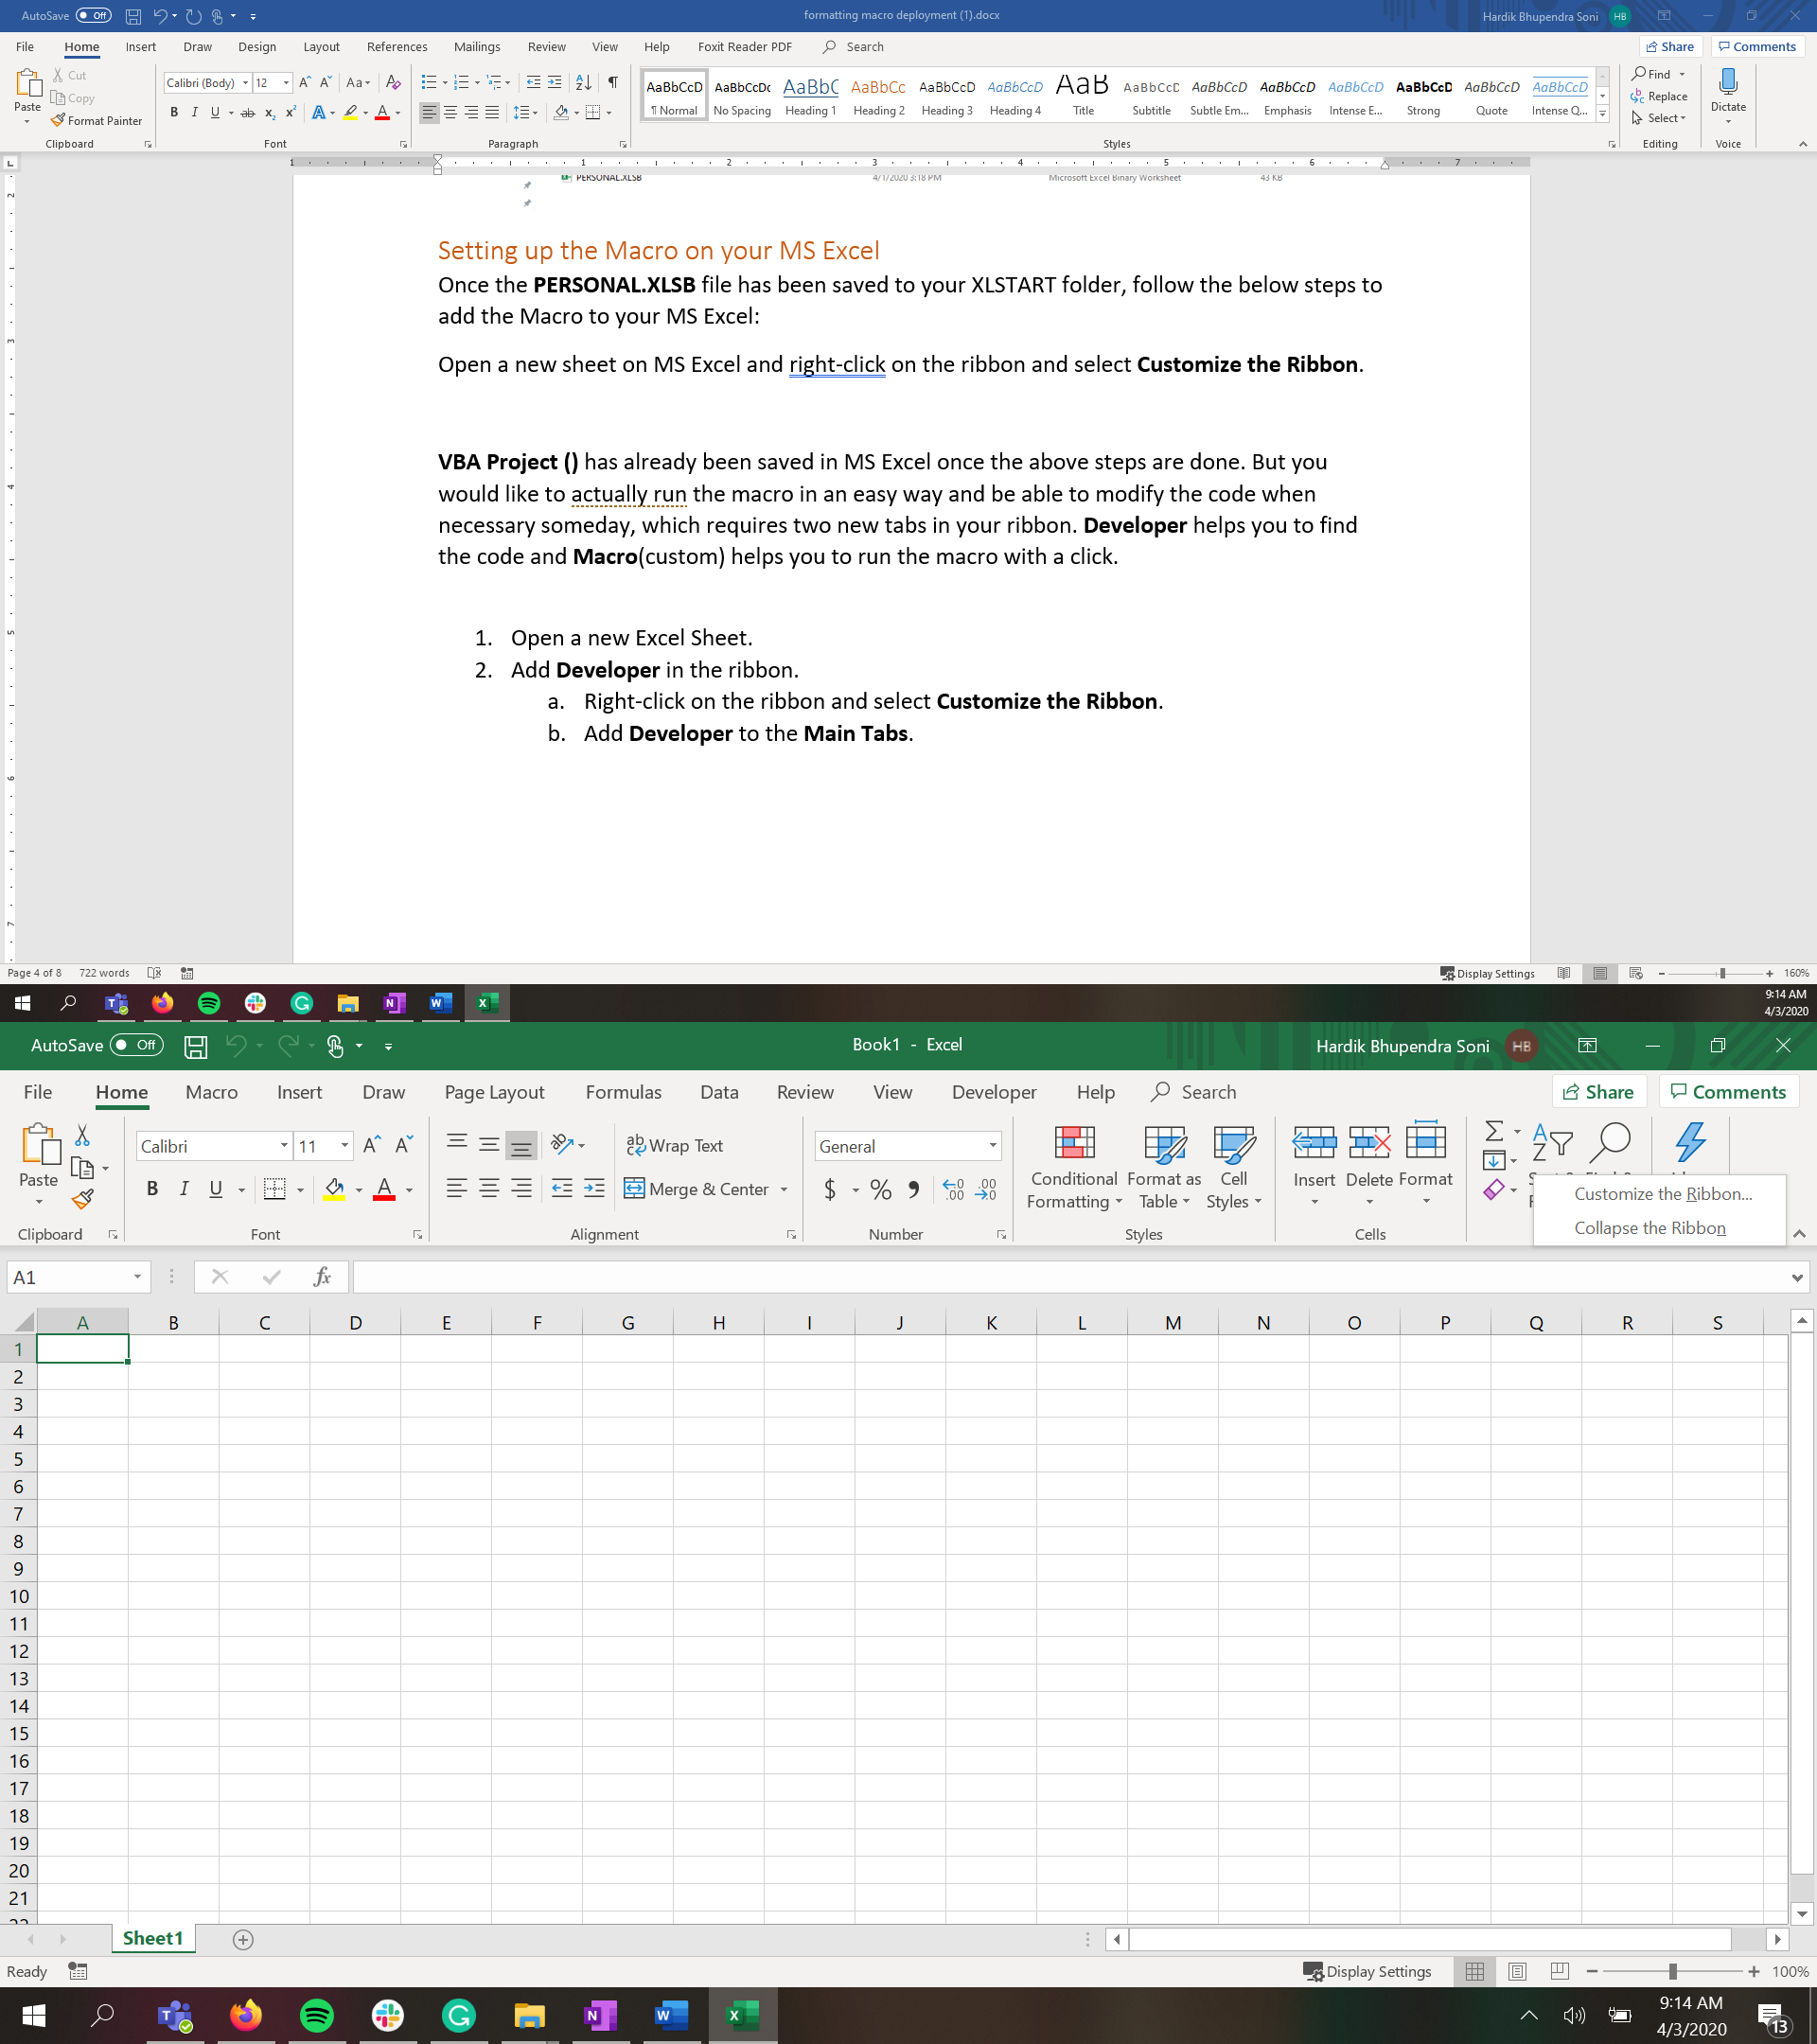

1. In the **Customize the Ribbon** popup, in the **Main Tabs** section add a new tab by clicking on the **New Tab** button.
2. Rename the tab as **Macros** and the **New Group** within it as **Monthly File Format**.
3. Select **Macros** from the **Choose commands from:** dropdown list, you should see the **Personal.XLSB!FinancialReportMacro** option in the list below.

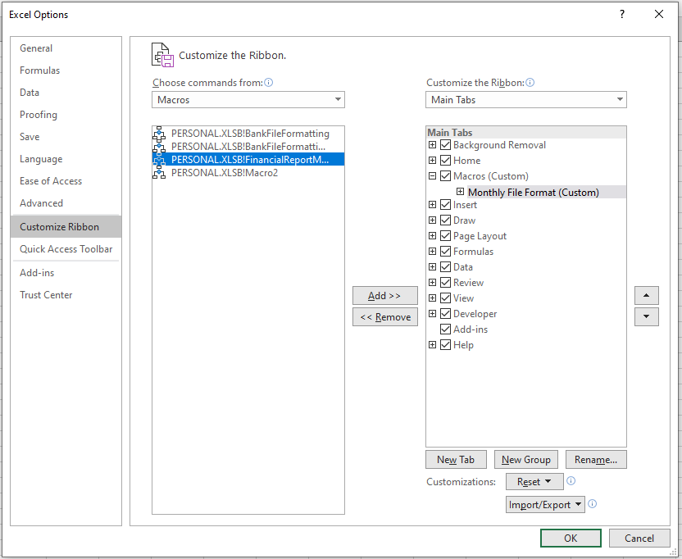

1. Select the group as shown in the screenshot above and add the selected macro to the group by clicking on the **Add >>** button.

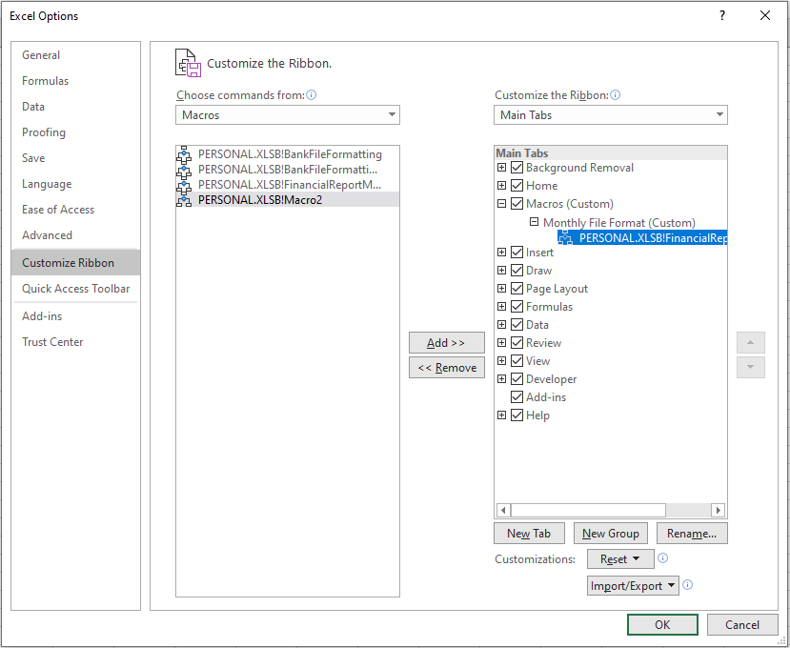

1. The group should now have a macro as shown in the screenshot above and click on **OK**.
2. You should now see a new tab on your Excel ribbon as shown in the screenshot below:

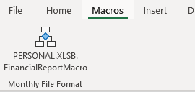

1. Great, now that you have the macro added to your Excel, open a raw bank file and run the macro by clicking on the macro within the bank file.
2. Voila! Your monthly file is formatted, follow the steps in the recommendation document to finish the rest of the steps.

## MacOS -- Setting up the macro on your MS Excel

Once the **PERSONAL.XLSB** file has been saved to your **Excel** folder, follow the below steps to add the macro to your MS Excel:

1. Open a new sheet on MS Excel and then go to the **Preferences** menu and select **Ribbon & Toolbar**.
2. Click on the **+** button at the bottom of the **Ribbon Customization** list box and select **New Tab** from the context menu that appears.

1. Rename the tab as **Macros** and the **New Group** within it as **Daily Bank File Format**.
2. Select **Macros** from the **Choose commands from:** dropdown list, you should see the **PERSONAL.XLSB!FinancialReportMacro** option in the list below.
3. Select the group and add the selected macro to the group by clicking on the **>** button.
4. The group should now have a macro and click on **Save**. You should now see a new tab on your Excel ribbon.
5. Great, now that you have the macro added to your Excel, open a raw bank file and run the macro by clicking on the macro within the bank file.
6. Voila! Your monthly file is formatted, follow the steps in the recommendation document to finish the rest of the steps.