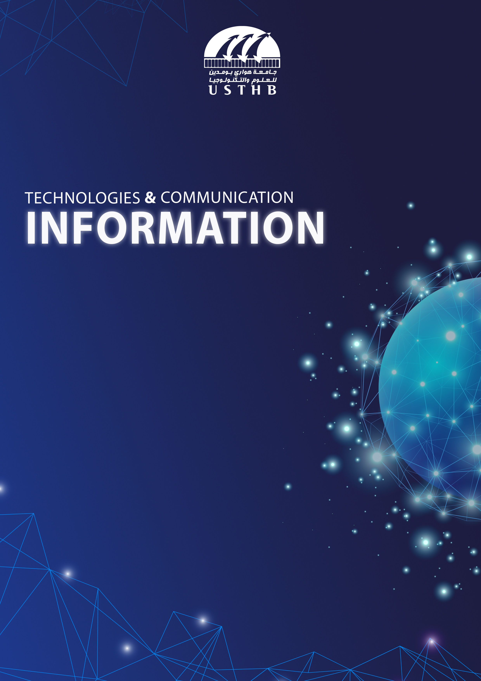

Le projet final

YACINE.SAHEB

omar.attar

adem.rizou

chettab.abderrahmane

farouk.belabdelouahab

 | Date: 29/12/2023

**Definition of Information and Communication Technologies (ICT):**

* Information and Communication Technologies, commonly known as ICT, refer to a diverse set of technologies used to manage telecommunications, broadcast media, audio-visual processing, and intelligent network-based control and monitoring functions. ICT encompasses a broad range of tools, applications, and systems that facilitate the creation, storage, processing, transmission, and retrieval of information. This includes traditional technologies such as telephones and radio, as well as modern digital technologies like computers, the internet, and mobile devices. ICT plays a pivotal role in connecting people, organizations, and devices, shaping the way information is communicated, shared, and utilized in the contemporary world.

1. **Importance of ICT in Today's Digital Age:**
2. **Communication and Connectivity:**

Information and Communication Technologies (ICT) play a pivotal role in shaping modern communication and connectivity. ICT facilitates instant communication through various channels, including emails, social media, and video conferencing. The internet, a fundamental component of ICT, connects individuals globally, breaking down geographical barriers. Mobile technologies ensure ubiquitous connectivity, allowing people to communicate and access information from virtually anywhere. The seamless integration of ICT in communication enhances efficiency, collaboration, and the speed at which information is shared, contributing to the interconnected nature of today's world.

1. **Access to Information:**

ICT has transformed access to information by democratizing knowledge. The internet serves as a vast repository of information, providing users with unprecedented access to educational resources, news, and diverse perspectives. Search engines and online databases enable rapid retrieval of information, while social media platforms contribute to real-time information dissemination. This accessibility is particularly significant in bridging information gaps and empowering individuals and communities with the tools to stay informed, learn, and participate in a globalized information society.

1. **Economic Growth and Innovation:**

ICT is a catalyst for economic growth and innovation. In the business sector, digital technologies enhance productivity, streamline operations, and create new opportunities. E-commerce platforms leverage ICT to connect buyers and sellers globally, fostering trade and economic activity. Innovations such as fintech, driven by ICT, revolutionize financial services. The digitalization of industries, supported by emerging technologies like artificial intelligence and the Internet of Things, contributes to ongoing economic transformation, creating a landscape ripe for innovation and sustainable economic growth.

1. **Education and Learning:**

ICT has revolutionized education by providing new avenues for learning and collaboration. Online learning platforms, digital textbooks, and educational apps offer flexible and personalized learning experiences. Virtual classrooms and video conferencing tools enable remote education, transcending geographical constraints. ICT facilitates interactive and multimedia-rich educational content, engaging students in ways traditional methods may not. The integration of technology in education equips learners with digital literacy skills and prepares them for a rapidly evolving, technology-driven future

1. **Brief History and Evolution of ICT:**

* The evolution of Information and Communication Technologies (ICT) is a fascinating journey that spans centuries, marked by key technological advancements. Here's a concise overview:

|  |  |  |  |  |
| --- | --- | --- | --- | --- |
| 1950s - 1970s | 1980s | 1990s | 2000s | 2010s-2023s |
| * Development of programming languages | * Graphical User Interface * TCP/IP Protocol | * Hypertext Transfer Protocol (HTTP) * Java Programming Language | * Open-Source Movement * Social Media Boom | * Artificial Intelligence (AI) * Quantum Computing |

* Some famous technologies related to ICT

GitHub



* **Version Control and Collaboration with GitHub.**
* **GitHub: A Hub for Code Hosting and Sharing.**
* **Issue Tracking and Project Management on GitHub.**
* **Pull Requests and Code Review on GitHub.**
* **Continuous Integration and GitHub Integration.**
* **Documentation and Wiki Creation on GitHub.**
* **GitHub as a Platform for Community and Open-Source Development.**



Google

* Google Services: Transforming ICT Landscape
* Google: A Catalyst for Digital Innovation
* Google's Impact on Communication and Information Access
* Google Cloud Platform: Enabling Scalable ICT Solutions
* Google Workspace: Collaborative Tools for Modern ICT
* Google Search: Navigating the Digital Information Era
* Android OS: Google's Influence on Mobile ICT



Amazon

* **Amazon Web Services (AWS): Revolutionizing Cloud Computing in ICT.**
* **Amazon's Influence on E-Commerce and Digital Transactions.**
* **AWS Cloud Solutions: Transforming ICT Infrastructure.**
* **Amazon Alexa: Redefining Human-Computer Interaction.**
* **Amazon Prime: Shaping Digital Content Delivery in ICT.**
* **Amazon S3 and EC2: Key Pillars of Cloud-Based ICT Services.**

**iuluii**

1. **Ethical Dilemmas in the Digital Age:**
2. **Digital Divide and Issues of ICT Accessibility:**

The digital divide is like an invisible gap between people who have easy access to the internet and technology and those who don't. This gap can create inequalities in education, jobs, and other opportunities. Some face challenges because they can't afford the internet or lack the skills to use technology. Bridging this gap means making the internet more affordable, providing training to use technology, and ensuring everyone has a fair shot at benefiting from the digital world.

1. **Privacy and Security Concerns in the Age of ICT:**

As we use more technology, there's a growing worry about keeping our personal information safe. Hackers and others might try to access our data without permission, leading to identity theft or data leaks. Striking a balance between using data for good things and protecting our privacy is crucial. We need strong cybersecurity measures, like using strong passwords and encrypting our data, to make sure our digital lives stay safe.

1. **Ethical Implications of AI and ML:**

Artificial Intelligence (AI) and Machine Learning (ML) bring up ethical questions. Sometimes, these technologies can unintentionally favor certain groups of people, and using them in important decisions, like in healthcare or the legal system, raises concerns. To make sure AI is used responsibly, we need clear guidelines, transparent algorithms, and ongoing efforts to make sure these technologies are fair for everyone.

1. **The Future Unveiled:**

**1. 5G Technology:** Revolutionizing connectivity with faster speeds, lower latency, and increased capacity for AR, VR, and IoT applications.

**2. AI and ML Advancements:** Smarter, more autonomous systems driving efficiency across industries.

**3. Edge Computing:** Bringing processing closer to data sources for real-time processing, benefiting applications like IoT and autonomous vehicles.

**4. Quantum Computing:** Early stages, but potential to revolutionize computational power for cryptography, optimization, and simulation.

**5. Blockchain and Decentralized Tech:** Beyond cryptocurrencies, finding applications in secure data storage, supply chain management, and digital identity verification.

**6. Extended Reality (XR):** Encompassing AR, VR, and mixed reality for immersive experiences in education, healthcare, and entertainment.

**7. Cybersecurity Innovations:** Advancements in threat detection, encryption, and AI-driven security solutions to counter growing cyber threats.

**8. Sustainable ICT:** Emphasis on energy-efficient technologies, responsible e-waste management, and eco-friendly computing solutions.

**9. Human-Computer Interaction:** Innovations in natural language processing, gesture recognition, and brain-machine interfaces for more intuitive technology.

**10. Ethical Considerations:** Increasing focus on privacy, data ownership, and responsible AI use as technology becomes more pervasive.

1. **Conclusion:**

In conclusion, Information and Communication Technologies (ICT) wield profound significance in the modern world. Acting as the linchpin for global connectivity, ICT transforms communication, fuels economic growth, revolutionizes education, and advances healthcare. Its influence extends to smart cities, sustainability, and emerging technologies, promising a future marked by connectivity and intelligence. As ICT progresses, ethical considerations, cybersecurity, and equitable access become critical. In essence, ICT is not just a technological force; it is a societal cornerstone shaping a more efficient, collaborative, and equitable global landscape.