Title

Title
/availability endpoint does not filter by status

Identification
Field | Value
ID | DEF_LS_API_001
Reported by | Gerson Medina
Date | 2026-08-05
Severity | Critical
Priority | P1
Component | API
Endpoint or Screen | GET /api/v1/hotels/{hotelId}/availability
Environment | Local
Build or Commit | git rev-parse --short HEAD
Status | Open

Preconditions
Preconditions | - To have run: npm run seed script with the service up on Docker.

Steps to reproduce
1. | In Docker console, run docker exec -it lumastay-postgres psql -U postgres -d lumastay.
2. | Run this query: UPDATE hotels SET status = 'inactive' WHERE id = 'htl_601';
3. | Open Postman, set GET method and run http://localhost:4000/api/v1/hotels/htl_601/availability?checkIn=2026-09-15&checkOut=2026-09-18&adults=2.
4. | See the response and notice that status field is not being considered, even if there is a hotel with ‘inactive’ status. This causes that the hotel could be reserved and payment could be done, even if the hotel is not available.
5. | Reset the hotel status: UPDATE hotels SET status = 'active' WHERE id = 'htl_601';

Expected result
Expected | Hotels with ‘inactive’ status must not be shown in the response payload.

Actual result
Actual | A hotel with ‘inactive’ status is shown in the response payload.

Evidence
Evidence | PSQL CLI:  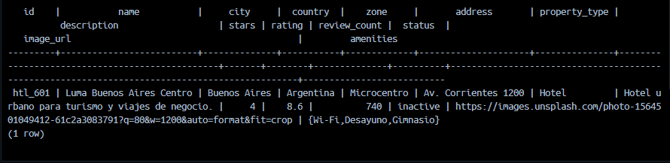  Payload:  {  "hotelId": "htl_601",  "criteria": {  "checkIn": "2026-09-15",  "checkOut": "2026-09-18",  "adults": 2,  "children": 0,  "rooms": 1  },  "rooms": [  {  "roomTypeId": "rm_901",  "name": "Executive King",  "bedType": "King",  "boardPlan": "Desayuno incluido",  "cancellationPolicy": "Flexible",  "capacityAdults": 2,  "capacityChildren": 1,  "availableUnits": 4,  "nightlyRate": "85000.00",  "currency": "ARS",  "ratePlanCode": "FLEX"  }  ]  }

Severity justification
Dimension | Your answer
Business impact  What does it cost if a real user hits this? | This causes that the hotel could be reserved and payment could be done, even if the hotel is not available, what will end in a payment for nothing.
Likelihood  How easily does a real user reach this state? | A customer could do a reservation and do the payment process and get a reservation ticket, even if the hotel is not available.
Why this level and not the one above or below | The customer is the target level of the app, and the one that uses it.

Root cause
Where the behavior originates, if you found it. Optional but high value.
Root cause | /hotels/:hotelId/availability endpoint is not considering status for availability check.

Suggested fix
Concrete. "Add validation" is not a proposal; naming the constraint or the clause is.
Suggested fix | Adding status validation in /hotels/:hotelId/availability endpoint.

Regression risk
What else could break when this is fixed.
Regression risk | No risk detected.

Automated coverage
☐ Regression test written — file and test name: Pending: GET /availability returns 404 for an inactive hotel — tests/api/availability.spec.ts
☐ Not automatable — reason:

