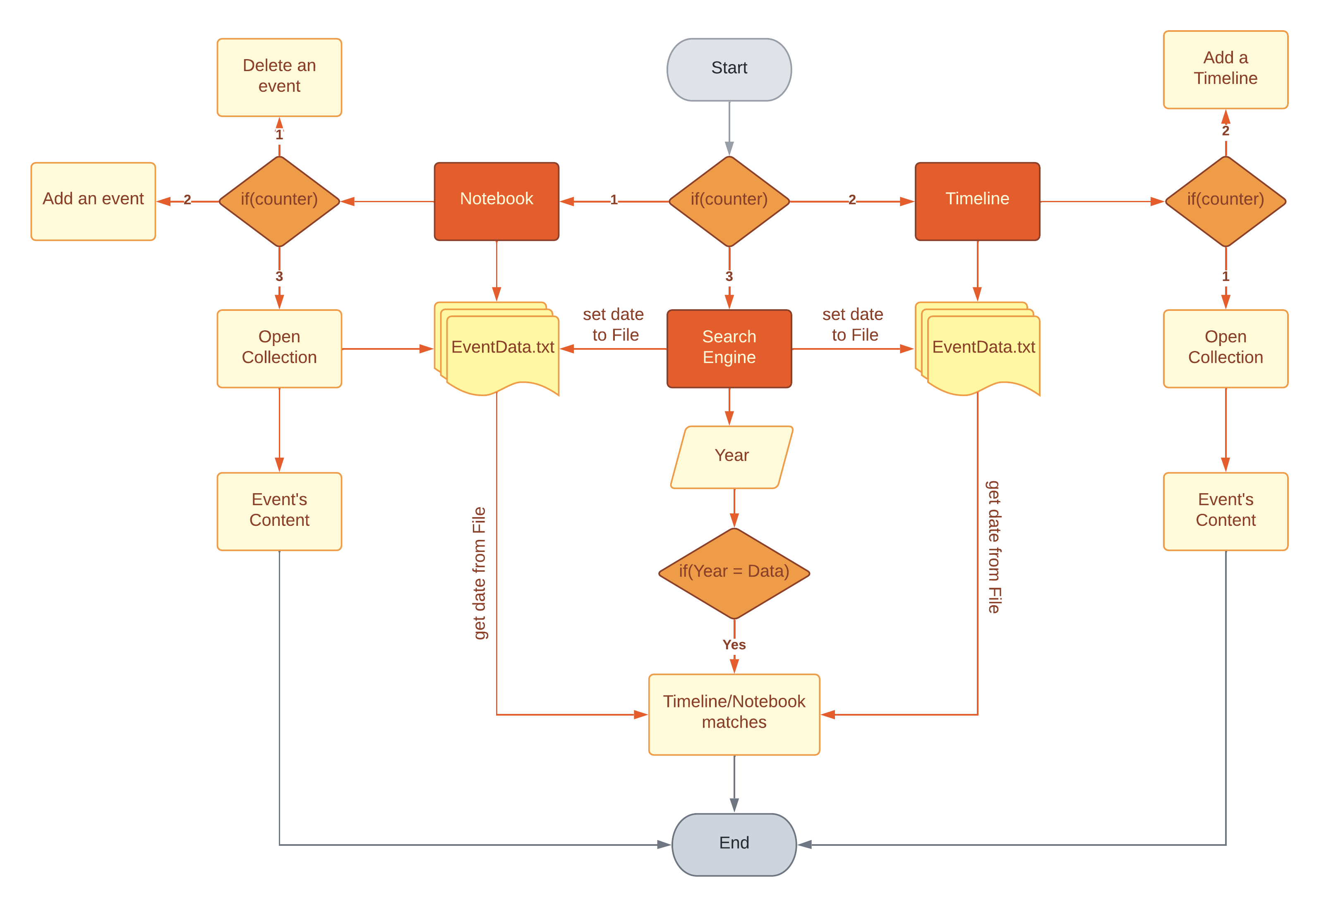

**PRESENTED BY**

Grey’s Warriors

**WORK WITH**

GitHub

**REPOSITORY**

Greys-Warriors

Content

Grey’s Warriors 4

Information and Development of a plan 4

Team roles 4

Introduction 4

Milestones in realization 5

Code plan 5

Plan testing 6

All tasks to perform 6

PURPOSE OF EACH SECTION 6

Table of Functions and Variables 7

**P**

# Grey’s Warriors

## Information and Development of a plan

**PRESENTATION OF THE PROJECT**

Our project is a C++ application for History events, which you can download from our repository.

Link - <https://github.com/INMihaylov19/Greys-Warriors.git>

### Team roles

|  |  |
| --- | --- |
| № | Roles in the team |
|  | Yanislav Stoyanov (YLStoyanov19) – Scrum Trainer |
|  | Veselin Stoyanov (VNStoyanov19) – Back-end Developer |
|  | Ivan Mihaylov (INMihyalov19) – Front-end Developer |
|  | Ivaylo Markov (IPMarkov19) – QA Engineer |

### Introduction

|  |  |
| --- | --- |
| № | Introduction |
|  | What is the product?  The product is a C++ application. We have a Menu |
|  | Where is it available?  Our collaborative work took place in **GitHub** and in order for the files to be accessible to everyone they were uploaded in the GitHub Repository of our project.  **Link** - <https://github.com/INMihaylov19/Greys-Warriors.git> |
|  | Communication?  Communication is realized through **Teams**. Thanks to all the features and the provided visualization - on-screen communication and feedback are sufficiently complete. |
|  | What technologies are used?  The technologies used are **Visual Studio** as IDE for creating the C++ application, **C++** as a programming language, **Git** and **GitHub** for collaborative work. **Teams** - connection and communication, **MS** **PowerPoint** - preparing a Presentation, **MS** **Word** - preparing Documentation, **MS Excel –** preparing a QA Documentation . |

### Milestones in realization

|  |  |
| --- | --- |
| № | Milestones in realization |
| 1 | Form the team  Our team is formed by 4 students and everyone has a unique role. That role is determined according to his skills and knowledge. |
| 2 | Do research on the topic  To achieve our goals, we had to spend some of our time in researching. Research is an essential part of the project. |
| 3 | Discuss ideas  After doing some research on the topic, everyone suggested their idea, we discussed the ideas and assigned everyone some tasks. |
| 4 | Sort and separate tasks  Each of us has a unique role and the tasks he receives are determined according to it. The tasks are sorted in the Projects section in GitHub and are well described, so that everyone can understand what they are supposed to do. |
| 5 | Work on the project  After everyone received their tasks, we started working on the project. With hard work and a lot of effort, together we managed to create the final product. |

## Code plan

|  |  |
| --- | --- |
| № | Plan for realization |
|  | Main Menu  We had to create a menu with simple but still eye-catching design. The menu includes an ASCII art of the application’s name and three different buttons. Each button takes the user to different sections. |
|  | Design of different sections  Our task was to create three different sections. Those sections are Notebook, Timeline and Search engine. Our Front-end developer was assigned the task to make design for those sections. |
|  | Functionality of each section  Our Back-end developer had the task to make those tabs functioning. |

## Plan testing

### All tasks to perform

|  |  |
| --- | --- |
| № | Completed tasks |
| 1 | Main Menu The design and functionality of the Main Menu was created by the Front-end developer. |
| 2 | Notebook section  The Notebook section’s design was created by the Front-end developer, including ASCII arts, text coloring, buttons and buttons’ placement. The functionality of the Notebook section was created by the Back-end developer, including the options of being able to see all the events, adding new and deleting old events. |
| 3 | Timeline section  The Timeline section’s design was created by the Front-end developer, including ASCII arts, text coloring, buttons and buttons’ placement. The functionality of the Timeline section was created by the Back-end developer, including the options of being able to see all the timelines, adding new and deleting old timelines. |
| 4 | Search engine  The search engine’s design was created by the Front-end developer and its functionality was created by the Back-end developer. |
| 5 | Create a Documentation  Our Scrum trainer had the task to create a Documentation where the essence of our project is described in the best possible way. |
| 6 | Create Presentation  Our Scrum trainer was assigned the task to create a proper presentation which represents our team and our work. |

### PURPOSE OF EACH SECTION

|  |  |
| --- | --- |
| № | Sections |
| 1 | Notebook  The Notebook is separated in three different subsections – Collection, Add an event, Delete. In the Collection section the user is able to see all the previously entered events. In the Add an event Section the user is able to add new events. In the Delete section the user is able to delete an event. |
| 2 | Timeline  The Timeline section is separated in three different subsections – Collection, Add, Back to Menu. The Collection section shows all previously added timelines. In the Add section the user is able to add more timelines with the choice of how many events he wants the timeline to include. Back to Menu is a button, which redirects the user to the Main Menu. |
| 3 | Search engine  In the search engine the user has to enter a year and the engine searches whether the year is in the Timeline/Notebook section or not. |

## Table of Functions and Variables

|  |  |  |
| --- | --- | --- |
| NAME | TYPE | DESCRIPTION |
| inputFromFileTimeline | Void Function | Extracts info from Timeline and puts it in EventDataTimeline.txt file |
| searchBoxTimeline | Void Function | Inputs a year and searches for it in timeline |
| Field | Void Function | Field Size |
| bubbleSort | Void Function | Sorts dates using the bubble sort method |
| drawTimelineInfo | Void Function | Prints timeline info |
| drawTimelines | Void Function | Prints timelines |
| addEventToNote | Void Function | Adds event to the note |
| numberOfEvents | Void Function | Asks the user how many dates he wants to put in the timeline |
| timelineSection | Void Function | Prints “Timeline” |
| SetColor | Int Function | Collection button 7 is for white, 14 for golden |
| color | Void Function | Sets color of the text |
| gotoxy | Void Function | Gets the coordinates inside the console |
| menuArt | Void Function | ASCII art in main menu |
| Menu | Int Function | Main menu |
| searchBoxNotebook | Void Function | Inputs data and searches for it in the Notebook file |
| mainGrid | Void Function | Grid Function |
| art | Void Function | Prints “History Book” |
| textField | Void Function | Creates a textfield for input boxes |
| newElement | Void Function | Adds new element to the linked list |
| extractInfoNotebook | String Function | Separates the data from each other |
| inputFromFileNotebook | Void Function | Uploads the input data in eventDataNotebook file |
| setDateToFileNotebook | Void Function | Gets the data from eventDataNotebook file |
| addEventToNotebook | Void Function | Adds event to the notebook |
| del_pos | Void Function | Deletes node |
| drawPageContent | Void Function | Outputs details |
| drawNotebookContent | Void Function | Outputs the content in notebook |
| addEventToNotebook | Void Function | Text field to input information |
| startNewNotebook | Void Function | Starts new notebook |
| bookMenu | Int Function | Menu in notebook section |

