CAM-MIPIOV7251 Quick Start
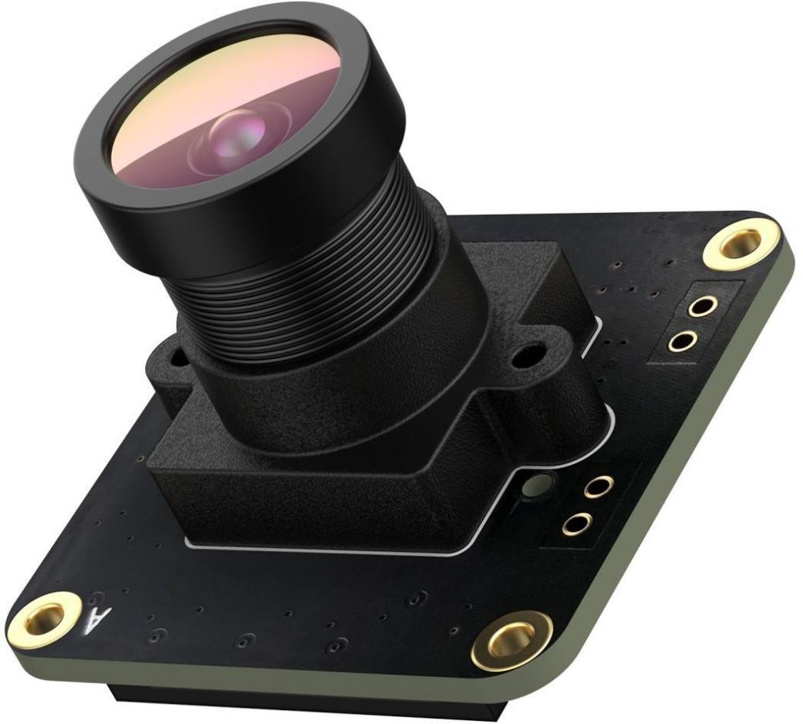

Date | Revision
2022-10-27 | Correct Chapter 2.3 Mode Description

1,Key Specifications:
1,Active array size: 640x480 ,Global Shutter,External Trigger.
2,Output formats: 8bit RAW BW and 10 bit RAW BW.
3,Frame rate: 158fps.
4,Optical coupled isolated external trigger input and flash output support
5,Support 4 work mode:
- 0,8 bit stream mode
- 1,10bit stream mode
- 2,8bit external trigger mode
- 3,10bit external trigger mode
Work on 8bit stream mode by default.
6, Software trigger input support.
7, driver feature support : gain,exposure,hflip,vflip
8, Provide GPL Linux 5.15.32 driver source code.

Hardware Description:
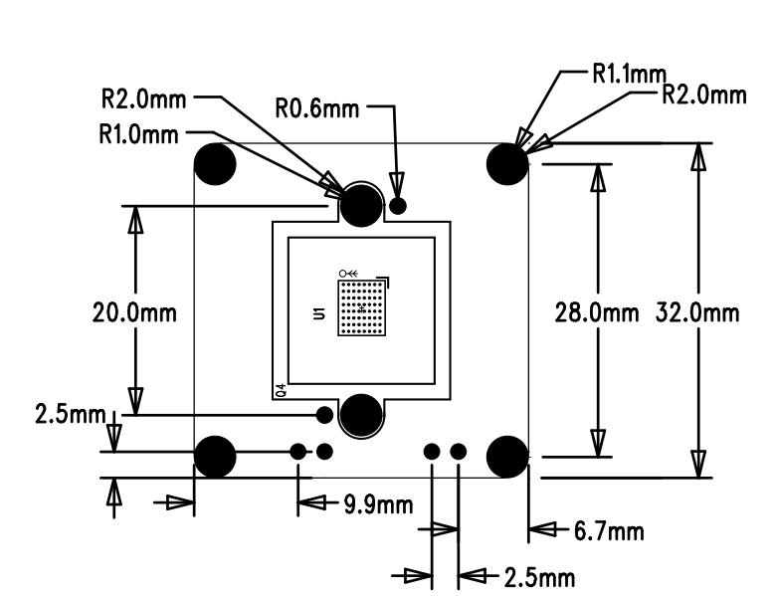

Default Len
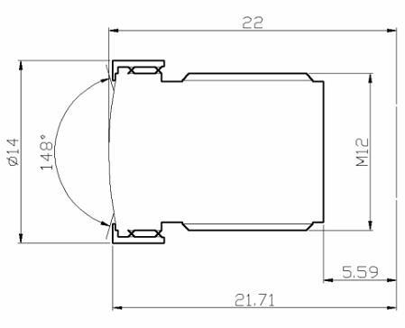
- Interface: M12
- Field of view Fov(D) = 148 degrees , Fov(H) = 118 degrees
- Focal Length 2.8 mm
- Focal Distance Adjustable
- TV DISTORTION <-17%
- F(N) /Aperture 2.2

Signal/Power Connector J1

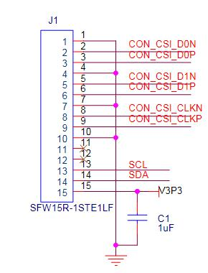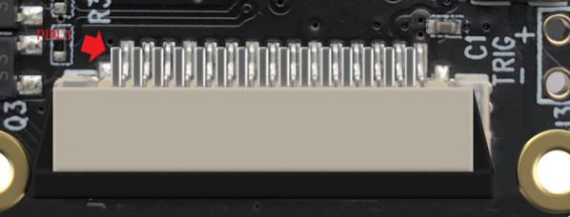

STROB Connector J2

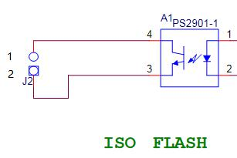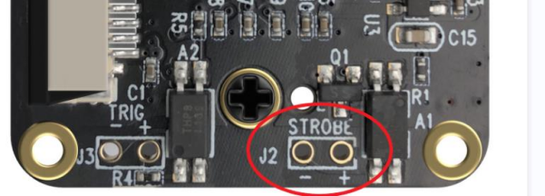
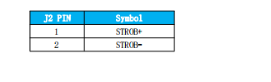

Reference Circuit
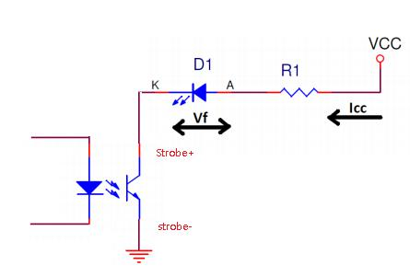

On-board TLP281 optocoupler isolation, Notice the max collector current is 50mA.
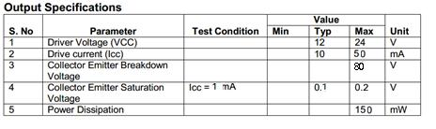
So If the current required to drive the Flash LED is no more than 50mA
The value of series resistor: R1 = ( VCC- Vf - VCE ) / If
VCC: system Voltage
Vf: Forward voltage of Flash LED for current Icc
VCE: Collection Emitter voltage, typical:0.1V
If the current required to drive the flash exceeds 50mA, then it is required to drive it with the
help of LED driver circuit, and LED driver circuit can be controlled by using the strobe output pin.

EXT TRIG Connector J3

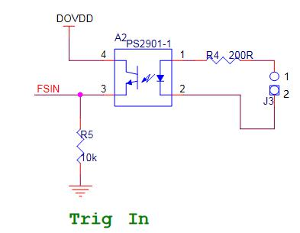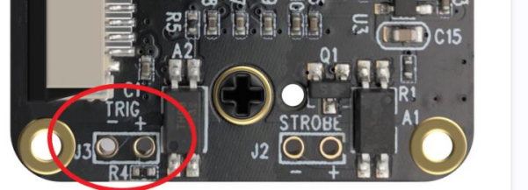

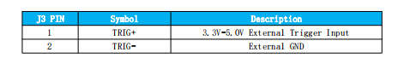

Reference Circuit
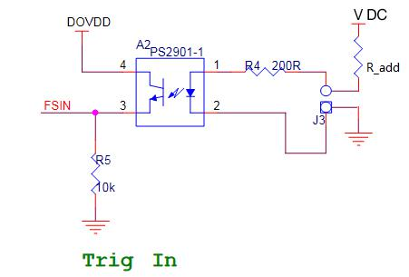
For example, VCC = 12V, Vf = 1.25V
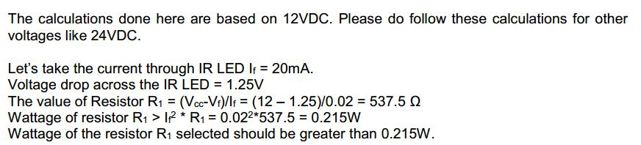
And there is a resistor on board(R4 = 200Ω), So the R_add = R1 - R4 = 537.5 - 200 = 337.5Ω

2,Key Operations:

2.1 Compile Driver Source Code
Step1 ,Download Source Code from our github:
$sudo git clone https://github.com/INNO-MAKER/cam-mipiov7251-trigger.git
Step2 ,Install the linux kernel header by:
$sudo apt-get update
$sudo apt-get upgrade
$sudo apt-get install raspberrypi-kernel-headers
$sudo reboot
Step3,Compile the driver source code
$cd cam-mipiov7251-trigger
$sudo tar -xvf vc_mipi_ov7251_driver_pi_lattice_linux5.15.tar.gz
$sudo chmod -R a+rwx *
$cd vc_mipi_ov7251_driver_pi_lattice_linux5.15
$sudo make
Step4,Install the innomaker driver
$sudo make install #Work on 8bit stream mode by default.

2.2 Enable Camera
Step1, edit /boot/config.txt
$sudo nano /boot/config.txt

Add below content to the last line and reboot
dtoverlay=vc_mipi_ov7251

$sudo reboot

*** Remark If USE pi zero(bcm2835)
dtoverlay=vc_mipi_ov7251,i2c_pins_28_29=1

*** If you wish to usd raspberry pi official driver :(pi driver do not support trigger mode)
Enable the official driver by edit /boot/config.txt by add below content
dtoverlay=ov7251,media-controller=1
.

2.3 Working Mode Description:
Mode | Description | array | Frame rate
0 | 8 bit stream mode | 640x480 | 158fps
1 | 10bit stream mode | 640x480 | 158fps
2 | 10bit external trigger mode | 640x480 | 158fps
3 | 8bit external trigger mode | 640x480 | 158fps

2.4 Working mode change:
$cd cam-mipiov7251-trigger/vc_mipi_ov7251_driver_pi_lattice_linux5.15
$sudo make setmodex # x can be 0 1 2 3

Get camera module work mode information:
$ modinfo vc_mipi_ov7251

3,Software Trigger:
Step1 : set camera work in external trigger mode.
For example set the module work in mode3
$ sudo make setmode3
Open /dev/video0 device in VLC
Step2: Transfer software trigger command through i2c bus
$ i2cset -f -y 10 0x10 204 1
Remark:
*** Set the sensor module back to external hardware trigger mode by:
$ i2cset -f -y 10 0x10 204 0

4,Hardware Trigger :
*** Set the sensor module back to external hardware trigger mode by:
$ i2cset -f -y 10 0x10 204 0

Wire connection
You can connect the TRIG- to the GND Pin and connect the TRIG+ to 3.3V Pin of Raspberry Pi to
simulate a trigger signal. This test function will comes with repeated trigger signal sometime.
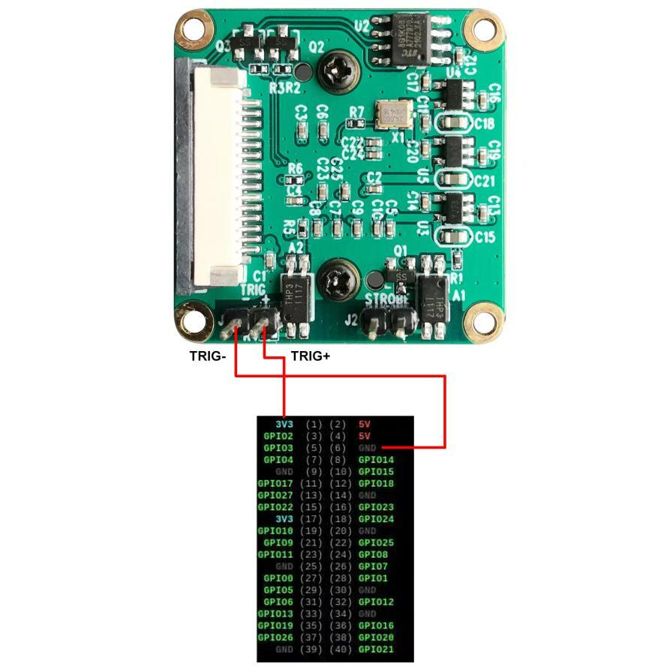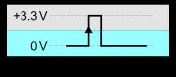

Step1 : set camera work in external trigger mode.
For example set the module work in mode3
$ sudo make setmode3
Open /dev/video0 device in VLC
Step2: Put external trigger signal through TRIG pin head.
For example a 3.3v gpio rising edge signal will trigger the frame output.
$cd cam-mipiov7251-trigger
$sudo ./gpio-sysfs

5,Tools

