Java Mini Assignment 5 – Railway System Documentation

Railway Booking System is created using Java –

To Run: Just run the main.java file with java installed.

Overview of the railway system –

1. It asks which type you want to login from – 1. User or 2. Admin
2. In User, It allows you to book tickets so it asks the user for his/her details
3. After submitting the details the ticket is booked according to the coach filling pattern and if the berth with user berth preference is available, it is assigned to him.
4. Pricing Is done according to the requirements using strategy and factory pattern.
5. The complete TrainSystem uses Singleton Pattern.
6. If the preferred berth type is not available, next available berth is allocated.
7. Trainsystem has trains, trains have coaches, coaches have seats.
8. The Admin view allows the admin to view the train and coach details.
9. Admin can select which train to select, which coach to view from that train and how many seats are occupied and left.
10. 2 Trains are created.

All requirements are fulfilled.

Screenshot of running project –

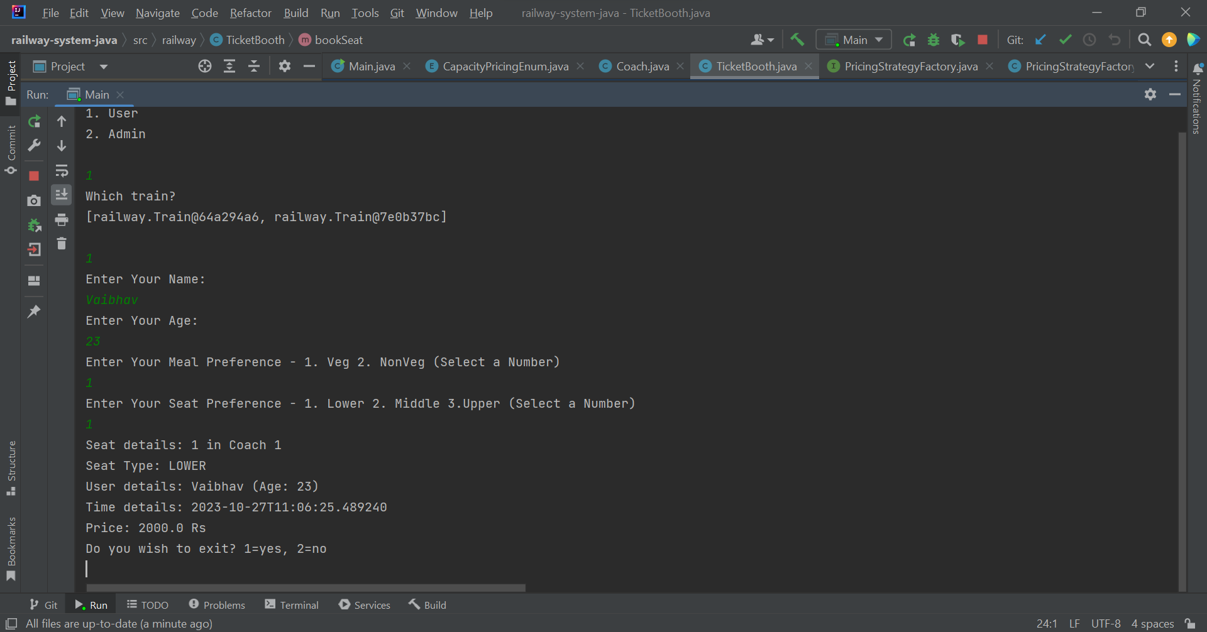

Above Screenshot of shows the User View –

Above Screenshot shows Admin View.

All requirements are satisfied and project is running as expected. The user details are shown with a 5 second delay as required.