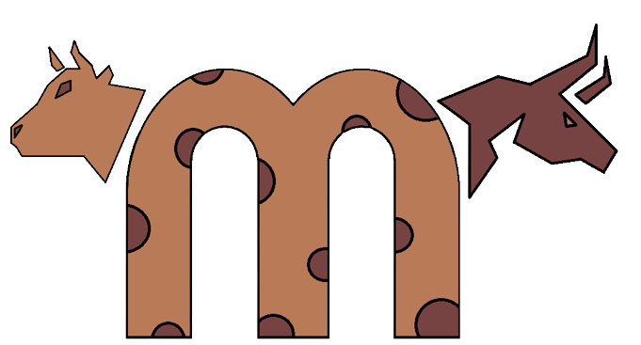**COWSERS**

**Table of Contents**

**1.** **INFORMATION ABOUT THE TEAM** 2

**2.** **OUR GAME** 2

**3.** **STAGES OF REALIZATION** 2

**4.** **USED TECHNOLOGIES** 2

**5.** **TEAM LOGO** 3

# **INFORMATION ABOUT THE TEAM**

|  |  |  |
| --- | --- | --- |
| **NAME** | **CLASS** | **ROLE** |
| **Iva Nedkova** | 9 B | Scrum trainer |
| **Yana Ilcheva** | 9 V | Back-end developer |
| **Svetoslav Zhelev** | 9 A | Back-end developer |
| **Polina Dineva** | 9 G | QA engineer |

# **OUR GAME**

Our project is 2D game where you have to guess numbers. Depending on whether you are a beginner or advanced, there are different levels of difficulty. You have an option to change your nickname if you want.

# **STAGES OF REALIZATION**

* We chose the theme of the game
* We assigned roles
* We created the logo
* We made the README.md file
* We wrote the code for the game
* We created the presentation and the documentation

# **USED TECHNOLOGIES**

* **Visual Studio** - for writing the code
* **Power Point** - for creating the presentation
* **Word** - for creating the documentation
* **Excel** - for creating the QA documentation
* **Figma** - for creating the logo
* **Chrome** -for some ideas about the game and the design
* **GitHub** - for project synchronization
* **Git** -to commit our changes
* **C++** - for creating the game

# **TEAM LOGO**