Contact tracing in the Bundibugyo virus disease outbreak, DRC
Analysis of linelist and contact-tracing data, cut of 9 October 2026 · Restricted: de-identified outbreak data, do not redistribute

1. Main findings
- Contact tracing sees a small part of the outbreak. Only 8.8% of 8,145 confirmed/probable cases had any contacts listed, and only 45 (0.6%) were already on a contact list before they were notified. Nearly all cases arise outside known chains of transmission.
- Large spatial gaps. Katwa and Butembo (735 cases together, half of Nord-Kivu's 1,452) have no contact-tracing records at all. In Beni, tracing only started in September (99.7% of its contacts were listed then). Haut-Uele does best (30% of cases traced) but is small.
- Faster listing, still too late. Time from a source case's notification to first contact listed fell from a median of 7 days (June) to 2 days (September). But contacts are still listed a median of 11 days after the source case's symptom onset, about one serial interval, so many secondary cases are already ill by then.
- Follow-up is patchy and has recently deteriorated. 23% of contacts whose 21-day follow-up has ended have no recorded visit result (median 2 of 21 days recorded). Since 14 September, 74% of follow-up visits have no result (vs 16% before), coinciding with the surge of new contacts in Beni.
- Epidemiological parameters. Secondary attack rate (SAR) 2.0% (95% CI 1.7–2.3); highest for spouses (6.9%) and parents (3.9%), funeral exposures (2.9%) and contacts of fatal source cases. Serial interval median 10.5 days; exposure-to-onset median 8 days. The low SAR most likely reflects missed transmission rather than low infectiousness.

2. Data summary
After merging duplicate records by person ID (SI-2), the linelist holds 8,145 cases (8,119 confirmed, 26 probable; 2,966 deaths recorded). The contact-tracing (CT) database lists 1,073 source persons and 12,846 contacts (13,143 source–contact pairs; 270 contacts named by >1 source). Only 717 source persons are confirmed cases in the linelist; 181 cannot be found in it and 75 are classified as not a case. Source cases named a median 6 contacts (IQR 1–15; mean 12.2; n=1,073); 28% named only one, while 44 named ≥50 and the top 10% of sources account for 46% of all contacts (mostly Beni and Rwampara). Contacts were mainly exposed in the household (70.7%) or hospital (19.7%), mostly through direct physical contact (76.4%); relationship was unknown for 31.2% and 'neighbour' for 27.2% (Figure 1). Table 1 summarises by province; Figure 1B and Figure S1 show coverage by health zone over time.
Table 1. Contact-tracing indicators by province (province of source case for CT columns).
Province | Cases | Deaths | % cases with contacts listed | % cases known contact before notif. | Source cases* | Contacts* | Median contacts / source | Mean % of 21 days with result | SAR % (k/n)
Ituri | 6,247 | 2,253 | 8.6 | 0.5 | 683 | 8,574 | 7 | 28 | 2.1 (144/6,943)
Nord-Kivu | 1,452 | 646 | 3.9 | 0.6 | 67 | 2,378 | 17 | 2 | 0.8 (8/1,059)
Haut-Uele | 373 | 57 | 30.3 | 1.9 | 162 | 1,416 | 6 | 19 | 3.5 (26/753)
Tshopo | 54 | 8 | 13.0 | 0.0 | 10 | 77 | 5 | 12 | 1.6 (1/64)
Bas-Uele | 15 | 1 | 13.3 | 0.0 | 2 | 82 | 41 | 67 | 0.0 (0/82)
Sud-Kivu | 4 | 1 | 25.0 | 0.0 | 2 | 34 | 17 | 18 | 0.0 (0/10)
National | 8,145 | 2,966 | 8.8 | 0.6 | 1,073 | 12,846 | 6 | 24 | 2.0 (179/8,911)
*National totals include 36 source persons with Kasai (Bulape) alert-ID prefixes, 109 with unlocatable IDs and 2 in Tshuapa (SI-3). SAR: contacts of confirmed/probable sources with a closed 21-day window.

3. Patient journey
Among confirmed cases (Figure 2), notification came a median 4 days (IQR 2–7; mean 5.2; n=6,770) after onset; sampling a median 1 day (IQR 0–5; mean 3.8; n=7,649) after notification; and lab analysis a median 0 days, i.e. the same day (IQR 0–1) after sampling. Overall, onset to lab result was median 7 days (IQR 4–13; mean 9.4; n=6,772). For cases that became source cases, contacts were first listed a median 4 days (IQR 1–12; mean 8.3; n=695) after notification (median 11 days (IQR 6–18.75; mean 13.6; n=606) after onset). The detection steps have been stable over time; the notification-to-sample delay is much shorter in Nord-Kivu (median 0 days) than in Ituri (1 days, IQR up to 7), which is worth checking with field teams (it may reflect how notification dates are recorded). Distributions will be fitted in a later version.

4. Effectiveness of contact tracing
New source cases rose to a peak of about 92 per week in mid-September, when 1,941 new contacts were listed in one week, mostly from Beni (Figure 3B). Even so, the weekly share of new cases that became source cases has stayed between about 5% and 15% since June, and fell in the last two weeks, partly because of reporting lag (Figure 3C), and the share already known as contacts has never passed ~1.5%. Of 101 cases ever on a contact list, 56 were listed only after their own notification, i.e. found through the case, not by tracing. The time from source-case notification to first contact listed was a median 4 days (IQR 1–11; mean 7.9; n=863); 42% were listed within 2 days. This has improved steadily (Figure 3D). For the 12,106 contacts whose follow-up window has closed, a median of 9 follow-up days were recorded, but only 2 had a result (IQR 1–12); 22% had ≥15 days with a result. Completeness differs sharply between areas: Nord-Kivu and Haut-Uele contacts have almost no recorded results (Table 1, Figure S3). Note that CT records end on 4 October, so the last week is incomplete.

5. Epidemiological implications
Of 8,911 contacts of confirmed/probable sources with a closed follow-up window, 179 became cases: SAR 2.0% (95% CI 1.7–2.3) (linelist-linked cases only: 0.8%; excluding CT 'case validated' (sensitivity): 1.3%). 14% of source cases had ≥1 secondary case among their listed contacts. Risk was higher for spouses (risk ratio [RR] 2.8, 95% CI 1.3–6.0) and parents (RR 1.6, 1.0–2.5) than for contacts with unknown relationship, and lower for neighbours (RR 0.66). Funeral exposure (RR 2.2, 1.3–4.0 vs household) and a source case who died (RR 0.7, 0.5–1.0) also increased risk, and bodily-fluid exposure tended to (RR 1.3, 0.8–2.1). These effects remained after mutual adjustment (SI-5). Contacts of sources who named only 1–5 people had an SAR of 5.2%, against 1.2% for lists of >50: very long lists dilute risk and stretch follow-up teams. Haut-Uele had a higher SAR (3.5%), possibly because more of its cases are traced, so links are more often detected. The serial interval (n=64 pairs) was a median 10.5 days (IQR 6.75–17.25; mean 11.8; n=64), with 9 negative values. Time from last exposure to onset (n=43) was a median 8 days (IQR 4–10.5; mean 8.7; n=43); a further 29 secondary cases had onset on or before their recorded last exposure, typical of carers exposed to an ill relative (Figure 4). These are small, selected samples and should be treated as preliminary.
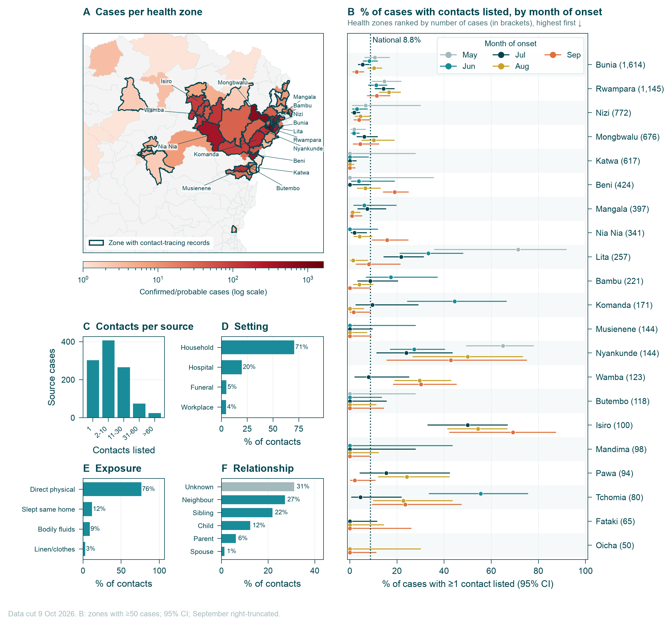
Figure 1. Data summary. (A) Confirmed/probable cases per health zone; zones with any contact-tracing records outlined. (B) Share of cases with ≥1 contact listed (95% Wilson CI) by month of onset (May–August), for zones with ≥50 cases; point colour matches panel A; dotted line = national share over the whole outbreak. Months with <5 cases omitted. (C) Contacts listed per source case. (D–F) Setting, exposure type and relationship for all source–contact pairs.

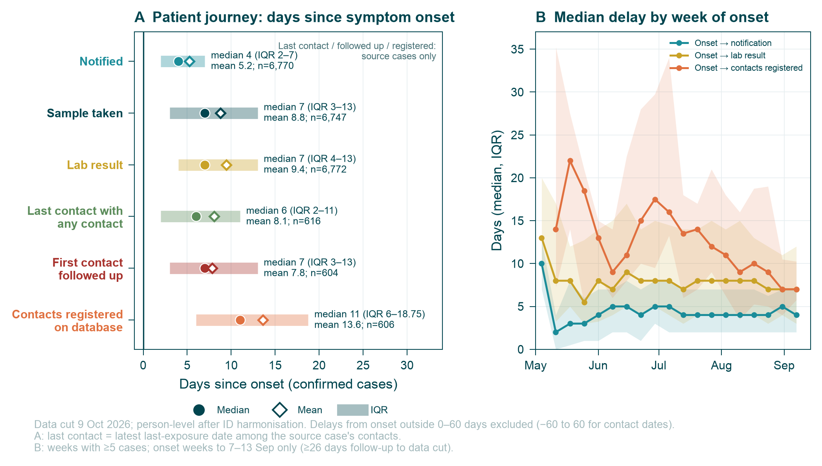
Figure 2. Patient journey of confirmed cases. (A) Median, mean and IQR of days from symptom onset to notification, sample collection, lab result and first contacts listed (source cases only). (B) Monthly median and IQR (shaded) of selected delays, by month of onset. (C) Median and IQR by province (provinces with ≥40 cases).
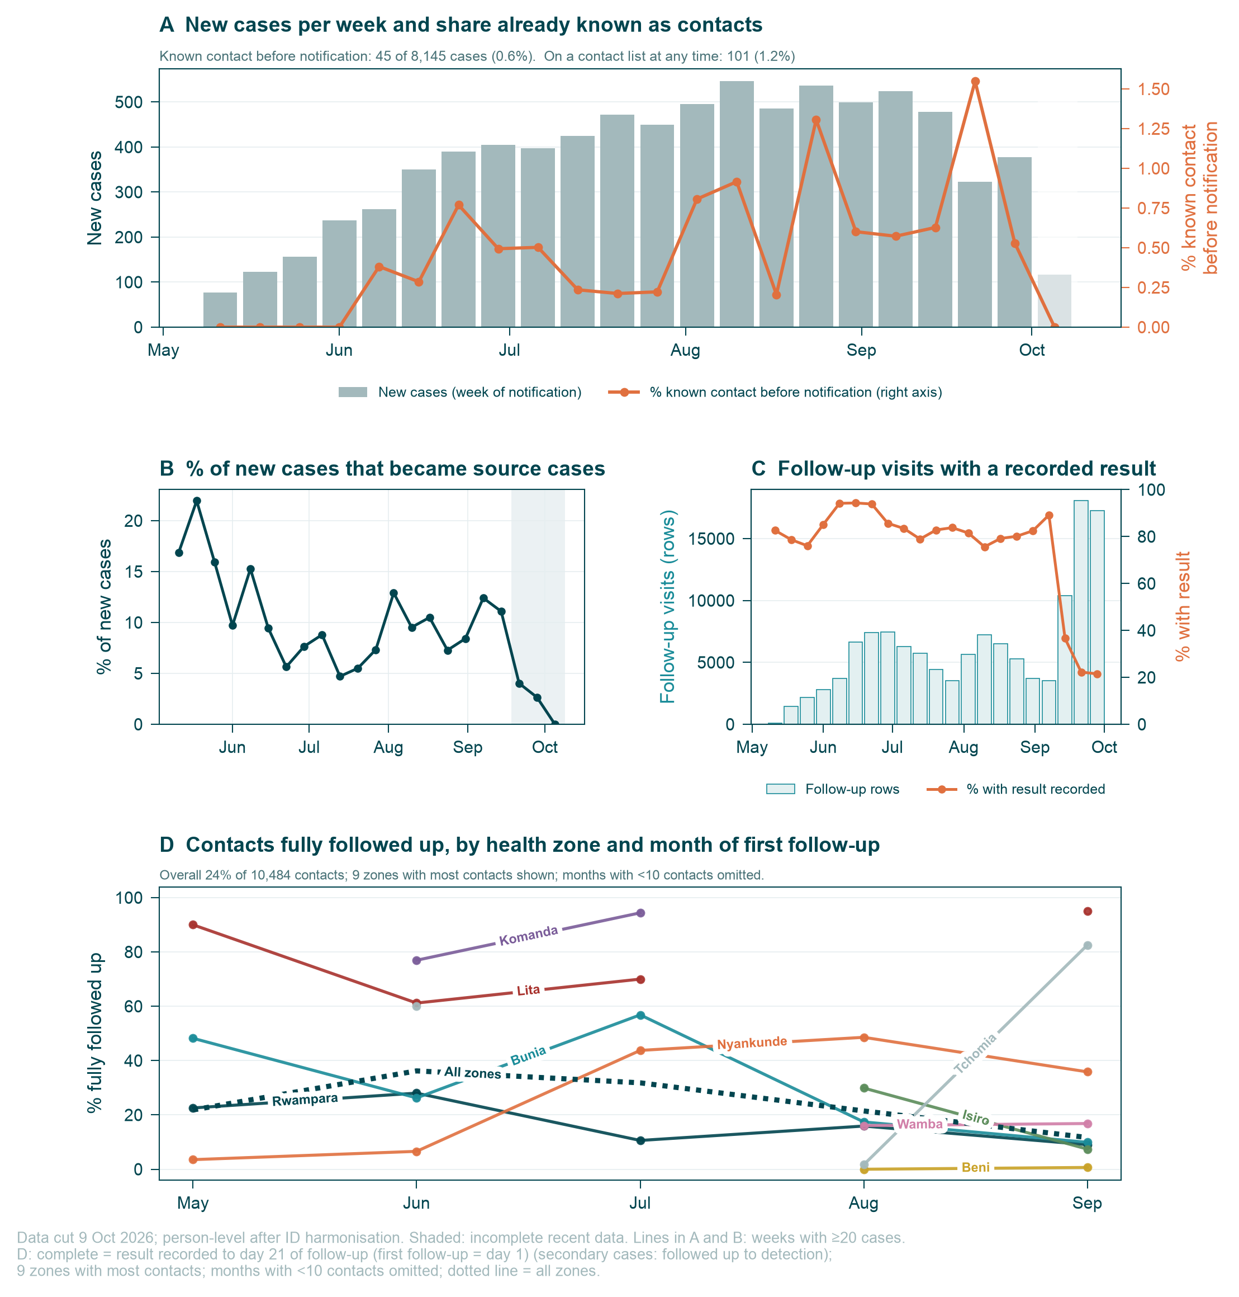
Figure 3. Effectiveness of contact tracing. (A) New cases by week of notification, split by whether they were a listed contact before notification, listed only afterwards, or never listed. (B) New source cases and new contacts listed per week. (C) Weekly share of new cases that became source cases or were known contacts (weeks with ≥20 cases). (D) Days from source-case notification to first contact listed, by month. (E) Follow-up visit rows per week and share with a result recorded.

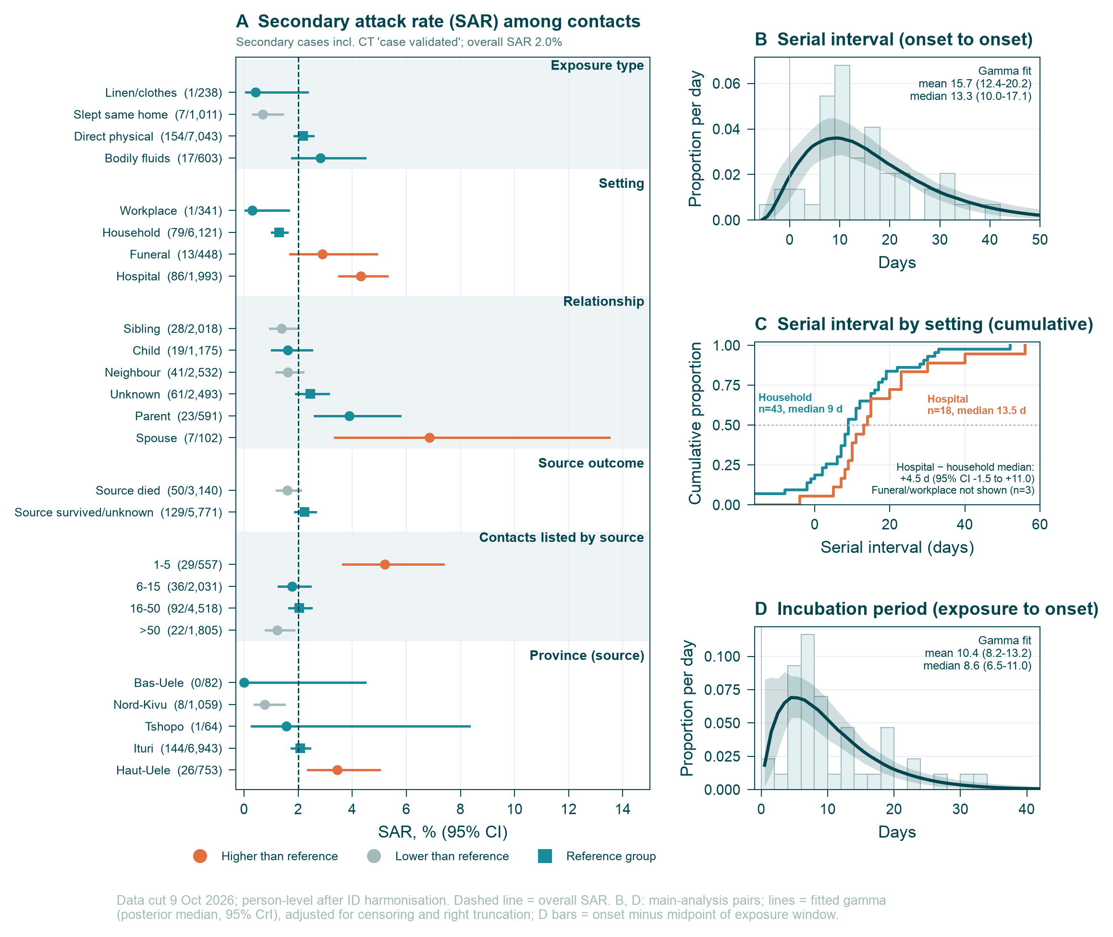
Figure 4. Epidemiological implications. (A) SAR (95% Wilson CI) by exposure type, setting, relationship, source outcome, number of contacts named by the source and province (levels with ≥50 contacts). Coral = RR CI above 1; grey = below 1. (B) Serial interval, confirmed source–contact pairs. (C) Days from last recorded exposure to symptom onset in secondary cases (values 1–42 days).

Supplementary information

SI-1. Data and definitions
Data. dhis2_processed_linelist_ctsafe.csv and contact_tracing_combined_ctsafe.csv from data/2026-10-09 (the combined CT file keeps contacts whose follow-up ended in earlier exports; the 'processed' file holds only the contacts current on 9 October). Health-zone boundaries: BDBV2026-Data build/drc_health_zones.geojson, built from data/shapefiles/DRC_Health_zones.shp (GeoJSON used because no shapefile reader was available in the analysis environment; zone names are identical). All analysis code is in the BDBV2026-Contact_Tracing_Analytics repo, pipelines/contact_tracing_report (01_harmonise.py → 06_fig3A_proportions.py).
Unit of analysis. The person (person_id), not the alert or contact record. A source–contact pair is a unique (source person, contact person) combination.
Case. Linelist person with final classification confirmed or probable (after harmonisation). Suspected cases are excluded.
Source case. Any person appearing as source_case_person_id in the CT data, whatever their linelist status; process indicators use all of them.
Secondary case. A contact who is a confirmed/probable linelist case, OR whose CT follow-up result was ever 'case_confirmed', unless the linelist classifies them as not a case. 'case_validated' is excluded in the main analysis (unclear meaning) and included in a sensitivity analysis.
SAR denominator. Pairs whose source is a confirmed/probable case and whose 21-day window (last contact + 21 days) closed by 9 October.
Known contact before notification. Case whose person_id is a CT contact with first registration on or before their earliest linelist notification date.
Delays. Notification = date_of_notification; investigation not used; sample = date_of_sample_collection; lab result = lab_analysis_date; contacts listed = earliest CT registration_date among the source's contacts. Delays outside 0–60 days excluded (−60 to 60 for 'contacts listed', where negative values are real: contacts can be listed before the source is notified). Summaries are means, medians and IQRs; no distribution fitting yet.
Timing. Weeks start on Monday. Epidemic curves use notification week. Monthly delay summaries are by month of onset (or notification if onset missing) and are right-truncated for recent months.
Serial interval / incubation. Serial interval: onset(contact) − onset(source) for pairs where both are linelist cases with onset dates, excluding pairs recorded in both directions; values outside −30 to 60 days excluded. Incubation: onset − last recorded exposure, for linelist-linked secondary cases, values 1–42 days; this is an approximation because exposure is often a window, not a single day.
Statistics. Wilson 95% CIs for proportions; risk ratios with log-normal (Wald) CIs; multivariable logistic regression fitted by IRLS (no adjustment for clustering by source case, so CIs are too narrow).

SI-2. Harmonisation of duplicates and discrepancies
Every executive decision taken while merging duplicates or fixing inconsistent values, with the number of records or persons affected. 'Primary record' = the person's linelist row with the highest classification, then the most non-missing fields.
Dataset | Issue | N | Decision
linelist | rows in linelist export | 58,828 | all alerts (cases, non-cases, unclassified)
linelist | distinct person_id | 58,446 | unit of analysis = person_id
linelist | health_zone 'Bili' (Bas-Uele) | 71 | renamed 'Bili (Bas-Uele)' to match shapefile
linelist | date_of_symptom_onset: implausible date (<2026-04-01 or >2026-10-09) | 110 | set to missing
linelist | date_of_notification: implausible date (<2026-04-01 or >2026-10-09) | 57 | set to missing
linelist | investigation_datetime: implausible date (<2026-04-01 or >2026-10-09) | 77 | set to missing
linelist | date_of_sample_collection: implausible date (<2026-04-01 or >2026-10-09) | 2 | set to missing
linelist | lab_analysis_date: implausible date (<2026-04-01 or >2026-10-09) | 1 | set to missing
linelist | persons with >1 linelist row | 366 | collapsed to one row per person (rules below)
linelist | multi-row persons including an 'undecided' ID match | 12 | kept as one person (person_id taken as given)
linelist | conflicting final classification | 216 | highest-ranked kept: confirmed > probable > suspected > not_a_case > blank (a positive lab result is treated as definitive)
linelist | conflicting date_of_symptom_onset | 130 | earliest plausible date kept (first-reported symptoms)
linelist | conflicting date_of_notification | 130 | earliest kept (first time health authorities were notified)
linelist | conflicting date_of_sample_collection | 68 | taken from the primary record (highest classification, then most complete); earliest if primary missing
linelist | conflicting lab_analysis_date | 57 | taken from the primary record; earliest if primary missing
linelist | conflicting sex | 37 | primary record value; missing filled from other rows
linelist | conflicting age | 90 | primary record value; missing filled from other rows
linelist | conflicting health_zone | 20 | primary record value (zone of the confirmed/primary alert)
linelist | conflicting type_of_alert | 25 | person counted as died if ANY row is a death alert or sample status 'deceased'
linelist | cases (confirmed + probable persons) | 8,145 | case definition used throughout; suspected (n=182) excluded
linelist | lab analysis date before sample date | 108 | lab analysis date set to missing
linelist | cases with no onset date | 1,238 | date of notification used for epi curve timing
CT | rows in combined CT file (all exports, incl. aged-out contacts) | 132,948 | combined file used (processed file holds only contacts current on 9 Oct)
CT | case_circumstances raw value '2.Hôpital' | 3 | recoded to 'hospital'
CT | case_circumstances raw value '1.Foyer' | 1 | recoded to 'household'
CT | relationship_to_case raw value 'Inconnue' | 2 | recoded to 'unknown' (code not in data dictionary)
CT | relationship_to_case raw value 'Epoux/ Épouse' | 2 | recoded to 'spouse'
CT | contact_type raw value '1.Contact physique direct' | 4 | recoded to 'direct_physical_contact'
CT | contact_type raw value 'MVE-005' | 139 | recoded to 'unknown' (code not in data dictionary)
CT | contact_type raw value '1' | 74 | recoded to 'unknown' (code not in data dictionary)
CT | contact_type raw value '2' | 11 | recoded to 'unknown' (code not in data dictionary)
CT | followup_result raw value 'Non Cas' | 2 | recoded to 'not_a_case'
CT | followup_result raw value 'Confirmé' | 1 | recoded to 'case_confirmed'
CT | followup_result raw value 'DB' | 10 | recoded to 'other_result' (code not in data dictionary)
CT | case_circumstances missing | 607 | set to 'unknown'
CT | relationship_to_case missing | 592 | set to 'unknown'
CT | contact_type missing | 20 | set to 'unknown'
CT | last_contact_with_source_date: implausible date (<2026-04-01 or >2026-10-09) | 49 | set to missing
CT | followup_date: implausible date (<2026-04-01 or >2026-10-09) | 53 | set to missing
CT | rows where source person = contact person (self-pairs) | 38 | dropped (ID-matching error)
CT | duplicate follow-up rows (same pair, date, result; e.g. same contact under 2 IDs) | 2,248 | dropped
CT | pairs recorded in both directions (A->B and B->A) | 1 | kept; excluded from serial-interval estimate
CT | pairs with conflicting contact_type | 54 | most frequent non-unknown value kept; ties -> value in most recent export
CT | pairs with conflicting relationship_to_case | 41 | most frequent non-unknown value kept; ties -> value in most recent export
CT | pairs with conflicting case_circumstances | 43 | most frequent non-unknown value kept; ties -> value in most recent export
CT | pairs with conflicting last-contact date | 30 | latest date kept (follow-up clock runs from last exposure)
CT | pairs with conflicting registration date | 110 | earliest kept
CT | pairs with >1 contact_id (same person registered twice) | 160 | merged into one pair via contact_person_id
CT | pairs whose follow-up results differ across visits | 247 | most severe result retained (confirmed > validated > suspected > other/recycled > not a case)
CT | source persons not found in linelist | 181 | kept as source cases; province/health zone inferred from alert-ID prefix (280 pairs still unlocated)
CT | contacts confirmed/probable in linelist | 109 | secondary case
CT | contacts confirmed/probable in linelist but CT outcome never updated (worst CT result 'not a case' or blank) | 62 | linelist classification wins (secondary case)
CT | contacts with CT result 'case_confirmed' but no linked linelist case | 57 | counted as secondary case (CT team reports confirmation; linkage to linelist missing)
CT | contacts with CT result 'case_validated' but no linked linelist case | 103 | counted as secondary case in main analysis (mostly Nyankunde May-June hospital cluster); excluded in strict sensitivity analysis
CT | contacts with CT result 'case_confirmed'/'case_validated' but linelist says not_a_case | 5 | NOT counted as secondary case (lab-based linelist classification wins)
CT | contacts with CT result 'contact_became_suspected_case' (not linelist-negative), not otherwise a secondary case | 226 | NOT counted in main analysis; included in upper-bound sensitivity analysis
CT | source persons classified not_a_case in linelist | 75 | kept in CT process metrics; excluded from SAR/serial interval

SI-3. Data-quality signals worth raising with the field teams
- No CT data in Katwa or Butembo. These zones have 617 and 118 cases and no source cases at all. Either tracing is not done there or its data are not reaching this database (e.g. a separate tool).
- Follow-up results missing. Contacts of Nord-Kivu and Haut-Uele sources have results on a mean of 2% and 19% of the 21 days. Since 14 September 74% of visit rows have a blank result. Visits may be happening but not recorded, or rows may be pre-filled schedules.
- CT outcomes not updated. 62 contacts who are confirmed cases in the linelist still have 'not a case' or no result as their CT outcome; conversely 57 contacts are 'case confirmed' in CT but cannot be linked to a linelist case.
- Source persons outside the linelist. 181 source persons are not in the linelist. 36 have Kasai/Bulape alert-ID prefixes (a different province with no BDBV cases in the linelist; possibly IDs re-used from the earlier Kasai Ebola outbreak) and 109 have non-standard IDs (e.g. 'CI-0000xx', numeric), so their location is unknown. A further 75 source persons are 'not a case' and 98 are unclassified.
- Mass listing. 44 source cases have ≥50 contacts (up to 389), mostly in Beni in September. Their contacts have a much lower SAR, suggesting community or ring listing rather than named close contacts. These should probably be analysed separately.
- Uncoded values. Contact type codes 'MVE-005', '1' and '2' and follow-up result 'DB' are not in the data dictionary; they were set to unknown/other.
- Contacts registered before exposure ended. Follow-up dates before the registration date and last-contact dates after the registration date are common; the follow-up window was therefore anchored on the last-contact date.

SI-4. Delays by province and month
Median (IQR) days; cells with <10 cases blank. National values in Figure 2. Exclusions (negative or >60 days): Onset → notification: 108 of 6,878; Notification → sample: 445 of 8,094; Sample → lab result: 5 of 8,048; Onset → sample: 116 of 6,863; Onset → lab result: 62 of 6,834; Notification → first contacts listed: 20 of 715; Onset → first contacts listed: 17 of 623; Onset → hospital admission: 0 of 0.
Level | Group | Onset→notification | Notification→sample | Sample→lab result | Onset→lab result | Notification→first contacts listed | Onset→first contacts listed
Month | 2026-05 | 3 (1–7) | 0 (0–3.5) | 1 (0–4) | 8 (4–14) | 16 (1.5–25) | 19 (8–27)
Month | 2026-06 | 4 (2–7) | 1 (0–6) | 0 (0–1) | 8 (4–15) | 7 (3–14) | 11.5 (8–19.75)
Month | 2026-07 | 4 (2–7) | 1 (0–6) | 0 (0–1) | 8 (4–15) | 6.5 (2–13) | 14.5 (8–21)
Month | 2026-08 | 4 (2–7) | 1 (0–5) | 0 (0–1) | 8 (4–14) | 3 (1–9) | 10 (5–18)
Month | 2026-09 | 4 (2–7) | 1 (0–3) | 0 (0–1) | 6 (3–10) | 2 (1–4) | 6 (4–10)
Month | 2026-10 | 2 (0–4) | 0 (0–1) | 1 (0–1) | 3 (2–5) | – | –
Province | Bas-Uele | – | 0 (0–0.5) | 1 (0–2) | – | – | –
Province | Haut-Uele | 4 (2–7) | 1 (0–9) | 1 (0–2) | 9 (5–15) | 3 (1–12.5) | 9.5 (5–18)
Province | Ituri | 4 (2–7) | 1 (0–7) | 0 (0–1) | 8 (4–14) | 5 (1–13) | 11 (6–19)
Province | Nord-Kivu | 3 (1–6) | 0 (0–0) | 0 (0–1) | 4 (2–7) | 3 (2–4) | 9 (6–12)
Province | Tshopo | 5 (2–8.5) | 0 (0–1) | 0 (0–0) | 6.5 (3–9) | – | –

SI-5. Risk factors for becoming a secondary case
Denominator: 8,911 eligible pairs. Reference = most common level. Adjusted model includes exposure type, setting, relationship, source province, source outcome and month listed; levels with no secondary cases dropped from the model ('–'). Sensitivity: SAR using all 13,143 pairs regardless of window/source status 2.0% (95% CI 1.8–2.3).
Factor | Level | k/n | SAR % (95% CI) | Crude RR (95% CI) | Adjusted OR (95% CI)
Exposure type | direct physical contact | 154/7,043 | 2.2 (1.9–2.6) | ref | ref
Exposure type | sleeping in the same home | 7/1,011 | 0.7 (0.3–1.4) | 0.32 (0.15–0.67) | 0.43 (0.19–0.93)
Exposure type | contact with bodily fluids | 17/603 | 2.8 (1.8–4.5) | 1.29 (0.79–2.11) | 1.29 (0.75–2.22)
Exposure type | handling contaminated clothes or linen | 1/238 | 0.4 (0.1–2.3) | 0.19 (0.03–1.37) | 0.17 (0.02–1.23)
Exposure type | unknown | 0/16 | 0.0 (0.0–19.4) | – | –
Setting | household | 79/6,121 | 1.3 (1.0–1.6) | ref | ref
Setting | hospital | 86/1,993 | 4.3 (3.5–5.3) | 3.34 (2.47–4.52) | 3.03 (2.09–4.38)
Setting | funeral | 13/448 | 2.9 (1.7–4.9) | 2.25 (1.26–4.01) | 2.22 (1.18–4.18)
Setting | workplace | 1/341 | 0.3 (0.1–1.6) | 0.23 (0.03–1.63) | 0.27 (0.04–1.98)
Setting | unknown | 0/8 | 0.0 (0.0–32.4) | – | –
Relationship | neighbour | 41/2,532 | 1.6 (1.2–2.2) | 0.66 (0.45–0.98) | 0.72 (0.47–1.10)
Relationship | unknown | 61/2,493 | 2.4 (1.9–3.1) | ref | ref
Relationship | sibling | 28/2,018 | 1.4 (1.0–2.0) | 0.57 (0.36–0.88) | 0.68 (0.42–1.11)
Relationship | child | 19/1,175 | 1.6 (1.0–2.5) | 0.66 (0.40–1.10) | 0.89 (0.51–1.58)
Relationship | parent | 23/591 | 3.9 (2.6–5.8) | 1.59 (0.99–2.55) | 2.64 (1.51–4.60)
Relationship | spouse | 7/102 | 6.9 (3.4–13.5) | 2.80 (1.32–5.98) | 4.25 (1.80–10.03)
Province (source) | Ituri | 144/6,943 | 2.1 (1.8–2.4) | ref | ref
Province (source) | Nord-Kivu | 8/1,059 | 0.8 (0.4–1.5) | 0.36 (0.18–0.74) | 0.75 (0.32–1.74)
Province (source) | Haut-Uele | 26/753 | 3.5 (2.4–5.0) | 1.66 (1.10–2.51) | 2.01 (1.16–3.48)
Province (source) | Bas-Uele | 0/82 | 0.0 (0.0–4.5) | – | –
Province (source) | Tshopo | 1/64 | 1.6 (0.3–8.3) | 0.75 (0.11–5.30) | 0.73 (0.10–5.46)
Province (source) | Sud-Kivu | 0/10 | 0.0 (0.0–27.8) | – | –
Month listed | 2026-08 | 46/2,727 | 1.7 (1.3–2.2) | ref | ref
Month listed | 2026-09 | 31/2,373 | 1.3 (0.9–1.8) | 0.77 (0.49–1.22) | 0.87 (0.52–1.46)
Month listed | 2026-06 | 85/2,207 | 3.9 (3.1–4.7) | 2.28 (1.60–3.25) | 2.51 (1.67–3.77)
Month listed | 2026-07 | 14/1,433 | 1.0 (0.6–1.6) | 0.58 (0.32–1.05) | 0.63 (0.34–1.18)
Month listed | 2026-05 | 2/118 | 1.7 (0.5–6.0) | 1.00 (0.25–4.09) | 0.89 (0.21–3.84)
Month listed | 2026-10 | 1/53 | 1.9 (0.3–9.9) | 1.12 (0.16–7.96) | 0.90 (0.11–7.07)
Source outcome | Source survived/unknown | 129/5,771 | 2.2 (1.9–2.6) | ref | ref
Source outcome | Source died | 50/3,140 | 1.6 (1.2–2.1) | 0.71 (0.52–0.98) | 0.91 (0.64–1.30)
Contacts listed by source | 16-50 | 92/4,518 | 2.0 (1.7–2.5) | ref
Contacts listed by source | 6-15 | 36/2,031 | 1.8 (1.3–2.4) | 0.87 (0.59–1.28) | not in model
Contacts listed by source | >50 | 22/1,805 | 1.2 (0.8–1.8) | 0.60 (0.38–0.95) | not in model
Contacts listed by source | 1-5 | 29/557 | 5.2 (3.6–7.4) | 2.56 (1.70–3.85) | not in model

SI-6. Health zones with ≥50 cases
Health zone | Cases | Deaths | % cases with contacts | % known contact before notif. | Source cases | Contacts | Median contacts/source | Mean % days with result | SAR % (k/n)
Bunia | 1,614 | 533 | 7.4 | 0.7 | 154 | 1,421 | 7 | 27 | 1.2 (14/1,149)
Rwampara | 1,145 | 198 | 13.6 | 0.5 | 187 | 3,402 | 14 | 16 | 0.7 (19/2,834)
Nizi | 772 | 396 | 3.1 | 0.1 | 32 | 187 | 1.5 | 33 | 10.6 (5/47)
Mongbwalu | 676 | 290 | 3.8 | 0.1 | 26 | 168 | 4.5 | 54 | 0.6 (1/168)
Katwa | 617 | 294 | 0.0 | 0.0 | 0 | 0 | – | – | –
Beni | 424 | 202 | 11.3 | 1.9 | 51 | 2,215 | 31 | 1 | 0.9 (8/936)
Mangala | 397 | 199 | 3.0 | 0.0 | 17 | 56 | 1 | 11 | 8.2 (4/49)
Nia Nia | 341 | 139 | 6.2 | 0.3 | 24 | 150 | 4 | 60 | 7.5 (4/53)
Lita | 257 | 122 | 17.1 | 1.6 | 54 | 549 | 6.5 | 68 | 2.9 (14/475)
Bambu | 221 | 85 | 5.4 | 0.5 | 25 | 159 | 5 | 0 | 0.0 (0/81)
Komanda | 171 | 95 | 7.6 | 0.0 | 18 | 520 | 20.5 | 81 | 0.0 (0/443)
Musienene | 144 | 56 | 0.0 | 0.7 | 4 | 20 | 2.5 | 70 | –
Nyankunde | 144 | 21 | 40.3 | 0.7 | 65 | 1,030 | 10 | 13 | 7.4 (66/890)
Wamba | 123 | 25 | 26.0 | 0.8 | 38 | 431 | 6 | 17 | 1.2 (3/241)
Butembo | 118 | 37 | 0.0 | 0.0 | 0 | 0 | – | – | –
Isiro | 100 | 18 | 55.0 | 6.0 | 88 | 749 | 6 | 16 | 5.0 (20/403)
Mandima | 98 | 44 | 0.0 | 0.0 | 1 | 5 | 5 | – | –
Pawa | 94 | 10 | 10.6 | 0.0 | 10 | 80 | 7.5 | 72 | 2.8 (2/72)
Tchomia | 80 | 16 | 26.2 | 0.0 | 28 | 320 | 8 | 57 | 4.4 (11/252)
Fataki | 65 | 27 | 0.0 | 0.0 | 1 | 1 | 1 | 0 | –
Oicha | 50 | 17 | 0.0 | 0.0 | 0 | 0 | – | – | –

SI-7. Supplementary figures
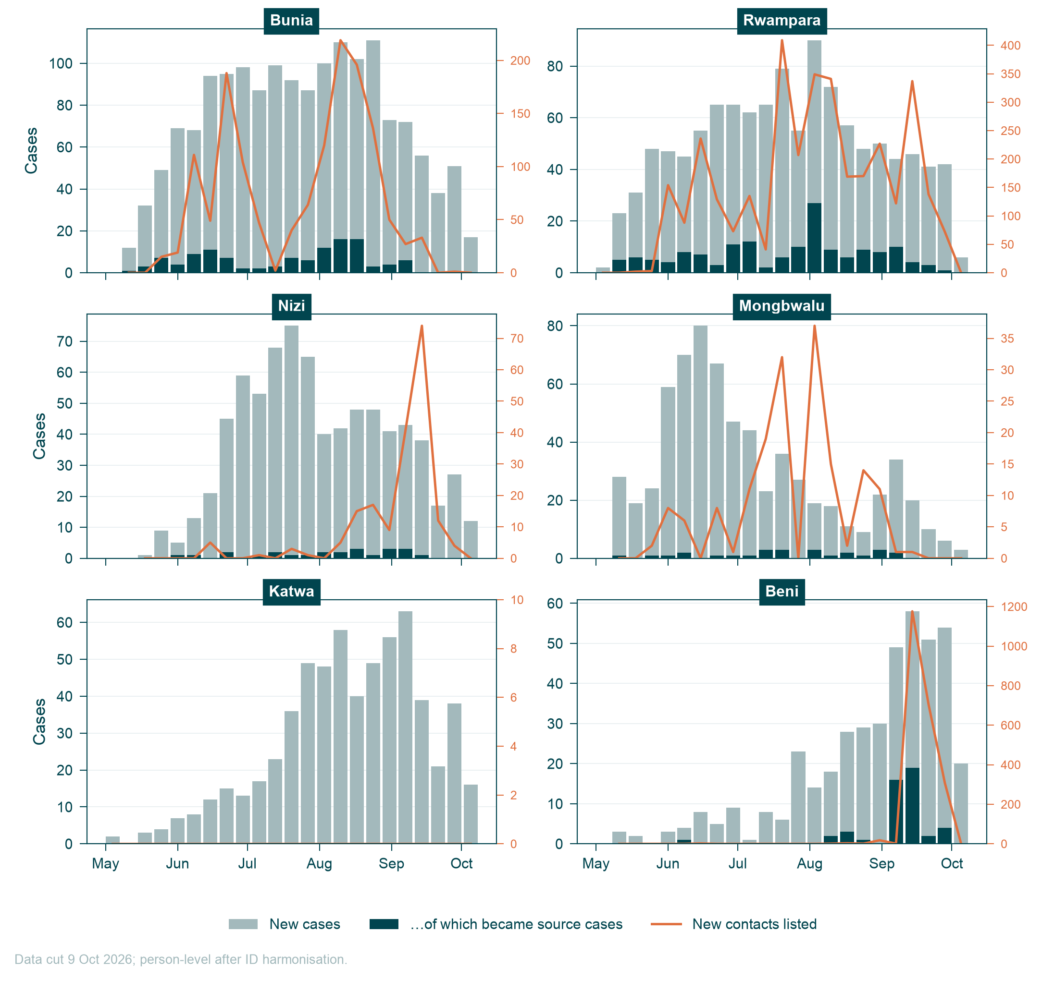
Figure S1. Weekly new cases (grey), cases who became source cases (dark teal) and new contacts listed (coral, right axis) in the six zones with most cases.
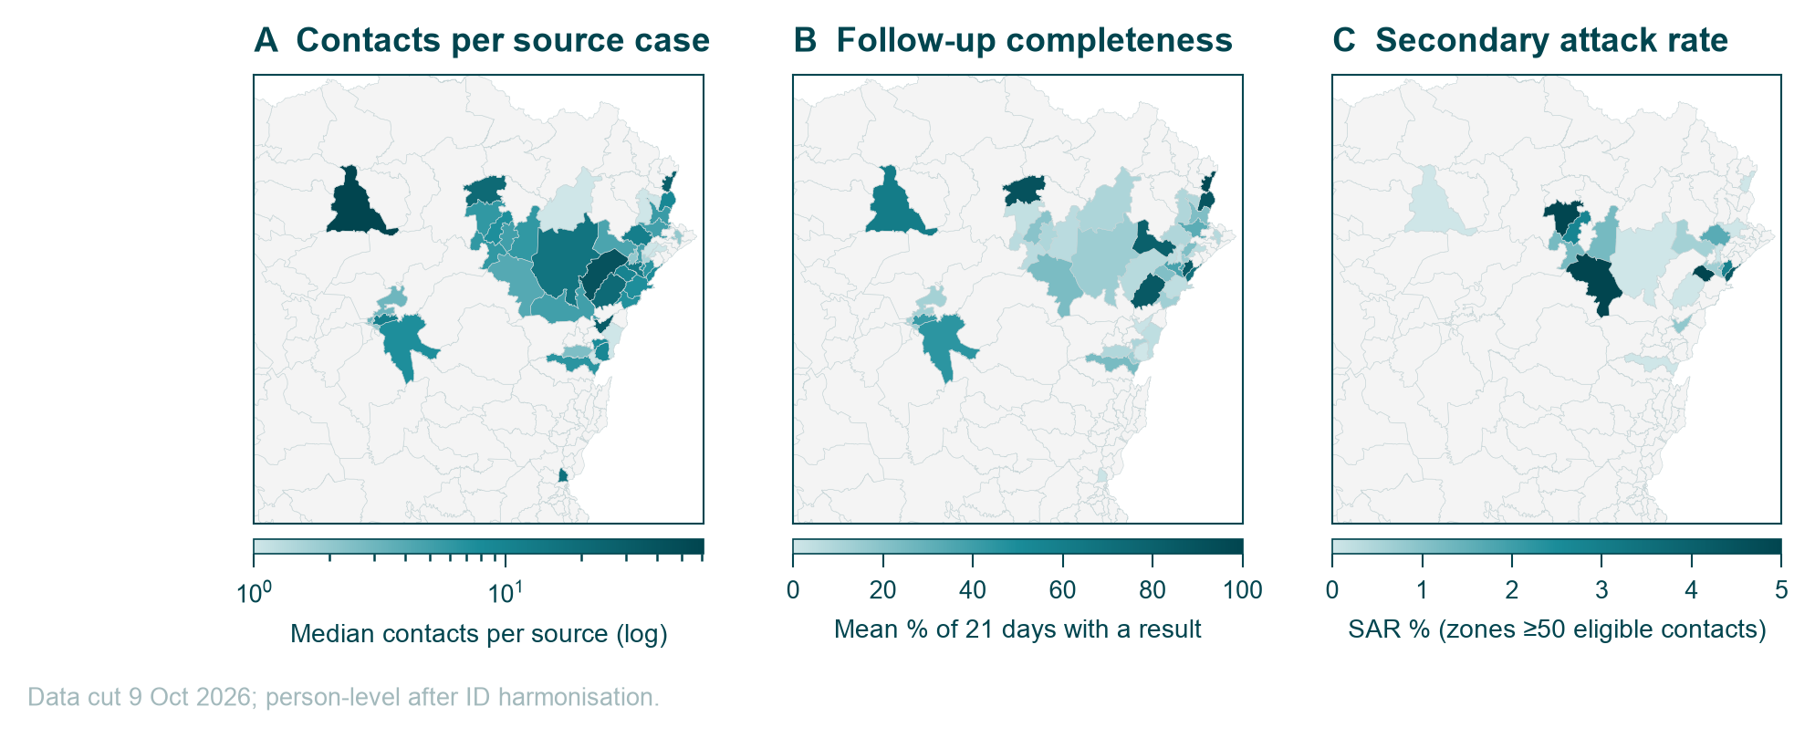
Figure S2. (A) Median contacts per source case, (B) mean share of the 21 follow-up days with a recorded result, (C) SAR, by health zone of source case.
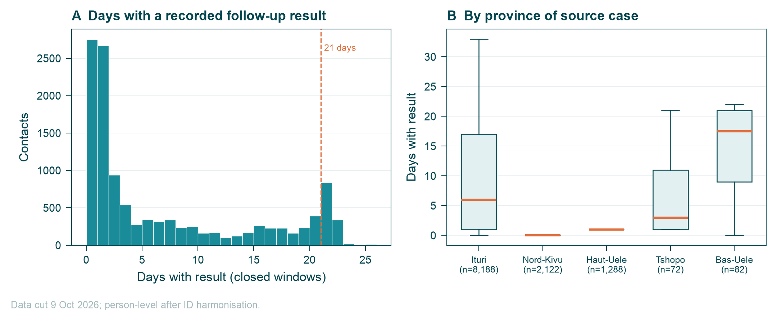
Figure S3. (A) Days with a recorded follow-up result per contact (closed windows). (B) Same, by province of the source case.

SI-8. Main limitations
- Linkage between the linelist and CT data depends on probabilistic name/demographic matching; missed links lower the SAR and the 'known contact' share.
- The SAR is per listed contact. With so few cases traced, it measures transmission within listed networks, not overall infectiousness.
- Serial interval and incubation estimates use few pairs (n≈60) from a selected subset and do not account for right truncation.
- Recent weeks are incomplete for both datasets (CT registrations stop on 4 October).
- The CT database records follow-up rows, not confirmed visits; a blank result may mean an unrecorded visit rather than a missed one.

