BENNETT UNIVERSITY
School of Computing Science and Technology
CBCA301 — Capstone Project
Milestone-2: Design Inputs, Evidence and Ownership
OrderOrder — An Agent-Based Citation Integrity System for Indian Jurisprudence

Item | Detail
Group ID | 44
Team members | Afjal Hussein (S24BCAU0171), Arush Pratap Sharma (S24BCAU0161), Ayush Kumar (S24BCAU0103)
Mentor | Professor Vicky Vikrant
Technology / paradigm | T3 — Agentic AI (secondary: T6 AI-Native computing)
SDG mapping | SDG 16 (16.3, 16.6) primary; SDG 4 (4.4) secondary
Scope of this document | M2 design diagrams; corrected corpus figures; WBS with named owners
Academic session | 2026-27, Semester V, BCA

1. Design diagrams
The five diagrams below are the design record for the system as built, not a plan drawn before it. Every element corresponds to a module in the repository: the use cases to the eight checks, the data flows to the ingestion and verification commands, the class diagram to the SQLite schema that is populated with 38,032 judgments, and the sequence diagram to the order in which the verification graph actually calls its nodes. Each figure is supplied as an editable .drawio source beside it, under docs/diagrams/.
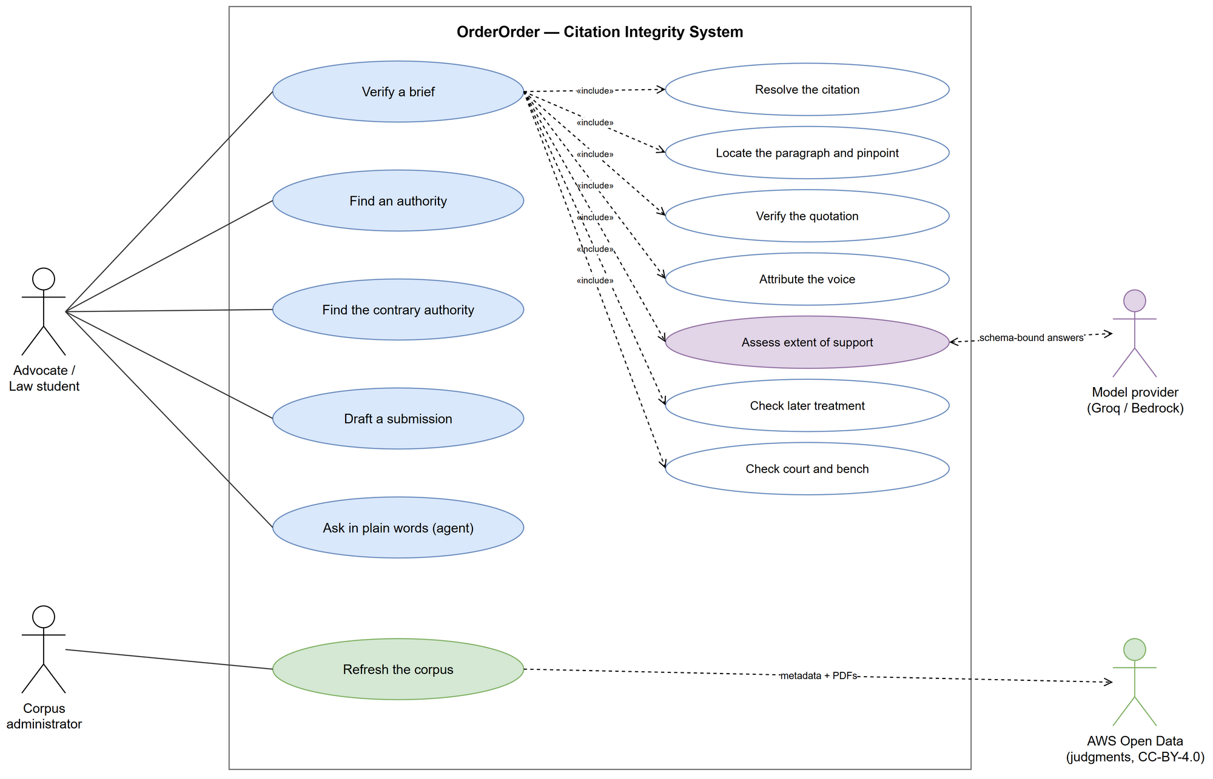
Figure 1 — Use-case diagram. Two actors initiate work: the advocate or student, and the corpus administrator. Verifying a brief includes the seven checks that decide it; only the extent-of-support check reaches a language model, and its answer must quote the judgment to count.
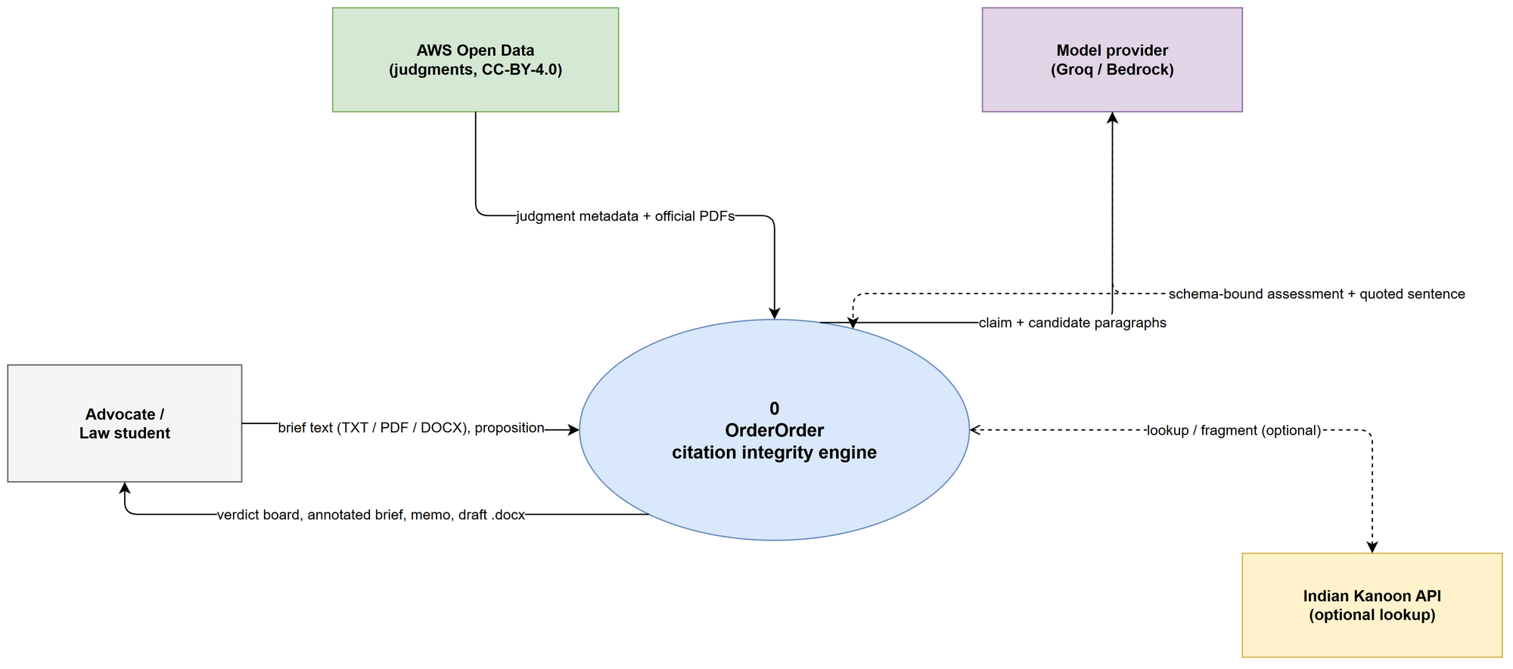
Figure 2 — Data-flow diagram, level 0 (context). The system as a single process. Note what crosses the boundary: brief text in, a verdict board and memo out, judgment data from AWS Open Data, and schema-bound assessments from the model.
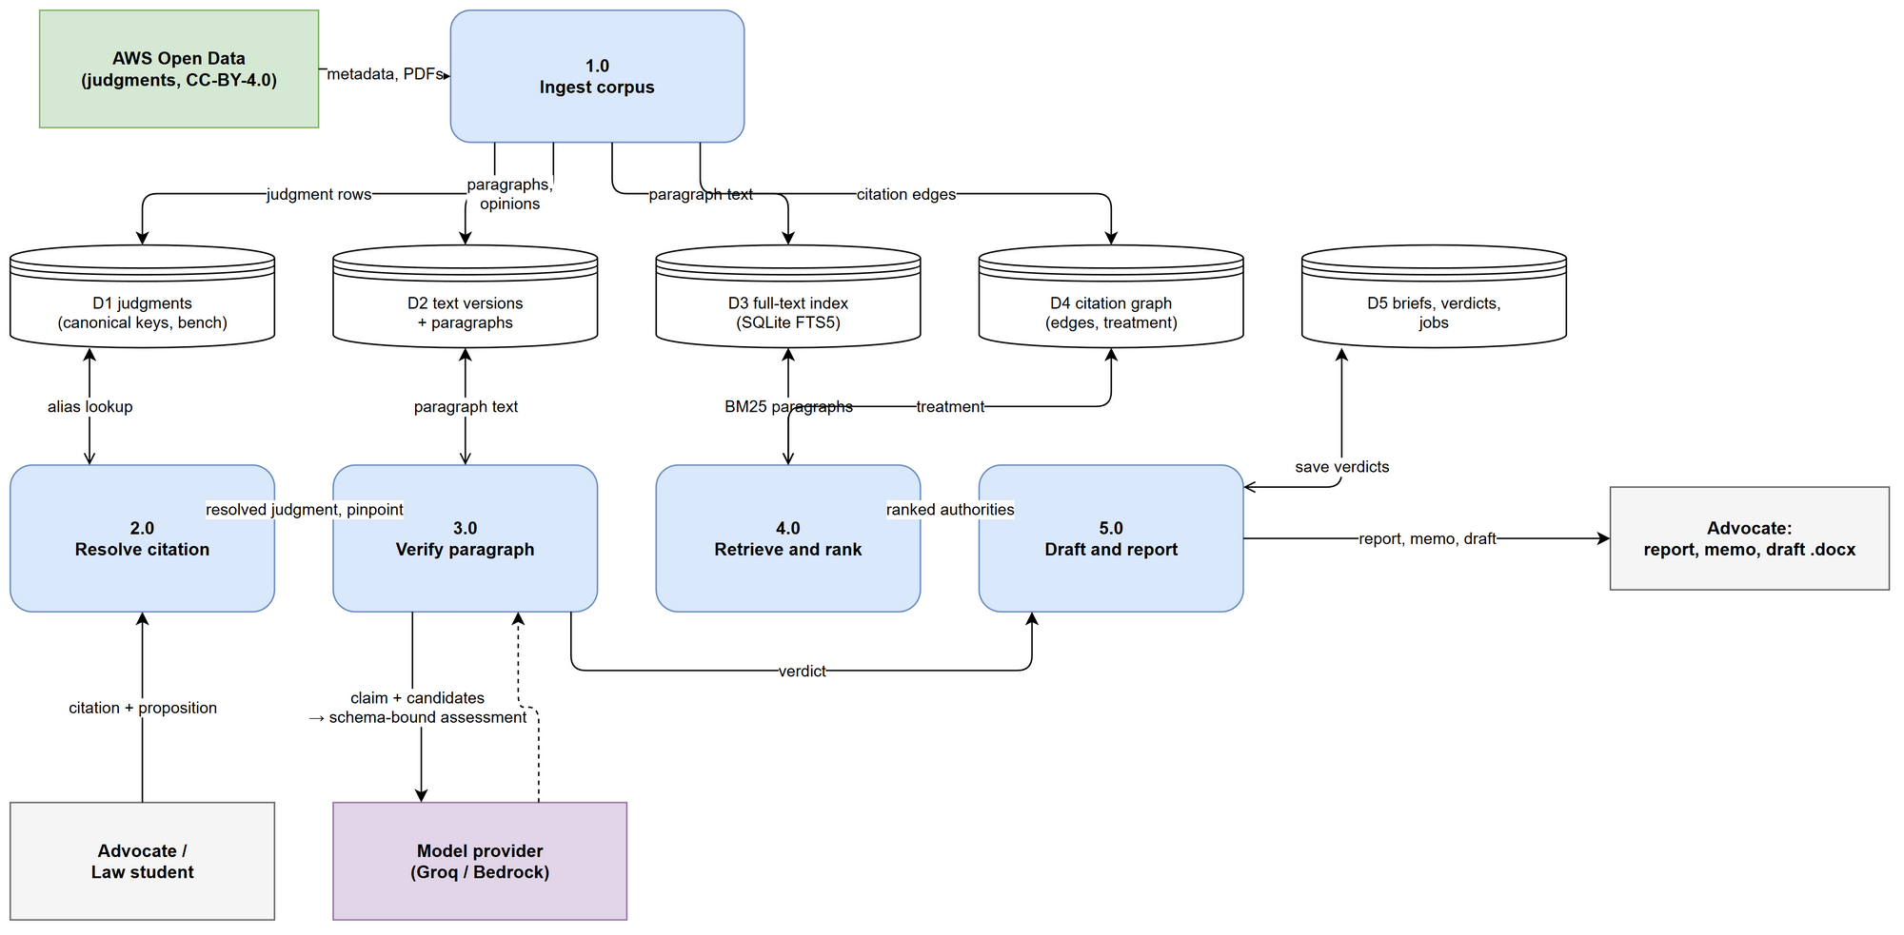
Figure 3 — Data-flow diagram, level 1. Five processes over five data stores. Ingestion is the only process that touches the open-data source; verification never writes to the corpus, so a bad check cannot damage the knowledge base.

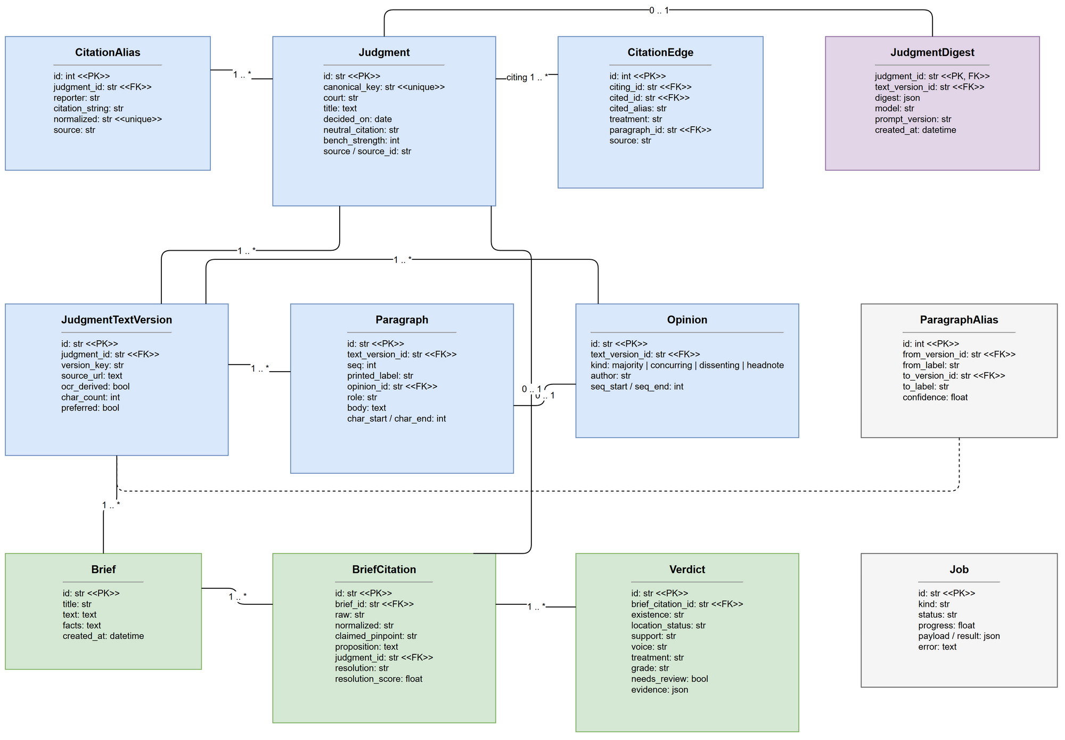
Figure 4 — UML class diagram of the data spine. Judgment, its citation aliases and its text versions; paragraphs and opinions inside a version; the citation graph that powers treatment checks; and the brief, citation and verdict tables that record what the engine concluded.
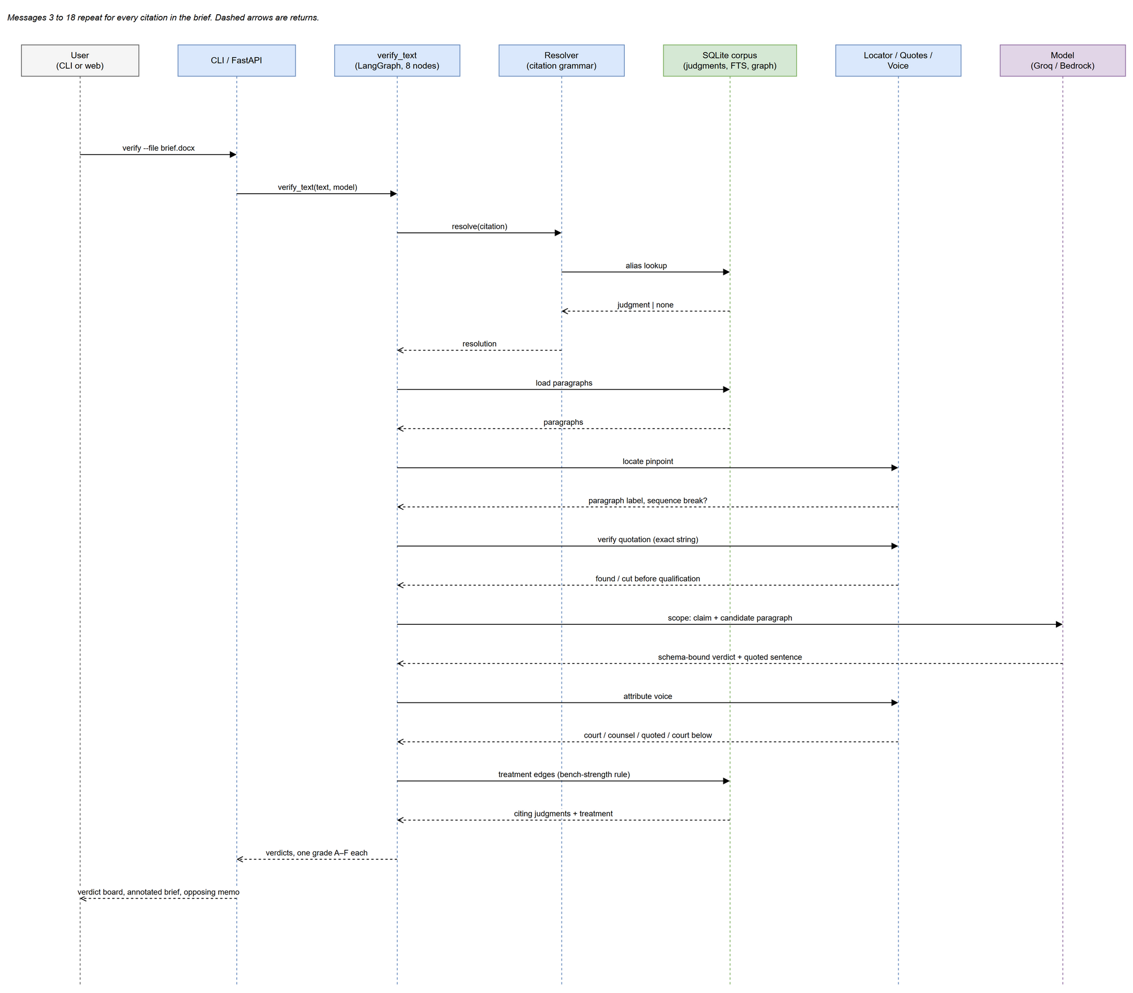
Figure 5 — UML sequence diagram — verifying one brief. Messages 3 to 18 repeat for every citation. The model appears in exactly two of them, and its reply is string-matched against the stored paragraph before any verdict uses it.

2. Corpus figures
These are measured from the database the tool runs against, not projected. The figures in the Milestone-1 submission were correct for the corpus at that time and are now superseded; the table below is what any later document should quote.
Measure | Value | Source
Judgments in the corpus | 38,032 (all Supreme Court of India) | judgment table
Judgments with full text | 38,005 (99.93%) | judgment_text_version
Opinions split out | 73,192 — majority 38,005 · headnote 34,704 · dissenting 252 · concurring 231 | opinion table
Paragraphs | 707,647 | paragraph table
Paragraphs in the full-text index | 707,647 (100%) | paragraph_fts (SQLite FTS5)
Characters of judgment text | 1,052,450,760 (≈1.05 billion) | sum(length(body))
Citation aliases | 79,508 — INSC 37,913 · SCR 30,639 · SCC 7,370 · AIR 2,022 · SCC OnLine 458 · SCC-Cri 346 | citation_alias
Citation edges (citator) | 64,828 | citation_edge
Paragraphs labelled by rhetorical role | 244,673 — ratio 48,493 · lower court 46,950 · argument 38,672 · precedent 25,858 · statute 15,654 · disposition 25,874 · other 33,172 | paragraph.role
Date range | 14 March 1950 to 12 December 2025 | min / max decided_on
Database size | 3.06 GiB (3.28 GB) in one SQLite file | filesystem

2.1 What changed since Milestone-1
The Milestone-1 document described a narrower corpus than the one now held. The differences are recorded here rather than silently corrected, because the scope statement in M1 §12 depended on them.
Milestone-1 stated | Measured now | Consequence
9,429 judgments, 2013–2025 | 38,032 judgments, 1950–2025 | 4.0× the corpus; authority decided before 2013 is now verifiable
409,000 paragraphs | 707,647 paragraphs | 1.7× the retrieval unit
Corpus about 1.2 GB | 3.28 GB | still a single local file; no server, no subscription
"Judgments before 2013 are out of scope" | 1950 onward is ingested and indexed | that exclusion is withdrawn
148-query search evaluation | 147 queries | the results table in M2 reports 147

The larger corpus strengthens two claims made at M1: that a citation can be checked against the judgment as decided rather than a summary of it, and that later treatment can be traced across seven decades of the same court's reasoning.

3. Work breakdown structure and ownership
Ownership follows module boundaries in the repository, so that each member can demonstrate the code they are accountable for at the viva. Where a work package spans two members, both are named. Cross-cutting packages remain joint.
ID | Work package | Deliverable | Owner | Status
1.1 | Problem identification, group formation | Milestone-0 form | All | Complete
1.2 | Proposal, requirements, feasibility | Milestone-1 document | All | Complete
2.1 | Source investigation and licence verification | Source list with licences | Arush | Complete
2.2 | Metadata import and citation aliases | Judgment and alias tables | Arush | Complete
2.3 | Full-text ingestion, PDF cleaning, segmentation | Paragraph table, full-text index | Arush | Complete
3.1 | Citation grammar and resolver | Parser and resolver with tests | Afjal | Complete
4.1 | Locator, pinpoint and quote verifier | Verified-quote module | Afjal | Complete
4.2 | Voice, weight, scope, hierarchy | Attribution and grading modules | Afjal | Complete
4.3 | Citator and bench-strength rule | Treatment report | Afjal | Complete
4.4 | Agent layer (Strands, eight tools) | `orderorder agent`, /api/agent | Afjal | Complete
5.1 | Authority search and contrary search | find and contrary commands | Ayush | Complete
5.2 | Drafting gate, draft assembly, self-attack | Draft .docx with appendix | Ayush | Complete
6.1 | Interface and reporting | CLI (Afjal); web page and annotated brief (Ayush) | Afjal / Ayush | Complete
7.1 | Evaluation harness and held-out runs | Reports in evals/ | Ayush | Complete
7.2 | Real briefs and stakeholder feedback | Feedback log, hand-checked set | All | In progress
8.1 | Milestone-2 document and demo evidence | Milestone-2 document | All | In progress
8.2 | Final report, slides, rehearsed demo | Report, deck, live demo | All | Planned

Two work packages carry the remaining risk. 7.2 is the only Milestone-1 success criterion not yet met, because it depends on people outside the group; three users and one faculty member remain to be interviewed. 8.1 and 8.2 are document work that cannot start until the evidence in 7.2 exists.

