4
Project INSIEME – Reference Model Template
Task XX - #YY Name of Use Case

CONTEXT:
- [TODO] If possible, please write explanations like recitals.
CHAPTER I
Regarding GENERAL PROVISIONS
Issue 1
On subject matter and scope
- [IGNORE FOR NOW]
Issue 2
On definitions
For the purpose of this implementing regulation, the definitions in Article 2 of Directive (EU) 2019/944 [TODO and state that the definitions in other pieces of European Legislation] shall apply. In addition, the following definitions shall apply:
- [EXAMPLE] ‘market party’, in the context of this act, means organisations that take part in data exchange for the access to metering and consumption data, master data, supplier switching, demand response and other energy services.
- [TODO] provide your additional definitions

CHAPTER II
Regarding [YOUR USE CASE]

[NOTE] Typically define responsibilities last and in close coordination with T5.5 EU Policy and regulation alignment

Article XX
On responsibilities of ROLE1

- ROLE1 shall …

ANNEX A
A1. The reference model for [YOUR USE CASE]
Table I contains information needed by [Stakeholder1 AND Stakeholder2] to set up for utilising [YOUR USE CASE] in a Member State. Table I - General information on Member State environments
ID | Name | Description
I1 | [EXAMPLE] National competent authority | Name Name of appointed national competent authority.  Website Website of appointed national competent authority.  Official contact Contact details for managing the mappings of national practices.
I2 | [EXAMPLE] Information about permission administrators in a Member State  (at least one mapping per each active consent administrator in a Member State) | Name Name of the organisation.  Type of identification May be ACER registration code, Legal Entity Identifier (LEI), Bank Identifier Code (BIC), Energy Identification Code (EIC), Global Location Number (GLN/GS1) or National Identification Code (NIC).  Identification of organisation Code or identification within the identification space nominated above.  Website If applicable, link to website of a web application that is used for consent administration.  User inface URL or user portal.  Official contact Contact details for data sharing.  Consent management responsibility for Metered data administrators for which the consent administrator manages consents. Note that it is also valid for a metered data administrator to utilize several consent administrators for a consent administrator to act for multiple metered data administrators.  Documentation of access A self-sufficient explanation of the Member State provisions with regards to utilize access to validated historical consumption data by an eligible party. It is recommended to also include an English version of this documentation.  Identity service provider Identity service provider utilized by the consent administrator to authenticate final customers.  Eligible party onboarding Either a link to the English documentation of the onboarding procedure or a complete, self-sufficient English explanation for how an eligible party can onboard to the productive environment to utilize sharing of validated historical consumption data with an eligible party.  Eligible party test onboarding If applicable, either a link to the English documentation of the onboarding procedure or a complete, self-sufficient English explanation for how an eligible party can onboard to a test environment to utilize sharing of validated historical consumption data with an eligible party.  Price list for access to data by eligible parties Exhaustive description of all costs for eligible parties.

[TODO] Please describe all HARMONISED ROLES below.
Table II - Roles
Role name | Role type | Role description
[EXAMPLE] Final customer | Business | A party connected to the grid that purchases electricity for its own use.  Please note, that this also includes the case of active customer.
[EXAMPLE] Competent authority | Business | The national competent authority providing the mappings of national practices. It makes them available online and in an easily usable and publicly accessible form.
[EXAMPLE] Party administrator | Business | A party responsible for maintaining the market party characteristics for the energy sector.
CESU operator | Business | A party responsible for organising a collective energy sharing unit settlement and billing.
CESU member | Business | Member of a collective energy sharing unit.
Flexibility service provider (FSP) | Business | A market participant with a legal or contractual obligation to supply local or balancing services to the system operator.
System Operator (SO) | Business | DSO or TSO procuring balancing or local services.
Flexibility requesting party (FRP) | Business | A party that has an agreement with one or more flexibility service providers to provide a flexibility service [ref][ref]. Can be a DSO, TSO, or BRP [ref].
Flexibility market operator (FMO) | Business | A party responsible for operating a flexibility market, i.e., provides a service whereby the offers to sell flexibility are matched with bids to buy flexibility (adapted from [ENTSO-E]).

All roles of type Business are expected to be acting in secure, authenticated manner and through trusted communication channels. For this reason, the authentication steps used for these communication partners are not listed in the scenarios below.
[TODO] First step should be to clearly state the list of procedures.
Table III - Procedure Conditions
No. | Procedure name | Primary actor | Pre-condition
1 | Legal Onboarding & Agreement Setup | TSO-e, TSO-g, DSO-e
2 | Credential Provision & Access Configuration | TSO-e, TSO-g
3 | TSO-DSO Data Sharing for Flexibility Planning | TSO-e, DSO-e
4 | Energy Community Flexibility Quantification & Asset Sharing | TSO-e, DSO-e, CESU Operator (?) | CESU is established.
5 | Cross-Sector Data Exchange Initialization (Gas/Electricity) | TSO-e, TSO-g
6 | Digital Twin Setup & Calibration (Electricity/Gas) | TSO-e, TSO-g
7 | Co-Optimization Model Execution (Electricity/Gas) | TSO-e
8 | Result Submission & Delivery to Operators | TSO-e
9 | Hydrogen Electrolyser Integration Assessment | TSO-e, TSO-g
10 | Data Deletion and Offboarding | TSO-e, TSO-g, DSO-e

All diagrams describing the scenarios are of an illustrative nature and follow Business Process Model and Notation 2.0. Information objects referred in columns Information exchanged (IDs) are defined in Table IV.

[TODO DEFINE NEEDED PROCEDURES STEP BY STEP TOGETHER WITH INFORMATION EXCHANGED]
[EXAMPLE SEE BELOW]

Procedure 1 - Legal Onboarding & Agreement Setup

Step No. | Step | Step description | Information producer (actor) | Information receiver (actor) | Information exchanged (IDs)
1.1 | Send NDA Draft (TSO-g) | Provide NDA draft text for confidentiality agreement between TSO-e and TSO-g. | TSO-e | TSO-g | AA – NDA Draft Document
1.2 | Execute NDA Draft Validation (TSO-g) | Check completeness, consistency, and compliance of NDA draft with internal and regulatory requirements. | TSO-g | TSO-g | [not relevant]
1.3 | [Conditional] Request for Revision of NDA – TSO-g | Request changes to NDA clauses based on validation outcome. | TSO-g | TSO-e | AA – NDA Draft Document
1.4 | [Conditional] Send Revised NDA Draft (TSO-g) | Provide updated NDA draft reflecting requested changes. | TSO-e | TSO-g | AA – NDA Draft Document
1.5 | Execute Revised NDA Draft Validation (TSO-g) | Re-check completeness and compliance after revision. | TSO-g | TSO-g | [not relevant]
1.6 | Send NDA Signing Request (TSO-g) | Request signature of finalized NDA. | TSO-e | TSO-g | AB – NDA Signing Request
1.7 | Sign NDA (TSO-g) | Formally sign the NDA. | TSO-g | TSO-e | AC – Signed NDA (TSO-e/TSO-g)
1.8 | Sign NDA (TSO-e) | Formally sign the NDA after receiving counterpart signature. | TSO-e | TSO-g | AC – Signed NDA (TSO-e/TSO-g)
1.9 | Acknowledge NDA Archiving (TSO-e) | Record and archive signed NDA for compliance. | TSO-e | TSO-e | [not relevant]
1.10 | Send NDA Draft (DSO-e) | Provide NDA draft text for confidentiality agreement. | TSO-e | DSO-e | AA – NDA Draft Document
1.11 | Execute NDA Draft Validation (DSO-e) | Check completeness, consistency, and compliance of NDA draft with internal and regulatory requirements. | DSO-e | DSO-e | [not relevant]
1.12 | [Conditional] Request for Revision of NDA – DSO-e | Request changes to NDA clauses based on validation outcome. | DSO-e | TSO-e | AA – NDA Draft Document
1.13 | [Conditional] Send Revised NDA Draft (DSO-e) | Provide updated NDA draft reflecting requested changes. | TSO-e | DSO-e | AA – NDA Draft Document
1.14 | Execute Revised NDA Draft Validation (DSO-e) | Re-check completeness and compliance after revision. | DSO-e | DSO-e | [not relevant]
1.15 | Send NDA Signing Request (DSO-e) | Request signature of finalized NDA. | TSO-e | DSO-e | AB – NDA Signing Request
1.16 | Sign NDA (DSO-e) | Formally sign the NDA. | DSO-e | TSO-e | AC – Signed NDA (TSO-e/DSO-e)
1.17 | Sign NDA (TSO-e) | Formally sign the NDA after receiving counterpart signature. | TSO-e | DSO-e | AC – Signed NDA (TSO-e/DSO-e)
1.18 | Acknowledge NDA Archiving (TSO-e) | Record and archive signed NDA for compliance. | TSO-e | TSO-e | [not relevant]
1.19 | Notify NDA Completion (TSO-g) | Notify TSO-g that both NDA agreement is finalized and legal onboarding is complete. | TSO-e | TSO-g | AD – NDA Completion Notification
1.20 | Notify NDA Completion (DSO-e) | Notify DSO that both NDA agreement is finalized and legal onboarding is complete. | TSO-e | DSO-e | AD – NDA Completion Notification
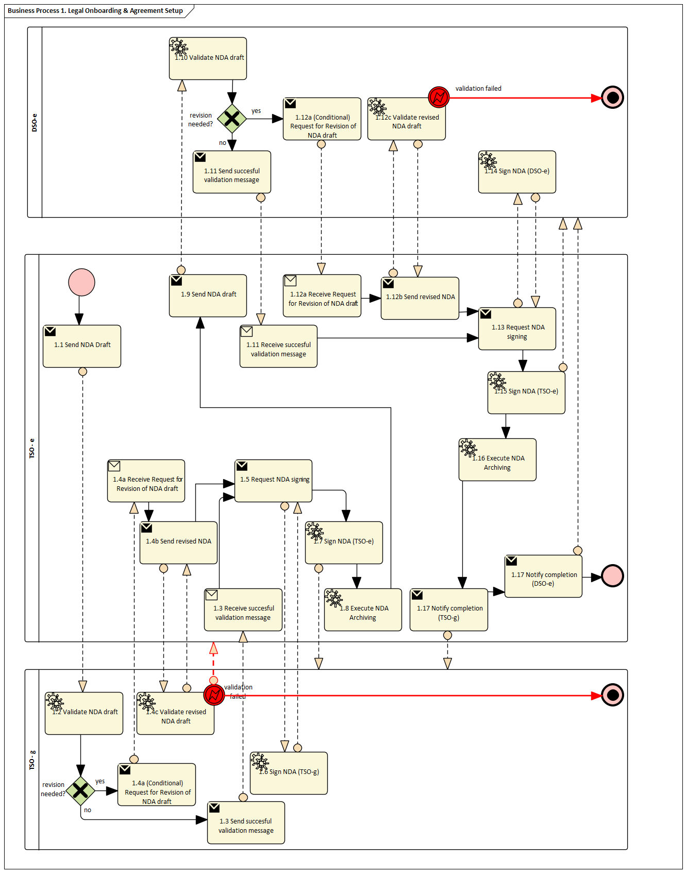
Diagram 1 – At the end, please provide Sequence Diagrams, BPMN Charts, even Class Diagrams – everything that helps for an understanding

Table IV - Information exchanged
Information exchanged, ID | Name of information | Description of information exchanged
AA | NDA Draft Document | NDA Terms  Document version  Signatory roles | Legal confidentiality clauses  Internal version number for traceability  Entities expected to sign
AB | NDA Signing Request | Reference to NDA draft version  Request date  Signature deadline | Link to agreed text  Date when signing request sent  Latest acceptable signing date
AC | Signed NDA | Final NDA text  Signatures of both parties  Signing date | Legally binding clauses  Signatures  Date of final agreement
AD | NDA Completion Notification | NDA ID/reference  Effective date  Confirmation of archiving | Unique identifier for NDA  Start of legal effect  Recorded in compliance system

[TODO] If it helps for understanding, please add EER and/or class Diagrams for Aggregated and Message Information Models

Procedure 2 - Credential Provision & Access Configuration

Step No. | Step |  | Step description |  |  | Information producer (actor) | Information receiver (actor) | Information exchanged (IDs)
2.1 | Send Environment Declaration (TSO-e > TSO-g) |  | Provide technical specifications of TSO-e secure IT environment. |  |  | TSO-e | TSO-g | BA – Environment Declaration
2.2 | Send Environment Declaration (TSO-e > DSO-e) |  | Provide technical specifications of TSO-e secure IT environment. |  |  | TSO-e | DSO-e | BA – Environment Declaration
2.3 | Send Environment Declaration (TSO-g > TSO-e) |  | Provide technical specifications of TSO-g secure IT environment. |  |  | TSO-g | TSO-e | BA – Environment Declaration
2.4 | Send Environment Declaration (DSO-e > TSO-e) |  | Provide technical specifications of DSO-e secure IT environment. |  |  | DSO-e | TSO-e | BA – Environment Declaration
2.5 | Send IAM Policy (TSO-e > TSO-g) |  | Provide identity & access management (IAM) and role-based access control (RBAC) policy. |  |  | TSO-e | TSO-g | BB – IAM & RBAC Policy
2.6 | Send IAM Policy (TSO-e > DSO-e) |  | Provide identity & access management (IAM) and role-based access control (RBAC) policy. |  |  | TSO-e | DSO-e | BB – IAM & RBAC Policy
2.7 | Send IAM Policy (TSO-g > TSO-e) |  | Provide identity & access management (IAM) and role-based access control (RBAC) policy. |  |  | TSO-g | TSO-e | BB – IAM & RBAC Policy
2.8 | Send IAM Policy (DSO-e > TSO-e) |  | Provide identity & access management (IAM) and role-based access control (RBAC) policy. |  |  | DSO-e | TSO-e | BB – IAM & RBAC Policy
2.9 | Execute Credential Generation (TSO-e) |  | Generate secure credentials (e.g., keys, certificates, user IDs) to grant access for external operators. |  |  | TSO-e | TSO-e | BC – Access Credentials (internal record)
2.10 | Send Access Credentials (TSO-e > TSO-g) |  | Provide generated credentials for secure access to TSO-e’s environment. |  |  | TSO-e | TSO-g | BC – Access Credentials
2.11 | Send Access Credentials (TSO-e > DSO-e) |  | Provide generated credentials for secure access to TSO-e’s environment. |  |  | TSO-e | DSO-e | BC – Access Credentials
2.12 | Execute Access Credentials Validation (TSO-g) |  | Verify correctness and usability of received credentials in TSO-g systems. |  |  | TSO-g | TSO-g | [validation record]
2.13 | Execute Access Credentials Validation (DSO-e) |  | Verify correctness and usability of received credentials in DSO-e systems. |  |  | DSO-e | DSO-e | [validation record]
2.14 | [Conditional] Request New Access Credentials (TSO-g) |  | Request replacement credentials in case of validation failure. |  |  | TSO-g | TSO-e | BC – Access Credentials (reissue request)
2.15 | [Conditional] Request New Access Credentials (DSO-e) |  | Request replacement credentials in case of validation failure. |  |  | DSO-e | TSO-e | BC – Access Credentials (reissue request)
2.16 | Execute Audit Log Activation (TSO-e) |  | Activate audit logging and traceability mechanisms for all credential-based access. |  |  | TSO-e | TSO-e | BD – Audit Log Activation Record
2.17 | Send Audit Log Activation Notice (TSO-e > TSO-g) |  | Provide audit log activation details for transparency and oversight. |  |  | TSO-e | TSO-g | BD – Audit Log Activation Notice
2.18 | Send Audit Log Activation Notice (TSO-e > DSO-e) |  | Provide audit log activation details for transparency and oversight. |  |  | TSO-e | DSO-e | BD – Audit Log Activation Notice
2.19 | [Conditional] Request Revision of Audit Log Setup (TSO-g) |  | Request updates or corrections to audit log setup. |  |  | TSO-g | TSO-e | BD – Audit Log Activation Notice
2.20 | [Conditional] Request Revision of Audit Log Setup (DSO-e) |  | Request updates or corrections to audit log setup. |  |  | DSO-e | TSO-e | BD – Audit Log Activation Notice
2.21 | Send Access Approval (TSO-g > TSO-e) |  | Confirm readiness of TSO-g to exchange data securely. |  |  | TSO-g | TSO-e | BE – Access Go-Ahead Confirmation
2.22 | Send Access Approval (DSO-e > TSO-e) |  | Confirm readiness of DSO to exchange data securely. |  |  | DSO-e | TSO-e | BE – Access Go-Ahead Confirmation
Table IV - Information exchanged
Information exchanged, ID |  | Name of information |  | Description of information exchanged
BA |  | Environment Declaration |  | Technical specifications  Compliance standards  Version reference | System architecture, interfaces  Security & regulatory references  Internal version for traceability
BB |  | IAM & RBAC Policy |  | Identity management rules  Role-based access matrix  Policy version | User authentication process  Who can access what  Internal policy reference number
BC |  | Access Credentials |  | Credential type  Validity period  Issuing entity | Keys, certificates, IDs  Activation and expiry date  Operator responsible for generation
BD |  | Audit Log Activation Notice |  | Log scope  Activation date  Traceability details | Systems and activities monitored  Date when logging was enabled  Records and retention rules
BE |  | Access Go-Ahead Confirmation |  | Confirmation reference  Approval date  Authorized scope | Unique approval ID  Date when readiness confirmed  What activities are approved

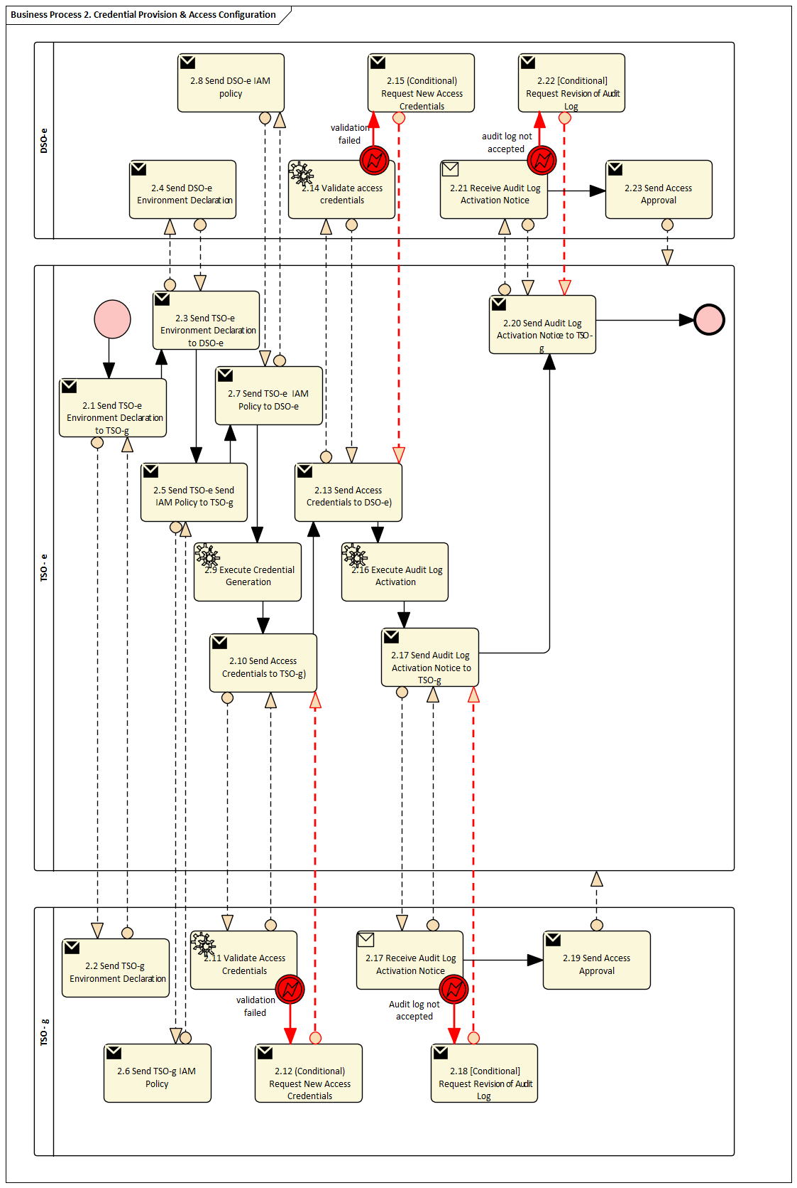

Procedure 3 - TSO-DSO Data Sharing for Flexibility Planning

Step No. | Step |  | Step description |  |  | Information producer (actor) | Information receiver (actor) | Information exchanged (IDs)
Table IV - Information exchanged
Information exchanged, ID |  | Name of information |  | Description of information exchanged
CA
CB
CC
CD
CE

Procedure 4 - Energy Community Flexibility Quantification & Asset Sharing

Following EU directives, flexibility markets are expected to provide flexibility services for system operators (SOs). As natural aggregators, flexibility can be offered by collective energy sharing units (CESUs) to flexibility requesting parties (FRPs), either directly as a flexibility service provider (FSP) or as technical aggregators and contracting a FSP as a market representant. There are two types of FRPs: commercial FRPs procuring flexibility for balancing, such as market agents in intraday-like markets, and regulated FRPs, such as DSOs requesting flexibility for local grid congestion, and TSOs requesting flexibility for global balancing purposes.
TSO flexibility services have been in place for several years, although being now extended to include distributed energy resources (DERs), and can be consulted in TSOs operational procedures. Meanwhile, DSO flexibility services are still in a much less mature stage. In general, distributed flexibility for SOs is a complex topic that involves different grid services for DSO and TSO and the need for coordination mechanism, as explained in [ref]. Moreover, the existence of multiple grid services and TSO-DSO coordination mechanisms makes it difficult to standardize these procedures.
Thus, it was decided, at this stage, to focus on the provision of flexibility in a day-ahead flexibility market, based on the approach for DSOs in [ref][ref], but mostly valid for TSOs as well. However, when providing flexibility for TSO, as already mentioned, TSO-DSO coordination mechanisms must be in place so that the activation of distributed flexibility by the TSO does not compromise the operation of the distribution grid by the DSO. It should be remarked that flexibility markets with DERs are still at a very initial stage of development, but they are expected to become relevant tools for future grid operation.
When providing flexibility to SOs, particularly to TSOs, a CESU must comply with requirements for the provision of ancillary services, namely manual frequency restoration reserves (mFRR). These requirements cover several dimensions, including:
- Quality of service: strict, pre-defined response times and minimum bid capacities, which can even require the aggregation of multiple CESUs under a single FSP/BSP.
- Data availability and communication: continuous data availability validate data exchanges and use communication protocols compatible with TSOs’ systems.
- Pre-qualification: consisting of multiple technical tests to demonstrate the CESU is able to exchange bids, receive and follow dispatch instructions, and ensure DERs control.
This section focuses on the CESUs planning procedure considering the participation in flexibility markets with the provision of explicit flexibility. The CESU provides the explicit flexibility to FRPs such as TSOs or DSOs, negotiated in a day-ahead flexibility market. The CESU operation with flexibility is included in Procedure 8 (Task 4.3).
Sizing a CESU involves computing potential new investments in DER to optimize predefined objectives, such as the total energy cost minimization. Therefore, the objective is to determine the optimal capacity of new DERs that balances capital expenditure (Capex) with operational expenditure (Opex), while profiting from the additional revenues of providing flexibility services.
INESC TEC has been developing a tool for CESU DER sizing, called SITEC, that determines the optimal contracted power as well as PV and BESS capacities for each CESU member. A complete overview of SITEC without considering flexibility, including its mathematical formulation, can be consulted in [ref]. Extending this MILP to include flexibility is not straightforward, since DER sizing with flexibility requires the computation of optimal DERs capacities for a given baseline, which itself depends on those capacities. This dependence leads to a complex bilevel optimization problem. To address this challenge, INESC is currently working on alternative approaches, such as grid search methods (change DER capacity and verify the impact on Capex and Opex), and metaheuristic-based algorithms.
Operation, described in Procedure 8 (Task 4.3), addresses the daily management of the CESU and its DERs. This includes the scheduling and dispatch of DERs, and, optionally, the computation of flexibility bids to participate in the day-ahead flexibility market, as well as the CESU baseline corresponding to its net consumption when no flexibility is provided.
INESC TEC has also been developing a tool for the operation of DERs within CESUs (or energy communities), called OSTEC. It determines the optimal setpoints for the DERs, includes PV panels, BESS, electric vehicles (EVs) and electric water heaters (EWHs). A complete overview of OSTEC, including its mathematical formulation, is provided in [ref]. Beyond DER scheduling, OSTEC can compute, for a given flexibility request, the optimal flexibility bids at CESU-level for participation in a day-ahead flexibility market, as well as the individual baselines of the CESU members, required for verification and settlement of the provided flexibility.
This procedure describes the process for sizing DERs, including PV panels and battery energy storage systems (BESS), for members of a CESU. The objective is to determine the optimal capacities of DERs for each CESU member, as well as their optimal contracted power, that minimize CESU costs. In addition, the procedure considers the potential revenues from the participation of the CESU in a flexibility market managed by a system operator (SOs) such as a DSO or a TSO (who, in this context, also takes the role of flexibility market operator (FMO)).
Prerequisites: consumers have joined the CESU, becoming CESU members; the CESU platform supports data specific for the sizing process, and have these data previously uploaded (these main data include: community structure definition, historical consumption data from smart meters, opportunity costs of each CESU member (buying price from its retailer and selling price to its aggregator), data on pre-existing DERs (PV and BESS), data on other relevant assets with potential flexibility, such as EVs and EWHs, etc., investments costs in new DERs, and contracted power tariffs. Prequalification to participate in the flexibility market (see Procedures 15 and 16, Task 4.3) is only required for the actual participation and not during the planning phase.

Step No. | Step | Step description | Information producer (actor) | Information receiver (actor) | Information exchanged (IDs)
4.1 | Execute consumption data retrieval | CESU operator retrieves historical energy consumption for each CESU member. | CESU operator | [internal] | DA - Metering data
4.2 | Execute PV generation potential assessment | CESU operator evaluates rooftop solar PV generation potential for each CESU member. If member-specific data are available (location, roof orientation, irradiation), generation profiles are assessed. If such data are unavailable, standard generation profiles may be applied. | CESU operator | [internal] | [not relevant]
4.3 | Execute DER data collection | CESU operator collects technical and economic DERs data (e.g., costs, incentives, lifetimes, degradation rates, efficiencies). | CESU operator | [internal] | [not relevant]
4.4 | Execute DER installation constraints definition | CESU operator, in agreement with CESU members, defines constraints for DER installation based on technical, economic and regulatory criteria, to limit DER sizes. | CESU operator | [internal] | [not relevant]
4.5 | Execute CESU objectives definition | CESU operator, in agreement with CESU members, defines sizing objectives (e.g., total costs minimization w/wo flexibility market participation). | CESU operator | [internal] | [not relevant]
4.6 | Execute DER sizing | Using an internal algorithm, the CESU operator determines the optimal PV and BESS capacity and contracted power for each CESU member, considering an estimation of the expected flexibility requirements and market price. | CESU operator | [internal] | [not relevant]
4.7 | Send preliminary sizing results | CESU operator shares preliminary sizing results with CESU members for review. | CESU operator | CESU member | DB - Preliminary sizing results
4.8 | Execute sizing results review | CESU members review sizing results, confirm budgets. | CESU member | [internal] | [not relevant]

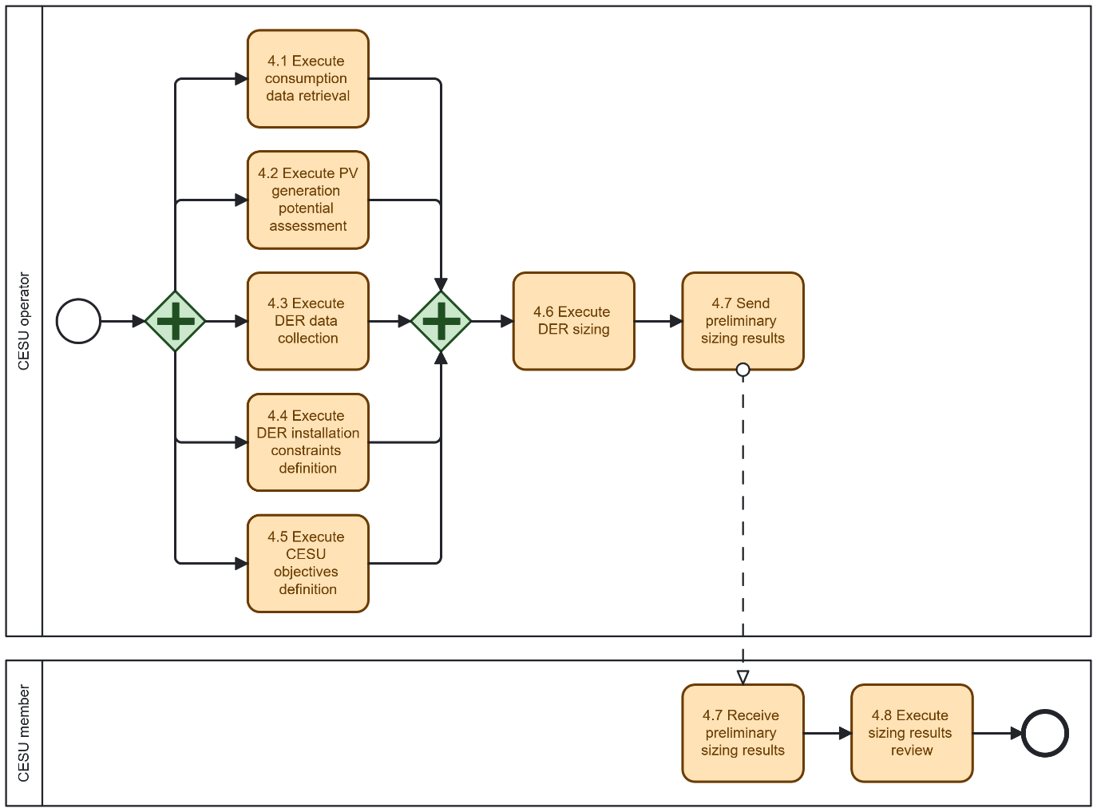
Diagram 2 - Procedure 'Energy Community Flexibility Quantification & Asset Sharing'

Table IV - Information exchanged
Information exchanged, ID | Name of information | Description of information exchanged
DA | Metering data |  | Verified energy measurements, used for self-consumption calculations.
DB | Preliminary sizing results |  | Preliminary DER sizing results per CESU member, including contracted power and PV and BESS capacities. Pending CESU members approval.

Procedure 5 - Cross-Sector Data Exchange Initialization (Gas/Electricity)

Step No. | Step | Step description | Information producer (actor) | Information receiver (actor) | Information exchanged (IDs)
5.1 | Execute Gas-Electrolyser Data Packaging | Compile dataset on hydrogen electrolysers (TBA). | TSO-g | TSO-g | EA – Gas-Electrolyser Dataset
5.2 | Send Gas-Electrolyser Data | Transfer packaged dataset to electricity TSO (Data Management). | TSO-g | TSO-e | EA – Gas-Electrolyser Dataset
5.3 | Execute Dataset Integrity Validation | Verify dataset integrity (completeness, metadata consistency, etc). | TSO-e | TSO-e | EB – Dataset Integrity Report
5.4 | [Conditional] Request Dataset Resubmission | Request new dataset if integrity check fails. | TSO-e | TSO-g | EB – Dataset Integrity Report
5.5 | [Conditional] Send Resubmitted Dataset | Provide corrected dataset. | TSO-g | TSO-e | EA – Gas-Electrolyser Dataset
5.6 | Execute Schema Validation | Validate dataset structure, format, and compliance with expected model (electrolyser data mapping to grid model). | TSO-e | TSO-e | EC – Schema Validation Report
5.7 | [Conditional] Request Dataset Revision | Request dataset correction if schema mismatches found. | TSO-e | TSO-g | EC – Schema Validation Report
5.8 | [Conditional] Send Revised Dataset | Provide revised dataset with corrected schema. | TSO-g | TSO-e | EA – Gas-Electrolyser Dataset
5.9 | Execute Data Quality Validation | Validate dataset content for missing values, invalid ranges, or inconsistent fields. | TSO-e | TSO-e | ED – Data Quality Report
5.10 | [Conditional] Request Dataset Revision (Quality) | Request dataset correction if quality issues found. | TSO-e | TSO-g | ED – Data Quality Report
5.11 | [Conditional] Send Revised Dataset (Quality) | Provide corrected dataset with improved quality. | TSO-g | TSO-e | EA – Gas-Electrolyser Dataset

Table IV - Information exchanged
Information exchanged, ID | Name of information | Description of information exchanged
EA | Gas-Electrolyser Dataset | Location of electrolysers  Installed capacity  Gas consumption profile  Flexibility potential | Coordinates (electrical substation connection), nodes  MW, operational status  Time series  Up/down regulation capability
EB | Dataset Integrity Report | integrity check result  Detected issues  Validation timestamp | Pass/fail  Missing files, errors  Date when test executed
EC | Schema Validation Report | Schema conformity  Mapping checks  Report version | Format, structure compliance  Fields align with model  Internal version for traceability
ED | Data Quality Report | Missing/invalid values  Range inconsistencies  Correction recommendations | Detected gaps  Out-of-bounds entries  Fields to adjust

Procedure 6 - Digital Twin Setup & Calibration (Electricity/Gas)

Step No. | Step | Step description | Information producer (actor) | Information receiver (actor) | Information exchanged (IDs)
6.1 | Send Electrical Network Dataset | Provide electricity network dataset (topology, generation, load, power flows) for DT input. | TSO-e | TSO-e | FA – Electrical Network Dataset
6.2 | Execute Digital Twin Initialization | Initialize the digital twin environment with baseline datasets. | TSO-e | TSO-e | FB – Digital Twin Setup Record
6.3 | Execute Dataset Compatibility Validation | Validate compatibility between electrical network dataset and gas-electrolyser dataset. | TSO-e | TSO-e | FC – Dataset Compatibility Report
6.4 | Execute Test Simulation | Run preliminary simulations to test DT behaviour and detect anomalies. | TSO-e | TSO-e | FD – Test Simulation Report
6.5 | [Conditional] Request Dataset Adjustments (TSO-g) | Request corrected gas-electrolyser dataset if anomalies are linked to gas-side data. | TSO-e | TSO-g | FD – Test Simulation Report
6.6 | [Conditional] Request Dataset Adjustments (TSO-e) | Request corrected electricity dataset if anomalies are linked to electrical data. | TSO-e | TSO-e | FD – Test Simulation Report
6.7 | Send Revised Dataset (TSO-g) | Provide corrected gas-electrolyser dataset. | TSO-g | TSO-e | EA – Gas-Electrolyser Dataset
6.8 | Send Revised Dataset (TSO-e) | Provide corrected electricity network dataset. | TSO-e | TSO-e | FA – Electrical Network Dataset
6.9 | Execute Recalibration of Digital Twin | Calibrate DT parameters and confirm readiness for scenario-based assessments. | TSO-e | TSO-e | FE – DT Calibration Report

Table IV - Information exchanged
Information exchanged, ID | Name of information | Description of information exchanged
FA | Electrical Network Dataset | Grid topology  Generation and load data  Power flows | Nodes, Lines, Transformers, Generation units, Shunt Reactors, etc.  Time series (generation and load data)  Historical time series
FB | Digital Twin Setup Record | Initialization status  Input dataset references  Responsible entity | DT creation timestamp  IDs of loaded datasets  Entity who executed initialization
FC | Dataset Compatibility Report | Mapping validation  Balance checks  Inconsistency log | Electrolysers to grid nodes  Load vs. generation impact  Issues for correction
FD | Test Simulation Report | Test scenario description  Detected anomalies  Recommendation | What was simulated  Data or model issues  Required corrections
FE | DT Calibration Report | Calibration parameters  Validation results  Ready status | Adjusted coefficients, settings  Calibration test outcomes  Confirmation for use in simulations

Procedure 7 - Co-Optimization Model Execution (Electricity/Gas)

Step No. | Step |  | Step description |  |  | Information producer (actor) | Information receiver (actor) | Information exchanged (IDs)
Table IV - Information exchanged
Information exchanged, ID |  | Name of information |  | Description of information exchanged
GA
GB
GC
GD
GE

Procedure 8 - Result Submission & Delivery to Operators

Step No. | Step |  | Step description |  |  | Information producer (actor) | Information receiver (actor) | Information exchanged (IDs)
Table IV - Information exchanged
Information exchanged, ID |  | Name of information |  | Description of information exchanged
HA
HB
HC
HD
HE

Procedure 9 - Hydrogen Electrolyser Integration Assessment

Step No. | Step | Step description | Information producer (actor) | Information receiver (actor) | Information exchanged (IDs)
9.1 | Execute Electrolyser Integration Simulation | Run simulation scenarios to assess electrolyser deployment (TBA). | TSO-e | TSO-e | IA – Simulation Results Dataset
9.2 | Send Simulation Results | Share simulation outcomes (impacts on grid reliability, storage contribution, etc.). | TSO-e | TSO-g | IA – Simulation Results Dataset
9.3 | Send Initialization Completion Notice | Confirm successful initialization and data exchange cycle completed. | TSO-e | TSO-e | IB – Initialization Completion Notice

Table IV - Information exchanged
Information exchanged, ID | Name of information | Description of information exchanged
IA | Simulation Results Dataset | Grid impact metrics  Storage contribution  Renewable integration effects | Voltage stability, congestion  MW equivalent from electrolysers  Curtailment reduction, etc.
IB | Initialization Completion Notice | Reference ID  Completion date  Confirmation of readiness | unique identifier  Date when process finalized  Validation and initialization

Procedure 10 - Data Deletion and Offboarding

Step No. | Step | Step description | Information producer (actor) | Information receiver (actor) | Information exchanged (IDs)
10.1 | Send Offboarding Instruction (to TSO-g) | Issue formal request to initiate offboarding and data cleanup | TSO-e | TSO-g | JA – Offboarding Instruction
10.2 | Send Offboarding Instruction (to DSO-e) | Issue formal request to initiate offboarding and data cleanup | TSO-e | DSO-e | JA – Offboarding Instruction
10.3 | Execute Data Deletion (TSO-g) | Delete all electricity TSO-provided datasets from TSO-g systems and log the action | TSO-g | TSO-g | JB – Data Deletion Log
10.4 | Execute Data Deletion (DSO-e) | Delete all electricity TSO-provided datasets from DSO-e systems and log the action | DSO-e | DSO-e | JB – Data Deletion Log
10.5 | Execute Credential Revocation (TSO-e) | Disable user accounts, API keys, or certificates previously assigned to TSO-g and DSO-e | TSO-e | TSO-e | JC – Access Termination Record
10.6 | Notify Access Termination (TSO-e > TSO-g) | Notify TSO-g that credentials have been revoked | TSO-e | TSO-g | JC – Access Termination Notice
10.7 | Notify Access Termination (TSO-e > DSO-e) | Notify DSO-e that credentials have been revoked | TSO-e | DSO-e | JC – Access Termination Notice
10.8 | Send Data Deletion Certificate (TSO-g > TSO-e) | Provide signed confirmation that all TSO-e datasets were deleted | TSO-g | TSO-e | JD – Data Deletion Certificate
10.9 | Send Data Deletion Certificate (DSO-e > TSO-e) | Provide signed confirmation that all TSO-e datasets were deleted | DSO-e | TSO-e | JD – Data Deletion Certificate
10.10 | Execute Project Documentation Archiving (TSO-e) | Archive project-related documents for traceability and compliance | TSO-e | TSO-e | JE – Final Archive Index
10.11 | Request Project Closure Acknowledgment (TSO-g) | Request closure acknowledgment from TSO-g | TSO-e | TSO-g | JF – Collaboration Closure Memo
10.12 | Send Project Closure Acknowledgment (TSO-g) | Confirm closure and compliance | TSO-g | TSO-e | JF – Collaboration Closure Memo
10.13 | Request Project Closure Acknowledgment (DSO-e) | Request closure acknowledgment from DSO-e | TSO-e | DSO-e | JF – Collaboration Closure Memo
10.14 | Send Project Closure Acknowledgment (DSO-e) | Confirm closure and compliance | DSO-e | TSO-e | JF – Collaboration Closure Memo

Table IV - Information exchanged
Information exchanged, ID | Name of information | Description of information exchanged
JA | Offboarding Instruction | Instruction type  Effective date  Data scope | Formal offboarding request  Date when deletion starts  Datasets and services to delete
JB | Data Deletion Log | Deletion timestamps  Affected files/directories  Deletion method | Timestamps per dataset/file  What exactly was removed  Tool, script, process used, etc.
JC | Access Termination Record | Credential types revoked  Revocation time  Systems affected | API keys, accounts, certificates  Timestamp of deactivation  Portals, storage, access points, etc.
JD | Access Termination Notice | Confirmation of revocation  Reference IDs  Contact for verification | Credentials removed  For deactivated accounts/keys  Responsible security officer
JE | Data Deletion Certificate | Declaration of deletion  Signature  Covered data scope | Official statement  Authorized officer at TSO-g or DSO-e  Datasets, logs, backups
JF | Final Archive Index | Archived items  Archive location  Retention policy | Contracts, outputs, audit reports  System reference, path  Duration and legal basis
JG | Collaboration Closure Memo | Closure summary  Parties involved  Reference to artifacts | Confirmation of completion  TSO-e, TSO-g, DSO-e  Logs, certificates, archive index

Note that the referred information will also be published and accessible from the EU Advisory Authority.
Business Process Model and Notation 2.0: https://www.omg.org/spec/BPMN/2.0.2/PDF

