
INSPIRE

Infrastructure for Spatial Information in Europe

Member State Report: LITHUANIA, 2010

Title | Member State Report: LITHUANIA, 2010
Creator | National Land Service under the Ministry of Agriculture of the Republic of Lithuania
Date | 25 April 2010
Subject | National Report on INSPIRE Monitoring
Status | v.1.3
Publisher | Ministry of Agriculture of the Republic of Lithuania
Type | Text
Description | National Report on INSPIRE Monitoring
Contributor | State Enterprise National Centre of Remote Sensing and Geoinformatics GIS-Centras.
Format | MS Word 97/2000
Source | National Land Service under the Ministry of Agriculture of the Republic of Lithuania
Rights | Public
Identifier | msr10LTv4
Language | LT
Relation | Not applicable
Coverage | Not applicable

These are Dublin Core metadata elements. See for more details and examples http://www.dublincore.org/

Version number | Date | Modified by | Comments
1.3 | 15.05.2010 | Saulius Urbanas | The final version delivered to the EC

Table of contents

Table of contents Error! Bookmark not defined.
1 Sumary Error! Bookmark not defined.
2 Abbreviations and acronyms Error! Bookmark not defined.
3 Introduction Error! Bookmark not defined.
4 Coordination and quality assurance (Art. 12) Error! Bookmark not defined.
4.1 Coordination (Art. 12.1.) Error! Bookmark not defined.
4.1.1 Member State contact point Error! Bookmark not defined.
4.1.2 Coordinating body Error! Bookmark not defined.
4.1.3 Comments on the monitoring and reporting process 9
4.2 Quality assurance (Art. 12.2.) 9
4.2.1 Quality assurance procedures 9
4.2.2 Analysis of quality assurance problems 10
4.2.3 Measures taken to ensure the quality of the infrastructure 10
4.2.4 Quality certification mechanism 10
Functioning and coordination of the infrastructure (Art.13) Error! Bookmark not defined.
4.3 General overview of the infrastructure for spatial information Error! Bookmark not defined.
4.4 INSPIRE parties concerned Error! Bookmark not defined.
4.5 Role of the parties concerned Error! Bookmark not defined.
4.6 Measures taken to create more favourable conditions for public authorities to exchange spatial data sets and related services Error! Bookmark not defined.
4.7 Cooperation among the parties concerned Error! Bookmark not defined.
4.8 Access to services using the INSPIRE geoportal Error! Bookmark not defined.
5 Using the infrastructure for spatial information (Art.14) Error! Bookmark not defined.
5.1 Using spatial data services of the infrastructure for spatial information Error! Bookmark not defined.
5.2 Using spatial data sets Error! Bookmark not defined.
5.3 Use of the infrastructure for spatial information by the public 20
5.4 Transboundary use Error! Bookmark not defined.
5.5 Use of transformation services Error! Bookmark not defined.
6 Data-sharing agreements (Art.15) Error! Bookmark not defined.
6.1 Data-sharing agreements between public authorities Error! Bookmark not defined.
6.2 Data-sharing agreements between public authorities and Community institutions and bodies Error! Bookmark not defined.
6.3 Obstacles preventing public authorities from sharing spatial data sets and related services, and a description of actions taken to eliminate such obstacles Error! Bookmark not defined.
7 Cost-benefit aspects (Art.16) Error! Bookmark not defined.
7.1 Costs of implementation of Directive 2007/2/EC Error! Bookmark not defined.
7.2 Benefits observed Error! Bookmark not defined.
8 Conclusions Error! Bookmark not defined.
9 Annexes Error! Bookmark not defined.
9.1 List of organisations: names and contact details Error! Bookmark not defined.
9.2 List of references to documents used during preparation of the Report Error! Bookmark not defined.

Summary
This Report is submitted in accordance with Commission Decision of 5 June 2009 implementing Directive 2007/2/EC of the European Parliament and of the Council as regards monitoring and reporting. The Report contains information on the establishment and use of the infrastructure for spatial information in Lithuania, spatial data sets corresponding to the themes referred to in Annexes I, II and III to Directive 2007/2/EC and their metadata that have been accumulated by public authorities, measures taken to facilitate effective exchange of spatial data sets and related services.

Abbreviations and acronyms
Directive Directive 2007/2/EC of the European Parliament and of the Council establishing an Infrastructure for Spatial Information in the European Community (INSPIRE) (OJ 2007 L 108, p. 1)
SDS Spatial data sets and related services
GIS-Centras State Enterprise National Centre of Remote Sensing and Geoinformatics GIS-Centras
INSPIRE Infrastructure for Spatial Information in the European Community
Commission Commission of the European Communities
LSIP Lithuanian spatial information portal
LISI Lithuanian infrastructure for spatial information
LIGI Development of the Lithuanian infrastructure for geographical information
LCP Lithuanian Contact Point
NLS National Land Service under the Ministry of Agriculture
MA Ministry of Agriculture
ISDC Information Society Development Committee under the Government of the Republic of Lithuania

Introduction
Directive 2007/2/EC of the European Parliament and of the Council of 14 March 2007 (OJ 2007 L 108, p. 1) establishing an Infrastructure for Spatial Information in the European Community (INSPIRE) (hereinafter ‘the Directive’) [1] came into force on 15 May 2007.

In an effort to ensure the implementation of the provisions of the Directive, the National Land Service under the Ministry of Agriculture (hereinafter ‘the NLS’) was designated as a body in charge of the creation of infrastructure facilities for ensuring the functionality of metadata corresponding to the themes referred to in the Directive, data sets, network services, sharing services and access via the INSPIRE geoportal by paragraph 2 of Government Resolution No 911 of 10 September 2008 on the designation of responsible authorities to ensure the implementation of Directive 2007/2/EC of the European Parliament and of the Council [2].

By this Resolution, the Government of the Republic of Lithuania charged the Ministry of Agriculture (hereinafter ‘the MA’) with drafting a law amending the Law of the Republic of Lithuania on Geodesy and Cartography and implementing legislation for transposing the provisions of the Directive into the legal system of the Republic of Lithuania. By paragraph 3 of the Resolution, the MA was charged with acting as a representative in the INSPIRE committee and technical implementation working groups on issues covered by the Directive, as well as with monitoring the establishment and use of the infrastructure for spatial data and submitting reports to the European Commission.

Acting in accordance with this Resolution and the Decision of the Commission of the European Communities (hereinafter ‘the Commission’) implementing the Directive as regards monitoring and reporting [3], the NLS monitored the course of development of the Lithuanian infrastructure for spatial information in 2008–2010 and prepared this Report on the implementation of the Directive.

Chapters 4 and 5 of the Report are based on the general decisions on the Lithuanian infrastructure for spatial information (hereinafter ‘the LISI’) adopted during the implementation of the project ‘Development of the Lithuanian infrastructure for geographical information’ (hereinafter ‘the LIGI’) within the framework of the measure ‘Development of information technology services and infrastructure’ of the Single Programming Document of Lithuania for 2004–2006 co-financed by the EU Structural Funds (http://www.gis-centras.lt/LGII). The following was created during the implementation of the LIGI project in 2005–2009:
- Documents describing the LISI vision, operating model and methodical provisions;
- Technical means of computer-assisted spatial data-sharing via a single portal;
- An operational geoportal (www.geoportal.lt) where tested spatial data services are available.
The LISI provided for in the Law of the Republic of Lithuania on Geodesy and Cartography (Žin. [Official Gazette], 2001, No 62-2226; 2010 No 54-2649) is being developed on the basis of LIGI decisions. The LIGI geoportal is a prototype of the Lithuanian spatial information portal (hereinafter ‘the LSIP’) provided for in this Law. It is planned to be developed to become a state information system providing centralised services for the use of spatial data sets and related metadata.

Methodical materials prepared during the LIGI project, technical documents ([9], [10], [11], [12]) and studies carried out before the project ([2], [3], [4], [5], [6]) were used during the preparation of this Report. The LSIP prototype launched in 2009 was monitored. Lithuanian governmental and municipal authorities were surveyed about the spatial data managed by them. A list of spatial data sets of the Republic of Lithuania (grouped according to the themes referred to in Annexes I, II and III to the Directive) was drawn up and monitoring indicators were calculated based on the information provided by these authorities.

Coordination and quality assurance (Art. 12)

Coordination (Art. 12.1.)

Member State contact point

Name and contact information
Lithuanian contact point
Name of the public authority | National Land Service under the Ministry of Agriculture
Contact information:
Mailing address | Gedimino pr. 19, LT-01103 Vilnius.
Telephone number | +370 (5) 239 1307
Telefax number | +370 (5) 239 1331
Email address | nzt@zum.lt
Organisation’s website URL | www.nzt.lt
Contact person (if available) | Dr. Saulius Urbanas
Telephone number | +370 (5) 239 8440
Email address | sauliusu@zum.lt
Contact person - substitute (if available) | Aušra Kalantaitė
Telephone number | +370 (5) 239 8446
Email address | ausrak@zum.lt

Role and responsibilities

The NLS is a public authority of the Republic of Lithuania that participates in the formulation and implementation of national policies in the areas of land management and administration, land reform, the real estate cadastre, accounting, geodesy, cartography and creation of georeferenced databases, formulates the strategy for the public geodesic framework, national mapping and georeferenced databases, coordinates and controls their implementation.

The most important tasks of the NLS include formulation of an information system development and support strategy; harmonisation of geographical information systems of the territory of Lithuania with other state cadastres and registers as well as with technical requirements and standards of the European Union; public supervision and quality control of the creation and support of public georeferenced databases.

Pursuant to the Law of the Republic of Lithuania on Geodesy and Cartography, the NLS must perform the following functions in implementing the national policies of the Republic of Lithuania in the fields of geodesy, cartography, public georeferenced spatial data sets and the Lithuanian infrastructure for spatial information:
(1) prepare, in accordance with the procedure laid down in legal acts, programmes for the establishment, updating and mapping of the public geodesic framework, and for ensuring the operation and improvement of public georeferenced spatial data sets and the Lithuanian infrastructure for spatial information as well as submit them to the Government for approval;
(2) methodically supervise national and municipal geodesic and cartographic works, the works of formation of the public geodesic framework and public georeferenced spatial data sets, ensuring and improvement of the operation of the Lithuanian infrastructure for spatial information, and coordinate, within the limits of its competence, unification and compatibility of spatial data sets and the services of using them;
(3) approve a list of public georeferenced spatial data sets and georeferenced base maps as well as public geodesic network accuracy classes;
(4) organise the implementation of programmes for the establishment, updating and mapping of the public geodesic framework and preparation of public georeferenced spatial data sets and georeferenced base maps;
(5) organise geodesic and cartographic works on the state border of the Republic of Lithuania;
(6) organise the management and improvement of LitPOS;
(7) coordinate the implementation of international and national programmes and projects in the areas of geodesy, cartography and the Lithuanian infrastructure for spatial information;
(8) coordinate aerial photography and remote scanning works with other authorities;
(9) prepare and approve technical regulations and specifications for the preparation of geodesic, cartographic and public georeferenced spatial data sets and georeferenced base maps, ensure their compliance with the international standards and requirements of the European Union and the North Atlantic Treaty Organisation (NATO) in the area of collection of geodesic, cartographic and spatial data sets.
(10) issue surveyor’s qualification certificates, suspend and cancel qualification certificates in accordance with the procedure laid down in legal acts;
(11) administer, in accordance with the procedure laid down in laws, the exclusive property rights of the authors of georeferenced base maps, public orthophotographic maps and public georeferenced spatial data sets;
(12) establish the procedure for the submission of geodesic, cartographic material and public georeferenced spatial data sets;
(13) perform public supervision and quality control of geodesic and cartographic works as well as public georeferenced spatial data sets, and ensure and improve the functionality of the Lithuanian infrastructure for spatial information;
(14) store public geodesic and cartographic material (material on the establishment and upgrading of geodesic networks, maps, aerial photographs, space photographs, spatial data sets, etc.);
(15) supervise geodesic and cartographic works performed in municipalities.

The NLS is headed by the general manager.

Pursuant to Government Resolution No 911 of 10 September 2008 [2], the main functions of the NLS as the Lithuanian contact point (hereinafter ‘the LCP’) are as follows:
- Maintenance of contacts with the Commission regarding the implementation of INSPIRE;
- creation of infrastructure facilities for ensuring the functionality of metadata corresponding to the themes referred to in the Directive, data sets, network services, sharing services and access via the INSPIRE geoportal.

Based on the Law of the Republic of Lithuania on Geodesy and Cartography, the NLS has been designated as the LSIP manager.

NLS representatives were designated by Order No 3D-565 of 4 August 2009 of the Minister of Agriculture approving lists of representatives designated to present the position of the Republic of Lithuania in the working bodies of European Union authorities.

Coordinating body

Name and contact information

Coordinating structure supporting the MSCP
Name of the coordination structure | Ministry of Agriculture of the Republic of Lithuania
Contact information:
Mailing address | Gedimino pr. 19, LT-01103 Vilnius
Telephone number | +370 (5) 239 1111
Telefax number | +370 (5) 239 1212
Email address | zum@zum.lt
Organisation’s website URL | www.zum.lt
Contact person (if available) | Nerijus Gudelis
Telephone number | +370 (5) 239 1118
Email address | nerijusg@zum.lt
Contact person - substitute (if available) | Dr. Saulius Urbanas
Telephone number | (+370 5) 239 8440
Email address | sauliusu@zum.lt
Date and period of mandate | Since 10 September 2008

Role and responsibilities

The Ministry of Agriculture of the Republic of Lithuania (hereinafter ‘the MA’) is a public authority of the Republic of Lithuania. The MA performs state management functions in the areas of agriculture and food sector, fishery and rural development assigned to it by laws and other legal acts as well as implements the national policy in these areas.

The Ministry of Agriculture formulates the national policy in the area of preparation of geodesic, cartographic and public georeferenced spatial data sets and LISI development.

Under Government Resolution No 911 of 10 September 2008 [2], the MA is obliged to:
- Draft a law amending the Law of the Republic of Lithuania on Geodesy and Cartography and implementing legislation for transposing the provisions of the Directive into the legal system of the Republic of Lithuania.
- Act as a representative in the INSPIRE committee and technical implementation working groups on issues covered by the Directive;
- Monitor the establishment and use of the infrastructure for spatial data;
- Submit reports on the implementation of the Directive in Lithuania to the Commission.

A detailed scheme of the MA structure is available on the Internet at:
http://www.zum.lt/documents/apie_ministerija_struktura-vadovybe/Struktura-100401.pdf

Organisation chart

The organisation chart of the implementation of INSPIRE includes the LCP, the coordinating body, spatial data suppliers and users, the Information Society Development Committee under the Government of the Republic of Lithuania (hereinafter ‘the ISDC’) and other organisations concerned that manage public spatial data sets and actively participate in the formulation of the state spatial information policy.
.
The ISDC is involved in this chart as a body formulating the information society development strategy, preparing long-term development programmes and coordinating their implementation in Lithuania. The ISDC:
- Coordinates rational use of state-controlled information resources, ensuring their integrity, effectiveness and safety;
- Participates in the formulation of a single information society development policy of the European Union together with other public authorities and bodies;
- Coordinates the creation and functioning of the system of state registers (cadastres) and individual state registers (cadastres), monitors the establishment, creation, management, reorganisation and liquidation of the system of state registers (cadastres) and individual state registers (cadastres);
- Registers the regulations and specifications of state information systems and publishes information on established and validated state information systems;
- Monitors compliance by information society service providers with the Law of the Republic of Lithuanian on Information Society Services and implementing legislation, and performs other functions related to the supervision of provision of information society services.

The ministries and public bodies concerned participate, within the limits of their competence, in the formulation of the strategy for the creation of public georeferenced spatial data sets.

The state enterprise National Centre of Remote Sensing and Geoinformatics GIS-Centras (hereinafter ‘GIS-Centras’) is a state enterprise and the LSIP manager provided for in the Law of the Republic of Lithuania on Geodesy and Cartography whose functions will be regulated upon adopting legislation implementing this Law.

The functions of a spatial data supplier in the current geoportal that are planned to be moved to the LSIP are as follows:
- To ensure the provision and updating of metadata as well as adequate provision of spatial data sets and related services (hereinafter ‘SDS’);
- To ensure that employees handling (supervising) the provision and updating of metadata and the provision of spatial data sets and related services have adequate qualifications;
- To ensure the protection of spatial data sets supplied on the data supplier’s side.

The LSIP prototype provides for the following user rights:
- To get access to LSIP spatial data sets in accordance with the procedure laid down in legal acts;
- To get access to metadata;
- Other rights of LSIP users to be granted in accordance with the procedure laid down in legal acts in view of agreements on the use of spatial data between the LSIP manager and portal users.

Ministry of Agriculture
National Land Service
ISDC
GIS-Centras
SDS providers
Other ministries
Political and legal coordination and supervision
Methodical coordination
Implementation of measures
Organisation of data-sharing
Ensuring of data-sharing
LSIP
Provision of data and services
INSPIRE portal
Public
Coordination of information society

Organisational structure of implementation of the Directive

Relations with third parties

The coordinating body maintains relations with the ministries and public bodies concerned. The relations will be governed by legislation implementing the Law of the Republic of Lithuania on Geodesy and Cartography.

The NLS currently cooperates with third parties responsible for spatial data sets corresponding to INSPIRE themes and intends to provide these data sets for national purposes via the LSIP and INSPIRE. The main authorities and enterprises collecting and controlling state geographical data sets are as follows:
- Environmental Protection Agency (http://aaa.am.lt/)
- State Forest Service under the Ministry of the Environment (http://www.lvmi.lt/vmt/)
- Lithuanian Geological Survey under the Ministry of the Environment (http://www.lgt.lt/)
- State Service for Protected Area under the Ministry of the Environment (http://vstt.lt/)
- State Enterprise Centre of Registers (http://www.registrucentras.lt)
- Lithuanian Road Administration under the Ministry of Transport and Communications (http://www.lra.lt/)
- Fire and Rescue Department under the Ministry of the Interior (http://www.vpgt.lt/)

It is also planned to start negotiating in the nearest future for spatial connection and provision of metadata and data sets with the following organisations:
- Department of Statistics under the Government of the Republic of Lithuania (http://www.stat.gov.lt)
- Department of Cultural Heritage under the Ministry of Culture (http://www.kpd.lt)
- Lithuanian Maritime Safety Administration (http://www.msa.lt)
- Lithuanian Hydrometeorological Service under the Ministry of the Environment (www.meteo.lt)

Overview of working practices and procedures

On 27 April 2010, the Parliament of the Republic of Lithuania adopted the Law amending the Law of the Republic of Lithuania on Geodesy and Cartography establishing the procedure for access to spatial data via the Lithuanian spatial information portal. The following legislation implementing the Law is being prepared:
- LISI spatial data themes (resolution of the Government of the Republic of Lithuania)
- LSI portal regulations (resolution of the Government of the Republic of Lithuania)
- LSI portal safety regulations
- Rules for safe management of electronic information contained on the LSI portal
- Plan on the management of continuity of the LSI portal activities
- LISI technical requirements
- Procedure for the preparation and provision of LISI metadata
- Procedure for monitoring data supply and for preparing and submitting reports to the Commission.

Comments on the monitoring and reporting process

Acting in accordance with Commission Decision of 5 June 2009 implementing Directive 2007/2/EC of the European Parliament and of the Council as regards monitoring and reporting, the NLS has approached Lithuanian spatial data set managers (public authorities) with a request to provide information on spatial data sets and metadata collected by them as well as related services. Upon analysing the material received, the NLS and GIS-Centras have prepared systemised information on the current situation in Lithuania. It is planned to install automated tools for monitoring the use of SDS on the LSIP.

Quality assurance (Art. 12.2.)

Quality assurance procedures

The LSIP manager and data suppliers are responsible for the quality of data and network services in accordance with the procedure laid down in laws and other legal acts.

Pursuant to the Law of the Republic of Lithuania on Geodesy and Cartography:
- State cadastre and register management bodies, state and municipal authorities managing spatial data sets corresponding to the spatial data themes of the Lithuanian infrastructure for spatial information approved by the Government must ensure that spatial data sets are accessible to users via the Lithuanian spatial information portal.
- Spatial data sets must be created in accordance with the procedure established by the body authorised by the Government and requirements approved by the European Commission.
- The contents, symbols, element codes and attributes of spatial data sets must be determined by the body authorised by the Government, the NLS.
- For the purpose of defence, spatial data sets must be compiled according to the NATO standard codification system and data structure.
- Spatial data sets must be compiled so that it is possible to collect, manage, store, integrate them with other spatial data sets in a systematic manner and according to general interoperability requirements as well as apply them in state cadastres, registers and information systems.
- Bodies managing state cadastres, registers and spatial data sets accumulated by state and municipal authorities must prepare metadata according to the requirements for metadata of the Lithuanian infrastructure for spatial information approved by the body authorised by the Government and provide them publicly and free of charge via the Lithuanian spatial information portal in accordance with the procedure established by the body authorised by the Government.
- Having agreed it with the body authorised by the Government, the body responsible for the creation of metadata may expand the contents of metadata with additional information. Metadata must be exhaustive and accurate so that they can help to find, evaluate their quality and use spatial data sets and related services.

LSIP regulations and other legal acts currently under preparation provide for additional quality assurance requirements.

Detailed requirements for the quality of data supply and metadata relevance will be laid down in LISI data supply agreements.

The following quality assurance procedures have been implemented and are currently tested on the LSIP prototype:
- Metadata validation is performed semi-automatically during metadata supply.
- SDS configuration validation is performed by the portal manager after testing. SDS configuration parameters are agreed with data suppliers and both parties pledge not to change them without prior agreement.

Network service and data availability monitoring tools and procedures are planned.

Analysis of quality assurance problems

The main quality assurance problem is the absence of financing and lack of internal resources, which makes it difficult to prepare and implement detailed quality assurance procedures as well as for data providers to achieve the desired quality of data provided.

Measures taken to ensure the quality of the infrastructure

Legal acts defining more detailed quality assurance procedures and requirements are being prepared.
Methodological documents are being completed, the national metadata profile [12] is being developed and a metadata editor has been installed in the LSIP. LSIP monitoring, problem registration and other tools related to quality assurance are being installed.

Quality certification mechanism

Spatial data suppliers are not certified at present. The right to supply spatial data sets is considered to be enjoyed by each state or municipal authority which:
- Manages state or municipal digital spatial data sets, performing the functions assigned to it by legal acts;
- Agrees and is capable of fulfilling the conditions for spatial data supply via SDS determined by the LSIP manager and metadata supply;
- Signs a spatial data supply agreement with the LSIP manager.

Functioning and coordination of the infrastructure (Art. 13)

General overview of the infrastructure for spatial information

Pursuant to the Law of the Republic of Lithuania on Geodesy and Cartography, the LISI is designed for:
  - Collecting metadata of spatial data sets of state cadastres, registers, state and municipal authorities according to a methodology approved by the body authorised by the Government;
  - Providing spatial data sets and related metadata via the Lithuanian spatial information portal;
  - Ensuring the quality of services provided via the Lithuanian spatial information portal and required technological solutions;
  - Coordinating and monitoring the services of using spatial data sets and related metadata;
  - Ensuring interoperability of spatial data sets.

The LISI is aimed at:
  - Making it possible to combine spatial data sets of different state and municipal authorities and state authorities of different countries in a consistent way;
  - Making it possible to use spatial data sets applying various software tools;
  - To make it possible to link public georeferenced spatial data sets with spatial data sets created by municipal authorities;
  - To make it possible to familiarise oneself with spatial data sets and conditions for using spatial data sets.
LISI technical requirements are established by the body authorised by the Government.

The creation of LISI was actually started during implementation of the LIGI project in 2005–2009. The main methodical and technical preconditions for the LISI to function were created and a LSIP prototype, the national geoportal, started operating during the LIGI project. LIGI project results described in detail in sections 4.3–5.5 of this Report are being actively developed and used in the implementation of the provisions of the Directive. The terms and descriptions used in sections 4.3–5.5 below correspond to the definitions, terms and descriptions used in LISI development documents ([9], [10], [11], [12]) prepared during the LIGI project. The LIGI mentioned further in this section should be considered a LISI prototype.

A combination of methodical, organisational and legal solutions and technological tools facilitating effective use of spatial data accumulated in the country make up the core of LIGI. The national geoportal (www.geoportal.lt) has become publicly available and will definitely influence the overall culture of use of spatial information and geographical education of society.

The LIGI vision is fully compatible spatial data of the public sector easily integrated with state registers as well as a considerable share of private sector data accessible to the user as a whole, irrespective of their source, theme or distribution conditions.

The LIGI methodical framework consists of several components.

1. A model of documentation, search and provision of spatial data to users based on a centralised metadata system and a fully distributed spatial data system, both coordinated by one authority. This solution is distinctive in that metadata are accumulated and updated in one database rather than automatically provided from the primary source. This facilitates better control of their quality. Meanwhile, users receive real-time spatial data from the primary source and the supplier is responsible for their quality. Spatial data that can be provided by various methods (electronic services or data sets) are considered to be geoproducts, which portal users find, evaluate, review and acquire electronically. Electronic services that facilitate performance of analysis operations of different complexity on selected data are generally called applied spatial tasks.
2. The LIGI provisions, creation and development vision as well as operating model, which is an important achievement in the area of spatial data licensing and pricing. The model enables geoproduct suppliers to flexibly choose standard and compare ordinary configuration parameters in view of the specific features and restrictions of data supply. Thus, data licensing and pricing become universal and understandable to the user.
3. Spatial data models that have not been fully installed yet and cover only georeferenced data. It is a single georeferenced data model and a methodology for its installation and harmonisation of georeferenced databases as well as a spatial data classification system based on international standards. The single georeferenced data model means that there is a way to achieve effective interoperability of official databases of various scales, which Lithuania really lacks today.
4. A directory of spatial information terms. It is an electronic system on the LIGI portal designed for cooperation in harmonising definitions of spatial information terms. Since there are no established terms in this area, they are rapidly changing, are constantly replaced by new ones, and many of them are interpreted very differently in various related areas, this directory can and should replace printed dictionaries. One can comment on the terms provided in the directory, approve them, compile and publish various dictionaries using terms selected based on various criteria. The terms in the directory are connected so as to make it possible to find their equivalents in another language, synonyms and generalising terms. A professional user can also define new connections between terms. The directory is multilingual and the number of possible languages is not limited in it.

The LIGI system is based on the following:
- The national geographical information documentation (metadata) system making it possible to easily find and evaluate geographical data of a certain territory, scale and theme yet before acquiring them;
- The national geographical information system combining data sets collected and managed by different legal entities; first of all, Lithuanian topographic map information and state cadastres and then municipal geographical data, statistical information and data managed by business enterprises;
- The LIGI portal is the main means of access to entire LIGI information;
- Electronic services for finding and using data are accessible via the portal;

During LIGI development, much attention was also given to the attraction of users. Thematic areas, i.e. media enabling various interest groups to collect links to geoproducts available in the LIGI, discuss, publish news and other information, have been created on the portal for this purpose. All users of the portal are also provided with links to sources of geographical information, software, technical documents (specifications, standards), legal acts and other information.

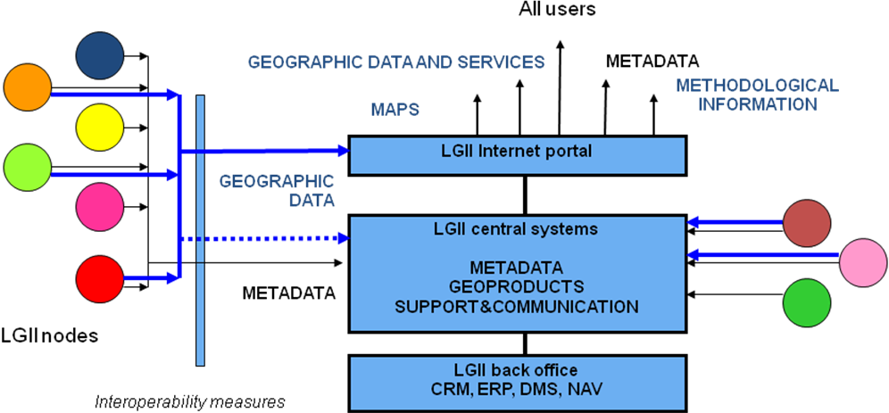

LIGI architecture

The LIGI strategy covers the long-term LISI development programme in different aspects: spatial coverage, institutional partnership, the variety of data themes, functionality, human resource development, electronic service development, promotion of the use of spatial information and its integration into European Community and global spatial information infrastructures.

The main achievements in LIGI development are as follows:
- A systematic geographical information management vision including various aspects (scientific, technological, educational);
- A single system for using geographical information has been created and the concept of a geoproduct and an applied geographical task has been introduced; geographical data in various formats are accessible via a single access point (the LIGI portal) irrespective of the location, format or structure of the data source;
- A single georeferenced data model and georeferenced database harmonisation principles have been created;
- A single methodology for describing geographical data using metadata has been created (National Metadata Profile).

INSPIRE parties concerned

During implementation of the LIGI project, the parties concerned were grouped by the nature of their activities:
- Public and municipal authorities coordinating the collection of spatial data;
- Spatial data suppliers
  - State and municipal organisations;
  - Business enterprises;
  - Developers of value-added spatial information-based products and services – business enterprises, science and research organisations.
- Spatial data users

These groups are also INSPIRE parties concerned. They overlap with each other as the authorities often have subordinate enterprises producing spatial data, and spatial information producers also create various value-added products and services. Nevertheless, each group has different objectives and expects to derive different types of basic benefits from the LISI.

Being active users of spatial information and electronic public sector services based on it, all the residents and non-governmental organisations of Lithuania comprise a huge target group whose needs are also planned to be satisfied using both INSPIRE and LSIP services specific to Lithuania.

Role of the parties concerned

In order to achieve the objectives of LISI and INSPIRE, as many as possible spatial data managers must contribute to its creation. They will make their data sets available to all on the single LISI portal. The more various data LISI users find in one place, the more benefit data suppliers will derive from them.

The main groups of LISI data suppliers are as follows:
- State public administration authorities and managers of state cadastres, registers and state information systems containing official spatial data.
- Municipal administrations or other municipal public administration authorities managing official spatial data;
- Other legal or natural persons that have received the LISI manager’s permission to provide data to the LISI and have concluded a data supply agreement with the LISI manager.

The first LISI data suppliers are nine public authorities and enterprises that control and manage almost all the most important Lithuanian national data sets and are ready to provide electronic spatial information services. They undertake to make georeferenced base, register, cadastre, information system and other spatial data available on the LISI portal as well as finance the management and assurance of the quality of these data.

LISI data suppliers will be able to:
- supply exclusively metadata, i.e. information on data sets available to them and instructions on how to access them;
- publish LISI data sets that will usually remain within the organisation of the data supplier and will be accessible via electronic services, but, having agreed it with the LISI manager, can be duplicated in the LISI central system as well;
- supply initial data for updating national data sets.

All LISI data suppliers will be able to:
- supply and update metadata on spatial data and data services controlled by them on time; metadata will have to be prepared in accordance with the approved LISI standard and technical regulations;
- ensure the quality of spatial data supplied and publish data samples on the LISI portal;
- ensure Internet access to spatial data supplied and related services if they are provided from sources other than the LISI central information system;
- prepare rules for licensing, supplying and pricing spatial data and data services, which will have to be harmonised with the approved LISI general rules for licensing, supplying and pricing spatial data and data services.

LISI data suppliers will receive, free of charge, reports on orders and actual use of spatial data and data services provided by them as well as will use the services of communication with other LISI users. They will be able to receive remuneration for paid spatial data and paid data services provided via the LISI portal.

LISI users are legal or natural persons using LISI data and metadata services. They may include public and municipal authorities, business enterprises, non-governmental organisations, residents an anyone who finds spatial data to be important.

All LISI users will have the right to:
- register in the LISI free of charge, receive metadata supplied via the LISI portal, review published samples of spatial data, receive publicly supplied spatial information, and use the services of metadata search and review as well as the directory of terms;
- use, free of charge, the services of LISI public communication among users, communication with the LISI management body and LISI data suppliers.

Users registered in the LISI and identified in accordance with the established procedure will have the right to:
- order, receive and use spatial data and data services provided via the LISI portal as well as receive, free of charge, information on the conditions for their acquisition and use;
- receive, free of charge, information on the execution of orders submitted by them and reports on the use of data services ordered;
- present proposals and comments on the quality of spatial data and data services provided via the LISI as well as use communication services and spatial information intended for LISI registered users;

LISI users, state and municipal public administration authorities, will have the right to:
- receive, free of charge, state official georeferenced spatial data, except in cases where such data are used for creating value-added services or products, and use georeferenced data services in accordance with the procedure and conditions established by the LISI management body;
- receive, free of charge, spatial data controlled by other data suppliers – state and municipal public administration authorities – and use data services provided on the basis of spatial data, provided that this does not contravene the effective legal acts.

Measures taken to create more favourable conditions for public authorities to exchange spatial data sets and related services

Information systems were created and installed during the LIGI project, with the information systems of nine authorities modernised by providing them with technical facilities for providing metadata and spatial data services.

A large-scale LISI publicity campaign was carried out. It included an information event for public authorities aimed at demonstrating the benefits and examples of exchange of spatial data sets and related services.

A law amending the Law of the Republic of Lithuania on Geodesy and Cartography was passed. It supplemented the previous version of the Law with provisions on the use of LISI and LSIP.

The parties concerned are currently informed of the opportunities offered by the LSIP. Specific conditions for the provision of SDS are being coordinated with data suppliers, public authorities. It is planned to sign agreements on data supply via the LSIP according to a typical model of the agreement prepared by the LSIP manager.

Cooperation among the parties concerned

Spatial data of different LISI data suppliers and related services will be managed and supplied to users according to specifications and conditions for supply and use approved by common agreement of suppliers. Acting in accordance with the LSIP regulations currently under preparation, the LSIP manager will ensure the recording and administration of spatial information stored in the LISI and its effective supply to users.

The NLS cooperates with the authorities concerned in preparing LISI methodical material.

During the implementation of the LIGI project, GIS-Centras prepared typical documents describing the conditions of supply and use of spatial data in Lithuania:
- Agreement on the granting of distribution rights on spatial data products and on the supply of spatial data products to the LISI. This agreement is concluded between the LSIP manager and a spatial data supplier. It defines the main terms, the legal basis of provision of SDS via the LSIP, the procedure for distributing SDS and paying the data supplier for them, the rights and obligations of the parties as well as the general procedure for providing spatial data and services to users. Annexes to the agreement contain structured forms with explanations for entering the parameters of spatial data or services provided. It provides for flexible coordination of typical agreements with specific data suppliers and describes procedures for changing the parameters of spatial data or services provided.
- Model agreements on the use of spatial data and services. They set out the main conditions for using SDS based on which the LSIP manager concludes typical licence agreements with SDS end users. They provide for different methods of approval of licence agreements: by a physical signature, electronic signature and clicking upon checking the person’s identity. The licence agreement sets out the procedure for providing spatial data and related services to users, the purpose and conditions for use as well as the payment procedure.
- Conditions for use of www.geoportal.lt services that are applied to spatial data sets and services provided publicly and free of charge. They are simpler than licence agreements. These conditions will be applied to the LSIP.
These documents have not been applied to data supply to INSPIRE yet, but they serve as a basis for the preparation of equivalent procedures for spatial data supply to INSPIRE.

No special working groups for cooperation between the parties concerned have been established yet.

LISI development and Directive implementation activities were publicised during information events, in publications and reports.

Articles
Beconytė G. and Kryžanauskas A. (2009). ‘Cartographic communication for sustainable development of the society’. M. Grasserbauer, L. Sakalauskas, E. K. Zavadskas (Eds.): KORSD-2009 Selected Papers. ISBN 978-9955-28-482-6. Vilnius, 2009, Vilnius: Technika, p. 52–57
Beconytė G., Kryžanauskas A., Papšienė L., Papšys K. and Stankevičius Ž. (2009). ‘Lithuanian infrastructure for geographical information: the road to a single geographic methodology’. Geography 45(1), Vilnius 2009, p. 1–10
Beconytė G., Govorov M., Ningal T.F., Paršeliūnas E., Urbanas S. (2008). ‘Geographic information e-training initiatives for national spatial data infrastructure //Technological and economic development of economy, Baltic Journal on Sustainability, 2008, vol.14, No.1, 11-28
Beconytė G., Paršeliūnas E., Pubellier C. (2006) ‘Sustainable development of Lithuanian geographic information infrastructure’. // The 4th International Conference ‘Citizens and Governance for Sustainable Development’. Selected Papers, 28–30 September 2006, Vilnius, Lithuania. Vilnius: Technika. ISBN: 9955-28-041-7, p. 151–155.
Beconytė G., Paršeliūnas E., Pubellier C. (2007) ‘Sustainable development of Lithuanian geographic information infrastructure’. // Ekologija/Ecology, 2007, Vol. 53, ISSN 0235-7224, p. 22–26
Beconytė G. and Pubellier C. (2006). ‘Geographic information infrastructure – towards interoperability of public data’. Geography 42(1), Vilnius 2006, p. 23-27
Beconytė G. and Pubellier C. (2006). ‘Geographic information infrastructure in Lithuania – components and data themes’. Geography 42(2), Vilnius 2006, p. 29-34
Urbanas S. (2006). ‘National mapping and cadastral agencies’ trends developing European Spatial Data Infrastructure // The 6th International Conference ‘Environmental Engineering’. Selected Papers Vol. II, Vilnius: Technika 2006, p. 1018–1023
Urbanas S. (2009) ‘Step forward practically implementing national spatial data infrastructure in Lithuania’. ESRI European User Conference Proceedings. ESRI Press.
Urbanas S. and Pažemys M. (2008). ‘Step vise approach developing Lithuanian geographic information infrastructure //INSPIRE Conference abstracts, Maribor, Slovenia, 23–25 June 2008, European Commission Publications Office, EUR 23388 EN, 110-111.

Twelve targeted LISI publicity events were attended by 750 people. In addition, NLS and GIS-Centras specialists read reports at various events for geographical information users.

Keynote reports read at the events

Development of the Lithuanian Infrastructure for Geographical Information. (2007–8). Twelve reports in Lithuanian counties and at national events.
Beconytė G. (2009). Lithuanian Geographic Information Infrastructure. INTERCARTO/INTERGIS, 5 July 2009, Ghent, Belgium.
Beconytė G. and coauthors (2009). Online Geographic Information Training for SDI Capacity Building in Lithuania. 2009 ESRI European User Conference (EUC). 14–16 October, 2009. Vilnius, Lithuania.
Beconytė G. and Kryžanauskas A. (2009). ‘Cartographic communication for sustainable development’. //The 5th International Conference ‘Knowledge-Based Technologies and OR Methodologies for Strategic Decisions of Sustainable Development’. 30 September – 3 October, 2009, Vilnius, Lithuania.
Kryžanauskas A. (2009) ‘Unified approach to geographic problems’. // 5th Vilnius Seminar on Cartosemiotics, 6 May 2009, Vilnius University.
Kryžanauskas A. (2009). ‘Geographic names in national products & projects’. //13th Meeting of the Baltic Division of UNGEGN, Vilnius, 1–2 October 2009, National Land Service
Kryžanauskas A. (2009). ‘Geoinformational database of toponyms at the Institute of the Lithuanian Language’. //13th Meeting of the Baltic Division of UNGEGN, Vilnius, 1–2 October 2009
Kryžanauskas A. (2009). ‘Lithuanian geoportal live: user’s perspective’. //2009 ESRI European User Conference, 14–16 October, 2009, Vilnius.
Kryžanauskas A. (2010). ‘Data transformation in the Lithuanian NSDI portal’. //FMEdays 2010, 9–10 March 2010, Muenster.
Vilūnaitė B. (2009). EuroRegionalMap: From National to European Medium Scale Geodatabase. XXII ESRI European User Conference. Vilnius.

Description of the Lithuanian geoportal

The LSIP is established on the basis of:
- Law of the Republic of Lithuania on Geodesy and Cartography [13];
- Rules for the establishment and validation of state information systems approved by Government Resolution No 451 of 19 April 2004 (Žin., 2004, No 58-2061) [13];
- Regulations of the National Land Service under the Ministry of Agriculture approved by Order No 194 of 14 June 2001 of the Minister for Agriculture (Žin., 2001, No 52-1852; 2008, No 150-6122), [15].
The Law of the Republic of Lithuania on Geodesy and Cartography provides for the LSIP, a state information system for centralised provision of metadata, spatial data sets and related services.

The following main functions of LSIP are laid down in the Law of the Republic of Lithuania on Geodesy and Cartography:
- to collect metadata of spatial data of state cadastres, registers, state and municipal authorities and other organisations according to a methodology approved by the portal manager;
- to provide metadata and spatial data sets to users on the Internet;
- to provide services related to spatial data sets to users on the Internet;
- to publicise and promote the use of spatial data for solving public administration sector problems; to provide information on the possibilities for the public and private business entities to effectively use spatial data controlled by the public sector;
- to create technological conditions for linking spatial data sets managed by different authorities and using them together.

An LSIP prototype, the Lithuanian geoportal www.geoportal.lt created as a result of the LIGI project in 2008, is currently operational and is being developed.

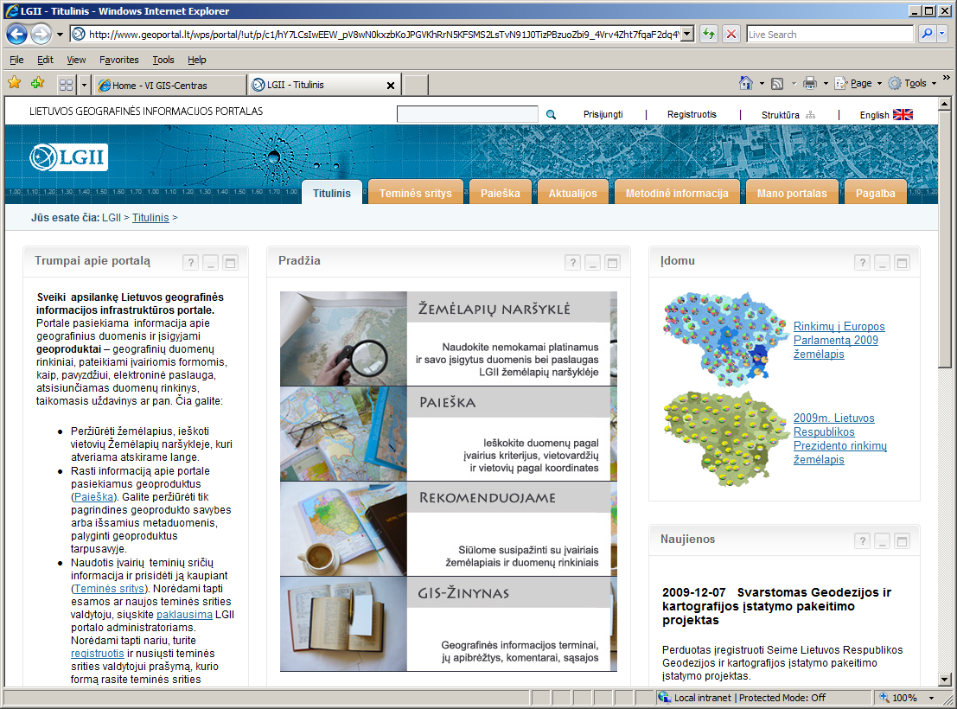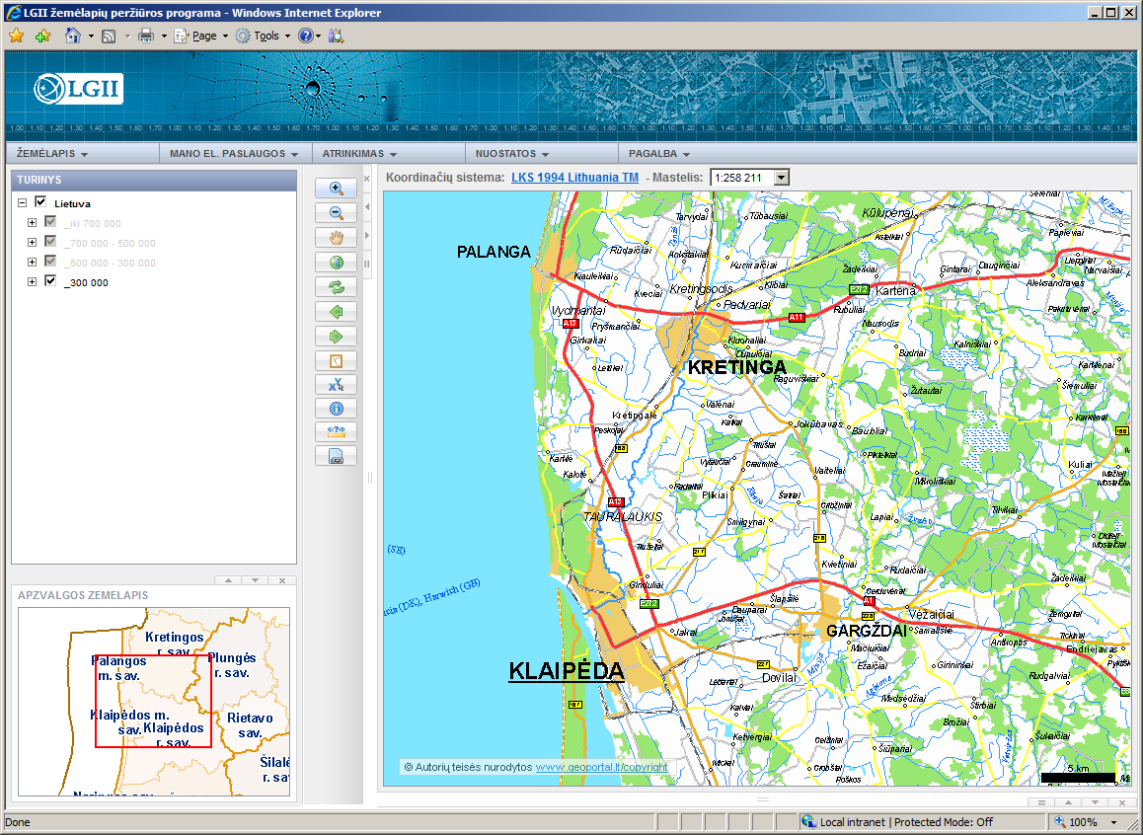

Windows of the homepage and map browser pages of the Lithuanian geoportal

The LSIP manager is state enterprise GIS-Centras which manages portal users, the information structure and general contents, collects and processes metadata, stores them and initiates their regular updating, creates electronic data and metadata services and provides them to users. The LSIP manager ensures correct registration, management and transfer of all information published on the LSIP and its protection from illegal actions. The LSIP manager has the right to remove false information or information not meeting requirements from the LSIP without warning.

The Lithuanian geoportal consists of the following:
- Content management system;
- Metadata search, management and publication system;
- System of configuration, ordering, production, management, publication and protection of spatial data sets and related services;
- Map browser;
- Administration system.

Created network service prototypes are currently tested on the Lithuanian geoportal:
The main services corresponding to INSPIRE network services by their nature:
- Discovery services: search for spatial data sets and related services by the content of certain metadata;
- View services: to display, navigate, zoom in/out, pan or overlay viewable data sets and to display them using legend information or display metadata contents;
- Download services: to download copies of spatial data sets or parts thereof;
- Transformation services: to transform spatial data sets;
- Invoke spatial data services: to invoke some spatial data or services on the basis of other spatial data sets or services.
Special services:
- Data access services: to access on the Internet and use spatial data in online map browsers and/or computer programmes;
- Spatial processing services: to solve dynamic spatial problems using spatial data and present the results obtained;
- Services of processing by thematic features: to process spatial data using their thematic features and present the results obtained:
- Services of processing by time features: to process spatial data using their time features and present the results obtained:
- Integrated services combining other abovementioned services for satisfying specific needs of users.

Access to services using the INSPIRE geoportal

Access to services using the INSPIRE geoportal is not used at present.

Using the infrastructure for spatial information (Art. 14)

Using the spatial data services of the infrastructure for spatial information

The following services provided via the LSIP are defined in the Law of the Republic of Lithuania on Geodesy and Cartography:
(1) discovery services: to search for spatial data sets and services by the content of certain metadata and display the content of such metadata;
(2) view services: to display, navigate, zoom in/out, pan or overlay viewable spatial data sets, as well as to display them with legend information and any relevant metadata content;
(3) download services: to download copies of spatial data sets or parts thereof and use them directly;
(4) transformation services: to transform spatial data sets to achieve interoperability;
(5) invoke spatial data services: to invoke some spatial data or services on the basis of other spatial data sets or services.

Prototypes of these and other services have been created and are being tested on the LIGI portal. Their compliance with the INSPIRE requirements is yet to be assessed. Therefore, the compliance and use of infrastructure services cannot be assessed yet.

On the LIGI portal, a data supplier can supply spatial data to a user as data sets or as related services:
- A data set is a set of systemised digital geospatial data which share the same purpose, the territory described or another common feature;
- OGC WFS are electronic services for publication of geoobjects, as defined by the OpenGIS specification, which transform vector data into the form required by the client. WFS services also enable customers to perform actions with data on the server: receive or question geoobjects according to established spatial or non-spatial restrictions, create a new geoobject, cancel it and update its features. The data for these services are used as conventional vector data;
- OGC WCS are electronic services for sending spatial data, as defined by the OpenGIS specification, which make it possible to access data on the Internet in a form equivalent to that available on the server. The programme available to the customer can analyse and process such data and generate a map. The data for these services are used as conventional raster data;
- OGC WMS are electronic services for Internet maps, as defined by the OpenGIS specification, which allow access to map layers on the Internet server publishing them according to parameters chosen by a data user. Unlike WFS and WCS services, WMS services do not allow access to the original data on the basis of which a map is prepared for publication.
Depending on the selected method of spatial data supply, users can receive the result in the form of a copy of the data (a data set), which they can save to their computer, or gain access to the data itself (e-services), thus ensuring that every time they use the most up-to-date data. By evaluating the available software and its characteristics when ordering a data set, a user can choose a data format and system of coordinates. Having ordered electronic services (WFS, WCS or WMS), a user receives an address providing real-time access to spatial data from certain GIS software (e.g. ArcGIS, AutoCAD, Gaia) or web map viewing applications on geoportals.

Spatial data supplied by the LIGI and related services are public, except for the cases laid down in laws and other legal acts. Any person can use spatial data provided via the LIGI and related services in accordance with the procedure set forth in the laws of the Republic of Lithuania and regulations governing state and municipal information systems controlled by LIGI data suppliers. These provisions also apply to the provision of LSIP services.

Using spatial data sets

Before validation of LISI, public authorities had been exchanging spatial data sets under licence agreements and agreements with spatial data suppliers.

The Law of the Republic of Lithuania on Geodesy and Cartography defines the following conditions for the use of spatial data sets via the LSIP:
- Access to spatial data via the Lithuanian spatial information portal must be public, unless access to spatial data is otherwise defined in other laws.
- Spatial data sets and services needed by European Union authorities, public authorities and municipalities for carrying out public tasks or submitting reports in accordance with European Union environmental legislation must be provided free of charge.
- State cadastre and register management bodies and state and municipal authorities managing spatial data sets have the right to restrict access to spatial data sets via the Lithuanian spatial information portal if this is provided for in other laws.
- Users of the spatial data sets and services of the Lithuanian infrastructure for spatial information must agree to conditions established by spatial data and service providers or their authorised distributors.
- Spatial data set suppliers may be state cadastre and register management bodies or state or municipal authorities managing spatial data sets. Persons wishing to create value-added products using data from state cadastres, registers, georeferenced spatial data sets or spatial data sets and thematic spatial data sets must be entitled to do so in accordance with the procedure established by spatial data set suppliers. Value-added products must be supplied to users by authorised distributors in accordance with the procedure established by spatial data set suppliers.
- In accordance with the procedure set forth in legal acts, access to spatial data sets and/or services via the Lithuanian spatial information portal must be provided to Member States’ public authorities and enterprises and organisations that provide public services. Access to the spatial data sets and services of public bodies and organisations of parties to the European Economic Area Agreement must be provided via the Lithuanian spatial information portal to Lithuanian users providing public services, unless otherwise provided for by law.
- In the event of provision of paid services, the service provider must ensure that users from the Republic of Lithuania and other Member States are able to use e-commerce services.

The diagram below shows the present use of LIGI portal services. Similar statistics can be expected once the LSIP has been developed.

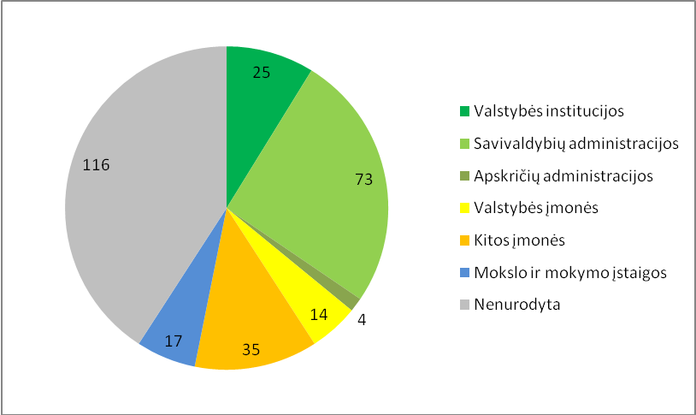

Distribution of active registered LIGI users by organisation as at 1 May 2010

Valstybės institucijos | Public authorities
Savivaldybių administracijos | Municipal administrations
Apskričių administracijos | County administrations
Valstybės įmonės | State enterprises
Kitos įmonės | Other enterprises
Mokslo ir mokymo įstaigos | Education and training institutions
Nenurodyta | Not indicated

Use of the infrastructure for spatial information by the public

The public is currently using the LIGI portal, through which they can find and view metadata, some spatial data sets and network service prototypes. The actual scale of use of LISI by the public cannot be evaluated until all planned legal acts defining the conditions of use of SDS have been prepared.

The diagram below shows the activity dynamics of LIGI portal users in 2009. Still more intensive use is expected once the LSIP has been developed.

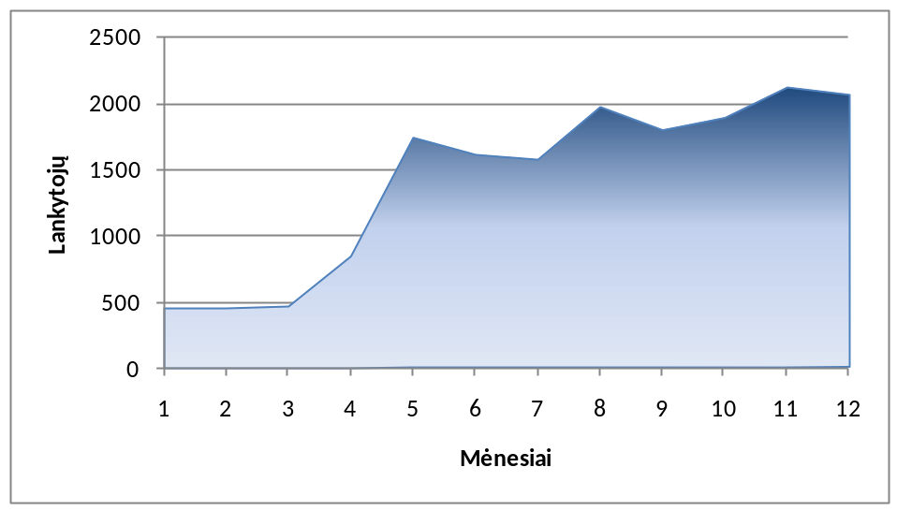

Summary of portal users’ dynamics in 2009

Lankytojų | Visitors
Mėnesiai | Months

Transboundary use

The transboundary use of spatial data sets corresponding to the themes listed in Annexes I, II and III to the Directive and their compatibility is ensured by the NLS by regular participation in EuroGeographics projects for creating common European spatial data products using official state data sets. During these projects, spatial data are harmonised among their suppliers. The NLS supports and manages the EuroGeographics-coordinated databases EuroDEM, EuroBoundaryMap, EuroRegionalMap, EuroGlobalMap and EuroGeoNames within the Republic of Lithuania.

Use of transformation services
Transformation services are not provided at present. The LSIP allows for their possible development.

Data-sharing agreements (Art. 15)

Data-sharing agreements between public authorities

No valid agreements have been signed yet. The Law of the Republic of Lithuania on Geodesy and Cartography obliges public and municipal authorities to provide spatial data via the LSIP.

Agreements on the granting of distribution rights for spatial data products and on the supply of spatial data products to the LISI (specific information contained in the annexes thereto) are currently being coordinated with the main spatial data suppliers listed in points 1–10 of section 9.1.

Lithuanian municipalities have been informed of the possibility to provide spatial data and related services and are being acquainted with the contents of a model agreement on the granting of distribution rights for spatial data products and on the supply of spatial data products to the LISI.

Data-sharing agreements between public authorities and Community institutions and bodies

There are currently no valid official agreements.

Obstacles preventing public authorities from sharing spatial data sets and related services, and a description of actions taken to eliminate such obstacles

The main problem is that no funds have been earmarked for ensuring the compatibility of the spatial data of Community states. State internal resources are not sufficient to ensure both internal exchange of spatial data for the needs of the state and quality supply of such data to Community institutions and bodies. The problem is being solved by trying to harmonise national needs with INSPIRE requirements as much as possible.

The Regulations on State cadastres, registers and information systems establish the procedure for data supply, which, in some cases, appears to be unsuitable for the provision of electronic data (agreements and licences required, inflexible pricing). This complicates the coordination of conditions for data supply and the signing of agreements. The necessary amendments to legal acts are planned to be made, but it is a lengthy process.

Data suppliers often lack resources to be able to supply data in accordance with LISI and INSPIRE requirements. Owing to the incompatibility of spatial data specifications, it is impossible to fully automate data-sharing. Therefore, it is difficult to ensure quality data supply. Attempts are being made to solve this problem by presenting data suppliers with precise procedures as well as metadata and unified data supply tools.

Cost-benefit aspects (Art. 16)

Costs of implementation of Directive 2007/2/EC

LISI development costs were first estimated in a feasibility study prepared in 2004 [7]. The cost of the work that would need to be carried out in order to properly implement the Directive in Lithuania was estimated on the basis of these calculations and experience gathered during the implementation of the LISI development project.

The following main categories of costs for implementation of the Directive were listed:
- Preparation of metadata;
- Data harmonisation;
- Creation of network services;
- Monitoring and reporting;
- Preparation and implementation of coordination and horizontal measures.

Costs of works necessary for the implementation of the Directive are provided in the charts below according to the indicated categories.

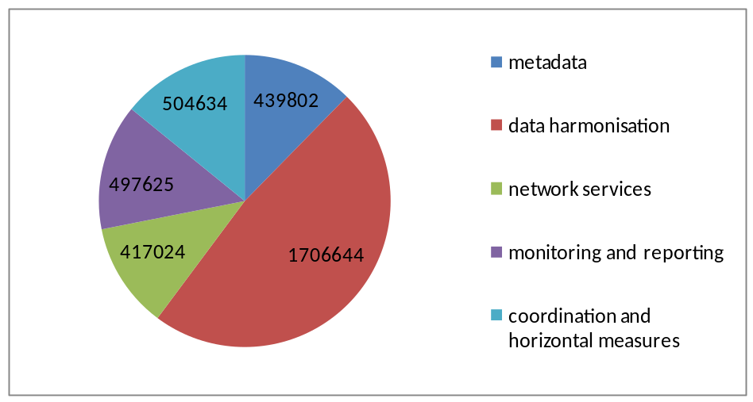

Implementation costs (EUR) by category, 2010–2015
(A total of LTL 12 311 750, EUR 3 565 729)

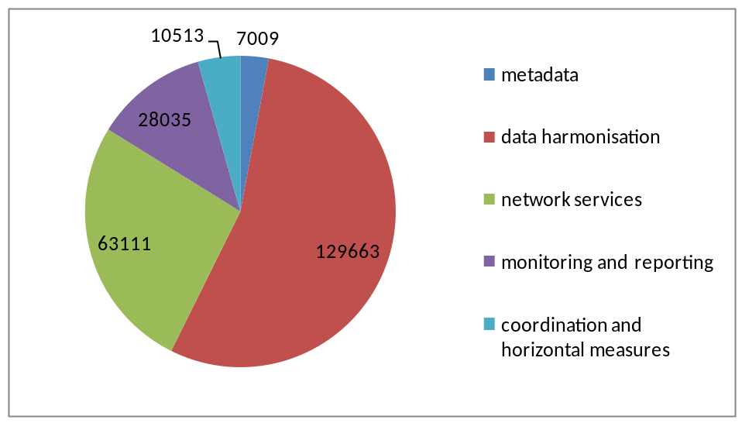

Implementation support costs (EUR) by category, annually from 2011
(A total of LTL 822 909, EUR 238 331)

It is difficult to estimate potential costs of management of data sets corresponding to the themes listed in Annexes I and II to the Directive at present. According to preliminary estimates, the management and supply of currently known data sets could cost the state approximately EUR 5 million.

Benefits observed

Preconditions for integrating state registers, statistical information and other data sets based on spatial data sets were created during the development of LISI:
- Less data duplication and lower management costs can be expected;
- Possibility for the public to access data more easily;
- Data harmonisation;
- Related data integration initiatives.

Creation of a single spatial information infrastructure will produce significant benefits for the public, business and public sector:
- The public. Access to relevant spatial data accumulated by public authorities and improved quality of public services.
- Business. Possibilities to include the latest data in a common information system, for example, local restaurants, hotels and filling stations. In addition, supply various value-added products to the market.
- The public sector. Possibilities to use data stored by other authorities and agencies as well as increase work efficiency in performing public administration functions and providing services to citizens.

The LISI will also be useful to data suppliers:
- Data suppliers will be guaranteed accessibility of data controlled by them and a data-sharing mechanism;
- Preconditions for harmonising data of different suppliers and effectively exchanging them will be created;
- Data suppliers will be able to represent their interests during preparation of spatial information methodologies and standards;
- It will be possible to create and develop new electronic services by using LISI tools;
- Additional LISI services will be provided to data suppliers.

After the provisions of the Directive are introduced, geodesic and cartographic activities will be facilitated and more clearly defined, and more specific requirements will be established for persons engaged in geodesic activities. Regulation of service provision activities will be simplified and the administrative burden on business will be reduced.

Examples of benefits observed:
- Purposeful formation of a spatial information policy was started;
- Impact on the environmental policy: the obligation to handle the existing data and collect new GIS data.
- Authorities’ understanding of the benefits of spatial information and data integration when taking decisions has improved, thus creating preconditions for closer cooperation;
- The public is better informed and the need for spatial data services is on the rise.

Conclusions
A methodological and technological basis of the spatial information infrastructure has been created upon implementing the LIGI project in Lithuania. There is an operational geoportal which provides access to metadata of state spatial data sets and where one can acquire data sets and related services. The LISI provided for in the Law of the Republic of Lithuania on Geodesy and Cartography and its portal LSIP are being created by applying LIGI solutions. Not all legal acts required to ensure complete functioning of LSIP have been adopted yet and therefore network services are not being officially provided and used. Their prototypes are being tested. It is planned to evaluate the compatibility of specifications of LIGI portal systems, metadata and network services with the approved INSPIRE specifications as well as achieve their compatibility with these specifications within established time limits. Data on Lithuanian place names can be supplied using the global EuroGeoNames service. Lithuania is not responsible for the compliance of these network services with the INSPIRE requirements.

Existing metadata of spatial data sets that correspond to the national metadata profile of Lithuania are currently available to users via the LIGI portal. It will not be difficult to achieve their compatibility with INSPIRE (there is minimal incompatibility). Metadata of data sets corresponding to the themes referred to in Annexes I and II are planned to be provided on time.

Digital spatial data sets currently available in Lithuania cover virtually all INSPIRE themes, except for the following:
- Coordinate reference systems
- Geographical grid systems
- Oceanographic geographical features
- Sea regions
- Bio-geographical regions
The first two themes describe reference system requirements rather than data sets.

The lowest number of data sets corresponds to the themes referred to in Annex III. It is planned to include new LISI nodes to facilitate the merger of existing numerical data with spatial data and develop them. Information currently collected in georeferenced data sets on different scales fully or partly covers 11 data themes.

The collected data sets corresponding to theme I currently do not conform to the INSPIRE specifications. Georeferenced base management works are planned to be carried out in order to achieve conformity.

To sum up, Lithuania is technically prepared for the implementation of most of the INSPIRE requirements. The implementation is limited by a lack of human and financial resources and complex legal and organisational data-sharing procedures.

Annexes

List of organisations: names and contact details

- National Land Service under the Ministry of Agriculture (www.nzt.lt), Gedimino pr. 19, LT-01103 Vilnius, tel. +370 (5) 239 1307, fax +370 (5) 239 1331, e-mail nzt@zum.lt.
- Ministry of the Environment (www.am.lt), Jakšto g. 4/9, LT-01105 Vilnius, tel. +370 (5) 266 3661, fax +370 (5) 266 3663, e-mail info@am.lt.
- Environmental Protection Agency (http://aaa.am.lt/), A. Juozapavičiaus g. 9, LT-09311 Vilnius, tel. +370 (5) 2662808. fax +370 (5) 2662800, e-mail aaa@aaa.am.lt.
- State Forest Service under the Ministry of the Environment (http://www.lvmi.lt/vmt/), Pramonės pr.11ª, LT-51327 Kaunas, tel. +370 (37) 490,220, fax +370 (37) 490,251, e-mail vmt@lvmi.lt.
- Geological Survey of Lithuania under the Ministry of the Environment (http://www.lgt.lt/), S. Konarskio 35, LT-03123 Vilnius, tel. +370 (5) 233 2889, fax +370 (5) 233 6156, e-mail lgt@lgt.lt.
- State Service for Protected Areas under the Ministry of the Environment (http://vstt.lt), A.Juozapavičiaus g. 9, LT-09311 Vilnius, tel. +370 (5) 272 3284, fax +370 (5) 272 2572, e-mail vstt@vstt.lt.
- Lithuanian Hydrometeorological Service under the Ministry of the Environment (www.meteo.lt), Rudnios g. 6, LT-09300 Vilnius, tel. +370 (5) 275 1194, fax +370 (5) 272 8874, e-mail lhmt@meteo.lt.
- State Enterprise Centre of Registers (http://www.registrucentras.lt/), V.Kudirkos g. 18, LT-03105 Vilnius, tel. +370 (5) 268 8202, fax +370 (5) 268 8311, e-mail info@registrucentras.lt.
- Lithuanian Road Administration under the Ministry of Transport and Communications (http://www.lra.lt/), J.Basanavičiaus g. 36/2, LT–03109 Vilnius, tel. +370 (5) 232 9600, fax +370 (5) 232 9609, e-mail lakd@lakd.lt.
- Fire and Rescue Department under the Ministry of the Interior (http://www.vpgt.lt/), Švitrigailos g. 18, LT-03223 Vilnius, tel. +370 (5) 271 6866, fax +370 (5) 216 3494, e-mail pagd@vpgt.lt.
- Department of Statistics under the Government of the Republic of Lithuania (http://www.stat.gov.lt), Gedimino pr. 29, LT-01500 Vilnius, tel. +370 (5) 236 4800, fax +370 (5) 236 4845, e-mail statistika@stat.gov.lt.
- Department of Cultural Heritage under the Ministry of Culture (http://www.kpd.lt), Šnipiškių g. 3, LT-09309 Vilnius, tel. +370 (5) 273 42 56, fax +370 (5) 272 40 58, e-mail centras@heritage.lt.
- Lithuanian Maritime Safety Administration (http://www.msa.lt), J.Janonio g. 24, LT-92251, Klaipėda, tel. +370 (46) 469,602, fax +370 (46) 469,600, e-mail msa@msa.lt.
- State Territorial Planning and Construction Inspectorate under the Ministry of the Environment (http://www.vtpsi.lt/), A. Juozapavičiaus g. 9, LT-09311 Vilnius, tel. +370 (5) 272 2748, fax +370 (5) 272 3620, e-mail info@vtpsi.am.lt.

List of references to documents used during preparation of the Report

- Directive 2007/2/EC of the European Parliament and of the Council of 14 March 2007 establishing an Infrastructure for Spatial Information in the European Community (INSPIRE) (OJ 2007 L 108, p. 1).
- Government Resolution No 911 of 10 September 2008 on the designation of responsible authorities in order to ensure implementation of Directive 2007/2/EC of the European Parliament and of the Council of 14 March 2007 (Žin., 2008, No 109-4157; 2009, No 116-4940).
- Commission Decision of 5 June 2009 implementing Directive 2007/2/EC of the European Parliament and of the Council as regards monitoring and reporting (notified by document No C(2009) 4199).
- Availability Report. Development of Lithuanian Geographic Information Infrastructure (LEII) Project Preparation (2004). ASTEC Global Consultancy. Vilnius, p. 197.
- Assessment for priority intervention needs. Development of Lithuanian Geographic Information Infrastructure (LEII) Project Preparation (2004). ASTEC Global Consultancy. Vilnius, p. 74.
- Framework Report. Development of Lithuanian Geographic Information Infrastructure (LEII) Project Preparation (2004). ASTEC Global Consultancy. Vilnius, p. 73.
- Feasibility Study. Development of Lithuanian Geographic Information Infrastructure (LEII) Project Preparation (2004). ASTEC Global Consultancy. Vilnius, p. 106.
- Development of Lithuanian Geographic Information Infrastructure. Investment project (2004). GIS-Centras VĮ, Vilnius, p. 76
- LISI creation and development vision. V.1.1. State Enterprise National Centre of Remote Sensing and Geoinformatics GIS-Centras (http://www.geoportal.lt/wps/portal/!ut/p/c1/04_SB8K8xLLM9MSSzPy8xBz9CP0os_gAQwNnc09LYwMLA3dzA08D8yB_E4NAA_dQI6B8JLK8paergZG5gaGHpaW7u7-HIQHd4SD78OsHyRvgAI4G6PrRbDDX9_PIz03VL8iNMMgMSFcEABIIVZU!/dl2/d1/L2dJQSEvUUt3QS9ZQnB3LzZfUDEwQzdJOTMwODBHNzBJMDdSTzQwUTBHMTI!/)
- Principal provisions of LISI. V.1.1. State Enterprise National Centre of Remote Sensing and Geoinformatics GIS-Centras (http://www.geoportal.lt/wps/portal/!ut/p/c1/04_SB8K8xLLM9MSSzPy8xBz9CP0os_gAQwNnc09LYwMLA3dzA08D8yB_E4NAA3dDI6B8JLK8paergZG5gaGHpaW7u7-HIQHd4SD78OsHyRvgAI4G6PpRbQg1JyBvpO_nkZ-bql-QG2GQ6anrCACLBw3q/dl2/d1/L2dJQSEvUUt3QS9ZQnB3LzZfUDEwQzdJOTMwODBHNzBJMDdSTzQwUTBHMTc!/)
- LISI operating (business) model V.1.3. State Enterprise National Centre of Remote Sensing and Geoinformatics GIS-Centras (http://www.geoportal.lt/wps/portal/!ut/p/c1/04_SB8K8xLLM9MSSzPy8xBz9CP0os_gAQwNnc09LYwMLA3dzA08D8yB_E4NAA3cvQ6B8JLK8paergZG5gaGHpaW7u7-HIQHd4SD78OsHyRvgAI4G6PpRbQg1IiBvru_nkZ-bql-QG2GQ6anrCABV1Ut1/dl2/d1/L2dJQSEvUUt3QS9ZQnB3LzZfUDEwQzdJOTMwODBHNzBJMDdSTzQwUTBHSDE!/)
- Lithuanian national metadata profile V.1.3. State Enterprise National Centre of Remote Sensing and Geoinformatics GIS-Centras (http://www.geoportal.lt/wps/portal/!ut/p/c1/04_SB8K8xLLM9MSSzPy8xBz9CP0os_gAQwNnc09LYwMLA3dzA08D8yB_E4NAA3cPQ6B8JLK8paergZG5gaGHpaW7uz9QniTdqPKh5gR0h4Nci992kLwBDuBogK4fzX4jAvLm-OUtTfT9PPJzU_ULckMjDDI9s0wcFRUBbViQPA!!/dl2/d1/L2dJQSEvUUt3QS9ZQnB3LzZfUDEwQzdJOTMwODBHNzBJMDdSTzQwUTBHOTE!/)
- Law of the Republic of Lithuania on Geodesy and Cartography (Žin., 2001, No 62-2226; 2010, No 54-2649).
- Rules for the establishment and validation of state information systems approved by Government Resolution No 451 of 19 April 2004 (Žin., 2004, No 58-2061);
- Regulations of the National Land Service under the Ministry of Agriculture approved by Order No 194 of 14 June 2001 of the Minister for Agriculture (Žin., 2001, No 52-1852; 2008, No 150-6122).

